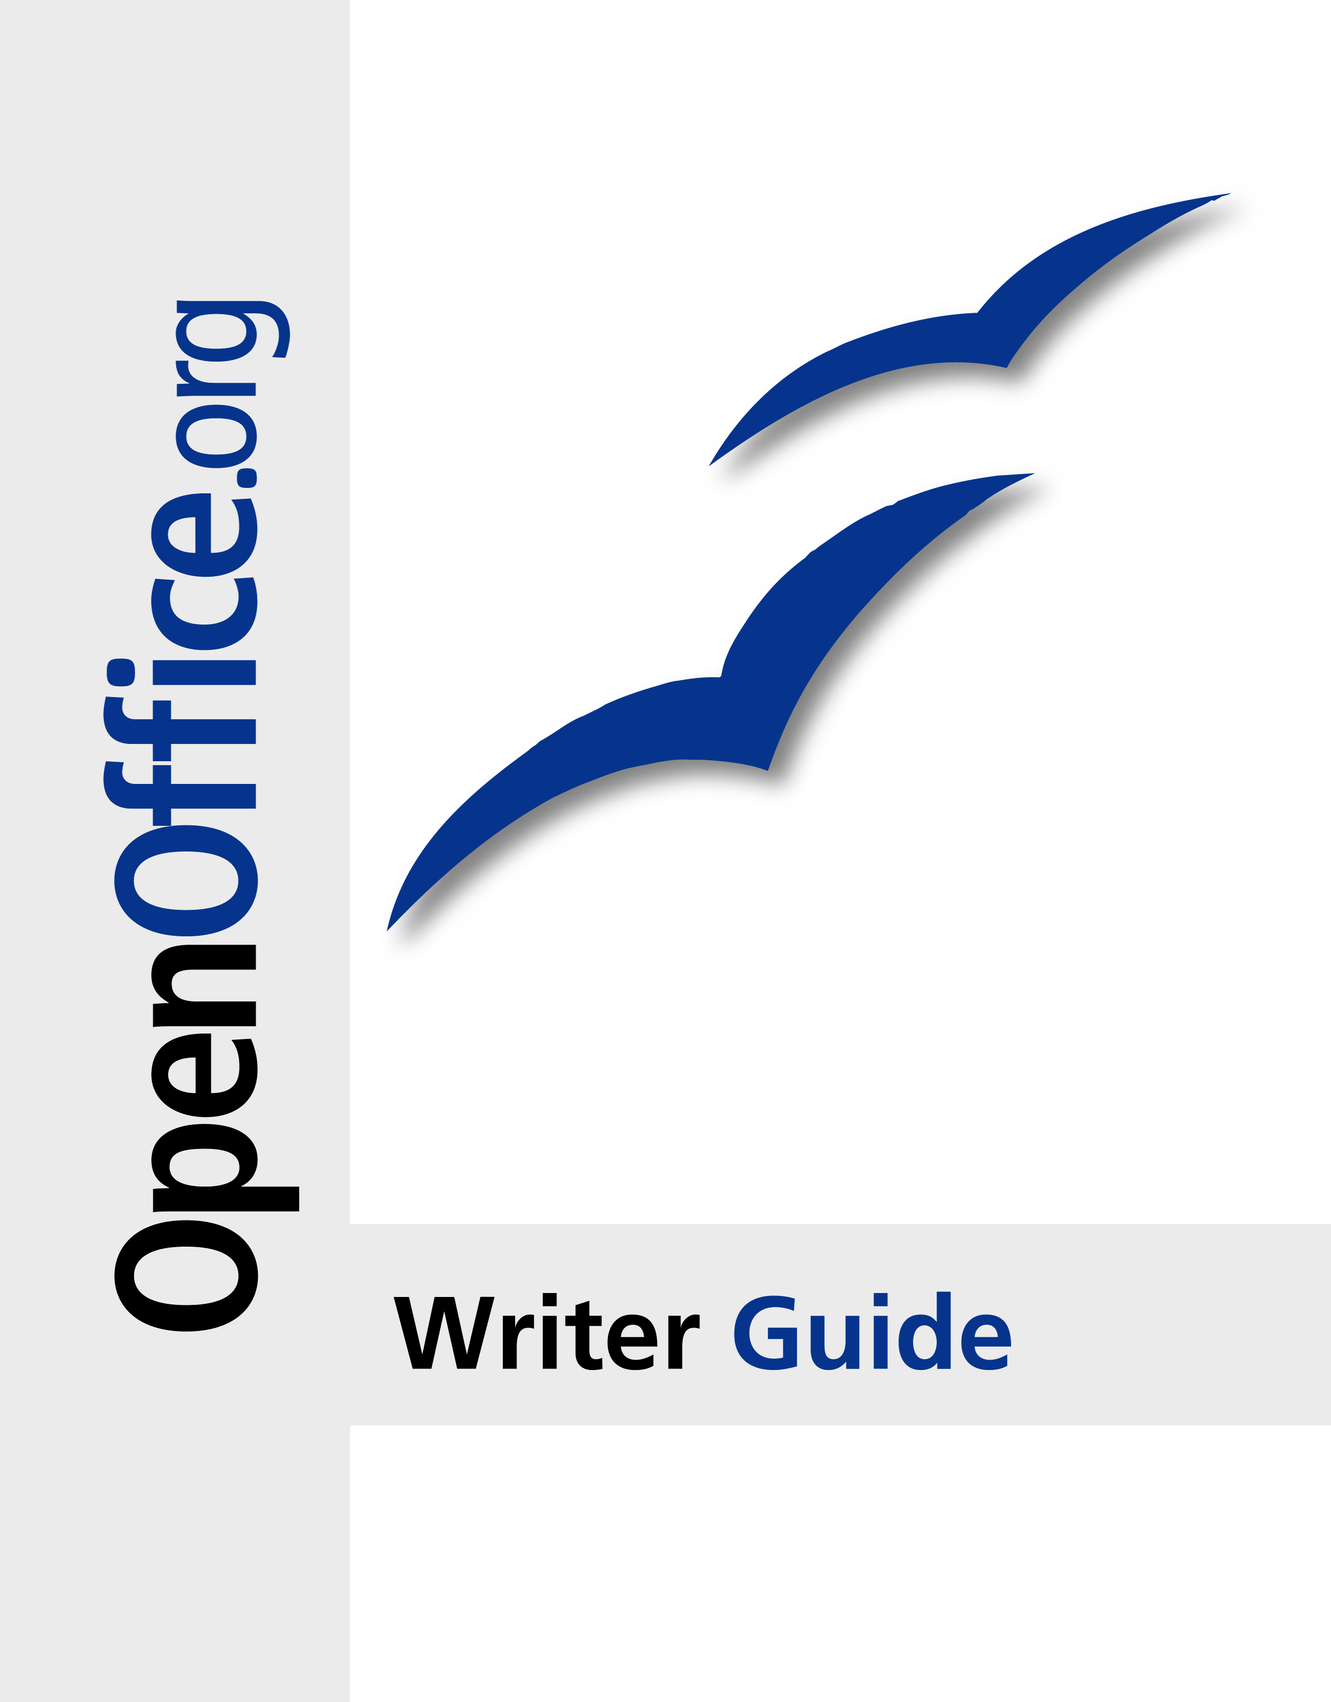

Copyright

This document is Copyright © 2005–2007 by its contributors as listed in the section titled Authors. You can distribute it and/or modify it under the terms of the Creative Commons Attribution License, version 3.0 or later (<http://creativecommons.org/licenses/by/3.0/>).

All trademarks within this guide belong to their legitimate owners.

Authors

Magnus Adielsson  
Agnes Belzunce  
Ken Byars  
Bruce Byfield  
Camillus Gerard Cai  
Daniel Carrera  
Dick Detwiler  
Laurent Duperval  
Martin Fox  
Katherine Grief  
Tara Hess  
Peter Hillier-Brook  
John Kane  
Michael Kotsarinis  
Sigrid Kronenberger  
Peter Kupfer  
Ian Laurenson  
Alan Madden  
Paul Miller  
Vincenzo Ponzi  
Carol Roberts  
Iain Roberts  
Robert Scott  
Janet M. Swisher  
Catherine Waterman  
Jean Hollis Weber  
Linda Worthington  
Michele Zarri

Feedback

Maintainer: Jean Hollis Weber  
Please direct any comments or suggestions about this document to:  
[authors@user-faq.openoffice.org](mailto:authors@user-faq.openoffice.org)

Publication date and software version

Published 16 December 2007. Based on OpenOffice.org 2.3.

* 1. Contents

[Chapter 1  
 Introducing Writer](#1.Chapter 1   Introducing Writer|outline) [1](#1.Chapter 1   Introducing Writer|outline)

[What is Writer?](#1.1.What is Writer?|outline) [2](#1.1.What is Writer?|outline)

[Starting Writer](#1.2.Starting Writer|outline) [2](#1.2.Starting Writer|outline)

[Starting from the system menu](#1.2.1.Starting from the system menu|outline) [3](#1.2.1.Starting from the system menu|outline)

[Starting from an existing document](#1.2.2.Starting from an existing document|outline) [7](#1.2.2.Starting from an existing document|outline)

[Using the Quickstarter under Windows](#1.2.3.Using the Quickstarter under Windows|outline) [7](#1.2.3.Using the Quickstarter under Windows|outline)

[Using the Quickstarter under Linux](#1.2.4.Using the Quickstarter under Linux|outline) [8](#1.2.4.Using the Quickstarter under Linux|outline)

[Preloading OOo under Linux/KDE](#1.2.5.Preloading OOo under Linux/KDE|outline) [8](#1.2.5.Preloading OOo under Linux/KDE|outline)

[Starting from the command line](#1.2.6.Starting from the command line|outline) [8](#1.2.6.Starting from the command line|outline)

[The Writer interface](#1.3.The Writer interface|outline) [9](#1.3.The Writer interface|outline)

Menus 9

Toolbars 10

Rulers 12

[Changing document views](#1.4.Changing document views|outline) [12](#1.4.Changing document views|outline)

[Using dockable/floating windows](#1.5.Using dockable/floating windows|outline) [13](#1.5.Using dockable/floating windows|outline)

[Using the Navigator](#1.6.Using the Navigator|outline) [14](#1.6.Using the Navigator|outline)

[Arranging chapters using the Navigator](#1.6.1.Arranging chapters using the Navigator|outline) [15](#1.6.1.Arranging chapters using the Navigator|outline)

[Creating a new document](#1.7.Creating a new document|outline) [16](#1.7.Creating a new document|outline)

[Creating a blank document](#1.7.1.Creating a blank document|outline) [16](#1.7.1.Creating a blank document|outline)

[Creating a document from a template](#1.7.2.Creating a document from a template|outline) [16](#1.7.2.Creating a document from a template|outline)

[Opening an existing document](#1.8.Opening an existing document|outline) [17](#1.8.Opening an existing document|outline)

[Saving a document](#1.9.Saving a document|outline) [18](#1.9.Saving a document|outline)

[Saving as a Microsoft Word document](#1.9.1.Saving as a Microsoft Word document|outline) [18](#1.9.1.Saving as a Microsoft Word document|outline)

[Printing a document](#1.10.Printing a document|outline) [19](#1.10.Printing a document|outline)

[Quick printing](#1.10.1.Quick printing|outline) [19](#1.10.1.Quick printing|outline)

[Controlling printing using the Print dialog box](#1.10.2.Controlling printing using the Print dialog box|outline) [19](#1.10.2.Controlling printing using the Print dialog box|outline)

[Previewing pages before printing](#1.10.3.Previewing pages before printing|outline) [20](#1.10.3.Previewing pages before printing|outline)

[Exporting to PDF](#1.11.Exporting to PDF|outline) [21](#1.11.Exporting to PDF|outline)

[Quick export to PDF](#1.11.1.Quick export to PDF|outline) [21](#1.11.1.Quick export to PDF|outline)

[Controlling PDF content and quality](#1.11.2.Controlling PDF content and quality|outline) [21](#1.11.2.Controlling PDF content and quality|outline)

[Getting help](#1.12.Getting help|outline) [22](#1.12.Getting help|outline)

[Closing a document](#1.13.Closing a document|outline) [22](#1.13.Closing a document|outline)

[Closing Writer](#1.14.Closing Writer|outline) [23](#1.14.Closing Writer|outline)

[Chapter 2  
 Setting up Writer](#2.Chapter 2   Setting up Writer|outline) [25](#2.Chapter 2   Setting up Writer|outline)

[Choosing options that affect all of OOo](#2.1.Choosing options that affect all of OOo|outline) [26](#2.1.Choosing options that affect all of OOo|outline)

[User Data options](#2.1.1.User Data options|outline) [26](#2.1.1.User Data options|outline)

[General options](#2.1.2.General options|outline) [27](#2.1.2.General options|outline)

[View options](#2.1.3.View options|outline) [29](#2.1.3.View options|outline)

[Print options](#2.1.4.Print options|outline) [31](#2.1.4.Print options|outline)

[Path options](#2.1.5.Path options|outline) [32](#2.1.5.Path options|outline)

[Color options](#2.1.6.Color options|outline) [33](#2.1.6.Color options|outline)

[Font options](#2.1.7.Font options|outline) [34](#2.1.7.Font options|outline)

[Security options](#2.1.8.Security options|outline) [35](#2.1.8.Security options|outline)

[Appearance options](#2.1.9.Appearance options|outline) [36](#2.1.9.Appearance options|outline)

[Choosing options for loading and saving documents](#2.2.Choosing options for loading and saving documents|outline) [37](#2.2.Choosing options for loading and saving documents|outline)

[General Load/Save options](#2.2.1.General Load/Save options|outline) [37](#2.2.1.General Load/Save options|outline)

[VBA Properties Load/Save options](#2.2.2.VBA Properties Load/Save options|outline) [38](#2.2.2.VBA Properties Load/Save options|outline)

[Microsoft Office Load/Save options](#2.2.3.Microsoft Office Load/Save options|outline) [39](#2.2.3.Microsoft Office Load/Save options|outline)

[HTML compatibility Load/Save options](#2.2.4.HTML compatibility Load/Save options|outline) [40](#2.2.4.HTML compatibility Load/Save options|outline)

[Choosing options for Writer](#2.3.Choosing options for Writer|outline) [41](#2.3.Choosing options for Writer|outline)

[General options](#2.3.1.General options|outline) [41](#2.3.1.General options|outline)

[View options](#2.3.2.View options|outline) [43](#2.3.2.View options|outline)

[Formatting Aids options](#2.3.3.Formatting Aids options|outline) [43](#2.3.3.Formatting Aids options|outline)

[Grid options](#2.3.4.Grid options|outline) [44](#2.3.4.Grid options|outline)

[Default fonts](#2.3.5.Default fonts|outline) [44](#2.3.5.Default fonts|outline)

[Print options](#2.3.6.Print options|outline) [45](#2.3.6.Print options|outline)

[Default table options](#2.3.7.Default table options|outline) [46](#2.3.7.Default table options|outline)

[Change tracking options](#2.3.8.Change tracking options|outline) [47](#2.3.8.Change tracking options|outline)

[Compatibility options](#2.3.9.Compatibility options|outline) [48](#2.3.9.Compatibility options|outline)

[AutoCaption options](#2.3.10.AutoCaption options|outline) [49](#2.3.10.AutoCaption options|outline)

[Mail Merge E-mail options](#2.3.11.Mail Merge E-mail options|outline) [50](#2.3.11.Mail Merge E-mail options|outline)

[Choosing language settings](#2.4.Choosing language settings|outline) [51](#2.4.Choosing language settings|outline)

[Install the required dictionaries](#2.4.1.Install the required dictionaries|outline) [51](#2.4.1.Install the required dictionaries|outline)

[Change some locale and language settings](#2.4.2.Change some locale and language settings|outline) [51](#2.4.2.Change some locale and language settings|outline)

[Choose spelling options](#2.4.3.Choose spelling options|outline) [53](#2.4.3.Choose spelling options|outline)

[Controlling Writer’s AutoCorrect functions](#2.5.Controlling Writer’s AutoCorrect functions|outline) [54](#2.5.Controlling Writer’s AutoCorrect functions|outline)

[Chapter 3  
 Working with Text](#3.Chapter 3   Working with Text|outline) [55](#3.Chapter 3   Working with Text|outline)

Introduction 56

[Selecting text](#3.2.Selecting text|outline) [56](#3.2.Selecting text|outline)

[Selecting items that are not consecutive](#3.2.1.Selecting items that are not consecutive|outline) [56](#3.2.1.Selecting items that are not consecutive|outline)

[Cutting, copying, and pasting text](#3.3.Cutting, copying, and pasting text|outline) [57](#3.3.Cutting, copying, and pasting text|outline)

[Moving paragraphs quickly](#3.4.Moving paragraphs quickly|outline) [58](#3.4.Moving paragraphs quickly|outline)

[Finding and replacing text](#3.5.Finding and replacing text|outline) [59](#3.5.Finding and replacing text|outline)

[Use wildcards (regular expressions)](#3.5.0.Use wildcards (regular expressions)|outline) [60](#3.5.0.Use wildcards (regular expressions)|outline)

[Find and replace specific formatting](#3.5.1.Find and replace specific formatting|outline) [61](#3.5.1.Find and replace specific formatting|outline)

[Find and replace paragraph styles](#3.5.2.Find and replace paragraph styles|outline) [62](#3.5.2.Find and replace paragraph styles|outline)

[Inserting special characters](#3.6.Inserting special characters|outline) [63](#3.6.Inserting special characters|outline)

[Inserting dashes and non-breaking spaces](#3.6.1.Inserting dashes and non-breaking spaces|outline) [63](#3.6.1.Inserting dashes and non-breaking spaces|outline)

[Formatting paragraphs](#3.7.Formatting paragraphs|outline) [64](#3.7.Formatting paragraphs|outline)

[Setting tab stops and indents](#3.7.1.Setting tab stops and indents|outline) [65](#3.7.1.Setting tab stops and indents|outline)

[Formatting characters](#3.8.Formatting characters|outline) [66](#3.8.Formatting characters|outline)

Autoformatting 66

[Creating numbered or bulleted lists](#3.10.Creating numbered or bulleted lists|outline) [68](#3.10.Creating numbered or bulleted lists|outline)

[Using the Bullets and Numbering toolbar](#3.10.1.Using the Bullets and Numbering toolbar|outline) [68](#3.10.1.Using the Bullets and Numbering toolbar|outline)

[Using footnotes and endnotes](#3.11.Using footnotes and endnotes|outline) [69](#3.11.Using footnotes and endnotes|outline)

[Inserting footnotes/endnotes](#3.11.1.Inserting footnotes/endnotes|outline) [69](#3.11.1.Inserting footnotes/endnotes|outline)

[Defining the format of footnotes/endnotes](#3.11.2.Defining the format of footnotes/endnotes|outline) [70](#3.11.2.Defining the format of footnotes/endnotes|outline)

[Checking spelling](#3.12.Checking spelling|outline) [71](#3.12.Checking spelling|outline)

[Using the thesaurus](#3.13.Using the thesaurus|outline) [72](#3.13.Using the thesaurus|outline)

[Hyphenating words](#3.14.Hyphenating words|outline) [73](#3.14.Hyphenating words|outline)

[Using AutoCorrect](#3.15.Using AutoCorrect|outline) [75](#3.15.Using AutoCorrect|outline)

[Using word completion](#3.16.Using word completion|outline) [75](#3.16.Using word completion|outline)

[Using AutoText](#3.17.Using AutoText|outline) [76](#3.17.Using AutoText|outline)

[Line numbering](#3.18.Line numbering|outline) [77](#3.18.Line numbering|outline)

[Undoing and redoing changes](#3.19.Undoing and redoing changes|outline) [78](#3.19.Undoing and redoing changes|outline)

[Tracking changes to a document](#3.20.Tracking changes to a document|outline) [79](#3.20.Tracking changes to a document|outline)

[Preparing a document for review](#3.20.1.Preparing a document for review|outline) [79](#3.20.1.Preparing a document for review|outline)

[Recording changes](#3.20.2.Recording changes|outline) [80](#3.20.2.Recording changes|outline)

[Inserting notes](#3.20.3.Inserting notes|outline) [80](#3.20.3.Inserting notes|outline)

[Accepting or rejecting changes and comments](#3.20.4.Accepting or rejecting changes and comments|outline) [81](#3.20.4.Accepting or rejecting changes and comments|outline)

[Merging modified documents](#3.20.5.Merging modified documents|outline) [83](#3.20.5.Merging modified documents|outline)

[Comparing documents](#3.20.6.Comparing documents|outline) [83](#3.20.6.Comparing documents|outline)

[Linking to another part of a document](#3.21.Linking to another part of a document|outline) [83](#3.21.Linking to another part of a document|outline)

[Using hyperlinks](#3.21.1.Using hyperlinks|outline) [84](#3.21.1.Using hyperlinks|outline)

[Using cross-references](#3.21.2.Using cross-references|outline) [84](#3.21.2.Using cross-references|outline)

[Using bookmarks](#3.21.3.Using bookmarks|outline) [84](#3.21.3.Using bookmarks|outline)

[Working with hyperlinks](#3.22.Working with hyperlinks|outline) [84](#3.22.Working with hyperlinks|outline)

[Editing hyperlinks](#3.22.1.Editing hyperlinks|outline) [86](#3.22.1.Editing hyperlinks|outline)

[Switching between insert and overwrite mode](#3.23.Switching between insert and overwrite mode|outline) [87](#3.23.Switching between insert and overwrite mode|outline)

[Counting the words in a selection](#3.24.Counting the words in a selection|outline) [87](#3.24.Counting the words in a selection|outline)

[Chapter 4  
 Formatting Pages](#4.Chapter 4   Formatting Pages|outline) [89](#4.Chapter 4   Formatting Pages|outline)

Introduction 90

[Choosing a layout method](#4.2.Choosing a layout method|outline) [90](#4.2.Choosing a layout method|outline)

[Setting up basic page layout using styles](#4.3.Setting up basic page layout using styles|outline) [92](#4.3.Setting up basic page layout using styles|outline)

[Inserting a page break without switching the style](#4.3.1.Inserting a page break without switching the style|outline) [92](#4.3.1.Inserting a page break without switching the style|outline)

[Defining a different first page for a document](#4.3.2.Defining a different first page for a document|outline) [93](#4.3.2.Defining a different first page for a document|outline)

[Changing page orientation within a document](#4.3.3.Changing page orientation within a document|outline) [95](#4.3.3.Changing page orientation within a document|outline)

[Changing page margins](#4.4.Changing page margins|outline) [97](#4.4.Changing page margins|outline)

[Using columns to define the page layout](#4.5.Using columns to define the page layout|outline) [98](#4.5.Using columns to define the page layout|outline)

[Defining the number of columns on a page](#4.5.1.Defining the number of columns on a page|outline) [98](#4.5.1.Defining the number of columns on a page|outline)

[Changing the number of columns for existing text](#4.5.2.Changing the number of columns for existing text|outline) [101](#4.5.2.Changing the number of columns for existing text|outline)

[Using frames for page layout](#4.6.Using frames for page layout|outline) [102](#4.6.Using frames for page layout|outline)

[Creating frames](#4.6.1.Creating frames|outline) [102](#4.6.1.Creating frames|outline)

[Moving, resizing, and changing frame attributes](#4.6.2.Moving, resizing, and changing frame attributes|outline) [103](#4.6.2.Moving, resizing, and changing frame attributes|outline)

[Anchoring a frame](#4.6.3.Anchoring a frame|outline) [105](#4.6.3.Anchoring a frame|outline)

[Linking frames](#4.6.4.Linking frames|outline) [106](#4.6.4.Linking frames|outline)

[Using tables for page layout](#4.7.Using tables for page layout|outline) [108](#4.7.Using tables for page layout|outline)

[Example: Creating sideheads using tables](#4.7.1.Example: Creating sideheads using tables|outline) [108](#4.7.1.Example: Creating sideheads using tables|outline)

[Using sections for page layout](#4.8.Using sections for page layout|outline) [111](#4.8.Using sections for page layout|outline)

[Creating sections](#4.8.1.Creating sections|outline) [111](#4.8.1.Creating sections|outline)

[Using the Section page](#4.8.2.Using the Section page|outline) [111](#4.8.2.Using the Section page|outline)

[Using the Columns page](#4.8.3.Using the Columns page|outline) [114](#4.8.3.Using the Columns page|outline)

[Using the Indents page](#4.8.4.Using the Indents page|outline) [114](#4.8.4.Using the Indents page|outline)

[Using the Footnotes/Endnotes page](#4.8.5.Using the Footnotes/Endnotes page|outline) [115](#4.8.5.Using the Footnotes/Endnotes page|outline)

[Using the Background page](#4.8.6.Using the Background page|outline) [117](#4.8.6.Using the Background page|outline)

[Saving a new section](#4.8.7.Saving a new section|outline) [117](#4.8.7.Saving a new section|outline)

[Editing and deleting sections](#4.8.8.Editing and deleting sections|outline) [117](#4.8.8.Editing and deleting sections|outline)

[Updating links](#4.8.9.Updating links|outline) [120](#4.8.9.Updating links|outline)

[Creating headers and footers](#4.9.Creating headers and footers|outline) [121](#4.9.Creating headers and footers|outline)

[Portrait headers on landscape pages](#4.9.1.Portrait headers on landscape pages|outline) [122](#4.9.1.Portrait headers on landscape pages|outline)

[Numbering pages](#4.10.Numbering pages|outline) [125](#4.10.Numbering pages|outline)

[Including the total number of pages](#4.10.1.Including the total number of pages|outline) [125](#4.10.1.Including the total number of pages|outline)

[Restarting page numbering](#4.10.2.Restarting page numbering|outline) [126](#4.10.2.Restarting page numbering|outline)

[Changing the format of page numbers](#4.10.3.Changing the format of page numbers|outline) [127](#4.10.3.Changing the format of page numbers|outline)

[Problems with restarting page numbering](#4.10.4.Problems with restarting page numbering|outline) [127](#4.10.4.Problems with restarting page numbering|outline)

[Numbering portrait and landscape pages](#4.10.5.Numbering portrait and landscape pages|outline) [130](#4.10.5.Numbering portrait and landscape pages|outline)

[Numbering the first page something other than 1](#4.10.6.Numbering the first page something other than 1|outline) [130](#4.10.6.Numbering the first page something other than 1|outline)

[Numbering pages by chapter](#4.10.7.Numbering pages by chapter|outline) [131](#4.10.7.Numbering pages by chapter|outline)

[Chapter 5  
 Printing, Faxing, Exporting, and E-mailing](#5.Chapter 5   Printing, Faxing, Exporting, and E-mailing|outline) [133](#5.Chapter 5   Printing, Faxing, Exporting, and E-mailing|outline)

Introduction 134

[Quick printing](#5.2.Quick printing|outline) [134](#5.2.Quick printing|outline)

[Controlling printing](#5.3.Controlling printing|outline) [134](#5.3.Controlling printing|outline)

[Selecting print options for a document](#5.3.1.Selecting print options for a document|outline) [135](#5.3.1.Selecting print options for a document|outline)

[Selecting default print options](#5.3.2.Selecting default print options|outline) [136](#5.3.2.Selecting default print options|outline)

[Printing in black and white on a color printer](#5.3.3.Printing in black and white on a color printer|outline) [136](#5.3.3.Printing in black and white on a color printer|outline)

[Previewing pages before printing](#5.3.4.Previewing pages before printing|outline) [137](#5.3.4.Previewing pages before printing|outline)

[Printing a brochure](#5.4.Printing a brochure|outline) [138](#5.4.Printing a brochure|outline)

[Printing envelopes](#5.5.Printing envelopes|outline) [138](#5.5.Printing envelopes|outline)

[Printing labels](#5.6.Printing labels|outline) [141](#5.6.Printing labels|outline)

[Sending a fax](#5.7.Sending a fax|outline) [143](#5.7.Sending a fax|outline)

[Sending a fax through the Print dialog box](#5.7.1.Sending a fax through the Print dialog box|outline) [143](#5.7.1.Sending a fax through the Print dialog box|outline)

[Adding a Fax icon to the toolbar (advanced)](#5.7.2.Adding a Fax icon to the toolbar (advanced)|outline) [143](#5.7.2.Adding a Fax icon to the toolbar (advanced)|outline)

[Exporting to PDF](#5.8.Exporting to PDF|outline) [145](#5.8.Exporting to PDF|outline)

[Quick export to PDF](#5.8.1.Quick export to PDF|outline) [145](#5.8.1.Quick export to PDF|outline)

[Controlling PDF content and quality](#5.8.2.Controlling PDF content and quality|outline) [145](#5.8.2.Controlling PDF content and quality|outline)

[Exporting to other formats](#5.9.Exporting to other formats|outline) [150](#5.9.Exporting to other formats|outline)

[E-mailing Writer documents](#5.10.E-mailing Writer documents|outline) [150](#5.10.E-mailing Writer documents|outline)

[Digital signing of documents](#5.11.Digital signing of documents|outline) [153](#5.11.Digital signing of documents|outline)

[Chapter 6  
 Introduction to Styles](#6.Chapter 6   Introduction to Styles|outline) [155](#6.Chapter 6   Introduction to Styles|outline)

Introduction 156

[What are styles?](#6.1.1.What are styles?|outline) [156](#6.1.1.What are styles?|outline)

[Why use styles?](#6.1.2.Why use styles?|outline) [156](#6.1.2.Why use styles?|outline)

[Types of styles](#6.1.3.Types of styles|outline) [157](#6.1.3.Types of styles|outline)

[Styles and Formatting window](#6.1.4.Styles and Formatting window|outline) [157](#6.1.4.Styles and Formatting window|outline)

[Using paragraph styles](#6.2.Using paragraph styles|outline) [158](#6.2.Using paragraph styles|outline)

[First steps](#6.2.1.First steps|outline) [158](#6.2.1.First steps|outline)

[Using the Apply Style list](#6.2.2.Using the Apply Style list|outline) [159](#6.2.2.Using the Apply Style list|outline)

[Modifying paragraph styles](#6.2.3.Modifying paragraph styles|outline) [159](#6.2.3.Modifying paragraph styles|outline)

[Linked styles](#6.2.4.Linked styles|outline) [162](#6.2.4.Linked styles|outline)

[Creating custom styles](#6.3.Creating custom styles|outline) [163](#6.3.Creating custom styles|outline)

[Creating the Poem paragraph style](#6.3.1.Creating the Poem paragraph style|outline) [164](#6.3.1.Creating the Poem paragraph style|outline)

[Creating the PoemHeading style](#6.3.2.Creating the PoemHeading style|outline) [165](#6.3.2.Creating the PoemHeading style|outline)

[Sample poem](#6.3.3.Sample poem|outline) [166](#6.3.3.Sample poem|outline)

[Changing the formatting of your styles](#6.3.4.Changing the formatting of your styles|outline) [166](#6.3.4.Changing the formatting of your styles|outline)

[Using page styles](#6.4.Using page styles|outline) [168](#6.4.Using page styles|outline)

[What page style does a page have?](#6.4.1.What page style does a page have?|outline) [168](#6.4.1.What page style does a page have?|outline)

[Modifying a page style](#6.4.2.Modifying a page style|outline) [169](#6.4.2.Modifying a page style|outline)

[Mirrored margins for facing pages](#6.4.3.Mirrored margins for facing pages|outline) [169](#6.4.3.Mirrored margins for facing pages|outline)

[The Next Style property](#6.4.4.The Next Style property|outline) [170](#6.4.4.The Next Style property|outline)

[Manual page breaks](#6.4.5.Manual page breaks|outline) [171](#6.4.5.Manual page breaks|outline)

[Page numbering](#6.5.Page numbering|outline) [173](#6.5.Page numbering|outline)

[Preliminaries: fields](#6.5.1.Preliminaries: fields|outline) [173](#6.5.1.Preliminaries: fields|outline)

[Inserting a header](#6.5.2.Inserting a header|outline) [173](#6.5.2.Inserting a header|outline)

[Simple page numbering](#6.5.3.Simple page numbering|outline) [174](#6.5.3.Simple page numbering|outline)

[More complex variations](#6.5.4.More complex variations|outline) [175](#6.5.4.More complex variations|outline)

[Using character styles](#6.6.Using character styles|outline) [178](#6.6.Using character styles|outline)

[Why use character styles?](#6.6.1.Why use character styles?|outline) [178](#6.6.1.Why use character styles?|outline)

[Applying character styles](#6.6.2.Applying character styles|outline) [179](#6.6.2.Applying character styles|outline)

[Using list (numbering) styles](#6.7.Using list (numbering) styles|outline) [180](#6.7.Using list (numbering) styles|outline)

[Why use list styles?](#6.7.1.Why use list styles?|outline) [180](#6.7.1.Why use list styles?|outline)

[Creating a simple list style](#6.7.2.Creating a simple list style|outline) [180](#6.7.2.Creating a simple list style|outline)

[Chapter 7  
 Working with Styles](#7.Chapter 7   Working with Styles|outline) [187](#7.Chapter 7   Working with Styles|outline)

Introduction 188

[Applying styles](#7.2.Applying styles|outline) [188](#7.2.Applying styles|outline)

[Using the Styles and Formatting window](#7.2.1.Using the Styles and Formatting window|outline) [189](#7.2.1.Using the Styles and Formatting window|outline)

[Using Fill Format mode](#7.2.2.Using Fill Format mode|outline) [190](#7.2.2.Using Fill Format mode|outline)

[Using the Apply Style list](#7.2.3.Using the Apply Style list|outline) [190](#7.2.3.Using the Apply Style list|outline)

[Assigning styles to shortcut keys](#7.2.4.Assigning styles to shortcut keys|outline) [191](#7.2.4.Assigning styles to shortcut keys|outline)

[Modifying styles](#7.3.Modifying styles|outline) [192](#7.3.Modifying styles|outline)

[Changing a style using the Style dialog box](#7.3.1.Changing a style using the Style dialog box|outline) [192](#7.3.1.Changing a style using the Style dialog box|outline)

[Updating a style from a selection](#7.3.2.Updating a style from a selection|outline) [193](#7.3.2.Updating a style from a selection|outline)

[Using AutoUpdate (paragraph and frame styles only)](#7.3.3.Using AutoUpdate (paragraph and frame styles only)|outline) [194](#7.3.3.Using AutoUpdate (paragraph and frame styles only)|outline)

[Updating styles from another document or template](#7.3.4.Updating styles from another document or template|outline) [194](#7.3.4.Updating styles from another document or template|outline)

[Creating new (custom) styles](#7.4.Creating new (custom) styles|outline) [194](#7.4.Creating new (custom) styles|outline)

[Creating a new style using the Style dialog box](#7.4.1.Creating a new style using the Style dialog box|outline) [194](#7.4.1.Creating a new style using the Style dialog box|outline)

[Creating a new style from a selection](#7.4.2.Creating a new style from a selection|outline) [195](#7.4.2.Creating a new style from a selection|outline)

[Dragging and dropping a selection to create a style](#7.4.2.Dragging and dropping a selection to create a style|outline) [196](#7.4.2.Dragging and dropping a selection to create a style|outline)

[Copying and moving styles](#7.5.Copying and moving styles|outline) [196](#7.5.Copying and moving styles|outline)

[Using the Template Management dialog box](#7.5.1.Using the Template Management dialog box|outline) [196](#7.5.1.Using the Template Management dialog box|outline)

[Loading styles from a template or document](#7.5.2.Loading styles from a template or document|outline) [198](#7.5.2.Loading styles from a template or document|outline)

[Deleting styles](#7.6.Deleting styles|outline) [198](#7.6.Deleting styles|outline)

[Working with paragraph styles](#7.7.Working with paragraph styles|outline) [199](#7.7.Working with paragraph styles|outline)

[Controlling page breaks](#7.7.1.Controlling page breaks|outline) [199](#7.7.1.Controlling page breaks|outline)

[Controlling tab stops](#7.7.2.Controlling tab stops|outline) [201](#7.7.2.Controlling tab stops|outline)

[Specifying a relative font size](#7.7.3.Specifying a relative font size|outline) [202](#7.7.3.Specifying a relative font size|outline)

[Selecting a language for a paragraph style](#7.7.4.Selecting a language for a paragraph style|outline) [203](#7.7.4.Selecting a language for a paragraph style|outline)

[Rotating the text in a paragraph style](#7.7.5.Rotating the text in a paragraph style|outline) [204](#7.7.5.Rotating the text in a paragraph style|outline)

[Kerning text](#7.7.6.Kerning text|outline) [205](#7.7.6.Kerning text|outline)

[Outline numbering](#7.8.Outline numbering|outline) [205](#7.8.Outline numbering|outline)

[Defining a hierarchy of headings](#7.9.Defining a hierarchy of headings|outline) [206](#7.9.Defining a hierarchy of headings|outline)

[Choosing paragraph styles for outline levels](#7.9.1.Choosing paragraph styles for outline levels|outline) [206](#7.9.1.Choosing paragraph styles for outline levels|outline)

[Setting up heading numbering](#7.9.2.Setting up heading numbering|outline) [208](#7.9.2.Setting up heading numbering|outline)

[Setting up the indentation of headings](#7.9.3.Setting up the indentation of headings|outline) [210](#7.9.3.Setting up the indentation of headings|outline)

[Including chapter or section names in page headers](#7.9.4.Including chapter or section names in page headers|outline) [212](#7.9.4.Including chapter or section names in page headers|outline)

[Working with list (numbering) styles](#7.10.Working with list (numbering) styles|outline) [213](#7.10.Working with list (numbering) styles|outline)

[Defining the appearance of a nested list](#7.10.1.Defining the appearance of a nested list|outline) [214](#7.10.1.Defining the appearance of a nested list|outline)

[Applying the different levels of a list-numbered paragraph style](#7.10.2.Applying the different levels of a list-numbered paragraph style|outline) [216](#7.10.2.Applying the different levels of a list-numbered paragraph style|outline)

[Working with conditional paragraph styles](#7.11.Working with conditional paragraph styles|outline) [216](#7.11.Working with conditional paragraph styles|outline)

[Defining the conditional style](#7.11.1.Defining the conditional style|outline) [217](#7.11.1.Defining the conditional style|outline)

[Working with frame styles](#7.12.Working with frame styles|outline) [219](#7.12.Working with frame styles|outline)

[How frame styles work](#7.12.1.How frame styles work|outline) [219](#7.12.1.How frame styles work|outline)

[Planning the styles](#7.12.2.Planning the styles|outline) [219](#7.12.2.Planning the styles|outline)

[Formatting frames](#7.12.3.Formatting frames|outline) [220](#7.12.3.Formatting frames|outline)

[Applying frame styles](#7.12.4.Applying frame styles|outline) [221](#7.12.4.Applying frame styles|outline)

[Working with page styles](#7.13.Working with page styles|outline) [222](#7.13.Working with page styles|outline)

[Setting up a book chapter sequence of pages](#7.13.1.Setting up a book chapter sequence of pages|outline) [222](#7.13.1.Setting up a book chapter sequence of pages|outline)

[Chapter 8  
 Working with Graphics](#8.Chapter 8   Working with Graphics|outline) [227](#8.Chapter 8   Working with Graphics|outline)

[Graphics in Writer documents](#8.1.Graphics in Writer documents|outline) [228](#8.1.Graphics in Writer documents|outline)

[How to add a graphic from a file](#8.2.How to add a graphic from a file|outline) [228](#8.2.How to add a graphic from a file|outline)

[Inserting a graphic from a file](#8.2.1.Inserting a graphic from a file|outline) [228](#8.2.1.Inserting a graphic from a file|outline)

[Resizing a graphic](#8.2.2.Resizing a graphic|outline) [229](#8.2.2.Resizing a graphic|outline)

[Inserting images from other sources](#8.2.3.Inserting images from other sources|outline) [231](#8.2.3.Inserting images from other sources|outline)

[Adding an image to the Gallery](#8.3.Adding an image to the Gallery|outline) [233](#8.3.Adding an image to the Gallery|outline)

[Modifying an image](#8.4.Modifying an image|outline) [234](#8.4.Modifying an image|outline)

[Positioning graphics within the text](#8.5.Positioning graphics within the text|outline) [236](#8.5.Positioning graphics within the text|outline)

[Arranging and aligning graphics](#8.5.1.Arranging and aligning graphics|outline) [236](#8.5.1.Arranging and aligning graphics|outline)

[Wrapping text around graphics](#8.5.2.Wrapping text around graphics|outline) [237](#8.5.2.Wrapping text around graphics|outline)

[Anchoring graphics and drawing objects](#8.6.Anchoring graphics and drawing objects|outline) [239](#8.6.Anchoring graphics and drawing objects|outline)

[Adding captions to graphics](#8.7.Adding captions to graphics|outline) [240](#8.7.Adding captions to graphics|outline)

[Adding captions automatically](#8.7.1.Adding captions automatically|outline) [240](#8.7.1.Adding captions automatically|outline)

[Using the Caption dialog box](#8.7.2.Using the Caption dialog box|outline) [241](#8.7.2.Using the Caption dialog box|outline)

[Adding captions manually](#8.7.3.Adding captions manually|outline) [242](#8.7.3.Adding captions manually|outline)

[Using Writer’s drawing tools](#8.8.Using Writer’s drawing tools|outline) [243](#8.8.Using Writer’s drawing tools|outline)

[Creating drawing objects](#8.8.1.Creating drawing objects|outline) [243](#8.8.1.Creating drawing objects|outline)

[Setting or changing properties for drawing objects](#8.8.2.Setting or changing properties for drawing objects|outline) [244](#8.8.2.Setting or changing properties for drawing objects|outline)

[Grouping drawing objects](#8.8.3.Grouping drawing objects|outline) [245](#8.8.3.Grouping drawing objects|outline)

[Graphic file types supported](#8.9.Graphic file types supported|outline) [246](#8.9.Graphic file types supported|outline)

[Chapter 9  
 Working with Tables](#9.Chapter 9   Working with Tables|outline) [247](#9.Chapter 9   Working with Tables|outline)

Introduction 248

[The Table menu and toolbar](#9.2.The Table menu and toolbar|outline) [248](#9.2.The Table menu and toolbar|outline)

[Creating a table](#9.3.Creating a table|outline) [250](#9.3.Creating a table|outline)

[Inserting a new table](#9.3.1.Inserting a new table|outline) [250](#9.3.1.Inserting a new table|outline)

[Creating nested tables](#9.3.2.Creating nested tables|outline) [251](#9.3.2.Creating nested tables|outline)

[Using AutoCorrect to create a table](#9.3.3.Using AutoCorrect to create a table|outline) [251](#9.3.3.Using AutoCorrect to create a table|outline)

[Formatting a table](#9.4.Formatting a table|outline) [252](#9.4.Formatting a table|outline)

[Default parameters](#9.4.1.Default parameters|outline) [252](#9.4.1.Default parameters|outline)

[Formatting individual cells](#9.4.2.Formatting individual cells|outline) [252](#9.4.2.Formatting individual cells|outline)

[Inserting rows and columns](#9.4.3.Inserting rows and columns|outline) [253](#9.4.3.Inserting rows and columns|outline)

[Merging and splitting cells](#9.4.4.Merging and splitting cells|outline) [253](#9.4.4.Merging and splitting cells|outline)

[Merging and splitting tables](#9.4.5.Merging and splitting tables|outline) [254](#9.4.5.Merging and splitting tables|outline)

[Choosing table spacing and alignment](#9.4.6.Choosing table spacing and alignment|outline) [254](#9.4.6.Choosing table spacing and alignment|outline)

[Specifying text flow](#9.4.7.Specifying text flow|outline) [256](#9.4.7.Specifying text flow|outline)

[Resizing rows and columns](#9.4.8.Resizing rows and columns|outline) [257](#9.4.8.Resizing rows and columns|outline)

[Specifying table borders](#9.4.9.Specifying table borders|outline) [258](#9.4.9.Specifying table borders|outline)

[Selecting background colors and graphics](#9.4.10.Selecting background colors and graphics|outline) [259](#9.4.10.Selecting background colors and graphics|outline)

[Vertical alignment](#9.4.11.Vertical alignment|outline) [261](#9.4.11.Vertical alignment|outline)

[Number formats](#9.4.12.Number formats|outline) [261](#9.4.12.Number formats|outline)

[Adding a caption](#9.4.13.Adding a caption|outline) [261](#9.4.13.Adding a caption|outline)

[Cross-referencing a table](#9.4.14.Cross-referencing a table|outline) [263](#9.4.14.Cross-referencing a table|outline)

[AutoFormatting tables](#9.4.15.AutoFormatting tables|outline) [263](#9.4.15.AutoFormatting tables|outline)

[Create a heading row in an existing table](#9.4.16.Create a heading row in an existing table|outline) [264](#9.4.16.Create a heading row in an existing table|outline)

[Rotating text in a table cell](#9.4.17.Rotating text in a table cell|outline) [264](#9.4.17.Rotating text in a table cell|outline)

[Displaying or hiding table boundaries](#9.4.18.Displaying or hiding table boundaries|outline) [264](#9.4.18.Displaying or hiding table boundaries|outline)

[Data entry in tables](#9.5.Data entry in tables|outline) [265](#9.5.Data entry in tables|outline)

[Moving between cells](#9.5.1.Moving between cells|outline) [265](#9.5.1.Moving between cells|outline)

[Number recognition](#9.5.2.Number recognition|outline) [265](#9.5.2.Number recognition|outline)

[Converting between table and text](#9.5.3.Converting between table and text|outline) [265](#9.5.3.Converting between table and text|outline)

[Sorting data in a table](#9.5.4.Sorting data in a table|outline) [266](#9.5.4.Sorting data in a table|outline)

[Deleting, copying, and moving a table](#9.6.Deleting, copying, and moving a table|outline) [266](#9.6.Deleting, copying, and moving a table|outline)

[Deleting a table](#9.6.1.Deleting a table|outline) [266](#9.6.1.Deleting a table|outline)

[Copying a table](#9.6.2.Copying a table|outline) [267](#9.6.2.Copying a table|outline)

[Moving a table](#9.6.3.Moving a table|outline) [267](#9.6.3.Moving a table|outline)

[Using tables as a page layout tool](#9.7.Using tables as a page layout tool|outline) [267](#9.7.Using tables as a page layout tool|outline)

[Using spreadsheet functions in a table](#9.8.Using spreadsheet functions in a table|outline) [268](#9.8.Using spreadsheet functions in a table|outline)

[Chapter 10  
 Working with Templates](#10.Chapter 10   Working with Templates|outline) [271](#10.Chapter 10   Working with Templates|outline)

Introduction 272

[Using a template to create a document](#10.2.Using a template to create a document|outline) [272](#10.2.Using a template to create a document|outline)

[Creating a template](#10.3.Creating a template|outline) [273](#10.3.Creating a template|outline)

[Creating a template from a document](#10.3.1.Creating a template from a document|outline) [273](#10.3.1.Creating a template from a document|outline)

[Creating a template using a wizard](#10.3.2.Creating a template using a wizard|outline) [274](#10.3.2.Creating a template using a wizard|outline)

[Editing a template](#10.4.Editing a template|outline) [275](#10.4.Editing a template|outline)

[Adding templates with Extension Manager](#10.5.Adding templates with Extension Manager|outline) [277](#10.5.Adding templates with Extension Manager|outline)

[Setting a default template](#10.6.Setting a default template|outline) [278](#10.6.Setting a default template|outline)

[Setting a custom template as the default](#10.6.1.Setting a custom template as the default|outline) [278](#10.6.1.Setting a custom template as the default|outline)

[Resetting Writer’s Default template as the default](#10.6.2.Resetting Writer’s Default template as the default|outline) [279](#10.6.2.Resetting Writer’s Default template as the default|outline)

[Organizing templates](#10.7.Organizing templates|outline) [279](#10.7.Organizing templates|outline)

[Creating a template folder](#10.7.1.Creating a template folder|outline) [279](#10.7.1.Creating a template folder|outline)

[Deleting a template folder](#10.7.2.Deleting a template folder|outline) [280](#10.7.2.Deleting a template folder|outline)

[Moving a template](#10.7.3.Moving a template|outline) [280](#10.7.3.Moving a template|outline)

[Deleting a template](#10.7.4.Deleting a template|outline) [280](#10.7.4.Deleting a template|outline)

[Importing a template](#10.7.5.Importing a template|outline) [280](#10.7.5.Importing a template|outline)

[Exporting a template](#10.7.6.Exporting a template|outline) [281](#10.7.6.Exporting a template|outline)

[Chapter 11  
 Using Mail Merge](#11.Chapter 11   Using Mail Merge|outline) [283](#11.Chapter 11   Using Mail Merge|outline)

[What is mail merge?](#11.1.What is mail merge?|outline) [284](#11.1.What is mail merge?|outline)

[Creating the data source](#11.2.Creating the data source|outline) [284](#11.2.Creating the data source|outline)

[Registering a data source](#11.3.Registering a data source|outline) [285](#11.3.Registering a data source|outline)

[Creating a form letter](#11.4.Creating a form letter|outline) [289](#11.4.Creating a form letter|outline)

[Printing mailing labels](#11.5.Printing mailing labels|outline) [293](#11.5.Printing mailing labels|outline)

[Editing a saved file of mailing labels](#11.5.1.Editing a saved file of mailing labels|outline) [298](#11.5.1.Editing a saved file of mailing labels|outline)

[Printing envelopes](#11.6.Printing envelopes|outline) [299](#11.6.Printing envelopes|outline)

[Setting up envelopes for printing](#11.6.1.Setting up envelopes for printing|outline) [299](#11.6.1.Setting up envelopes for printing|outline)

[Merging and printing the envelopes](#11.6.2.Merging and printing the envelopes|outline) [303](#11.6.2.Merging and printing the envelopes|outline)

[Using the Mail Merge Wizard to create a form letter](#11.7.Using the Mail Merge Wizard to create a form letter|outline) [304](#11.7.Using the Mail Merge Wizard to create a form letter|outline)

[Step 1: Select starting document](#11.7.1.Step 1: Select starting document|outline) [305](#11.7.1.Step 1: Select starting document|outline)

[Step 2: Select document type](#11.7.2.Step 2: Select document type|outline) [306](#11.7.2.Step 2: Select document type|outline)

[Step 3: Insert address block](#11.7.3.Step 3: Insert address block|outline) [306](#11.7.3.Step 3: Insert address block|outline)

[Step 4: Create salutation](#11.7.4.Step 4: Create salutation|outline) [311](#11.7.4.Step 4: Create salutation|outline)

[Step 5: Adjust layout](#11.7.5.Step 5: Adjust layout|outline) [312](#11.7.5.Step 5: Adjust layout|outline)

[Step 6: Edit document and insert extra fields](#11.7.6.Step 6: Edit document and insert extra fields|outline) [313](#11.7.6.Step 6: Edit document and insert extra fields|outline)

[Step 7: Personalize documents](#11.7.7.Step 7: Personalize documents|outline) [315](#11.7.7.Step 7: Personalize documents|outline)

[Step 8: Save, print or send](#11.7.8.Step 8: Save, print or send|outline) [316](#11.7.8.Step 8: Save, print or send|outline)

[Chapter 12  
 Creating Tables of Contents, Indexes and Bibliographies](#12.Chapter 12   Creating Tables of Contents, Indexes and Bibliographies|outline) [319](#12.Chapter 12   Creating Tables of Contents, Indexes and Bibliographies|outline)

Introduction 320

[Creating a table of contents](#12.2.Creating a table of contents|outline) [320](#12.2.Creating a table of contents|outline)

[Creating a table of contents quickly](#12.2.1.Creating a table of contents quickly|outline) [320](#12.2.1.Creating a table of contents quickly|outline)

[Customizing a table of contents](#12.2.2.Customizing a table of contents|outline) [322](#12.2.2.Customizing a table of contents|outline)

[Using the Index/Table page](#12.2.3.Using the Index/Table page|outline) [323](#12.2.3.Using the Index/Table page|outline)

[Using the Entries page](#12.2.4.Using the Entries page|outline) [326](#12.2.4.Using the Entries page|outline)

[Using the Styles page](#12.2.5.Using the Styles page|outline) [329](#12.2.5.Using the Styles page|outline)

[Using the Columns page](#12.2.6.Using the Columns page|outline) [330](#12.2.6.Using the Columns page|outline)

[Using the Background page](#12.2.7.Using the Background page|outline) [331](#12.2.7.Using the Background page|outline)

[Maintaining a table of contents](#12.2.8.Maintaining a table of contents|outline) [333](#12.2.8.Maintaining a table of contents|outline)

[Creating an alphabetic index](#12.3.Creating an alphabetic index|outline) [335](#12.3.Creating an alphabetic index|outline)

[Adding index entries](#12.3.1.Adding index entries|outline) [335](#12.3.1.Adding index entries|outline)

[Creating an alphabetic index quickly](#12.3.2.Creating an alphabetic index quickly|outline) [336](#12.3.2.Creating an alphabetic index quickly|outline)

[Customizing index entries](#12.3.3.Customizing index entries|outline) [336](#12.3.3.Customizing index entries|outline)

[Customizing the appearance of an index](#12.3.4.Customizing the appearance of an index|outline) [337](#12.3.4.Customizing the appearance of an index|outline)

[Maintaining an index](#12.3.5.Maintaining an index|outline) [341](#12.3.5.Maintaining an index|outline)

[Viewing and editing existing index entries](#12.3.6.Viewing and editing existing index entries|outline) [342](#12.3.6.Viewing and editing existing index entries|outline)

[Creating and using other types of indexes](#12.4.Creating and using other types of indexes|outline) [342](#12.4.Creating and using other types of indexes|outline)

[Creating a bibliography](#12.5.Creating a bibliography|outline) [343](#12.5.Creating a bibliography|outline)

[Creating a bibliographic database](#12.5.1.Creating a bibliographic database|outline) [344](#12.5.1.Creating a bibliographic database|outline)

[Adding entries to the database](#12.5.2.Adding entries to the database|outline) [347](#12.5.2.Adding entries to the database|outline)

[Maintaining entries in the database](#12.5.3.Maintaining entries in the database|outline) [348](#12.5.3.Maintaining entries in the database|outline)

[Adding a reference (citation) into a document](#12.5.4.Adding a reference (citation) into a document|outline) [348](#12.5.4.Adding a reference (citation) into a document|outline)

[Formating the bibliography](#12.5.5.Formating the bibliography|outline) [349](#12.5.5.Formating the bibliography|outline)

[Defining the paragraph style for the bibliography](#12.5.6.Defining the paragraph style for the bibliography|outline) [351](#12.5.6.Defining the paragraph style for the bibliography|outline)

[Updating and editing an existing bibliography](#12.5.7.Updating and editing an existing bibliography|outline) [354](#12.5.7.Updating and editing an existing bibliography|outline)

[Chapter 13  
 Working with Master Documents](#13.Chapter 13   Working with Master Documents|outline) [355](#13.Chapter 13   Working with Master Documents|outline)

[Why use a master document?](#13.1.Why use a master document?|outline) [356](#13.1.Why use a master document?|outline)

[Styles and master documents](#13.2.Styles and master documents|outline) [356](#13.2.Styles and master documents|outline)

[Using the Navigator](#13.3.Using the Navigator|outline) [356](#13.3.Using the Navigator|outline)

[Creating a master document](#13.4.Creating a master document|outline) [358](#13.4.Creating a master document|outline)

[Splitting one document into a master document and subdocuments](#13.4.1.Splitting one document into a master document and subdocuments|outline) [358](#13.4.1.Splitting one document into a master document and subdocuments|outline)

[Combining several documents into a master document](#13.4.2.Combining several documents into a master document|outline) [358](#13.4.2.Combining several documents into a master document|outline)

[Starting with no existing documents](#13.4.3.Starting with no existing documents|outline) [359](#13.4.3.Starting with no existing documents|outline)

[Editing a master document](#13.5.Editing a master document|outline) [368](#13.5.Editing a master document|outline)

[Changing the appearance of the document](#13.5.1.Changing the appearance of the document|outline) [368](#13.5.1.Changing the appearance of the document|outline)

[Editing subdocuments](#13.5.2.Editing subdocuments|outline) [368](#13.5.2.Editing subdocuments|outline)

[Cross-referencing between subdocuments](#13.6.Cross-referencing between subdocuments|outline) [369](#13.6.Cross-referencing between subdocuments|outline)

[Creating one file from a master document and its subdocuments](#13.7.Creating one file from a master document and its subdocuments|outline) [372](#13.7.Creating one file from a master document and its subdocuments|outline)

[Problem solving](#13.8.Problem solving|outline) [373](#13.8.Problem solving|outline)

[Including a chapter reference in the header of the first page](#13.8.1.Including a chapter reference in the header of the first page|outline) [373](#13.8.1.Including a chapter reference in the header of the first page|outline)

[Including landscape pages in a portrait-oriented master document](#13.8.2.Including landscape pages in a portrait-oriented master document|outline) [375](#13.8.2.Including landscape pages in a portrait-oriented master document|outline)

[Anchoring pictures to a page](#13.8.3.Anchoring pictures to a page|outline) [376](#13.8.3.Anchoring pictures to a page|outline)

[Chapter 14  
 Working with Fields](#14.Chapter 14   Working with Fields|outline) [377](#14.Chapter 14   Working with Fields|outline)

[Introduction to fields](#14.1.Introduction to fields|outline) [378](#14.1.Introduction to fields|outline)

[Quick and easy field entry](#14.2.Quick and easy field entry|outline) [378](#14.2.Quick and easy field entry|outline)

[Using document properties to hold information that changes](#14.3.Using document properties to hold information that changes|outline) [378](#14.3.Using document properties to hold information that changes|outline)

[Using other fields to hold information that changes](#14.4.Using other fields to hold information that changes|outline) [380](#14.4.Using other fields to hold information that changes|outline)

[Using AutoText to insert often-used fields](#14.5.Using AutoText to insert often-used fields|outline) [381](#14.5.Using AutoText to insert often-used fields|outline)

[Defining your own numbering sequences](#14.6.Defining your own numbering sequences|outline) [382](#14.6.Defining your own numbering sequences|outline)

[Create a number range variable](#14.6.1.Create a number range variable|outline) [382](#14.6.1.Create a number range variable|outline)

[Use AutoText to insert a number range field](#14.6.2.Use AutoText to insert a number range field|outline) [384](#14.6.2.Use AutoText to insert a number range field|outline)

[Using automatic cross-references](#14.7.Using automatic cross-references|outline) [384](#14.7.Using automatic cross-references|outline)

[Prepare items as targets for cross-referencing](#14.7.1.Prepare items as targets for cross-referencing|outline) [385](#14.7.1.Prepare items as targets for cross-referencing|outline)

[Insert cross-references](#14.7.2.Insert cross-references|outline) [386](#14.7.2.Insert cross-references|outline)

[Using fields in headers and footers](#14.8.Using fields in headers and footers|outline) [388](#14.8.Using fields in headers and footers|outline)

[Using fields instead of outline numbering for chapter numbers](#14.9.Using fields instead of outline numbering for chapter numbers|outline) [389](#14.9.Using fields instead of outline numbering for chapter numbers|outline)

[Tricks for working with fields](#14.10.Tricks for working with fields|outline) [390](#14.10.Tricks for working with fields|outline)

[Keyboard shortcuts for fields](#14.10.1.Keyboard shortcuts for fields|outline) [390](#14.10.1.Keyboard shortcuts for fields|outline)

[Fixing the contents of fields](#14.10.2.Fixing the contents of fields|outline) [390](#14.10.2.Fixing the contents of fields|outline)

[Converting fields into text](#14.10.3.Converting fields into text|outline) [390](#14.10.3.Converting fields into text|outline)

[Developing conditional content](#14.11.Developing conditional content|outline) [390](#14.11.Developing conditional content|outline)

[Choose the types of conditional content to use](#14.11.1.Choose the types of conditional content to use|outline) [391](#14.11.1.Choose the types of conditional content to use|outline)

[Plan your conditional content](#14.11.2.Plan your conditional content|outline) [391](#14.11.2.Plan your conditional content|outline)

[Create the variable](#14.11.3.Create the variable|outline) [392](#14.11.3.Create the variable|outline)

[Apply the condition to the content](#14.11.4.Apply the condition to the content|outline) [394](#14.11.4.Apply the condition to the content|outline)

[Change the value of the variable](#14.11.5.Change the value of the variable|outline) [397](#14.11.5.Change the value of the variable|outline)

[Editing hidden paragraphs and sections](#14.11.6.Editing hidden paragraphs and sections|outline) [397](#14.11.6.Editing hidden paragraphs and sections|outline)

[Using placeholder fields](#14.12.Using placeholder fields|outline) [398](#14.12.Using placeholder fields|outline)

[Chapter 15  
 Using Forms in Writer](#15.Chapter 15   Using Forms in Writer|outline) [399](#15.Chapter 15   Using Forms in Writer|outline)

Introduction 400

[When to use forms](#15.2.When to use forms|outline) [400](#15.2.When to use forms|outline)

[Alternatives to using forms in Writer](#15.2.1.Alternatives to using forms in Writer|outline) [400](#15.2.1.Alternatives to using forms in Writer|outline)

[Creating a simple form](#15.3.Creating a simple form|outline) [401](#15.3.Creating a simple form|outline)

[Create a document](#15.3.1.Create a document|outline) [401](#15.3.1.Create a document|outline)

[Form toolbars](#15.3.2.Form toolbars|outline) [401](#15.3.2.Form toolbars|outline)

[Design Mode](#15.3.3.Design Mode|outline) [402](#15.3.3.Design Mode|outline)

[Insert form controls](#15.3.4.Insert form controls|outline) [402](#15.3.4.Insert form controls|outline)

[Configure controls](#15.3.5.Configure controls|outline) [402](#15.3.5.Configure controls|outline)

[Using the form](#15.3.6.Using the form|outline) [403](#15.3.6.Using the form|outline)

[Form controls reference](#15.3.7.Form controls reference|outline) [404](#15.3.7.Form controls reference|outline)

[Example: a simple form](#15.4.Example: a simple form|outline) [408](#15.4.Example: a simple form|outline)

[Create the document](#15.4.1.Create the document|outline) [408](#15.4.1.Create the document|outline)

[Add form controls](#15.4.2.Add form controls|outline) [408](#15.4.2.Add form controls|outline)

[Configure form controls](#15.4.3.Configure form controls|outline) [409](#15.4.3.Configure form controls|outline)

[Finishing touches](#15.4.4.Finishing touches|outline) [410](#15.4.4.Finishing touches|outline)

[Accessing data sources](#15.5.Accessing data sources|outline) [411](#15.5.Accessing data sources|outline)

[Creating a database](#15.5.1.Creating a database|outline) [411](#15.5.1.Creating a database|outline)

[Accessing an existing data source](#15.5.2.Accessing an existing data source|outline) [414](#15.5.2.Accessing an existing data source|outline)

[Creating a form for data entry](#15.5.3.Creating a form for data entry|outline) [415](#15.5.3.Creating a form for data entry|outline)

[Entering data into a form](#15.5.4.Entering data into a form|outline) [417](#15.5.4.Entering data into a form|outline)

[Advanced form customization](#15.6.Advanced form customization|outline) [417](#15.6.Advanced form customization|outline)

[Linking a macro to a form control](#15.6.1.Linking a macro to a form control|outline) [417](#15.6.1.Linking a macro to a form control|outline)

[Read-only documents](#15.6.2.Read-only documents|outline) [419](#15.6.2.Read-only documents|outline)

[Fine-tuning database access permissions](#15.6.3.Fine-tuning database access permissions|outline) [419](#15.6.3.Fine-tuning database access permissions|outline)

[Form control formatting options](#15.6.4.Form control formatting options|outline) [419](#15.6.4.Form control formatting options|outline)

XForms 420

[Chapter 16  
 Math Objects](#16.Chapter 16   Math Objects|outline) [421](#16.Chapter 16   Math Objects|outline)

Introduction 422

[Getting started](#16.1.1.Getting started|outline) [422](#16.1.1.Getting started|outline)

[Entering a formula](#16.2.Entering a formula|outline) [423](#16.2.Entering a formula|outline)

[The Selection window](#16.2.1.The Selection window|outline) [423](#16.2.1.The Selection window|outline)

[Example 1:](#16.2.2.Example 1:|outline) [424](#16.2.2.Example 1:|outline)

[Right-click menu](#16.2.3.Right-click menu|outline) [425](#16.2.3.Right-click menu|outline)

Markup 425

[Greek characters](#16.2.5.Greek characters|outline) [426](#16.2.5.Greek characters|outline)

[Example 2:](#16.2.6.Example 2:|outline) [427](#16.2.6.Example 2:|outline)

Customizations 428

[Formula editor as a floating window](#16.3.1.Formula editor as a floating window|outline) [428](#16.3.1.Formula editor as a floating window|outline)

[How can I make a formula bigger?](#16.3.2.How can I make a formula bigger?|outline) [428](#16.3.2.How can I make a formula bigger?|outline)

[Formula layout](#16.4.Formula layout|outline) [429](#16.4.Formula layout|outline)

[Brackets are your friends](#16.4.1.Brackets are your friends|outline) [430](#16.4.1.Brackets are your friends|outline)

[Equations over more than one line](#16.4.2.Equations over more than one line|outline) [430](#16.4.2.Equations over more than one line|outline)

[Common problem areas](#16.5.Common problem areas|outline) [431](#16.5.Common problem areas|outline)

[How do I add limits to my sum/integral?](#16.5.1.How do I add limits to my sum/integral?|outline) [431](#16.5.1.How do I add limits to my sum/integral?|outline)

[Brackets with matrices look ugly!](#16.5.2.Brackets with matrices look ugly!|outline) [431](#16.5.2.Brackets with matrices look ugly!|outline)

[How do I make a derivative?](#16.5.3.How do I make a derivative?|outline) [432](#16.5.3.How do I make a derivative?|outline)

[Numbering equations](#16.5.4.Numbering equations|outline) [432](#16.5.4.Numbering equations|outline)

[Math commands - Reference](#16.6.Math commands - Reference|outline) [434](#16.6.Math commands - Reference|outline)

[Unary / binary operators](#16.6.1.Unary / binary operators|outline) [434](#16.6.1.Unary / binary operators|outline)

[Relational operators](#16.6.2.Relational operators|outline) [435](#16.6.2.Relational operators|outline)

[Set operations](#16.6.3.Set operations|outline) [436](#16.6.3.Set operations|outline)

Functions 437

Operators 438

Attributes 439

Miscellaneous 441

Brackets 442

Formats 443

[Characters – Greek](#16.6.10.Characters – Greek|outline) [444](#16.6.10.Characters – Greek|outline)

[Characters – Special](#16.6.11.Characters – Special|outline) [444](#16.6.11.Characters – Special|outline)

[Appendix A  
Keyboard Shortcuts](#17.Appendix A Keyboard Shortcuts|outline) [445](#17.Appendix A Keyboard Shortcuts|outline)

[Shortcut keys – Introduction](#17.1.Shortcut keys – Introduction|outline) [446](#17.1.Shortcut keys – Introduction|outline)

[Assigning shortcut keys](#17.2.Assigning shortcut keys|outline) [446](#17.2.Assigning shortcut keys|outline)

[Saving changes to a file](#17.2.1.Saving changes to a file|outline) [448](#17.2.1.Saving changes to a file|outline)

[Loading a saved keyboard configuration](#17.2.2.Loading a saved keyboard configuration|outline) [448](#17.2.2.Loading a saved keyboard configuration|outline)

[Resetting the shortcut keys](#17.2.3.Resetting the shortcut keys|outline) [448](#17.2.3.Resetting the shortcut keys|outline)

[Running macros](#17.2.4.Running macros|outline) [448](#17.2.4.Running macros|outline)

[Shortcut keys for OpenOffice.org Writer](#17.2.Shortcut keys for OpenOffice.org Writer|outline) [449](#17.2.Shortcut keys for OpenOffice.org Writer|outline)

[Shortcut keys for tables](#17.3.Shortcut keys for tables|outline) [451](#17.3.Shortcut keys for tables|outline)

[Shortcut keys for paragraphs and heading levels](#17.3.Shortcut keys for paragraphs and heading levels|outline) [452](#17.3.Shortcut keys for paragraphs and heading levels|outline)

Index 453



Writer Guide

1. Chapter 1  
    Introducing Writer

The Word Processor Component of OpenOffice.org

* 1. What is Writer?

Writer is the word processor component of OpenOffice.org (OOo). In addition to the usual features of a word processor (spell checking, thesaurus, hyphenation, autocorrect, find and replace, automatic generation of tables of contents and indexes, mail merge, and others), Writer provides these important features:

* Templates and styles
* Powerful page-layout methods (including frames, columns, and tables)
* Embedding or linking of graphics, spreadsheets, and other objects
* Built-in drawing tools
* Master documents—to group a collection of documents into a single document
* Change tracking during revisions
* Database integration, including a bibliography database
* Export to PDF, including bookmarks
* And many more

Styles are central to using Writer. Styles enable you to easily format your document consistently and to change the format with minimal effort. Often, when you format your document in Writer, you are using styles whether you realize it or not. A style is a named set of formatting options. Writer defines several types of styles, for different types of elements: characters, paragraphs, pages, frames, and lists. The use of styles is described in more detail in other chapters in this guide, including Chapter 6 (Introduction to Styles) and Chapter 7 (Working with Styles).

The other features of Writer listed above are also covered in detail in other chapters of this guide.

* 1. Starting Writer

If you are reading this document in OpenOffice.org, you already know how to start Writer. However, if this is a printed version or a PDF version, you may not know how to start Writer. So let’s look at three ways to do that:

* From the system menu
* From an existing document
* From the command line
  + 1. Starting from the system menu

Using the system menu is the most common way to start Writer. The system menu is the standard menu from which most applications are started. On Windows, it is called the Start menu. On GNOME, it is called the Applications menu. On KDE, it is identified by the KDE logo. On Mac OS X, it is the Applications menu.

When OpenOffice.org was installed, a menu entry was added to your system menu. The exact name and location of this menu entry depends on your graphical environment. This chapter looks at Windows, GNOME and KDE on Linux, and Mac OS X. The concepts should easily be applicable to another operating system.

* + - 1. Windows

On Windows, the OpenOffice.org menu is located in Programs > OpenOffice.org 2.x, where “2.x” corresponds to the version number of OpenOffice.org. shows a typical setup on Windows XP. Select **OpenOffice.org Writer**to start Writer with a blank document.

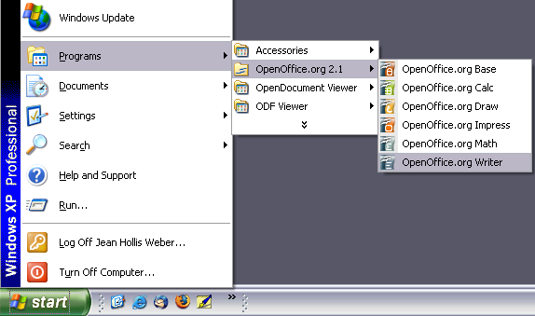

* + - 1. Linux/GNOME

GNOME installations differ from one distribution to the next. Most modern distributions come with OpenOffice.org already installed. You will find OpenOffice.org under **Applications > Office**, as shown in .

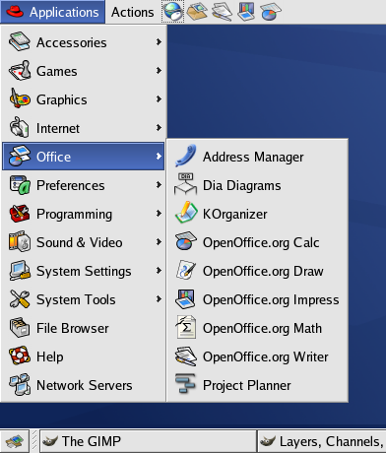

Fedora/Red Hat Enterprise Linux comes with OpenOffice.org installed. On the GNOME desktop, OOo can be found under **Main Menu > Office**. If you have installed a newer version of OOo, you will find it under **Main Menu > Office > More Office Applications**.

If you installed by downloading OOo from the [http://www.openoffice.org](http://www.openoffice.org/) website, it is under **Applications > Other**.

* + - 1. Linux/KDE

On KDE, OpenOffice.org is installed in its own menu, called **Office** (see ).

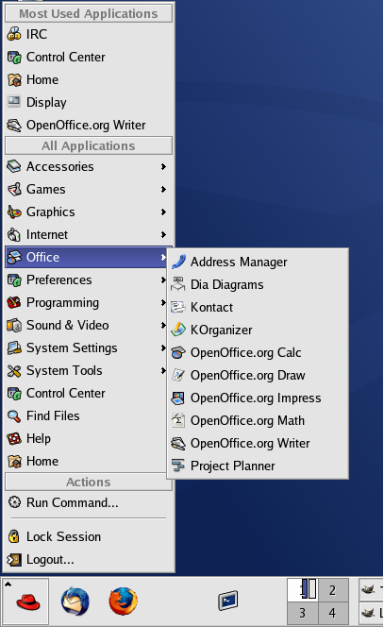

Some Linux distributions install OpenOffice.org in the Office submenu. Mandrake is such a distribution. In this case, to launch Writer, choose **Office > Word processors > OpenOffice.org Writer**. illustrates the OOo menu with **Math** selected.

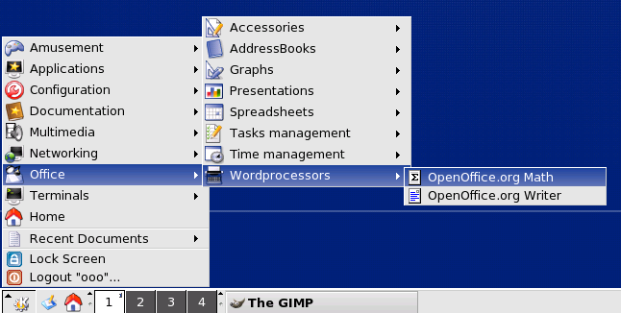

* + - 1. Mac OS X

Go to the folder where you installed OpenOffice.org. You should see its icon in the Applications folder (). To start Writer, double-click the OpenOffice.org icon.

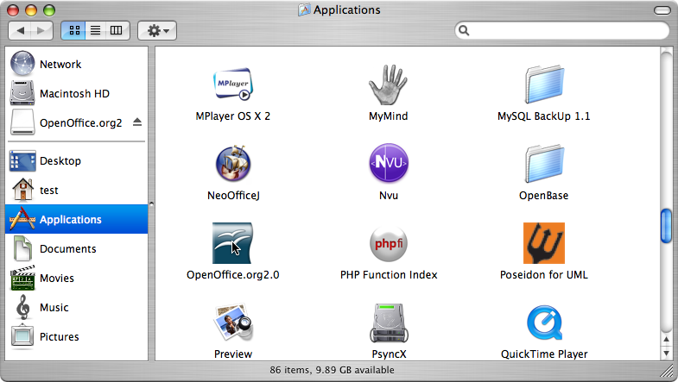

* + 1. Starting from an existing document

If you installed OpenOffice.org correctly, all Writer documents are associated with the Writer application. This means that you can start OpenOffice.org automatically, simply by double-clicking a Writer document in your favorite file manager (for example, Windows Explorer).

You can spot an OpenOffice.org Writer document by its icon: .

* + - 1. For Windows users

File associations are used to open certain types of files automatically with OpenOffice.org. When installing OOo, you could choose to associate Microsoft Office file types with OOo. If you chose to do this, then when you double-click on a *.doc file, it opens in OOo Writer.

If you did not associate the file types, then when you double-click on a Microsoft Word document, it opens in Microsoft Word (if Word is installed on your computer).

You can use another method to open *.doc files in OOo and save in the *.doc format from OOo. See “” on page for more information.

* + 1. Using the Quickstarter under Windows

The Quickstarter is an icon that is placed in the Windows system tray during system startup. It indicates that OpenOffice.org has been loaded and is ready to use. (The Quickstarter loads library *.DLL files required by OOo, thus shortening the startup time for OOo components by about half.) If the Quickstarter is disabled, see “” on page if you want to enable it.

* + - 1. Using the Quickstarter icon

Right-click the Quickstarter icon in the system tray to open a pop-up menu from which you can open a new document, open the Templates and Documents dialog box, or choose an existing document to open. (See .) You can also double-click the Quickstarter icon to display the Templates and Documents dialog box.

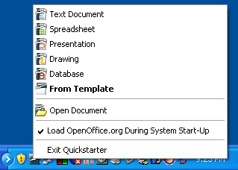

* + - 1. Disabling the Quickstarter

To close the Quickstarter, right-click on the icon in the system tray and then click Exit Quickstarter on the pop-up menu. The next time the computer is restarted, the Quickstarter will be loaded again.

To prevent OpenOffice.org from loading during system startup, deselect the Load OpenOffice.org During System Start-Up item on the pop-up menu. You might want to do this if your computer has insufficient memory, for example.

* + - 1. Reactivating the Quickstarter

If the Quickstarter has been disabled, you can reactivate it by selecting the **Load OpenOffice.org during system start-up** checkbox in **Tools > Options > OpenOffice.org > Memory**.

* + 1. Using the Quickstarter under Linux

Some installations of OpenOffice.org under Linux have a Quickstarter that looks and acts like the one described above for Windows (the checkbox on the Memory page is labeled **Enable systray quickstarter**). The Linux Quickstarter is disabled in other installations, but it will be operational in future releases.

* + 1. Preloading OOo under Linux/KDE

In Linux/KDE, you can use KDocker to have OOo loaded and ready for use at startup. KDocker is not part of OOo; it is a generic “systray app docker” that is helpful if you open OOo often.

* + 1. Starting from the command line

You may want to start Writer from the command line (using the keyboard instead of the mouse). Why? Well, by using the command line, you have more control over what happens when Writer is started. For example, using the command line, you can tell Writer to load a document and print it immediately, or to start without showing the splash screen.

|  |  |
| --- | --- |
| Note | Most users will never need to do this. |

There is more than one way to start Writer from the command line, depending on whether you have installed a customized version or the standard download from the OOo web site.

If you installed using the download on the OOo web site, you can start Writer by typing at the command line:

soffice -writer

or

swriter

Writer will start and create a new document.

To see a list of options you can use when starting Writer at the command line, type:

soffice -?

If you have a customized version of OOo (such as the one provided by Linux Mandrake or Gentoo), you can start Writer by typing at the command line:

oowriter

|  |  |
| --- | --- |
| Note | Although the command syntax differs, the effect is identical: it starts OOo with an empty Writer document. |

* 1. The Writer interface

The main Writer workspace is shown in .

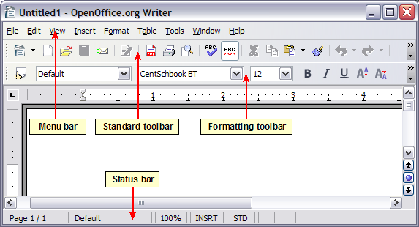

* + 1. Menus

*Menus* are located across the top of the Writer window. The main menu selections are File, Edit, View, Insert, Format, Table, Tools, Window, and Help. When you click one of the main menu names, a list of related options is displayed.

* File contains commands that apply to the entire document such as Open, Save, and Export as PDF.
* Edit contains commands for editing the document such as Undo and Find & Replace.
* View contains commands for controlling the display of the document such as Zoom and Web Layout.
* Insert contains commands for inserting elements into your document such as headers, footers, and pictures.
* Format contains commands for formatting the layout of your document, such as Styles and Formatting, Paragraph, and Bullets and Numbering.
* Table shows all commands to insert and edit a table in a text document.
* Tools contains functions such as Spellcheck, Customize, and Options.
* Window contains commands for the display window.
* Help contains links to the Help file, What’s This?, and information about the program. See “” on page .
  + 1. Toolbars

Writer has several types of toolbars: docked, floating, and tear-off. Docked toolbars can be moved to different locations or made to float, and floating toolbars can be docked.

The top docked toolbar (default position) is called the Standard toolbar. The Standard toolbar is consistent across the OpenOffice.org applications.

The second toolbar across the top (default location) is called the Formatting toolbar. It is a context-sensitive bar which shows the relevant tools in response to the cursor’s current position or selection. For example, when the cursor is on a graphic, the Formatting bar provides tools for formatting graphics; when the cursor is in text, the tools are for formatting text.

* + - 1. Floating toolbars

Writer includes several additional context-sensitive toolbars, whose defaults appear as floating toolbars in response to the cursor’s current position or selection. For example, when the cursor is in a table, a floating Table toolbar appears, and when the cursor is in a numbered or bullet list, the Bullets and Numbering toolbar appears. You can dock these toolbars to the top, bottom, or side of the window, if you wish (see “” on page ).

* + - 1. Long-click buttons and tear-off toolbars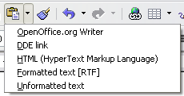

Buttons with a small triangle to the right will display submenus, tear-off toolbars, and other ways of selecting things with a long click, depending on the button.

shows the Paste submenu.

shows a tear-off toolbar from the Drawing toolbar.

The tear-off toolbars can be floating or docked along an edge of the screen or in one of the existing toolbar areas. To move a floating tear-off toolbar, drag it by the title bar. See “” below.

* + - 1. Displaying or hiding toolbars

To display or hide toolbars, choose View > Toolbars, then click on the name of a toolbar in the list. An active toolbar shows a check mark beside its name. Tear-off toolbars are not listed in the View menu.

* + - 1. Moving toolbars

To move a docked toolbar, place the mouse pointer over the toolbar handle, hold down the left mouse button, drag the toolbar to the new location, and then release the mouse button (.

To move a floating toolbar, click on its title bar and drag it to a new location. shows an example.

* + 1. Rulers

To show or hide rulers, chooseView > Ruler. To show the vertical ruler, choose Tools > Options > OpenOffice.org Writer > View and select Vertical ruler.

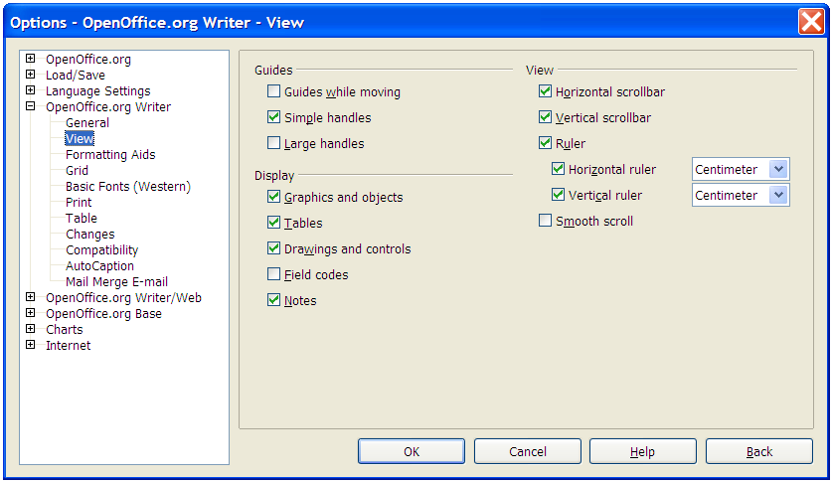

* 1. Changing document views

OpenOffice.org has several ways to view a document: Print Layout, Web Layout, Full Screen, and Zoom. You can select these choices on the View menu. The only document view option with a submenu is **Zoom**. When you choose View > Zoom, the following dialog box appears.

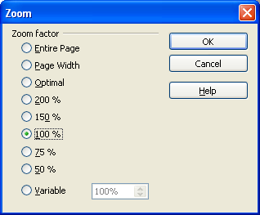

* Entire Page: Displays the entire page on the screen (text may be too small to read).
* Page Width: Displays the complete width of the document page. The top and bottom edges of the page may not be visible.
* Optimal: Resizes the display to fit the width of the text in the document.
* 200%: Displays the document at two times its actual size.
* 150%: Displays the document at one and a half times its actual size.
* 100%: Displays the document at its actual size.
* 75%: Displays the document at 75% of its actual size.
* 50%: Displays the document at half of its actual size.
* Variable: Enter the zoom factor (percentage) at which you want to display the document.
  1. Using dockable/floating windows

Some windows in OpenOffice.org, such as the Navigator and the Styles and Formatting window, are dockable. You can move, resize, or dock them to an edge.

|  |  |  |  |
| --- | --- | --- | --- |
| To dock a window, do one of the following:   * Click on the title bar of the floating window and drag it to the side until you see the outline of a box appear in the main window (see ) and then release the window. This method depends on your system’s window manager settings, so it may not work for you. * Hold down the *Control* key and double-click on a vacant part of the floating window to dock it in its last position. If that does not work, try double-clicking without using the *Contro*l key.   To undock a window, hold down the *Control* key and double-click on a vacant part of the docked window.   |  |  | | --- | --- | | Note | The Styles and Formatting window can also be docked or undocked by using *Control+ double-click* on the gray area next to the icons at the top of the window. | |  |

* 1. Using the Navigator

The Navigator displays all objects contained in a document. It provides a very convenient way to move around a document and find items in it. The Navigator button is located on the Standardtoolbar. You can also display the Navigator by choosing *Edit > Navigator*, or open it quickly by pressing F5.

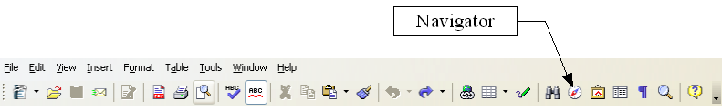

The Navigator displays lists of Headings, Tables, Text frames, Graphics, Bookmarks, and other items. Click the + sign by any of the lists to display the contents of the list.

If you only want to see the content in a certain category, highlight the category and click the Content View icon.

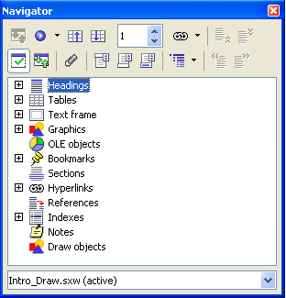

|  |  |
| --- | --- |
| Note | The Navigator looks somewhat different in a master document. For more information, see Chapter 13 (Working with Master Documents). |

The Navigator helps you to reach objects quickly. Double-click the object in the Navigator to jump directly to that object’s position in the document, as shown in .

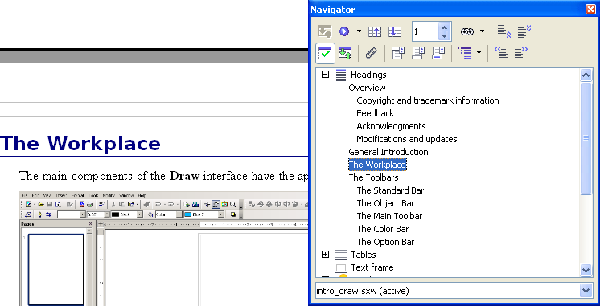

* + 1. Arranging chapters using the Navigator

You can arrange chapters and move headings in the document by using the Navigator.

1. Click the Content View icon to expand the headings, if necessary.
2. Click on the heading in question.
3. Drag the heading to a new location on the Navigator or click the heading in the Navigator list, and then click Promote Level,Demote Level, Promote Chapter, or Demote Chapter.

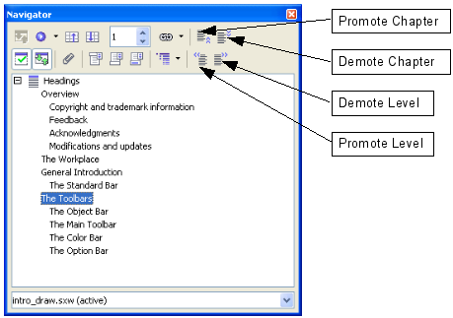

* 1. Creating a new document
     1. Creating a blank document

You can create a new, blank document in Writer in a number of ways:

* Press the Control+N keys. A new empty document opens. If you already have a document open, the new document appears in a new window.
* Use File > New > Text Document.
* Click the New button on the main toolbar .
  + 1. Creating a document from a template

You can use templates to create new documents in Writer. Templates serve as the foundation of a set of documents, to make sure they all have a similar layout. For example, all the documents of the Writer Guide are based on the same template. As a result, all the documents look alike—they have the same headers and footers, use the same fonts, and so on.

Unfortunately, a brand-new OpenOffice.org installation does not contain many templates. It is possible for you to add new templates to your installation and use them for new documents. This is explained in Chapter 10 (Working with Templates). Many more templates can be downloaded from the Internet.

Once you do have templates on your system, you can create new documents based on them by using File > New > Templates and Documents. This opens a window where you can choose the template you want to use for your document.

The example shown in uses a template called “book” in the My Templates folder. Select it, then click the Open button. A new document is created based on the formats defined in the template.

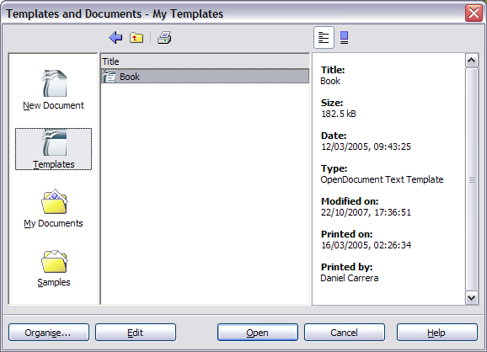

* 1. Opening an existing document

Here is one way to open an existing document in Writer:

1. Click File > Open (or press *Control+O*).
2. In the file chooser, you can reduce the list of files by selecting the type of file you are looking for. If you choose Text documents as the file type, you will only see documents Writer understands.
3. Select the file you want, and then click Open.

|  |  |
| --- | --- |
| Note | This method opens Word (*.doc) files, as well as OOo files and other formats. |

You can also open an existing OOo Writer document using the same methods you would use to open any document in your operating system.

* 1. Saving a document

There are three ways to save a document in Writer:

* Press Control+S.
* Select File > Save.
* Click the Save button on the main toolbar.

You also can tell Writer to save your document automatically at regular intervals. To enable this, you must configure OpenOffice.org to save all documents automatically.

1. Select Tools > Options. The Options window appears.
2. Select Load/Save > General.
3. Click on Save AutoRecovery information every. This enables the box to set the interval. The default value is 30 minutes. Enter the value you want by typing it or by pressing the up or down arrow keys.
   * 1. Saving as a Microsoft Word document

You may need to share your documents with other people who do not use OpenOffice.org, but use Microsoft Word instead. Fortunately, OpenOffice.org can read and write Word files. To save a document as a Microsoft Word file:

1. First save your document in OpenOffice.org’s format (*.odt). If you do not, any changes you made since the last time you saved will only appear in the Microsoft Word version of the document.
2. Then click File > Save As. The Save As dialog box () appears.
3. In the Save as type drop-down menu, select the type of Word format you need.
4. Click Save.

From this point on, all changes you make to the document will occur only in the Microsoft Word document. You have actually changed the name of your document. If you want to go back to working with the OpenOffice.org version of your document, you must open it again.

|  |  |
| --- | --- |
| Tip | To have OOo save documents in a default Microsoft Word file format, go to Tools > Options > Load/Save > General. There is a section named Default file format. Under Document type, select Text document, under Always save as, select your preferred file format. |

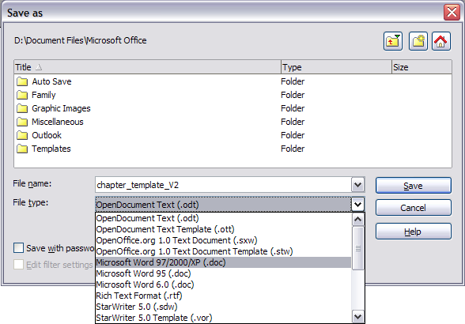

* 1. Printing a document

For more information about printing documents, see Chapter 5 (Printing, Faxing, Exporting, and E-mailing).

* + 1. Quick printing

Click the Print File Directly icon  to send the entire document to the default printer defined for your computer.

* + 1. Controlling printing using the Print dialog box

For more control over printing, use File > Print to display the Print dialog box ().

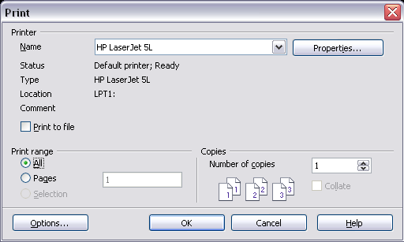

On the Print dialog box, you can choose:

* Which printer to use (if more than one are installed on your system) and the properties of the printer—for example, orientation (portrait or landscape), which paper tray to use, and what paper size to print on. The properties available depend on the selected printer; consult the printer’s documentation for details.
* Which pages to print, how many copies to print, and in what order to print them.
  + Use dashes to specify page ranges and commas or semicolons to separate ranges; for example, 1, 5, 11–14, 34–40.
  + Selection is the highlighted part of a page or pages.
* Which items to print. Click the Options button to display the Printer Options dialog box. For details about print options and setting defaults for Writer, see Chapter 5 (Printing, Faxing, Exporting, and E-mailing).
  + 1. Previewing pages before printing

The normal page view in Writer shows what each page will look like when printed, but it shows only one page at a time. If you are designing a document to be printed double-sided, you may want to see what facing pages look like. OOo provides a way to do this in Page Preview.

1. Click File > Page Preview, or click the Page Preview button .

The Writer window changes to display the current page and the following page and shows the Page Preview toolbar () in place of the Formatting toolbar.



1. Click the Book Preview icon  to display left and right pages in their correct orientation (facing pages).
2. To print the document in this page view, click the Print page view icon .
3. To choose margins and other options for the printout, click the Print options page view icon  to display the Print Options dialog box. For more information, see Chapter 5 (Printing, Faxing, Exporting, and E-mailing).
   1. Exporting to PDF

OpenOffice.org can export documents to PDF (Portable Document Format). This industry-standard file format for file viewing is ideal for sending the file to someone else to view using Acrobat Reader or other PDF viewers.

* + 1. Quick export to PDF

Click the Export Directly as PDF icon  to export the entire document using the default PDF settings. You are asked to enter the file name and location for the PDF file, but you do not get a chance to choose a page range, the image compression, or other options.

* + 1. Controlling PDF content and quality

For more control over the content and quality of the resulting PDF, use File > Export as PDF. The PDF Options dialog box opens. This dialog box has four pages (General, Initial View, User Interface, and Security). Here you can choose which pages to include in the PDF, the type of compression to use for images (which affects the quality of images in the PDF), and other options.

Make your selections, and then click **Export**. Then you are asked to enter the location and file name of the PDF to be created, and click Save to export the file.

For more information, see Chapter 5 (Printing, Faxing, Exporting, and E-mailing).

* 1. Getting help

Writer provides several forms of help. In addition to a full Help file, you can choose whether to activate tooltips, extended tips, and the Help Agent.

Placing the mouse pointer over any of the icons displays a small box, called a tooltip. It gives a brief explanation of the icon’s function. For a more detailed explanation, select Help > What’s This? and hold the mouse pointer over the icon you need more help with.

|  |  |
| --- | --- |
| Note | The extended tips option in OOo 2.x cannot be accessed from the Help menu as it was in OOo 1.x. Tips and extended tips can be turned on or off from Tools > Options > OpenOffice.org > General. What's This? help is a new feature in OOo 2.0. |

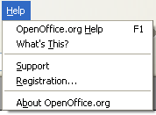

* 1. Closing a document

To close a document, click File > Close.

You can also close a document by clicking on the Close icon on the document window. In Windows XP, this button looks like the red X shown in .

If more than one OOo window is open, each window looks like the sample shown on the left in . Closing this window leaves the other OOo windows open.

If only one OOo window is open, it looks like the sample shown on the right in . Notice the small black X below the large red X. Clicking the small X closes the document but leaves OOo open. Clicking the large red X closes OOo completely.

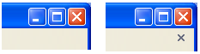

If the document has not been saved since the last change, a message box is displayed. Choose whether to save or discard your changes.

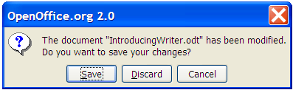

* Save: The document will be saved and then closed.
* Discard: The document will be closed, and all modifications since the last save will be lost.
* Cancel: Nothing will happen, and you will return to the document.

|  |  |
| --- | --- |
| Caution | Not saving your document could result in the loss of recently made changes, or worse still, your entire file. |

* 1. Closing Writer

To close Writer completely, click File > Exit, or close the last open document as described in “” on page .

If all the documents have been saved, Writer will close immediately. If any documents have been modified but not saved, a warning dialog box like the one shown in will appear. Follow the procedure in “” to save or discard your changes.



Writer Guide

1. Chapter 2  
    Setting up Writer

Choosing options to suit the way you work

* 1. Choosing options that affect all of OOo

This section covers some of the settings that apply to all the components of OOo and are particularly important when using Writer. Other general options are discussed in Chapter 5 (Setting Up OpenOffice.org) in the Getting Started guide.

|  |  |
| --- | --- |
| Note | The illustrations in this chapter were taken from the English (UK) version of OOo. The spelling of some terms may be different from those you see on your screen, especially if you are using the default English (US) version. |

1. Click Tools > Options. The list in the left-hand box varies depending on which component of OOo is open. The illustrations in this chapter show the list as it appears when Writer is open.
2. Click the + sign by OpenOffice.org in the left-hand section of the Options – OpenOffice.org dialog box. A list of subsections drops down.

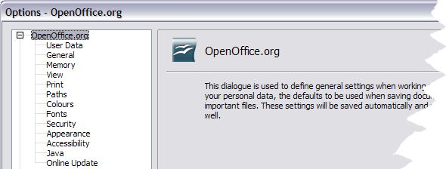

|  |  |
| --- | --- |
| Note | The Back button resets options to the values that were in place when you opened OOo. This button has the same behavior on all the Options dialog box pages. |

* + 1. User Data options

Because Writer’s revision features mark your changes and comments with the name or initials stored in the User Data page, you will want to ensure that your name and initials appear there. To do this:

1. In the Options dialog box, click OpenOffice.org > User Data.
2. Fill in the form on the OpenOffice.org – User Data page () or amend or delete any existing incorrect information.

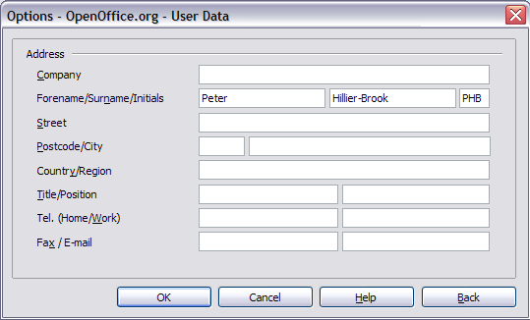

* + 1. General options

1. In the Options dialog box, click OpenOffice.org > General.
2. On the OpenOffice.org – General page (), the options are as described below.

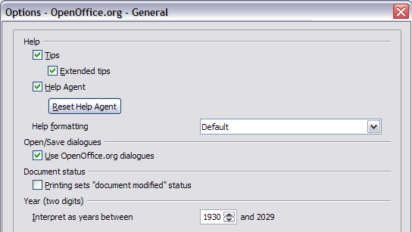

* + - 1. Help - Tips

When Help:Tips are active, one or two words will appear when you hold the cursor over an icon or field on the main OOo window, without clicking. This setting also affects the display of notes: if both Help: Tips and Extended Tips are turned off, then you won’t see the contents of a note when you hold the cursor over the note.

* + - 1. Help - Extended tips

When Extended tips are active, a brief description of the function of a particular icon or menu command or a field on a dialog box appears when you hold the cursor over that item.

* + - 1. Help Agent

To turn off the Help Agent (similar to Microsoft’s Office Assistant), deselect this checkbox. To restore the default Help Agent behavior, click Reset Help Agent.

* + - 1. Help formatting

High contrast is an operating system setting that changes the system color scheme to improve readability. To display Help in high contrast (if your computer’s operating system supports this), choose one of the high-contrast style sheets from the pull-down list. For Windows XP, the high-contrast style options are as described below.

|  |  |
| --- | --- |
| High-contrast style | Visual effect |
| Default | Black text on white background |
| High Contrast #1 | Yellow text on black background |
| High Contrast #2 | Green text on black background |
| High Contrast Black | White text on black background |
| High Contrast White | Black text on white background |

* + - 1. Open/Save dialog boxes

To use the standard Open and Save dialog boxes for your operating system, deselect the Use OpenOffice.org dialogs checkbox. When this checkbox is selected, the Open and Save dialog boxes supplied with OpenOffice.org will be used. See Chapter 3 (File Management) in the *Getting Started* guide for more about the OOo Open and Save dialog boxes.

* + - 1. Document status

Choose whether printing a document counts as changing the document. If this option is selected, then the next time you close the document after printing, the print date is recorded in the document properties as a change and you will be prompted to save the document again, even if you did not make any other changes.

* + - 1. Year (two digits)

Specifies how two-digit years are interpreted. For example, if the two-digit year is set to 1930, and you enter a date of 1/1/30 or later into your document, the date is interpreted as 1/1/1930 or later. An “earlier” date is interpreted as being in the following century; that is, 1/1/20 is interpreted as 1/1/2020.

* + 1. View options

The choices of View options affect the way the document window looks and behaves.

1. In the Options dialog box, click OpenOffice.org > View.
2. On the OpenOffice.org – View page (), set the options to suit your personal preferences. Some options are described below.
   * + 1. User Interface – Scaling

If the text in the help files or on the menus of the OOo user interface is too small or too large, you can change it by specifying a scaling factor. Sometimes a change here can have unexpected results, depending on the screen fonts available on your system. However, it does not affect the actual font size of the text in your documents.

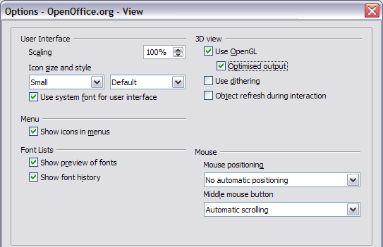

* + - 1. User Interface – Icon size and style

The first box specifies the display size of toolbar icons (Automatic, Small, or Large); the Automatic icon size option uses the setting for your operating system. The second box specifies the icon style (theme); here the Automatic option uses an icon set compatible with your operating system and choice of desktop: for example, KDE or Gnome on Linux.

* + - 1. User Interface – Use system font for user interface

If you prefer to use the system font (the default font for your computer and operating system) instead of the font provided by OOo for the user interface, select this checkbox.

* + - 1. User interface – Screen font antialiasing

(Not available in Windows, so not shown in .) Select this checkbox to smooth the screen appearance of text. Enter the smallest font size to apply antialiasing.

* + - 1. Menu – Show icons in menus

Select this option if you want icons as well as words to be visible in menus.

* + - 1. Font Lists - Show preview of fonts

When you select this option, the font list looks like , Left, with the font names shown as an example of the font; with the checkbox deselected, the font list shows only the font names, not their formatting (, Right). The fonts you will see listed are those that are installed on your system.

|  |  |
| --- | --- |
|  |  |

Figure 31. (Left) Font list showing preview; (Right) Font list without preview

* + - 1. Font Lists - Show font history

When you select this option, the last five fonts you have assigned to the current document are displayed at the top of the font list.

* + - 1. 3D view – Use OpenGL

Specifies that all 3D graphics from Draw and Impress will be displayed in your system using OpenGL-capable hardware. If your system does not have OpenGL-capable hardware, this setting will be ignored.

* + - 1. 3D view – Use OpenGL – Optimized output

Select this option for optimized OpenGL output. Disable the optimization in case of graphical errors of 3D output.

* + - 1. 3D view – Use dithering

The **Use dithering**option uses dithering to display additional colorswhen the computer’s graphics system offers less than the optimal 16 million (24-bit) colours. Dithering creates the illusion of new colors and shades by varying the pattern of color pixels. Varying the patterns of black and white dots, for instance, produces different shades of grey.

|  |  |
| --- | --- |
| Note | Internally, 3-D graphics are always created with 16 million colors (24-bit color depth) and dithering can be used to compensate when fewer actual colors are available. Without dithering, several bits of color information would be omitted, leading to significantly reduced image quality. |

* + - 1. 3D view – Object refresh during interaction

Specifies that if you rotate or move a 3-D object, the full display is rotated or moved and not a grid frame.

|  |  |
| --- | --- |
| **Tip** | Press **Shift+Control+R** to restore or refresh the view of the current document. |

* + - 1. Mouse positioning

Specifies if and how the mouse pointer will be positioned in newly opened dialog boxes.

* + - 1. Middle mouse button

Defines the function of the middle mouse button.

* **Automatic scrolling** – dragging while pressing the middle mouse button shifts the view.
* **Paste clipboard**– pressing the middle mouse button inserts the contents of the “Selection clipboard” at the cursor position.

The “Selection clipboard” is independent of the normal clipboard that you use by **Edit** > **Copy/Cut/Paste** or their respective keyboard shortcuts. Clipboard and “Selection clipboard” can contain different contents at the same time.

|  |  |  |
| --- | --- | --- |
| Function | **Clipboard** | **Selection clipboard** |
| Copy content | Edit > CopyControl+C | Select text, table, or object. |
| Paste content | Edit > PasteControl+V pastes at the cursor position. | Clicking the middle mouse button pastes at the mouse pointer position. |
| Pasting into another document | No effect on the clipboard contents. | The last marked selection is the content of the selection clipboard. |

* + 1. Print options

Set the print options to suit your default printer and your most common printing method. You can change these settings at any time, either through this dialog box or during the printing process (by clicking the Options button on the Print dialog box).

1. In the Options dialog box, click OpenOffice.org > Print.
2. On the OpenOffice.org – Print page (), look at the Printer warnings section near the bottom.
3. Here you can choose whether to be warned if the paper size or orientation specified in your document does not match the paper size or orientation available for your printer. Having these warnings turned on can be quite helpful, particularly if you work with documents produced by people in other countries where the standard paper size is different from yours.

|  |  |
| --- | --- |
| Tip | If your printouts are coming out incorrectly placed on the page or chopped off at the top, bottom, or sides or the printer is refusing to print, the most likely cause is page‑ size incompatibility. |

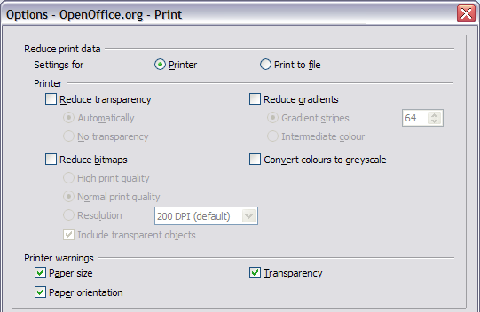

* + 1. Path options

You can change the location of files associated with, or used by, OpenOffice.org to suit your working situation. In a Windows system, for example, you might want to store documents by default somewhere other than My Documents.

1. In the Options dialog, click OpenOffice.org > Paths.
2. To make changes, select an item in the list shown in and click Edit. On the Select Paths dialog (not shown), add or delete folders as required, and then click **OK** to return to the Options dialog. Note that many items have at least two paths listed: one to a shared folder (which might be on a network) and one to a user-specific folder (normally on the user’s personal computer).

|  |  |
| --- | --- |
| Tip | You can use the entries in the OpenOffice.org – Paths dialog to compile a list of files, such as those containing AutoText, that you need to back up or copy to another computer. |

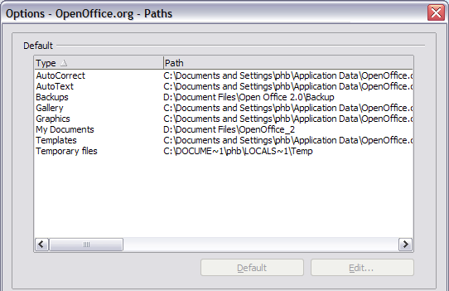

* + 1. Color options

In the OpenOffice.org – Colors dialog (), you can specify colors to use in OOo documents. You can select a color from a color table, edit an existing color, or define new colors. These colors will then be available in color selection palettes in OOo.

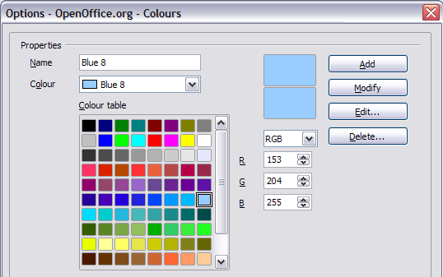

* + 1. Font options

You can define replacements for any fonts that might appear in your documents. If you receive from someone else a document containing fonts that you do not have on your system, OpenOffice.org will substitute fonts for those it does not find. You might prefer to specify a different font from the one the program chooses.

1. In the Options dialog, click OpenOffice.org > Fonts.
2. On the OpenOffice.org – Fonts dialog ():

* Select the Apply Replacement Table checkbox.
* Select or type the name of the font to be replaced in the Font box. (If you do not have this font on your system, it will not appear in the drop-down list in this box, so you need to type it in.)
* In the Replace with box, select a suitable font from the drop-down list of fonts installed on your computer.

1. The checkmark to the right of the Replace with box turns green. Click on this checkmark. A row of information now appears in the larger box below the input boxes. Select the checkboxes under Always and Screen.
2. In the bottom section of the dialog, you can change the typeface and size of the font used to display source code such as HTML and Basic (in macros).

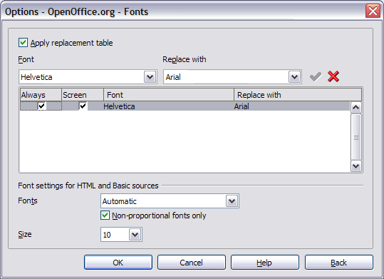

* + 1. Security options

Use the OpenOffice.org – Security page () to choose security options for saving documents and for opening documents that contain macros.

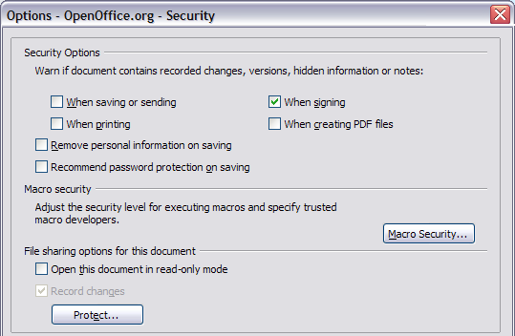

* + - 1. Security Options section

If you record changes, save multiple versions, or include hidden information or notes in your documents, and you do not want some of the recipients to see that information, you can set warnings to remind you to remove this information, or you can have OOo remove some information automatically. Note that (unless removed) much of this information is retained in a file whether the file is in OpenOffice.org’s default OpenDocument format, or has been saved to other formats, including PDF.

* + - 1. Remove personal information on saving

Select this checkbox to always remove user data from the file properties when saving the file. To manually remove personal information from specific documents, clear this checkbox and then use the Delete button under File > Properties > General.

* + - 1. Macro security

Click the Macro Security button to open the Macro Security dialog, where you can adjust the security level for executing macros and specify trusted sources.

* + - 1. File sharing options for this document

Select the Open this document in read-only mode checkbox to restrict this document to be opened in read-only mode only. This option protects the document against accidental changes. It is still possible to edit a copy of the document and save that copy with the same name as the original.

Select the Record changes checkbox to enable recording changes. This is the same as Edit - Changes – Record. To allow other users of this document to apply changes, but prevent them from disabling change recording, click the Protect button and enter a password.

* + 1. Appearance options

Writing, editing, and page layout are often easier to do when you can see as much as possible of what's going on in your document. You may wish to make visible such items as text, table, and section boundaries, and grid lines (see “” on page ). In addition, you might prefer different colors (from OOo’s defaults) for such items as note indicators or field shadings.

On the OpenOffice.org – Appearance page (), you can specify which items are visible and the colors used to display various items.

1. In the Options dialog box, click OpenOffice.org > Appearance.
2. To show or hide items such as text boundaries, select or deselect the checkboxes next to the names of the items.
3. To change the default colors for items, click the down-arrow in the Color setting column by the name of the item and select a color from the pop-up box.
4. To save your color changes as a color scheme, type a name in the Scheme box and click Save.

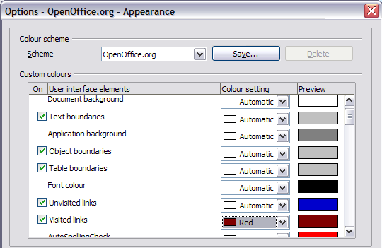

* 1. Choosing options for loading and saving documents

You can set the Load/Save options to suit the way you work.

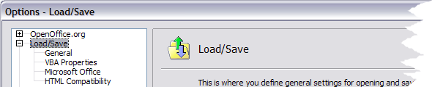

* + 1. General Load/Save options

1. If the Options dialog is not already open, click Tools > Options. Click the + sign to the left of Load/Save.
2. Choose Load/Save > General.

Most of the choices on the Options – Load/Save – General dialog () are familiar to users of other office suites. Some items of interest are described below.

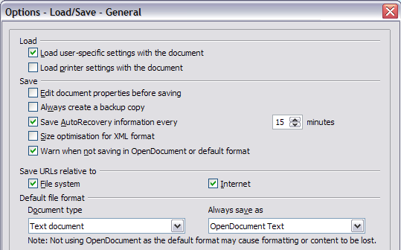

* + - 1. Load user-specific settings with the document

When you save a document, certain settings are saved with it. For example, your choice (in the options for OOo Writer) of how to update links is affected by the Load user-specific settings option. Some settings (printer name, data source linked to the document) are always loaded with a document, whether or not this checkbox is selected.

If you select this option, these document settings are overruled by the user-specific settings of the person who opens it. If you deselect this option, users’ personal settings do not overrule the settings in the document.

* + - 1. Load printer settings with the document

If this option (new in OOo 2.3) is not selected, the printer settings that are stored with the document are ignored when you print it using the Print File Directly icon. The default printer in your system will be used instead.

* + - 1. Edit document properties before saving

When you select this option, the Document Properties dialog pops up to prompt you to enter relevant information the first time you save a new document (or whenever you use Save As).

* + - 1. Save AutoRecovery information every

Note that AutoRecovery in OpenOffice.org overwrites the original file. If you have also chosen Always create backup copy, the original file then overwrites the backup copy. If you have this set, recovering your document after a system crash will be easier; but recovering an earlier version of the document may be harder.

* + - 1. Size optimization for XML format (no pretty printing)

OpenOffice.org documents are XML files. When you select this option, OOo writes the XML data without indents and line breaks. If you want to be able to read the XML files in a text editor in a structured form, deselect this option.

* + - 1. Default file format

If you routinely share documents with users of Microsoft Word, you might want to change the Always save as attribute for text documents in the Standard file format section to one of the Word document types.

* + 1. VBA Properties Load/Save options

1. Choose Load/Save > VBA Properties.
2. On the Options – Load/Save – VBA Properties dialog (), you can choose whether to keep any macros in MSOffice documents that are opened in OOo.

* If you choose Save original Basic code, the macros will not work in OOo but are retained if you save the file into Microsoft Office format.
* If you choose Load Basic code to edit, the changed code is saved in an OOo document but is not retained if you save into an MSOffice format.

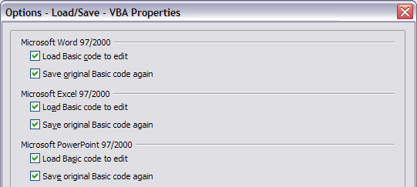

* + 1. Microsoft Office Load/Save options

1. Choose Load/Save > Microsoft Office.
2. On the Options – Load/Save – Microsoft Office dialog (), you can choose what to do when importing and exporting Microsoft Office OLE objects (linked or embedded objects or documents such as spreadsheets or equations).

Select the [L] checkboxes to convert Microsoft OLE objects into the corresponding OpenOffice.org OLE objects when a Microsoft document is loaded into OOo (mnemonic: “L” for “load”).

Select the [S] checkboxes to convert OpenOffice.org OLE objects into the corresponding Microsoft OLE objects when a document is saved in a Microsoft format (mnemonic: “S” for “save”).

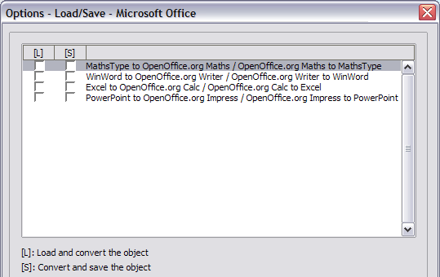

* + 1. HTML compatibility Load/Save options

Choices made on the Load/Save – HTML Compatibility dialog () affect HTML pages imported into OpenOffice.org and those exported from OOo. See HTML documents; importing/exporting in the Help for more information.

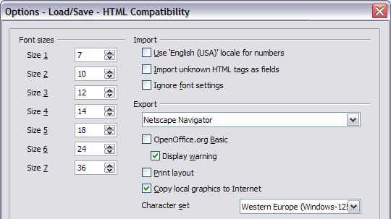

* + - 1. Font sizes

Use these fields to define the respective font sizes for the HTML <font size=1> to <font size=7> tags, if they are used in the HTML pages. (Many pages no longer use these tags.)

* + - 1. Import - Use 'English (USA)' locale for numbers

When importing numbers from an HTML page, the decimal and thousands separator characters differ according to the locale of the HTML page. The clipboard, however, contains no information about the locale. If this option (new in OOo 2.3) is not selected, numbers will be interpreted according to the Language - Locale setting in Tools > Options > Language Settings > Languages (see page ). If this option is selected, numbers will be interpreted as for the English (USA) locale.

* + - 1. Import - Import unknown HTML tags as fields

Select this checkbox if you want tags that are not recognized by OOo to be imported as fields. For an opening tag, an HTML_ON field will be created with the value of the tag name. For a closing tag, an HTML_OFF will be created. These fields will be converted to tags in the HTML export.

* + - 1. Import - Ignore font settings

Select this checkbox to have OOo ignore all font settings when importing. The fonts that were defined in the HTML Page Style will be used.

* + - 1. Export

To optimize the HTML export, select a browser or HTML standard from the Export box. If OpenOffice.org Writer is selected, specific OpenOffice.org Writer instructions are exported.

* + - 1. Export - OpenOffice.org Basic

Select this checkbox to include OOo Basic macros (scripts) when exporting to HTML format. You must activate this option before you create the OpenOffice.org Basic macro; otherwise the script will not be inserted. OpenOffice.org Basic macros must be located in the header of the HTML document. Once you have created the macro in the OpenOffice.org Basic IDE, it appears in the source text of the HTML document in the header.

If you want the macro to run automatically when the HTML document is opened, choose Tools > Customize > Events. See Chapter 17 (Getting Started with Macros) for more information.

* + - 1. Export - Display warning

When the OpenOffice.org Basic checkbox (see above) is not selected, the Display warning checkbox becomes available. If the Display warning checkbox is selected, then when exporting to HTML a warning is shown that OpenOffice.org Basic macros will be lost.

* + - 1. Export - Print layout

Select this checkbox to export the print layout of the current document as well. It can be read by OpenOffice.org and by Netscape Navigator and Microsoft Internet Explorer 4.0 and above.

The HTML filter supports CSS2 (Cascading Style Sheets Level 2) for printing documents. These capabilities are only effective if print layout export is activated.

* + - 1. Export - Copy local graphics to Internet

Select this checkbox to automatically upload the embedded pictures to the Internet server when uploading using FTP.

* + - 1. Export - Character set

Select the appropriate character set for the export.

* 1. Choosing options for Writer

Settings chosen on the pages in the OpenOffice.org Writer section of the Options dialog box determine how your Writer documents look and behave while you are working on them.

1. If the Options dialog box is not already open, click Tools > Options.
2. Click the + sign by OpenOffice.org Writer in the left-hand section of the Options – OpenOffice.org dialog box. A list of subsections drops down.
   * 1. General options

The choices on the OpenOffice.org Writer – General page affect the updating of links and fields, the units used for rulers and other measurements, whether captions are automatically added to selected objects such as tables or figures, paragraph spacing, and tab stop behavior.

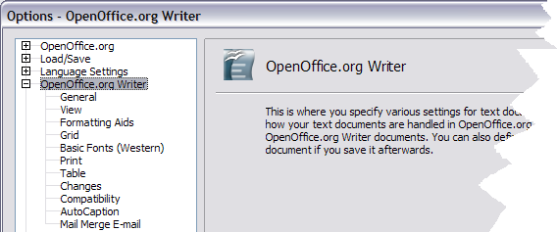

1. Choose OpenOffice.org Writer > General on the Options dialog box ().
2. Keep in mind the following considerations when selecting options on this page.

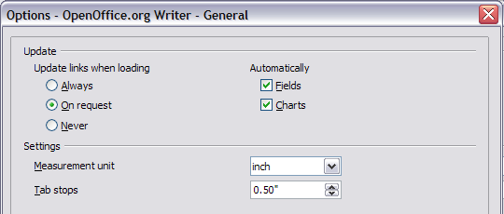

* + - 1. Update links when loading

Depending on your work patterns, you may not want links to be updated when you load a document. For example, if your file links to other files on a network, you won’t want those links to update when you are not connected to the network.

* + - 1. Update fields and charts automatically

You may not want fields or charts to update automatically when you are working, because that slows down performance.

* + - 1. Settings – Tab stops

The Tab stops setting is also used for the indent distance applied by the Increase Indent and Decrease Indent buttons on the Formatting Bar.

* + 1. View options

Two pages of options set the defaults for viewing Writer documents: View and Formatting Aids (described on page ).

Choose OpenOffice.org Writer > View on the Options dialog box ().

If the items on this page are not self-explanatory, you can easily test their effects in a blank document.

This is a good page to check if, for example, you cannot see graphics on the screen or you see field codes instead of the text or numbers you are expecting.

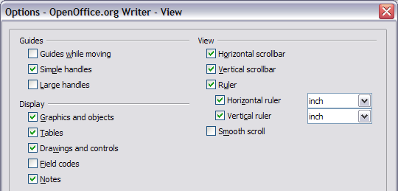

* + 1. Formatting Aids options

The display of symbols such as paragraph ends and tabs help you when writing, editing, and doing page layout. For example, you might want to know if any blank paragraphs or tabs are included or if any tables or graphics are too wide and intrude into the margins of the page.

On the OpenOffice.org Writer – Formatting Aids page (), select the required checkboxes.

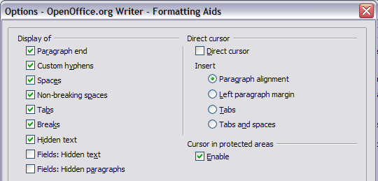

|  |  |
| --- | --- |
| Note | Direct cursor lets you enter text, images, tables, frames, and other objects in any blank area in your document. OOo inserts blank paragraphs and tabs to position the text or objects.  This feature is incompatible with rigorous use of styles and can lead to many formatting oddities, so it should be avoided by professional writers.  The AutoCorrect tool automatically removes empty paragraphs, tabs, and spaces that are inserted by the direct cursor. If you want to use the direct cursor, then disable the AutoCorrect tool. |

* + 1. Grid options

Specifying “snap to grid” can be very helpful when you are trying to align several objects such as graphics or tables. If the grid intervals (subdivisions) are too large, you may find that you do not have enough control in placing the objects.

On the OpenOffice.org Writer – Grid page (), you can choose whether to enable this feature and what grid intervals to use.

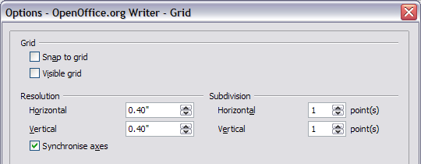

* + 1. Default fonts

The default fonts specified on the OpenOffice.org Writer – Basic Fonts (Western) page apply to both Writer documents and HTML (Web) documents.

1. If you want to change the defaults, do so on the OpenOffice.org Writer – Basic Fonts (Western) page (). You can, of course, choose other fonts for use in specific documents, either by applying direct formatting or by defining and applying styles in those documents.
2. When choosing fonts on this page you are not limited to single fonts or to the ones shown in the drop-down list. You can specify a “font family”as a comma‑separated set of fonts that includes those suitable for Windows, Macintosh, Linux, and other operating systems. These choices are particularly important in HTML documents.
3. If the document is viewed on a system that does not have the first font specified, it will use one of the other fonts if that one is available. Otherwise, it will substitute a font that is available on the system.
4. Type the list of fonts, separated by commas, in the boxes. If you want these defaults to apply to the current document only, select that checkbox. The Default button resets the values on this page to the defaults installed with OpenOffice.org.

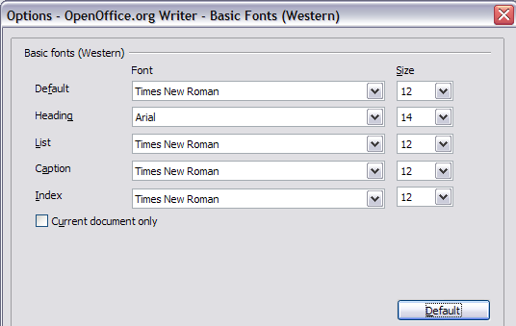

* + 1. Print options

On the OpenOffice.org Writer – Print page (), you can choose which items are printed with the document by default. These options are in addition to those on the OpenOffice.org – Print page ().

Some considerations:

* When you are working on drafts and you want to save printer ink or toner, you might want to deselect some of the items in the Contents section.
* The Print black selection causes color text (but not graphics) to print as black on a color printer; on a black-and-white printer, this option causes color text to print as solid black instead of shades of grey (dithered).
* Contrast Print black with Convert colors to greyscale on the Options – OpenOffice.org – Print page (), which prints all graphics as greyscale on color printers. (On black-and-white printers, color in graphics normally prints as greyscale.)
* If you are printing double-sided on a non-duplexing printer, you might choose to print only left or right pages, then turn the stack over and print the other pages.
* Depending on how your printer ejects pages (face up or face down), you might need to print the pages in reverse order so they stack in the correct order as they are printed.

|  |  |
| --- | --- |
| **Tip** | You can override any of these defaults when printing a document. Click **File > Print**, then click the **Options** button on the Print dialog box. The Printer Options dialog box that appears is similar to the one shown in . |

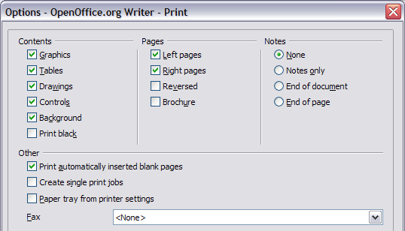

* + 1. Default table options

On the **OpenOffice.org Writer – Table** page (), you can specify the default table behavior.

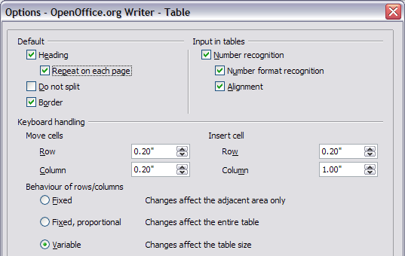

Some considerations:

* If most of your tables will require borders or headings, select those checkboxes. If most of your tables are used for page layout, deselect borders and headings.
* Number recognition can be very useful if most of your tables contain numerical data; Writer will recognize dates or currency, for example, and format the numbers appropriately. However, if you want the numbers to remain as ordinary text, this feature can be quite irritating, so you will want to deselect it.
* The Keyboard handling section specifies the distances that cells move when you use keyboard shortcuts to move them and the size of rows and columns inserted using keyboard shortcuts.
* The choices in the Behavior of rows/columns section determine the effects that changes to rows or columns have on adjacent rows or columns and the entire table. You might need to test these selections to fully understand the effects.
  + 1. Change tracking options

If you plan to use the change-tracking feature of Writer, use the OpenOffice.org Writer – Changes page () to choose the way inserted and deleted material is marked, whether and how attribute changes are marked, and whether and how change bars are marked in the margins.

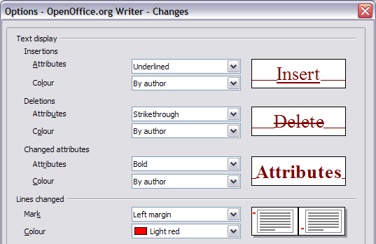

* + 1. Compatibility options

Do you need to import Microsoft Word documents into OOo Writer? If so, you might want to select some or all of the settings on the OpenOffice.org Writer – Compatibility page (). If you are not sure about the effects of these settings, leave them as the defaults provided by OOo. For information about the settings not described below, see the Help.

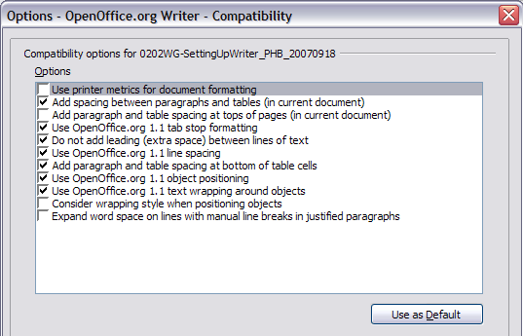

* + - 1. Use printer metrics for document formatting

If this checkbox is selected, the printer specified for the document determines how the document is formatted for viewing on screen. The line breaks and paragraph breaks you see on screen match those that apply when the document is printed on that printer.

This setting can be useful when several people are reviewing a document that will eventually be printed on a specific printer or when the document is exported to PDF (a process that uses “Adobe PDF” as the printer).

If this checkbox is not selected, a printer-independent layout will be used for screen display and printing.

* + - 1. Add spacing between paragraphs and tables (in current document)

In OpenOffice.org Writer, paragraph spacing is defined differently than it is in MS Word documents. If you have defined spacing between two paragraphs or tables, spacing is also added in the corresponding MS Word documents.

If this checkbox is selected, MS Word-compatible spacing is added between paragraphs and tables in OpenOffice.org Writer documents.

* + - 1. Add paragraph and table spacing at tops of pages (in current document)

You can define paragraphs to have space appear before (above) them. If this checkbox is selected, any space above a paragraph will also appear if the paragraph is at the beginning of a page or column, if the paragraph is positioned on the first page of the document, or after a manual page break.

If you import an MS Word document, the spaces are automatically added during the conversion.

* + - 1. Add paragraph and table spacing at bottom of table cells

Specifies that the bottom spacing is added to a paragraph, even when it is the last paragraph in a table cell.

* + - 1. Use as Default button

Click this button to use the current settings on this page as the default in OpenOffice.org.

* + 1. AutoCaption options

Do you want OOo to automatically insert captions for tables, pictures, frames, and OLE objects that have been inserted in a Writer document?

|  |  |
| --- | --- |
| Note | You may not always want captions for every table, for example, if you use tables for layout as well as for tables of data. You can always add captions to individual tables, graphics, or other objects (right-click > Caption). |

If you do want automatic captions on one or more object types:

1. Choose OpenOffice.org Writer > AutoCaption on the Options dialog box.
2. On the OpenOffice.org Writer – AutoCaption page (), select the checkbox next to an object you want to be automatically captioned (Picture in the example shown).
3. With the item highlighted, specify the characteristics of the caption. The supplied categories for captions are Drawing, Illustration, Table, and Text. However, you are not limited to the supplied categories. If you want to use another name (for example, Figure) for the caption label, type the required term in the box. In the example shown, I have added the category “Figure” to the list.

For more information about numbering captions by chapter, character styles, frame styles, and other items on the AutoCaption page, see other chapters in the *Writer Guide*.

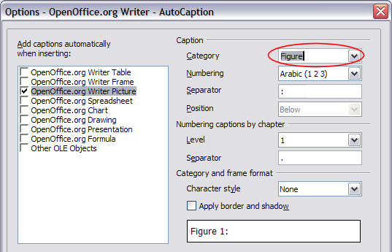

* + 1. Mail Merge E-mail options

You can produce form letters using Writer and then use the mail merge function to personalize those letters and send them to a number of addresses taken from a data source, such as an address book. Mail merged documents can be printed and mailed, or sent by e-mail.

Use the Options – OpenOffice.org Writer – Mail Merge E-mail page () to set up the user and server information for sending form letters by e-mail. If you are not sure what information to put in any of the fields, consult your e-mail program or your Internet service provider.

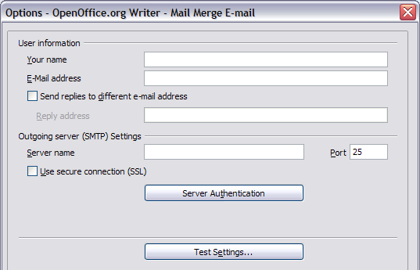

* 1. Choosing language settings

You may need to do several things to set the language settings to what you want:

* Install the required dictionaries
* Change some locale and language settings
* Choose spelling options
  + 1. Install the required dictionaries

OpenOffice.org 2.0 and later versions automatically install several dictionaries with the program. To add other dictionaries, use File > Wizards > Install new dictionaries. An OOo document will open with links to different languages that you can install. Follow the prompts to install them.

* + 1. Change some locale and language settings

You can change some details of the locale and language settings that OOo uses for all documents or for specific documents.

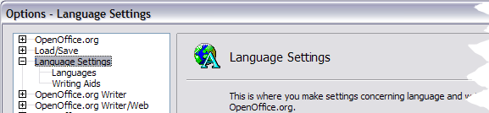

1. In the Options dialog box, click Language Settings > Languages.
2. On the right-hand side of the Language Settings – Languages page (), change the User interface, Locale setting, Default currency, and Default languages for documents as required. In the example, English (UK) has been chosen for all the appropriate settings.
3. If you want the language (dictionary) setting to apply to the current document only, instead of being the default for all new documents, select the checkbox labeledFor the current document only.
4. If necessary, select the checkboxes to enable support for Asian languages (Chinese, Japanese, Korean) and support for CTL (complex text layout) languages such as Hindi, Thai, Hebrew, and Arabic. If you choose either of these checkboxes, the next time you open this page, you will see some extra choices under Language Settings, as shown in . These choices (Searching in Japanese, Asian Layout, and Complex Text Layout) are not discussed here.
5. Click OK to save your changes and close the dialog box.

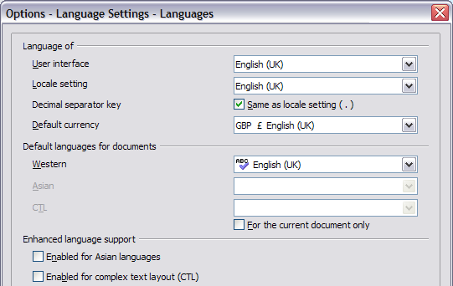

|  |  |
| --- | --- |
| Note | If you need to use non-Western languages, and especially if you need to use more than one non-Western language in the same document, refer to the tutorial, “OOo in a Multi-Lingual Environment.” |

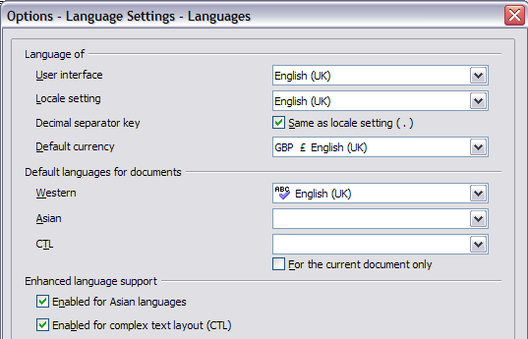

* + 1. Choose spelling options

To choose the options for checking spelling:

1. In the Options dialog box, click Language Settings > Writing Aids.
2. In the Options section of the Language Settings – Writing Aids page (), choose the settings that are useful for you. Some considerations:

* If you don’t want spelling checked while you type, deselect Check spelling as you typeand select Do not mark errors. (To find the second item, scroll down in the Options list.)
* If you use a custom dictionary that includes words in all uppercase and words with numbers (for example, AS/400), select Check uppercase words and Check words with numbers.
* Check special regions includes headers, footers, frames, and tables when checking spelling.
* Here you can also check which of the user-defined (custom) dictionaries are active, or you can add or remove dictionaries by clicking the New or Delete buttons.

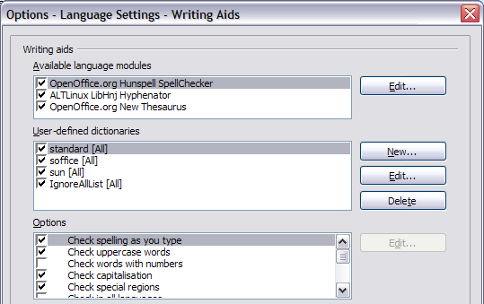

* 1. Controlling Writer’s AutoCorrect functions

Some people find some or all of the items in Writer’s AutoCorrect feature annoying because they change what you type when you don’t want it changed. Many people find some of the AutoCorrect functions quite helpful; if you do, then select the relevant checkboxes. But if you find unexplained changes appearing in your document, this is a good place to look to find the cause.

To open the AutoCorrect dialog box, click Tools > AutoCorrect/AutoFormat. (You need to have a document open for this menu item to appear.)

In Writer, this dialog box has five tabs, as shown in .

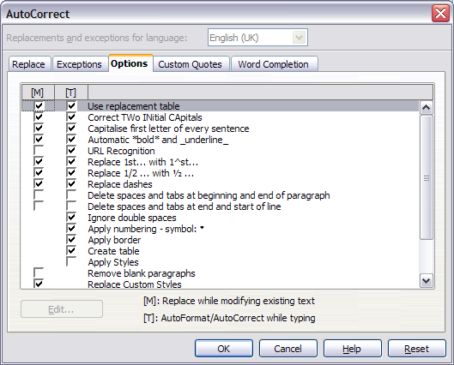



Writer Guide

1. Chapter 3  
    Working with Text

Using OpenOffice.org Writer

* 1. Introduction

This chapter covers the basics of working with text in Writer, the word-processing component of OpenOffice.org (OOo). It assumes that you are familiar with the use of a mouse and keyboard and that you have read about Writer’s menus and toolbars and other topics covered in Chapter 1 (Introducing Writer).

We recommend that you also follow the suggestions in Chapter 2 (Setting up Writer) about displaying formatting aids, such as end-of-paragraph marks, and selecting other setup options.

When you have read this chapter, you should know how to:

* Select, cut, copy, paste, and move text
* Find and replace text
* Insert special characters
* Format paragraphs and characters
* Create numbered or bulleted lists
* Check spelling, use the thesaurus, and choose hyphenation options
* Use the autocorrection, word completion, autotext, and line numbering features
* Track changes and undo and redo changes
  1. Selecting text

Before you can do anything with text, you need to select it. Selecting text in Writer is similar to selecting anything in other applications.

In addition to selecting blocks of text, you can select items that are not consecutive.

* + 1. **Selecting items that are not consecutive**

To select nonconsecutive items (as shown in ) using the mouse:

1. Select the first piece of text.
2. Hold down the Control (Ctrl) key and use the mouse to select the next piece of text.
3. Repeat as often as needed.
4. Now you can work with the selected text (copy it, delete it, change the style, or whatever).

|  |  |
| --- | --- |
| Note | Macintosh users: substitute the Command key when instructions in this chapter say to use the Control key. |

To select nonconsecutive items using the keyboard:

1. Select the first piece of text. (For more information about keyboard selection of text, see the topic “Navigating and Selecting with the Keyboard” in the OpenOffice.org Help (F1) in the Help menu.)
2. Press Shift+F8. This puts Writer in “ADD” mode. The word ADD appears on the Status Bar.
3. Use the arrow keys to move to the start of the next piece of text to be selected. Hold down the Shift key and select the next piece of text.
4. Repeat as often as needed. Now you can work with the selected text.
5. Press Esc to exit from this mode.

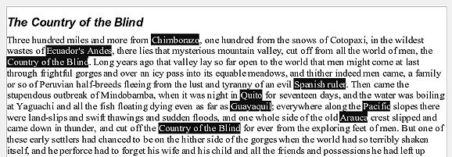

* 1. Cutting, copying, and pasting text

Cutting and copying text in Writer is similar to cutting and copying text in other applications. You can copy or move text within a document, or between documents, by dragging or by using menu selections, icons, or keyboard shortcuts. You can also copy text from other sources such as Web pages and paste it into a Writer document.

To move (cut and paste) selected text using the mouse, drag it to the new location and release it. To copy selected text, hold down the Control key while dragging. The text retains the formatting it had before dragging.

After selecting text, you can use the mouse or the keyboard for these operations.

Cut: Use **Edit > Cut** or the keyboard shortcut Control+X or the **Cut** icon on the toolbar .

Copy: Use **Edit > Copy** or the keyboard shortcut Control+C or the **Copy** icon .

Paste: Use **Edit > Paste**or the keyboard shortcut Control+V or the **Paste** icon .

The result of a paste operation depends on the source of the text to be pasted. If you simply click on the **Paste** icon, any formatting the text has (such as bold or italics) is retained. Text pasted from Web sites and other sources may also be placed into frames or tables. If you do not like the results, click the Undo icon and try again.

To make the pasted text take on the formatting of the surrounding text where it is to be pasted, choose either:

* Edit > Paste Special
* or click the triangle to the right of the **Paste** icon
* or click the **Paste** icon without releasing the left mouse button

Then select **Unformatted text** from the resulting menu.

The range of choices on the Paste Special menu varies depending upon the origin and formatting of the text (or other object) to be pasted. See for an example with text on the clipboard.

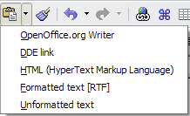

This example includes the formatting option DDE link. DDE is an acronym for Dynamic Data Exchange, a mechanism whereby selected data in document A can be pasted into document B as a linked, ‘live’ copy of the original. It would be used, for example, in a report written in Writer containing time‑varying data, such as sales results sourced from a Calc spreadsheet. The DDE link ensures that, as the source spreadsheet is updated so is the report, thus reducing the scope for error and reducing the work involved in keeping the Writer document up to date.

* 1. **Moving paragraphs quickly**

1. Put the cursor anywhere in the paragraph.
2. Press Control+Alt.
3. Holding the Control+Alt keys down, press the up-arrow or down-arrow key.

The paragraph will move to a new location either before the previous paragraph or after the next paragraph in your document. To move more than one paragraph at a time, select at least part of all paragraphs (including the end of the first paragraph you want to move and the start of the last) before pressing the Control+Alt+arrow keys.

If you are using Solaris, the key combination is Control+AltGr+arrow keys.

|  |  |
| --- | --- |
| **Tip** | If your paragraphs suddenly jumped from one place to another, the most likely reason is that you have accidentally pressed one of these key combinations. |

|  |  |
| --- | --- |
| Note | In some machines the Control+Alt+arrow key combination is reserved for screen flipping. You have to deactivate or assign different key combination for screen flipping (usually through display / graphics adapter settings in your computer) before using this feature. |

* 1. **Finding and replacing text**

When looking for certain words in a 3000-word essay, it would be inefficient (and close to impossible!) to go through every word manually. Writer has a Find and Replace feature that automates the process of searching for text inside a document.

In addition to finding and replacing words and phrases, you can:

* Use wildcards and regular expressions to fine-tune a search.
* Find and replace specific formatting.
* Find and replace paragraph styles.

To display the Find & Replace dialog box (), use the keyboard shortcut Control+F or select Edit > Find & Replace.

1. Type the text you want to find in the Search for box.
2. To replace the text with different text, type the new text in the Replace with box.
3. You can select various options, such as matching the case, matching whole words only, or doing a search for similar words. (See below for some other choices.)
4. When you have set up your search, click Find. To replace text, click Replace instead.

|  |  |
| --- | --- |
| **Tip** | If you click Find All, Writer selects all instances of the search text in the document. Similarly, if you click Replace All button, Writer will replace all matches. |

|  |  |
| --- | --- |
| **Caution** | Use Replace All with caution; otherwise, you may end up with some hilarious (and highly embarrassing) mistakes. A mistake with Replace All might require a manual, word-by-word search to fix. |

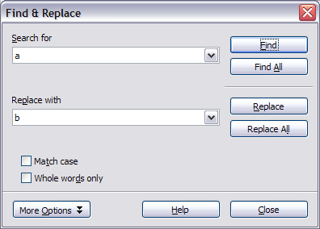

* 1. **Use wildcards (regular expressions)**

*Wildcards* (also known as *regular expressions*) are combinations of characters that instruct OOo how to search for something. Regular expressions are very powerful but not very intuitive. They can save time and effort by combining multiple finds into one.

shows a few of the regular expressions used by OOo.

|  |  |
| --- | --- |
| **Tip** | The online help describes many more regular expressions and their uses. |

|  |  |
| --- | --- |
| **Note** | To search for a character that is defined as a wildcard, type a backslash (\) before the character. For example, to find the text $5.00, you would conduct a search using \$5\.00. |

To use wildcards and regular expressions when searching and replacing:

1. On the Find & Replace dialog box, click **More Options** to see more choices. On this expanded dialog box (), select the Regular expressions checkbox.
2. Type the search text, including the wildcards, in the Search for box and the replacement text (if any) in the Replace withbox. Not all regular expressions work as replacement characters; the line break (\n) is one that does work.
3. Click Find, Find All, Replace, or **Replace All**(not recommended).

Table 1. Examples of search wildcards (regular expressions)

|  |  |  |
| --- | --- | --- |
| ***To find*** | ***Use this expression*** | ***Examples and comments*** |
| Any single character | . | b.d finds bad, bud, bid, and bed. |
| Any string of characters | .* | b.*d finds bad, brand, and board. |
| One of the specified characters | [xyz] | b[iu]n finds bin and bun. |
| Any single character in this range | [x-y] | [r-t]eed finds reed, seed, and teed; ranges must be in alphabetically ascending order. |
| Any single character except the characters inside the brackets | [^x] | p[^a]st finds post and pest, but not past. |
| The beginning of a word | \<start | \<log finds logbook and logistics, but not catalog. |
| The end of a word | end\> | log\> finds catalog, but not logistics. |
| A paragraph marker | $ | Does not work as a replacement character. Use \n instead. |
| A line break | \n | Finds a line break that was inserted with Shift+Enter. When used as a replacement character, it inserts a paragraph marker. |

* + 1. **Find and replace specific formatting**

A very powerful use of Find & Replace takes advantage of the format option. For example, you might want to replace underlined words with italics.

On the Find & Replace dialog box (with **More Options** displayed, as in ):

1. To search for text with specific formatting, enter the text in the Search for box. To search for specific formatting only, delete any text in the Search for box.
2. Click Format to display the Text Format (Search) dialog box. The tabs on this dialog box are similar to those on the Paragraph format and Paragraph Style dialog boxes. Choose the formats you want to search for and then click **OK**. The names of selected formats appear under the Search for box. For example, you might search for all text in 14-point bold Helvetica.
3. To replace text, enter the replacement text in the Replace with box.

To search for specific text with specific formatting (for example, the word hello in bold), specify the formatting, put the text in the Search for box and leave the Replace with box blank.

To remove specific character formatting, click Format, select the Font tab, then select the opposite format (for example, No Bold). The No Format button on the Find & Replace dialog box clears all previously selected formats.

1. Click Find, Find All, Replace, or Replace All.

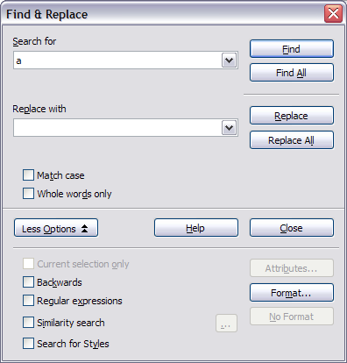

|  |  |
| --- | --- |
| **Tip** | Unless you plan to search for other text using those same attributes, click No Format to remove the attributes after completing your search. If you forget to do this, you may wonder why your next search fails to find words you know are in the document. |

* + 1. **Find and replace paragraph styles**

If you combine material from several sources, you may discover that lots of unwanted paragraph styles have suddenly shown up in your document. To quickly change all the paragraphs of one (unwanted) style to another (preferred) style:

1. On the expanded Find & Replace dialog box (), select Search for Styles. (If you have attributes specified, this checkbox is labeled Including Styles.) TheSearch forand Replace with boxes now contain a list of styles.
2. Select the styles you want to search for and replace.
3. Click Find, Find All, Replace, or Replace All.
   1. **Inserting special characters**

A “special” character is one not found on a standard English keyboard. For example, © ¾ æ ç ñ ö ø ¢ are all special characters. To insert a special character:

1. Place the cursor in your document where you want the character to appear.
2. Click **Insert > Special Character** to open the Special Characters dialog box ().

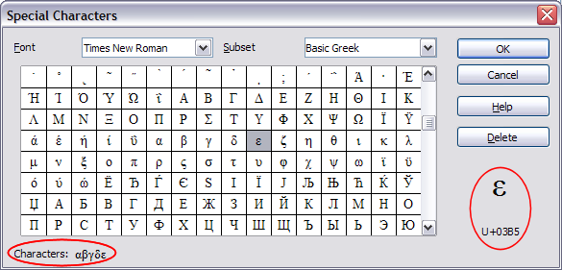

1. Select the characters (from any font or mixture of fonts) you wish to insert, in order; then click OK. The selected characters are shown in the lower left of the dialog box. As you select each character, it is shown on the lower right, along with the numerical code for that character.

|  |  |
| --- | --- |
| **Tip** | Notice that the characters selected appear in the bottom-left corner of the dialog box. |

|  |  |
| --- | --- |
| **Note** | Different fonts include different special characters. If you do not find a particular special character you want, try changing the Font selection. |

* + 1. Inserting dashes and non-breaking spaces
       1. Non-breaking spaces

To prevent two words from being separated at the end of a line, press Control+spacebar after the first word.

* + - 1. Non-breaking hyphen

You can use a non-breaking hyphen in cases where you do not want the hyphen to appear at the end of a line. Examples of non-breaking hyphens are: in a range such as A‑Z or the hyphens in a telephone number, such as 123‑4567. To insert a non-breaking hyphen, press Shift+Control+minus sign.

* + - 1. En and em dashes

To enter en and em dashes, use the Replace dashes option under Tools > AutoCorrect > Options (). This option replaces two hyphens, under certain conditions, with the corresponding dash.

Another means of inserting en or em dashes is through the Insert > Special Characters menu. Select the U+2013 or U+2014 character, respectively.

* 1. **Formatting paragraphs**

You can apply many formats to paragraphs using the buttons on the Formatting toolbar. shows the Formatting toolbar as a floating toolbar, customized to show only the buttons for paragraph formatting.

|  |  |
| --- | --- |
| **Tip** | It is highly recommended that you use paragraph styles rather than manually formatting paragraphs, especially for long or standardized documents. For information on the advantages of styles and how to use them, see Chapter 6 (Introduction to Styles). |

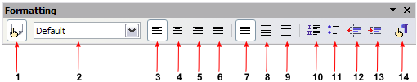

shows examples of the different alignment options.

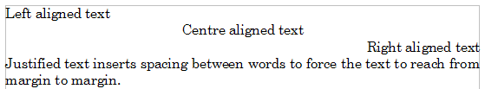

* + 1. **Setting tab stops and indents**

The horizontal ruler shows both the default tab stops and any that you have defined. To set the measurement unit and the spacing of default tab stops, go to **Tools > Options > OpenOffice.org Writer > General**.

You can also set or change the measurement unit by right-clicking on the ruler to open a list of units, as shown in . Click on one of them to change the ruler to that unit.

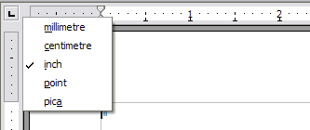

Double-click on a part of the ruler that is not between the left and right indent icons to open the *Indents & Spacing* page of the Paragraph dialog box. Double-click anywhere between the left and right indent icons on the ruler itself to open the Tabs page of the Paragraph dialog box ().

To fine-tune tab-stop settings, use the Tabs page of the Paragraph dialog box ().

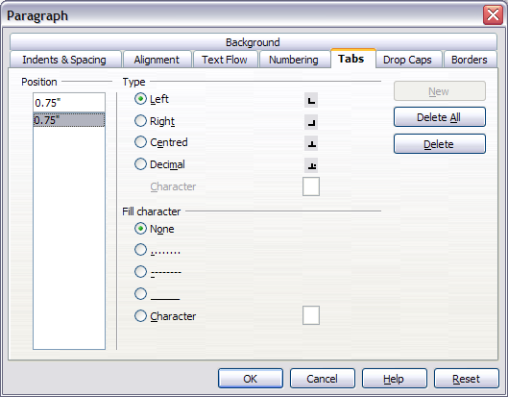

* 1. **Formatting characters**

You can apply many formats to characters using the buttons on the Formatting toolbar. shows the Formatting toolbar as a floating toolbar, customized to show only the buttons for character formatting.

|  |  |
| --- | --- |
| **Tip** | It is highly recommended that you use character styles rather than manually formatting characters. For information on the advantages of styles and how to use them, see Chapter 6 (Introduction to Styles). |

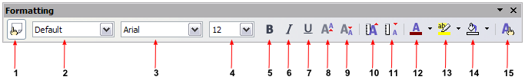

|  |  |
| --- | --- |
| **Tip** | To remove manual formatting, select the text and click Format > Default Formatting or right-click and select Default Formatting from the pop-up menu. |

* 1. **Autoformatting**

Writer can be set to automatically format parts of a document according to the choices made on the Options page of the AutoCorrect dialog box (Tools > AutoCorrect > Options). See .

The Help describes each of these choices and how to activate the autoformats. Some common unwanted or unexpected formatting changes include:

* Horizontal lines. If you type three or more hyphens (---), underscores (___) or equal signs (===) on a line and then press Enter the paragraph is replaced by a horizontal line as wide as the page. The line is actually the lower border of the preceding paragraph.
* Bulleted and numbered lists. A bulleted list is created when you type a hyphen (-), asterisk (*), or plus sign (+), followed by a space or tab at the beginning of a paragraph. A numbered list is created when you type a number followed by a period (.), followed by a space or tab at the beginning of a paragraph. Automatic numbering is only applied to paragraphs formatted with the Default, Text body or Text body indent paragraph styles.

|  |  |
| --- | --- |
| **Tip** | If you notice unexpected formatting changes occurring in your document, this is the first place to look for the cause. |

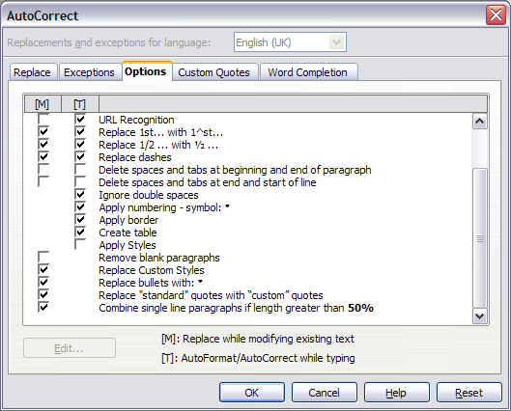

To turn autoformatting on or off, go to Format > AutoFormat () and select or deselect the items on the submenu.

* While Typing automatically formats the document while you type.
* If While Typing is deselected, you can select Apply to automatically format the file.
* Apply and Edit Changes automatically formats the file and then opens a dialog box where you can accept or reject the changes.

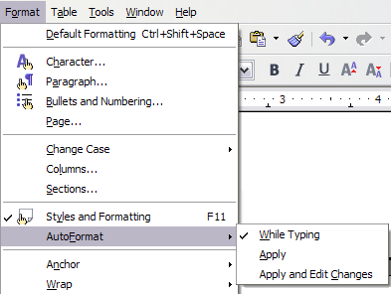

* 1. **Creating numbered or bulleted lists**

There are several ways to create numbered or bulleted lists:

* Use autoformatting, as described above.
* Use list styles, as described in Chapter 7 (Working with Styles).
* Use the Numbering and Bullets icons on the paragraph formatting toolbar (see ). This method is described here.

To produce a numbered or bulleted list, select the paragraphs in the list and then click on the appropriate icon on the toolbar.

|  |  |
| --- | --- |
| **Note** | It is a matter of personal preference whether you type your information first, then apply Numbering/Bullets or apply these as you type. |

* + 1. **Using the Bullets and Numbering toolbar**

You can create a nested list (where one or more list items has a sublist under it, as in an outline) by using the buttons on the Bullets and Numbering toolbar (). You can move items up or down the list, create subpoints, and even change the style of bullets.

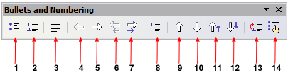

|  |  |
| --- | --- |
| **Tip** | It is possible to move a list entry up, together with all of its sub-entries. Do this by clicking the Promote One Level With Subpoints button. |

* 1. Using footnotes and endnotes

Footnotes appear at the bottom of the page on which they are referenced. Endnotes are collected at the end of a document.

To work effectively with footnotes and endnotes, you need to:

* Insert footnotes.
* Define the format of footnotes.
* Define the location of footnotes on the page; see Chapter 4 (Formatting Pages).
  + 1. **Inserting footnotes/endnotes**

To insert a footnote or an endnote, put the cursor where you want the footnote/endnote marker to appear. Then select Insert > Footnote from the menu bar or click the Insert Footnote Directly or Insert Endnote Directly icon on the Insert toolbar (see ).

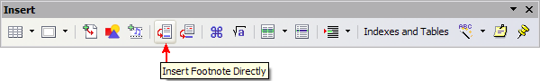

A footnote (or endnote) marker is inserted in the text, and the cursor is relocated to the footnote area at the bottom of the page (or to the endnote area at the end of the document). Type the footnote or endnote content in this area.

If you use Insert > Footnote, the Insert Footnote dialog box () is displayed. Here you can choose whether to use the automatic numbering sequence specified in the footnote settings and whether to insert the item as a footnote or an endnote.

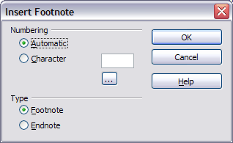

If you use the **Insert Footnote Directly** or Insert Endnote Directly icon, the footnote or endnote automatically takes on the attributes previously defined in the Footnote Settings dialog box ().

You can edit an existing footnote or endnote the same way you edit any other text.

To delete a footnote or endnote, delete the footnote marker. The contents of the footnote or endnote are deleted automatically, and the numbering of other footnotes or endnotes is adjusted automatically.

* + 1. **Defining the format of footnotes/endnotes**

To format the footnotes themselves, click Tools > Footnotes. On the Footnote Settings dialog box (), choose settings as required. The Endnotes page has similar choices.

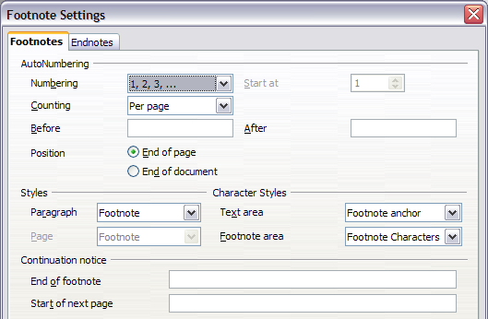

* 1. **Checking spelling**

Writer provides a spelling checker, which can be used in two ways.

AutoSpellcheck checks each word as it is typed and displays a wavy red line under any misspelled words. Once the word is corrected, the red wavy line disappears.

 To perform a separate spellcheck on the document (or a text selection) click the Spellcheck button. This checks the document or selection and opens the Spellcheck dialog box () if any misspelled words are found.

Here are some more features of the spelling checker:

* You can right-click on a word with a wavy underline, to open a powerful context menu. If you select from the suggested words on the menu, the selection will replace the misspelled word in your text. Other menu options are discussed below.
* You can change the dictionary language (for example, Spanish, French, or German) on the Spellcheck dialog box.
* You can add a word to a dictionary. Click Add in the Spellcheck dialog box and pick the dictionary to add it to.
* The Options dialog box of the Spellcheck tool has a number of different options such as whether to check uppercase words and words with numbers. It also allows you to manage custom dictionaries, that is, add or delete dictionaries and add or delete words in a dictionary.
* On the Font page of the Paragraph Styles dialog box, you can set paragraphs to be spell-checked in a specific language (different from the rest of the document). See Chapter 7 (Working with Styles) for more information.

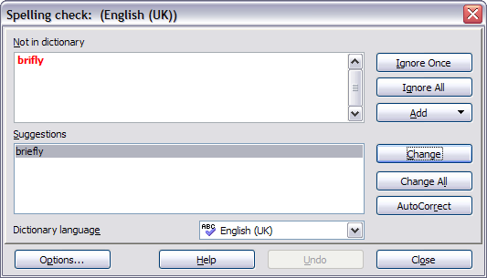

* 1. **Using the thesaurus**

The thesaurus offers alternative words and phrases. Select the word or phrase you want to find alternatives for and select Tools > Language > Thesaurus or press Control+F7. Click on a meaning to show alternative words and phrases for that meaning of the word. For example, when given the word “house”, the thesaurus offers several meanings, including “dwelling”, “legislature”, and “sign of the zodiac”. If you click on “dwelling”, you will see “dwelling”, “home”, “domicile”, “abode”, and other alternatives, as shown in .

|  |  |
| --- | --- |
| **Note** | If the current language does not have a thesaurus installed, this feature is disabled. |

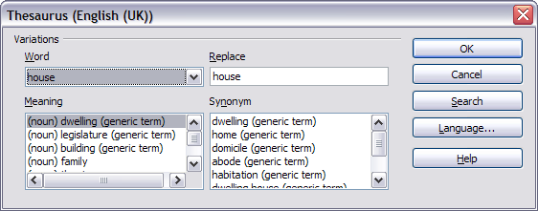

* 1. **Hyphenating words**

To turn automatic hyphenation of words on or off:

1. Press F11 to open the Styles and Formatting window ().

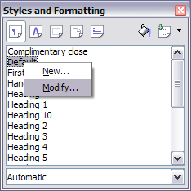

1. On the Paragraph Styles page of the Styles and Formatting window, right-click on **Default** and select Modify.
2. On the Paragraph Style dialog box, select the Text Flow tab ().
3. Under Hyphenation, select or deselect the Automatically checkbox.
4. Click OK to save.

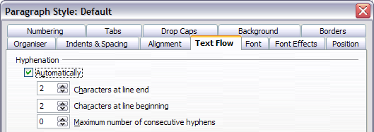

|  |  |
| --- | --- |
| **Note** | Turning on hyphenation for the Default paragraph style affects all other paragraph styles that are based on Default. You can individually change other styles so that hyphenation is not active; for example, you might not want headings to be hyphenated. Any styles that are not based on Default are not affected. For more on paragraph styles, see Chapter 6 (Introduction to Styles) and Chapter 7 (Working with Styles). |

You can also set hyphenation choices through Tools > Options > Language Settings > Writing Aids. In Options, near the bottom of the dialog box, scroll down to find the hyphenation settings (see ).

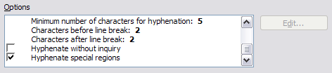

To change the minimal number of characters for hyphenation, the minimum number of characters before a line break, or the minimum number of characters after a line break, select the item, and then click Edit.

Hyphenate without inquiry specifies that you will never be asked to manually hyphenate words that the hyphenation dictionary does not recognize. If this box is not selected, when a word is not recognized, a dialog box will open where you can manually enter hyphens.

Hyphenate special regions specifies that hyphenation will also be carried out in footnotes, headers, and footers.

|  |  |
| --- | --- |
| **Notes** | Hyphenation options set on the Writing Aids dialog box are effective only if hyphenation is turned on through paragraph styles.  Choices on the Writing Aids dialog box for “characters before line break” and “characters after line break” override settings in paragraph styles for “characters at line end” and “characters at line begin”. This is a bug. |

To enter a conditional hyphen inside a word, press Control+minus sign. The word is hyphenated at this position when it is at the end of the line, even if automatic hyphenation for this paragraph is switched off.

* 1. **Using AutoCorrect**

Writer’s AutoCorrect function has a long list of common misspellings and typing errors, which it corrects automatically. For example, “hte” will be changed to “the”. Select Tools > AutoCorrect to open the AutoCorrect dialog box. There you can define what strings of text are corrected and how. In most cases, the defaults are fine.

|  |  |
| --- | --- |
| **Tip** | AutoCorrect is automatically turned on. To turn it off, uncheck Format > AutoFormat > While Typing. |

* To stop Writer replacing a specific spelling, use Tools > AutoCorrect > Replace, highlight the word pair and click Delete.
* To add a new spelling to correct, type it into the Replace and With boxes and click New.
* See the different pages of the dialog box for the wide variety of other options available to fine-tune AutoCorrect.

|  |  |
| --- | --- |
| **Tip** | AutoCorrect can be used as a quick way to insert special characters. For example, (c) will be autocorrected to ©. You can add your own special characters. |

* 1. **Using word completion**

If Word Completion is enabled, Writer tries to guess which word you are typing and offers to complete this word for you. To accept the suggestion, press Enter. Otherwise, continue typing.

|  |  |
| --- | --- |
| **Tip** | Many people prefer not to use Word Completion. If you do not want to use it, select Tools > AutoCorrect > Word Completion and uncheck Enable word completion. |

You can customize word completion from the Tools > AutoCorrect > Word Completion page ().

* Add (append) a space automatically after an accepted word.
* Show the suggested word as a tip (hovering over the word) rather than completing the text as you type.
* Change the maximum number of words remembered for word completion and the length of the smallest words to be remembered.
* Delete specific entries from the word completion list.
* Change the key that accepts a suggested entry—the options are right arrow, End key, Return (Enter), Space bar, and Tab.

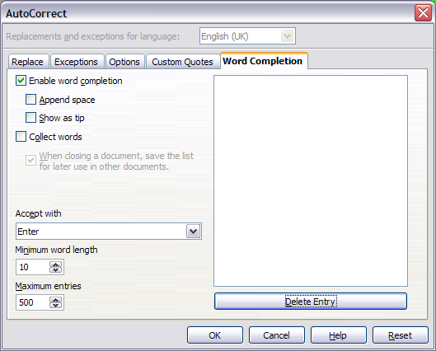

|  |  |
| --- | --- |
| **Note** | Automatic word completion only occurs after you type a word for the second time in a document. |

* 1. Using AutoText

AutoText allows you to assign text, tables, graphics, and other items to a key combination. For example, rather than typing out “Senior Management”, you just have to type “sm” and press F3. Or you can save a formatted Tip (like the one on the next page) as AutoText and then inserting a copy by typing “tip” and pressing F3.

To insert AutoText, type the shortcut and press F3.

To assign some text to an AutoText shortcut:

1. Type the text into your document.
2. Select the text.
3. Go to Edit > AutoText (or press Control+F3).
4. Enter a name for your shortcut. Writer will suggest a one-letter shortcut, which you can change.
5. Click the AutoText button on the right of the AutoText dialog box and select New (text only) from the menu.
6. Click Close to return to your document.

|  |  |
| --- | --- |
| **Tip** | If the only option under the AutoText button is Import, either you have not entered a name for your AutoText or there is no text selected in the document. |

AutoText is especially powerful when assigned to fields. See Chapter 14 (Working with Fields) for more information.

* 1. Line numbering

Line numbering puts line numbers in the margin. The line numbers are displayed on screen and are printed. shows an example with numbering on every line.

Click Tools > Line Numbering and select the Show numbering checkbox in the top left corner. Then click **OK.**

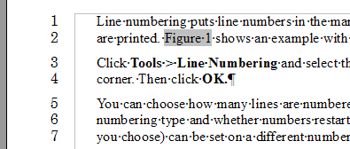

You can choose how many lines are numbered (for example, every line or every tenth line), the numbering type and whether numbers restart on each page. In addition, a text separator (any text you choose) can be set on a different numbering scheme (one every 12 lines, for example). See .

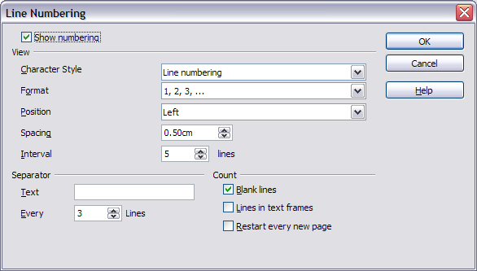

* 1. **Undoing and redoing changes**

To undo the most recent change, press Control+Z, click the Undo icon  on the Standard toolbar, or select Edit > Undo from the menu bar.

The Edit menu shows the latest change that can be undone, as shown in .

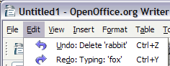

Click the small triangle to the right of the **Undo** icon to get a list of all the changes that can be undone (). You can select multiple changes and undo them at the same time.

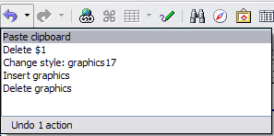

After changes have been undone, Redo becomes active. To redo a change, select Edit > Redo, or press Control+Y or click on the Redo icon . As with Undo, click on the triangle to the right of the arrow to get a list of the changes that can be reapplied.

To modify the number of changes OpenOffice.org remembers, select Tools > Options > OpenOffice.org > Memory and change Undo: Number of steps. Be aware that asking OOo to remember more changes makes it consume more memory.

* 1. **Tracking changes to a document**

You can use several methods to keep track of changes made to a document.

* Make your changes to a copy of the document (stored in a different folder, under a different name, or both), then use Writer to combine the two files and show the changes you made. Click Edit > Compare Document. This technique is particularly useful if you are the only person working on the document, as it avoids the increase in file size and complexity caused by the other methods.
* Save versions that are stored as part of the original file. However, this method can cause problems with documents of nontrivial size or complexity, especially if you save a lot of versions. Avoid this method if you can.
* Use Writer’s change marks (often called “redlines” or “revision marks”) to show where you have added or deleted material or changed formatting. Later, you or another person can review and accept or reject each change.

|  |  |
| --- | --- |
| **Tip** | Not all changes are recorded. For example, changing a tab stop from align left to align right and changes in formulas (equations) or linked graphics are not recorded. |

* + 1. **Preparing a document for review**

When you send a document to someone else to review or edit, you may want to prepare it first so that the editor or reviewer does not have to remember to turn on the revision marks. After you have protected the document, any user must enter the correct password in order to turn off the function or accept or reject changes.

1. Open the document. To check whether it contains multiple versions, click File > Versions. If multiple versions are listed, save the current version as a separate document with a different name and use this new document as the review copy.
2. With the review copy open, make sure that change recording is turned on. The Edit > Changes > Record menu item has a check mark next to it when recording is turned on.
3. Click Edit > Changes > Protect Records. On the Enter Password dialog box, type a password (twice) and click OK.

|  |  |
| --- | --- |
| **Note** | Passwords must contain at least five characters. It is not necessary to password protect the document while preparing it for review. |

* + 1. **Recording changes**

See Chapter 2 (Setting up Writer) for instructions on setting up how your changes will be displayed.

1. To begin tracking (recording) changes, click Edit > Changes > Record.

To show or hide the display of changes, click Edit > Changes > Show.

|  |  |
| --- | --- |
| **Tip** | Hold the mouse pointer over a marked change; you will see a Help Tip showing the type of change, the author, date, and time of day for the change. If Extended Tips are enabled, you will also see any comments recorded for this change. |

1. To enter a comment on a marked change, place the cursor in the area of the change and then click Edit > Changes > Comment. (See .) In addition to being displayed as an extended tip, the comment is also displayed in the list in the Accept or Reject Changes dialog box.

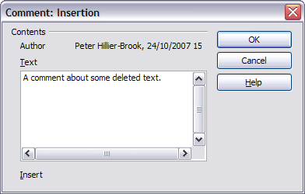

To move from one marked change to the next, use the arrow buttons. If no comment has been recorded for a change, the Text field is blank.

1. To stop recording changes, click Edit > Changes > Record again.
   * 1. **Inserting notes**

To insert a note that is not associated with a recorded change:

1. Place the cursor at the text you want to comment on, then click Insert > Note.
2. On the Insert Note dialog box (), type your note. Click the Author button to insert your initials and the date and time.

To view a note, move the mouse pointer over the note marker (displayed as a small yellow rectangle). Writer displays the note in a Tip above the text. You can also double-click on the note to see it inside the Edit Note dialog box. If you have trouble viewing or selecting notes this way, you can use the Navigator instead: expand the list of notes, select the one you want, right-click on it, select **Note**, and then select Edit to display the Edit Note dialog box.

The Edit Note dialog box looks much like the Insert Note dialog box, with the addition of forward and back arrow buttons if the document contains more than one note.

|  |  |
| --- | --- |
| **Tip** | You can change the color of the note marker using the Tools > Options > OpenOffice.org > Appearance dialog box. (In the Text Document section ─Note Indicator.) |

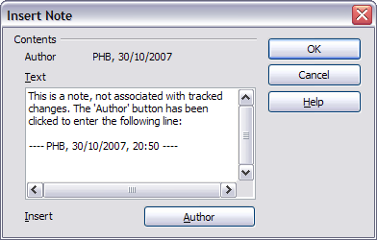

* + 1. **Accepting or rejecting changes and comments**

1. Click Edit > Changes > Accept or Reject. The Accept or Reject Changes dialog box () opens.
2. When you select a change in the dialog box, the actual change is highlighted in the document, so you can see what the editor changed.
3. Click Accept or Reject to accept or reject the selected change. You can also click Accept All or Reject All if you do not want to review the changes individually.

Changes that have not yet been accepted or rejected are displayed in the list. Accepted changes are removed from the list and appear in the text without any marking.

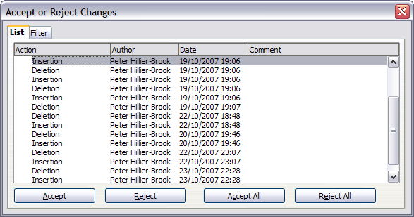

To show only the changes of certain people or only the changes on specific days or various other restrictions, use the Filter page () on the Accept or Reject Changes dialog box. After specifying the filter criteria, return to the List page to see those changes that meet your criteria.

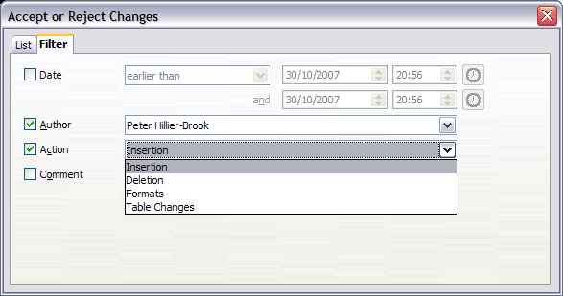

* + 1. **Merging modified documents**

The processes discussed to this point are effective when you have one reviewer at a time. Sometimes, however, multiple reviewers all return edited versions of a document at the same time. In this case, it may be quicker to review all of these changes at once, rather than one review at a time. For this purpose, you can merge documents in Writer.

To merge documents, all of the edited documents need to have recorded changes in them.

* 1. Open one copy.
  2. Click Edit > Changes > Merge Document and select and insert another copy of the document to be merged with the first.
  3. After the documents merge, the Accept or Reject Changes dialog box opens, as in , showing changes by more than one reviewer. If you want to merge more documents, close the dialog box and then repeat step 2.
  4. Repeat until all copies are merged.

All recorded changes are now included in the open copy. Save this file under another name.

* + 1. Comparing documents

Sometimes reviewers may forget to record the changes they make. This is not a problem with Writer because you can find the changes if you compare documents.

In order to compare documents, you need to have the original document and the one that is edited. To compare them:

1. Open the edited document. Select Edit > Compare Document.
2. The Insert dialog box appears. Select the original document and click Insert.

Writer finds and marks the changes and displays the Accept or Reject Changes dialog box. From this point, you can go through and accept or reject changes procedure as described earlier.

* 1. Linking to another part of a document

If you type in references to other parts of the document, those references can easily get out of date if you reorganize the order of topics, add or remove material, or reword a heading, OOo provides two ways to ensure that your references are up to date, by inserting links to other parts of the same document or to a different document.

* Hyperlinks
* Cross-references

The two methods have the same result if you Control+click the link when the document is open in OOo: you are taken directly to the cross-referenced item. However, they also have two major differences:

* The text in a hyperlink does not automatically update if you change the text of the linked item (although you can change it manually), but changed text does automatically update in a cross-reference.
* When using a hyperlink, you do not have a choice of the content of the link (for example text or page number), but when using a cross-reference, you do have several choices, including bookmarks.
  + 1. Using hyperlinks

To insert a cross-reference as a hyperlink in your document, use the Navigator:

1. Open the documents containing the items you want to cross-reference.
2. Open the Navigator (by clicking its icon, choosing Edit > Navigator, or pressing F5.
3. Click the arrow next to the Drag Mode icon, and select Insert as Hyperlink.
4. In the list at the bottom of the Navigator, select the document containing the item that you want to cross-reference.
5. In the Navigator list, select the item that you want to insert as a hyperlink.
6. Drag the item to where you want to insert the hyperlink in the document. The name of the item is inserted in the document as an active hyperlink.
   * 1. Using cross-references

To ensure that references update if you reword a heading, caption, or other linked item, use automatic cross-references. See “Using automatic cross-references” in Chapter 14 (Working with Fields) for details.

* + 1. Using bookmarks

Bookmarks are listed in the Navigator and can be accessed directly from there with a single mouse click. In HTML documents, bookmarks are converted to anchors that you can jump to by hyperlink. For more about bookmarks, see “Using bookmarks” in Chapter 14 (Working with Fields).

* 1. Working with hyperlinks

When you type text (such as a website addresses or URL) that can be used as a hyperlink, OOo formats it automatically, creating the hyperlink and applying to the text a color and underlining. If this does not happen, you can enable this feature using Tools > AutoCorrect > Options and selecting the URL Recognitioncheckbox.

|  |  |
| --- | --- |
| Tips | If you do not want OOo to convert a specific URL to a hyperlink, select Edit > Undo Insert from the menu bar or press Control+Z immediately after the formatting has been applied.  To change the color of hyperlinks, go to Tools > Options > OpenOffice.org >Appearance, scroll to Unvisited links and/or Visited links, select the checkboxes, pick the new colors and click OK. Caution: this will change the color for all hyperlinks in all components of OpenOffice.org—this may not be what you want.  In Writer and Calc (but not Draw or Impress), you can also change the Internet link character style or define and apply new styles to selected links. |

You can also insert and modify links using the Hyperlink dialog (). To display the dialog, click the Hyperlink icon  on the Standard toolbar or select Insert > Hyperlink from the menu bar. To turn existing text into a link, highlight it before opening the Hyperlink dialog.

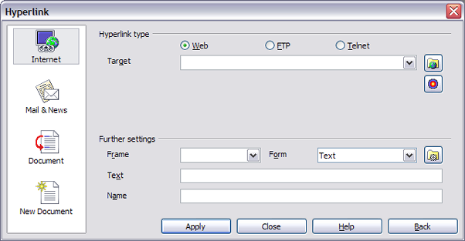

On the left hand side, select one of the four types of hyperlink:

* Internet: a web address, normally starting with http://
* Mail & News: for example an email address.
* Document: the hyperlink points to another document or to another place in the presentation.
* New document: the hyperlink creates a new document.

The top right part of the dialog changes according to the choice made for the hyperlink type. A full description of all the choices, and their interactions, is beyond the scope of this chapter. Here is a summary of the most common choices used in presentations.

For an Internet type hyperlink, choose the type of hyperlink (choose between Web, FTP or Telnet), and enter the required web address (URL).

For a Mail and News type hyperlink, specify whether it is a mail or news link, the receiver address and for email, also the subject.

For a Document type hyperlink, specify the document path (the Open File button opens a file browser); leave this blank if you want to link to a target in the same presentation. Optionally specify the target in the document (for example a specific slide). Click on the Target icon to open the Navigator where you can select the target, or if you know the name of the target, you can type it into the box.

For a New Document type hyperlink, specify whether to edit the newly created document immediately or just create it (Edit later) and the type of document to create (text, spreadsheet, etc.). For a presentation, Edit now is the more likely choice. The Select path button opens a directory picker.

The Further settings section in the bottom right part of the dialog is common to all the hyperlink types, although some choices are more relevant to some types of links.

* Set the value of Frame to determine how the hyperlink will open. This applies to documents that open in a Web browser.
* Form specifies if the link is to be presented as text or as a button.
* Text specifies the text that will be visible to the user.
* Name is applicable to HTML documents. It specifies text that will be added as a NAME attribute in the HTML code behind the hyperlink.
* Event button: this button will be activated to allow OOo to react to events for which the user has written some code (macro). This function is not covered in this book.
  + 1. Editing hyperlinks

From OOo 2.3, to edit a hyperlink, you can either click anywhere in the link text, or position the cursor in the link text using the arrow keys, and then open the Hyperlink dialog by clicking the Hyperlink icon on the Standard toolbar or selecting Edit > Hyperlink from the menu bar. (To activate a hyperlink, it is now necessary to hold down the Ctrl key while clicking on the link.)

With OOo 2.2.1 and earlier, clicking on a hyperlink activates the link. Therefore, to edit a link, either move the cursor into the link using the keyboard arrow keys, or change the status of the link by clicking on the acronym HYP (hyperlink) in the Status bar to change it to SEL (select), then open the Hyperlink dialog as described above.

|  |  |
| --- | --- |
| Tip | If you need to edit several hyperlinks, you can leave the Hyperlink dialog open until you have edited all of them. Be sure to click Apply after each one. When you are finished, click Close. |

* 1. Switching between insert and overwrite mode

With the keyboard, press Insert to toggle between overwrite mode and insert mode. In insert mode, any text after the cursor position moves forward to make room for the text you type; in overwrite mode, text after the cursor position is replaced by the text you type. The current mode is displayed on the Status Bar.

With the mouse, click in the area on the Status Bar that indicates the current mode in order to switch to the other mode.

* 1. Counting the words in a selection

Select a block of text and choose Tools > Word Count. OOo displays the number of words and characters in the selection as well as the number of words in the document. You can also see the number of words and characters (and other information) in the entire document in File > Properties > Statistics.



Writer Guide

1. Chapter 4  
    Formatting Pages

Using Page Styles, Tables, Frames, Columns, and Sections

* 1. Introduction

Writer provides several ways for you to control page layouts:

* Page styles
* Columns
* Frames
* Tables
* Sections

This chapter describes these methods and some associated things:

* Headers and footers
* Numbering pages
* Changing page margins

|  |  |
| --- | --- |
| Tip | Page layout is usually easier if you select the options to show text, object, table, and section boundaries in Tools > Options > OpenOffice.org > Appearance and if you select the options for paragraph ends, tabs, breaks, and other items in Tools > Options > OpenOffice.org Writer > Formatting Aids. |

* 1. Choosing a layout method

The best layout method depends on what the final document should look like and what sort of information will be in the document. Here are some examples. Do not worry if all this does not mean much to you now. The techniques mentioned are all described in this chapter.

|  |  |
| --- | --- |
| For a book similar to this user guide with one column of text, some figures without text beside them, and some other figures with descriptive text, use page styles for basic layout, and use tables to place figures beside descriptive text, when necessary. |  |
| Use page styles (with two columns) for an index or other document with two columns of text where the text continues from the left-hand column to the right-hand column and then to the next page, all in sequence (also known as snaking columns of text). If the title of the document (on the first page) is full-page width, put it in a single-column section. |  |
| For a newsletter with a complex layout, two or three columns on the page, and some articles that continue from one page to some place several pages later, use page styles for basic layout. Place articles in linked frames and anchor graphics to fixed positions on the page, if necessary. |  |
| For a document with terms and translations to appear side-by-side in what appear to be columns, use a table to keep items lined up so you can type in both “columns”. |  |

* 1. Setting up basic page layout using styles

In Writer, page styles define the basic layout of all pages, including page size, margins, the placement of headers and footers, borders and backgrounds, number of columns, and so on.

Writer comes with several page styles, which you can build on or modify, and you can define new (custom) page styles. You can have one or many page styles in a single document.

|  |  |
| --- | --- |
| Note | All pages in a Writer document are based on styles. If you do not specify a page style, Writer uses the Default page style. |

To change the layout of individual pages, either define a new page style or use one of the techniques (sections, frames, or tables) described later in this chapter.

This chapter describes some uses of page styles. Some other uses are discussed in Chapter 6 (Introduction to Styles). The Page Style dialog box is covered in detail in Chapter 7 (Working with Styles).

|  |  |
| --- | --- |
| Tip | Any modifications of page styles, including the Default page style, apply only to the document you are working on. If you want the changes to be the default for all documents, you need to put the changes into a template and make that template the default template. See Chapter 10 (Working with Templates) for details. |

* + 1. Inserting a page break without switching the style

In many documents (for example, a multi-page report), you may want the text to flow from one page to the next as you add or delete information. Writer does this automatically, unless you override the text flow using one of the techniques described earlier.

If you do want a page break in a particular place, for example, to put a heading at the top of a new page, here is how to do it:

1. Position the cursor in the paragraph you want to be at the start of the next page. Right-click and choose Paragraph in the pop-up menu.
2. On the Text Flow page of the Paragraph dialog box (), in the Breaks section, check Insert.Do not check With Page Style.

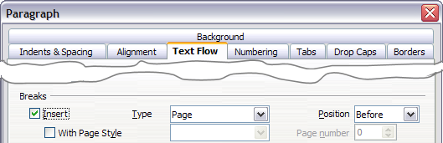

1. Click OK to position the paragraph at the start of the next page.
   * 1. Defining a different first page for a document

Many documents, such as letters and reports, have a first page that is different from the other pages in the document. For example, the first page of a letterhead typically has a different header, as shown in , or the first page of a report might have no header or footer, while the other pages do. With OOo, you can define the style for the first page and specify the style for the following page to be applied automatically.

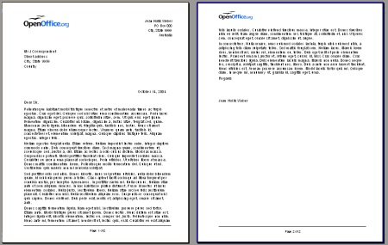

As an example, we can use the First Page and *Default* page styles that come with OOo. shows what we want to happen: the first page is to be followed by the default page, and all the following pages are to be in the *Default* page style.

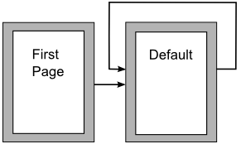

To set up this sequence:

1. Open the Styles and Formatting window. (You can choose one of the following: click the Styles and Formatting icon  located at the left-hand end of the object bar, choose Format > Styles and Formatting, or press F11.)
2. On the Styles and Formatting window (), click on the Page Styles icon  (fourth from the left) to display a list of page styles.
3. Right-click on First Page and select Modify from the pop-up menu.

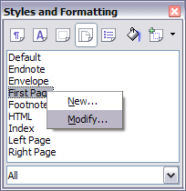

1. On the Organizer page of the Page Style dialog box (), look at the Next Style property. This property defines what the page style for the next page will be. It should be set to Default, but if it is not, you can change the next style by clicking on the drop-down button and choosing Default from the list of page styles.

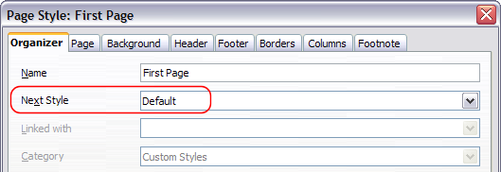

1. On the other pages of this dialog box, you can turn on or off the header and footer for the first page and define other characteristics, such as columns, a page border, or a page background. For more information, see Chapter 7 (Working with Styles).
2. Click OK to save the changes.

|  |  |
| --- | --- |
| Note | You can override the Next Style property by manually inserting a page break and specifying a page style or by starting a page with a paragraph or table that has its own page style property defined. These techniques are described in “” on page . |

* + 1. Changing page orientation within a document

A document can contain pages in more than one orientation. A common scenario is to have a landscape page in the middle of a document, whereas the other pages are in a portrait orientation. Here are the steps to achieve it.

* + - 1. Setting up a landscape page style

1. Note the page style that is current and the margin settings. (You can find the margin settings on the Page page of the Page Style dialog box, as shown in .)
2. Create a new style. (Right-click on the current page style in the Styles and Formatting window and choose New, as shown in .)

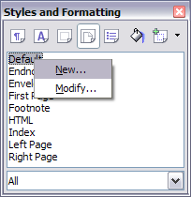

1. On the Organizer page of the Page Style dialog box (), name (by typing in the Name field) this new style Landscape and set the Next Style property to Landscape (to allow for having more than one sequential landscape page).

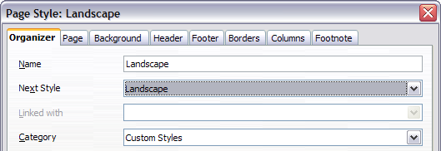

1. On the Page page of the Page Style dialog box (), set the Orientation to Landscape. The width and height attributes of the page will automatically change.
2. Change the margins so that they correspond with the margins of the portrait page. That is, the portrait top margin becomes the landscape left margin, and so on.
3. Click OK to save the changes.

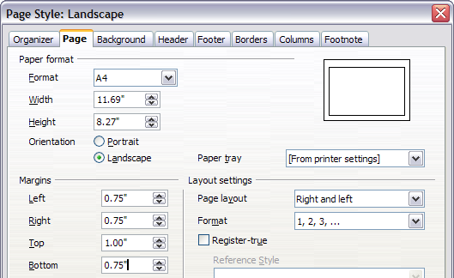

* + - 1. Inserting a landscape page into a portrait document

Now that you have defined the Landscape page style, here is how to apply it.

1. Position the cursor in the paragraph or table at the start of the page that is to be set to landscape. Right-click and choose Paragraph or Table, respectively, in the pop-up menu.
2. On the Text Flow page of the Paragraph dialog box () or the Table Format dialog box (), select Insert (or Break for a table) and With Page Style. Set the Page Style property to Landscape. Click OK to close the dialog box and to apply the new page style.
3. Position the cursor in the paragraph or table where the page is to return to portrait orientation and change the properties of that paragraph or table properties so that With Page Style is the portrait page style that was used before the Landscape page style.
4. Click OK to return to the previous portrait page style.

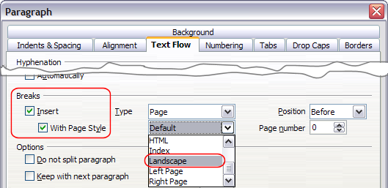

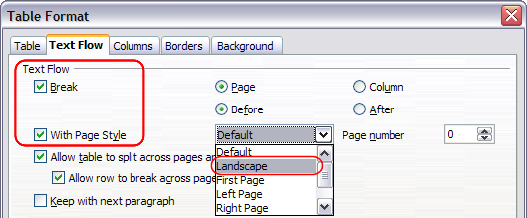

|  |  |
| --- | --- |
| Tip | If you need the headers or footers on the landscape pages to be in portrait orientation, see “” on page . |

* 1. Changing page margins

You can change page margins in two ways:

* Using the page rulers—quick and easy, but does not have fine control.
* Using the Page Style dialog box—can specify margins to two (fractional) decimal places.

|  |  |
| --- | --- |
| Note | If you change the margins using the rulers, the new margins affect the page style and will be shown in the Page Style dialog box the next time you open it. |

To change margins using the rulers:

1. The shaded sections of the rulers are the margins (see ). Put the mouse cursor over the line between the gray and white sections. The pointer turns into a double-headed arrow.
2. Hold down the left mouse button and drag the mouse to move the margin.

|  |  |
| --- | --- |
| Tip | The small arrows on the ruler are used for indenting paragraphs. They are often in the same place as the page margins, so you need to be careful to move the margin marker, not the arrows. Place the mouse pointer between the arrows and, when the pointer turns into a double-headed arrow, you can move the margin (the indent arrows will move with it). |

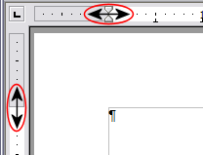

To change margins using the Page Style dialog box ():

1. Right-click anywhere on the page and select Page from the pop-up menu.
2. On the Page page of the dialog box, type the required distances in the Margins boxes.
   1. Using columns to define the page layout

You can use columns for page layout in several ways:

* Define the number of columns on a page, using page styles.
* Switch between one-column and multiple-column layouts on the same page.
* Select existing text and change the number of columns.
  + 1. Defining the number of columns on a page

It is a good idea to define your basic page style (such as Default) with the most common layout to be used in your document, either single-column or multiple-column. You can then either define extra page styles for pages with different numbers of columns or use sections (described in “” starting on page ) for pages or parts of pages with different numbers of columns.

To define the number of columns on a page:

1. Choose Format > Columns or go to the Columns page of the Page Style dialog box.
2. On the Columns dialog box (), choose the number of columns and specify any spacing between the columns and whether you want a vertical separator line to appear between the columns. You can use one of Writer’s predefined column layouts, or you can create a customized column layout. The preview box, located to the right of the Settings area, shows how the column layout will look.
3. Notice the Apply to box on the right-hand side of the dialog box. In this case, the changes are being applied to the Default page style.
4. Click OK to save the changes.

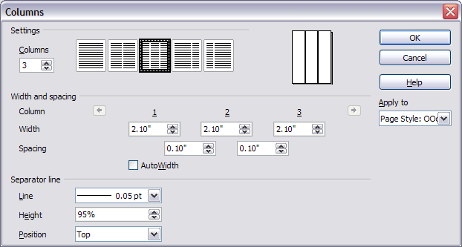

* + - 1. Using a predefined column layout

The Settings area displays five predefined column layouts. To use one of them, click the desired layout.

* + - 1. Specifying the number of columns

If you prefer to create a customized column layout, you must specify the number of columns that you want. Enter the desired number in the Columnsbox in the Settings area.

* + - 1. Distributing text across columns

You can distribute text across the columns in one of two ways:

* Evenly—If you choose to distribute text evenly, Writer will fill the first line of each column, followed by the second line of each column, and so on.
* Newspaper-style—If you choose to distribute text newspaper-style, Writer will fill the columns one at a time, beginning with the first column.

To distribute text evenly, check the Evenly distribute contents to all columns check box in the Settings area. Clear this check box if you want to distribute text newspaper-style.

|  |  |
| --- | --- |
| Note | This check box is not always displayed in the Settings area. See “” on page . |

* + - 1. Formatting column width and spacing

To create evenly-spaced columns that are all the same width, check the AutoWidthcheck box in the Width and spacing area.

To customize the width and spacing of the columns, follow these steps:

1. In the Width and spacing area, clear the AutoWidth check box.
2. On the Width line, enter a width for each column.
3. On the Spacing line, enter the amount of space that you want between each pair of columns.

If you specify more than three columns, use the arrow keys on the Column line to scroll among the columns.

* + - 1. Formatting separator lines

To display separator lines between the columns:

1. Eighteen separator line options exist: None or various lines of thicknesses which range from 0.05 to 9 pt). From the Line drop-down list in the Separator line area, select the type of line that you want. (1 pt = 1 point = 1/12 pica = 1⁄72 inch = 127⁄360 mm = 0.3527 mm.)
2. The default format is for the separator lines to have the same height as the columns. If you want the separator lines to be shorter than the columns, use the Height box to enter the height of the separator lines as a percentage of the height of the columns. For example, if you enter 50%, the separator lines will be half as high as the columns.
3. If you entered a height of less than 100%, use the Position drop-down list to select a vertical alignment for the separator lines. The vertical-positioning options are: Top, Centered, or Bottom.
   * + 1. Reverting to a single-column layout

To revert to a single-column layout, go to the Settings area and either reset the number in the Columns boxto 1 or click the single-column layout icon.

* + 1. Changing the number of columns for existing text

You might want some parts of a page to have one column and other parts of the page to have two or more columns. For example, you might have a page-width headline over a three-column news story.

You can create columns and then type or paste text into them, or you can select some existing text and change the number of columns for displaying it.

When you select text and change the number of columns for that text, Writer turns the selected text into a section, as described in “” on page .

shows the Columns dialog box for a selection. Notice that the Apply to box on the right-hand side has Selection highlighted and an extra check box (Evenly distribute contents to all columns) appears in the upper left-hand part of the dialog box.

As you add text to the section, you will see that the text flows from one column to the next so that all the columns adjust to the same height. If this is not what you want, click anywhere in the section, then choose Format > Columns to reopen the Columns dialog box, deselect the Evenly distribute contents to all columns check box, and click OK to effect the change.

|  |  |
| --- | --- |
| Tip | Choose View > Nonprinting Characters (or press Ctrl+F10) to display end of paragraph markers (¶). Often, unexpected behavior of columns is due to extra paragraphs that are normally invisible to the user but are taking up space. |

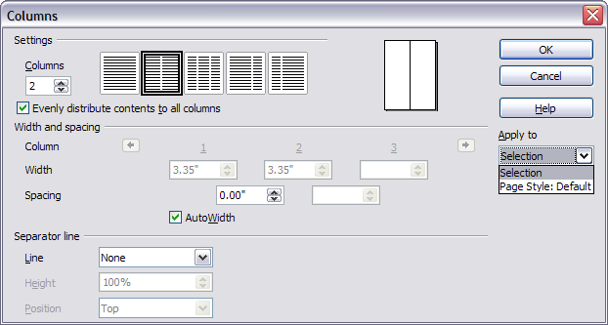

* 1. Using frames for page layout

Frames can be very useful when producing a newsletter or other layout-intensive documents. Frames can contain text, tables, multiple columns, pictures, and other objects.

Use frames when you need to:

* Position something in a particular place on a page, for example, a logo or a “stop press” news box in one corner of a page.
* Allow text on one page to continue on another page, somewhere more distant than the next one, by linking the content of one frame to another so the contents flow between them as you edit the text.
* Wrap text around an object, such as a photograph.

Because OpenOffice.org does not allow you to define page styles with recurring frames, consider doing some quick sketches of the basic page layouts you need, indicating the approximate positions of different frames and their purposes. Try to keep the number of different page layouts as low as possible in order to avoid chaos in your design.

Pay special attention to the positioning of frames. Many of the predefined styles default to a center alignment. This is the lowest common denominator of design; centering all frames looks reasonably good in most cases but is rarely the best choice.

One of the most visually effective ways to position a frame is to align its left margin with that of the paragraph above it. To achieve this effect, insert the frame in a blank paragraph of the same style as the paragraph above. Then, select Insert > Frame > Type > Position > Horizontal > From Left to position the frame exactly where you want it.

You also should think about the type of wrap and the spacing between the frame and text. Instead of cramming a frame close to the text, use the Wrap tab to place some white space between them.

You can format frames individually or define and apply frame styles—see Chapter 7 (Working with Styles).

|  |  |
| --- | --- |
| Tip | The Help uses the phrase “text frame” for two quite different things with very different characteristics: frames (as discussed here) and text objects, which are drawing objects similar to lines and boxes. |

* + 1. Creating frames

You can create a frame in several ways, depending on your needs.

* Choose **Insert > Frame**) to create an empty frame. The Frame dialog box () appears. You can click **OK** and come back to customize it later, or you can set the frame’s characteristics at this stage.
* Select text or a graphic, choose **Insert > Frame**, and click OK to create a frame containing the selection. The selected text is automatically deleted from the normal text flow and inserted into the frame, and the Frame dialog box appears.
* Insert a picture or other object by selecting**Insert > Picture > From file** or **Insert > Object** to start the process to insert a picture or object. The item inserted automatically appears in a frame, but the Frame dialog box does not appear.
* Use the Insert Frame Manually icon on the Insert toolbar (go to **View >Toolbars** > **Insert** to display it), select the number of frames in the drop-down menu, and drag the mouse to draw the frame.

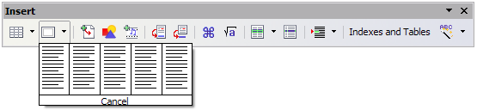

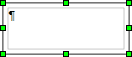When you release the mouse button, a box appears where the cursor is located in the document. This box represents the frame: an area isolated from the main document.

To add content to a frame, first deselect the frame by clicking somewhere else on the page. Then, click inside the frame so that the cursor shifts its focus there. Now add content just like you would on the main page. When you are done, deselect the frame.

* + 1. Moving, resizing, and changing frame attributes

When an object is added to Writer, it is automatically enclosed in a frame of a predetermined type. The frame sets how the object is placed on the page, as well as how it interacts with other elements in the document. You can edit the frame by modifying the frame style it uses or by using a manual override when a frame is added to the document. Frame styles are discussed in Chapter 7 (Working with Styles).

To change the size or location of a frame, first select the frame, then use either the mouse or the Frame dialog box (). Using the mouse is faster but less accurate. You might use the mouse for gross layout and the dialog box for fine-tuning.

You can resize the frame manually (by clicking on the green squares and dragging to the appropriate size) or start adding content to it (the frame will resize automatically if you, for example, add a large picture to it) or go back to the Frame dialog box and set the size and other characteristics.

To change the location of the frame using the mouse, drag and drop one of the edges or having the cursor anywhere within the frame. (The I-bar cursor changes to a four-headed arrow when properly positioned for a drag-and-drop move.) To change the size of the frame, drag one of the handles. Drag a handle on one of the sides to enlarge or reduce the text frame in one dimension only; drag a corner handle to enlarge or reduce it in both dimensions.

These resizing actions distort the proportions of the frame. Holding down the Shift key while dragging one of the handles makes the frame keep the same proportions.

You can open the Frame dialog box () at any time by selecting the frame, right-clicking, and choosing Frame from the pop-up menu.

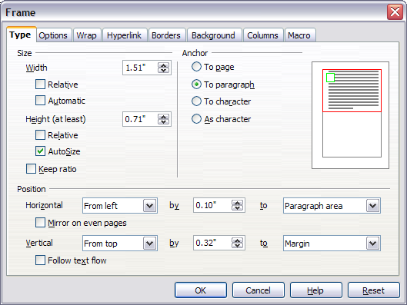

To remove the default border on a newly created frame, open the Frame dialog box, go to the Borders page, and under Line Style, select None. Alternatively, you can assign a borderless frame style to the frame; see the Chapter 7 (Working with Styles) for information on frame styles.

|  |  |
| --- | --- |
| Tip | Do not confuse a frame’s border with the text boundaries that are made visible using the View menu (by checking View > Text Boundaries). |

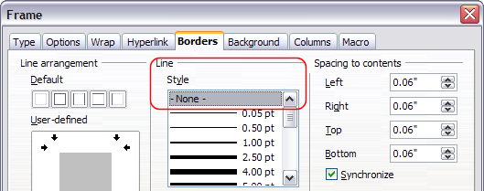

* + 1. Anchoring a frame

Using the Frame dialog box (or by right-clicking and pointing to Anchor), you can anchor a frame to a page, paragraph, or character, or you can anchor it as a character.

* + - 1. To Page

The frame keeps the same position in relation to the page margins. It does not move as you add or delete text. This method is useful when the frame does not need to be visually associated with a particular piece of text. It is often used when producing newsletters or other documents that are very layout-intensive.

* + - 1. To Paragraph

The frame is associated with a paragraph and moves with the paragraph. It may be placed in the margin or another location. This method is useful as an alternative to a table for placing icons beside paragraphs.

* + - 1. To Character

The frame is associated with a character but is not in the text sequence. It moves with the paragraph but may be placed in the margin or another location. This method is similar to anchoring to a paragraph.

* + - 1. As Character

The frame is placed in the document like any other character and, therefore, affects the height of the text line and the line break. The frame moves with the paragraph as you add or delete text before the paragraph. This method is useful for adding a small icon in sequence in a sentence. It is also the best method for anchoring a graphic to an empty paragraph so it does not move around the page in unexpected ways.

* + 1. Linking frames

You can link several frames to each other even when they are on different pages of a document. The contents will automatically flow from one to the next. This technique is very useful when designing newsletters, where articles may need to be continued on a different page.

To link one frame to another:

1. Select the frame to be linked from.
2. Click the Link Frames icon  on the object bar.
3. Click the next frame in the series (which must be empty).

When a linked frame is selected, any existing links are indicated by a faint connecting line, as shown in . Note that any frame-linking line will not be as clear as illustrated in the figure.

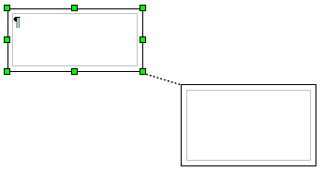

|  |  |
| --- | --- |
| Note | You cannot link from a frame to more than one other frame. |

The height of a frame that is being linked from is fixed; you can change this height manually or by using the Frame dialog box, but it does not automatically adjust to the size of the contents (that is, the AutoHeight attribute is disabled). Only the last frame of a chain can adapt its height to the content.

The Options page of the Frame dialog box () shows the names of the selected frame and any frames it is linked to or from. You can change this information here. On this page, you can also select check boxes to protect the contents, position, and size of the frame.

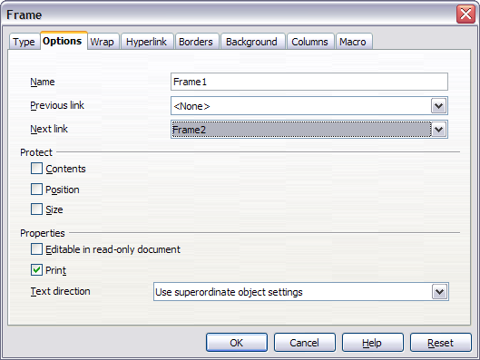

On the Hyperlink page (), you can specify the file for the hyperlink to open. This file can be on your machine, a network, or the Internet.

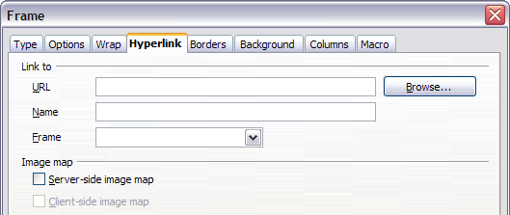

The Wrap, Borders, Background, Columns, and Macro pages of the Frame dialog box are the same as those for frame styles. Refer to the Chapter 7 (Working with Styles) for details.

* 1. Using tables for page layout

Writer’s tables can serve several purposes, such as holding data as you might see it in a spreadsheet, lining up material, and creating more complex page layouts. For information about using tables of data, see Chapter 9 (Working with Tables).

This topic describes how to achieve some common layouts by using tables.

* + 1. Example: Creating sideheads using tables

Sideheads and marginal notes are commonly used in documents from resumes to computer user guides. The main body of the text is offset to leave white space (usually on the left-hand side) in which the sideheads or notes are placed. The first paragraph is aligned beside the sidehead, as in .

|  |  |
| --- | --- |
| Example of a sidehead | In some cases you may want to put only one or two paragraphs in the table itself and the rest of the text and graphics in ordinary paragraphs (formatted to line up with the paragraphs in the table) so that text and graphics will flow more easily from one page to another when you add or delete material.  In other cases, you might put each paragraph in a separate row of the table and allow the table to break between pages. |

Figure 110: Example of a sidehead

|  |  |
| --- | --- |
| Note | Sideheads can also be created by placing text in a frame using the Marginalia frame style, as described in the Chapter 7 (Working with Styles). |

To create a table for use with a sidehead:

1. Place the cursor where you want the table to appear and choose Insert > Table (Ctrl+F12).
2. In the Insert Table dialog box (), define a one-row, two-column table with no border and no heading. Click OK to create the table.

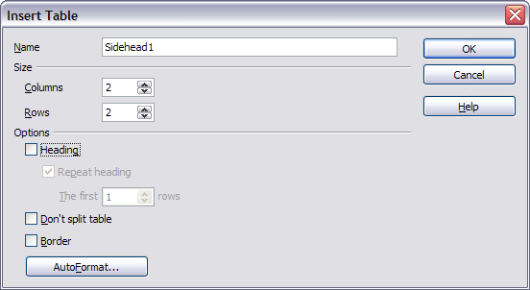

1. Position the cursor over the central dividing line in the table. The cursor turns into a double-headed arrow. Left-click and drag to resize the columns. Alternatively, right-click and choose Table from the pop-up menu; on the Columns page (), make the columns the required width.

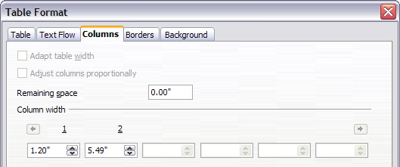

1. On the Table page of the Table Format dialog box (), in the Spacing section, make the Aboveand Belowvalues the same as the Top and Bottom spacing you have defined for ordinary paragraphs of text. Click OK to save your settings.

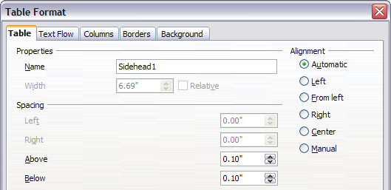

|  |  |
| --- | --- |
| Tip | To check the top and bottom spacing for ordinary paragraphs:  Position the cursor in a paragraph and press F11 (unless the Styles and Formatting window is already open). Check that the Styles and Formatting window shows paragraph styles (top left button).  The current style should be highlighted. If no paragraph style is highlighted, select All Styles in the bottom drop-down list. Right-click on it and select Modify from the pop-up list.  Go to the Indents & Spacing page and look in the Spacing area for the values in Above paragraph and Below paragraph. |

You may also want to turn off number recognition so that Writer will not try to format numbers if you want them to be plain text. To turn number recognition off:

1. Right-click in the table and then click **Number Format**on the pop-up menu.
2. On the Number Format dialog box (), make sure the Categoryis set to **Text**. Click OK.

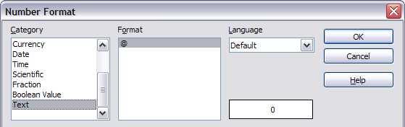

|  |  |
| --- | --- |
| Tip | If you use this table format often, you may want to save it as AutoText, as described in Chapter 3 (Working with Text). Select the table (not just the contents) to assign the shortcut. |

* 1. Using sections for page layout

A section is a block of text that has special attributes and formatting. You can use sections to:

* Write-protect text
* Hide text
* Dynamically insert the contents of another document
* Add columns, margin indents, a background color, or a background graphic to a portion of your document
* Customize the footnotes and endnotes for a portion of your document
  + 1. Creating sections

To create a section:

1. Place the cursor at the point in your document where you want to insert the new section. Or, select the text that you want to place in the new section.
2. From the main menu, choose Insert > Section. The Insert Section dialog box opens.
3. Click the Section tab, if it is not already displayed. (See .)

The Insert Section dialog box has five tabbed pages:

* Use the Sectionpage to set the section’s attributes.
* Use the Columnspage to format the section into columns.
* Use the Indentspage to set indents in the right and left margins of the section.
* Use the Backgroundpage to add color or a graphic to the section’s background.
* Use the Footnotes/Endnotespage to customize the section’s footnotes and endnotes.

At any time, you can reset a tabbed page to its default settings by clicking the Resetbutton. (Note, however, that you cannot reset the Section page. If you wish to undo changes to the Section page, you must do so manually.)

* + 1. Using the Section **page**

Use the Sectionpage () to set the attributes of the current section.

* + - 1. Naming sections

Writer automatically enters a name for the current section in the top box of the New section area. To change the name, select it and type over it. The name is displayed in the Sections category of the Navigator window. If you give your sections meaningful names, you can navigate to them more easily.

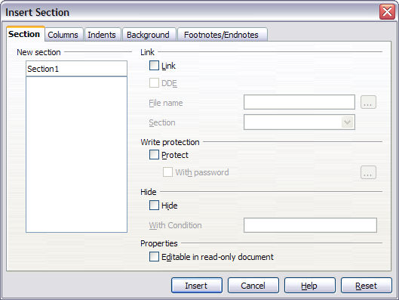

* + - 1. Linking sections

You can insert the contents of another document into the current section and then have Writer update the section whenever the other document is updated. This is called linking the section to the other document.

To link the current section to another document, follow these steps:

1. In the Link area (see ), check the Link check box.

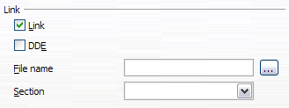

1. Click the (...) button to the right of the File name field. The Insert dialog box opens.
2. Find and select the document you want to insert and then click the Insert button. The Insert dialog box closes and the name of the selected document appears in the File name field.
3. If you want to insert only a section of the selected document, select the desired section from the Section drop-down list.

|  |  |
| --- | --- |
| Note | The section must already exist in the selected document. You cannot create a section in the selected document at this point. |

You can update links automatically or manually. See “” on page .

* + - 1. Write-protecting sections

To write-protect the current section so that its contents cannot be edited, check the Protect check box in the Write protection area ( ).

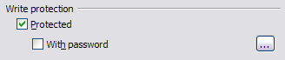

|  |  |
| --- | --- |
| Note | Write-protection protects only the section’s contents, not its attributes or format. |

* + - 1. Password-protecting sections

To prevent others from editing the section’s attributes or format, protect the section with a password, as follows:

1. Check the With password check box. The Enter Password dialog box () opens.
2. Type a password in the Password field and then confirm the password by typing it again in the Confirm field.
3. Click OK. The Enter Password dialog box closes. Anyone who tries to edit the section’s attributes or format will be prompted to enter the password.

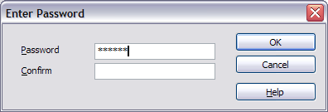

|  |  |
| --- | --- |
| Note | Passwords must contain at least five characters. The OK button remains inactive until you have typed five characters. |

* + - 1. Hiding sections

You can hide the current section so that it will not be displayed on the screen or printed. You can also specify conditions for hiding the section. For example, you can hide the section only from certain users.

|  |  |
| --- | --- |
| Note | You cannot hide a section if it is the only content on the page or if the section is in a header, footer, footnote, endnote, frame, or table cell. |

To hide a section, check the Hide check box in the Hide area ().

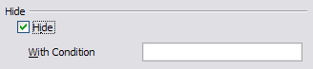

To hide the section only under certain conditions, enter the desired conditions in the With Condition field. The syntax and operators that you use to enter conditions are the same ones that you use to enter formulas. For syntax and a list of operators, see Writer’s online help under “conditions”.

If the section is write-protected with a password, the password must be entered to hide or reveal the text.

|  |  |
| --- | --- |
| Note | Hiding text is not a secure way to stop someone else reading it. It will stop the casual reader but will not prevent someone who actively wants to find out what you have hidden―even if it is password protected. |

* + 1. Using the Columns **page**

Use the Columnspage of the Insert Section dialog box to format the current section into columns. This page is very similar to the Columns dialog box shown in on page . Please refer to that topic for details.

* + 1. Using the Indents **page**

Use the Indentspage, pictured in , to set indents in the right and left margins of the current section. Enter the desired left-margin indent in the Before section box. Enter the desired right-margin indent in the After section box. The preview box on the right-hand side of the page shows you how the section will look with the indents applied.

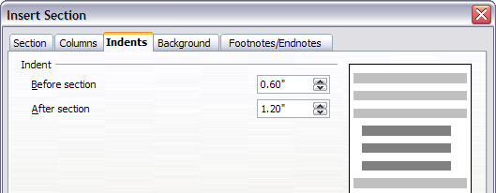

* + 1. Using the Footnotes/Endnotes **page**

Use the Footnotes/Endnotespage, pictured in , to customize the current section’s footnotes and endnotes.

* + - 1. Customizing footnotes

If you want the current section’s footnotes to appear separately from the other footnotes in the document, check the Collect at end of text check box in the Footnotes area.

To number the current section’s footnotes separately from the other footnotes in the document, follow these steps:

1. In the Footnotes area, make sure that the Collect at end of text check box is checked.
2. Check the Restart numbering check box.
3. If you want the section’s footnotes to start at a number other than 1, enter the desired starting number in the Start at spin box.

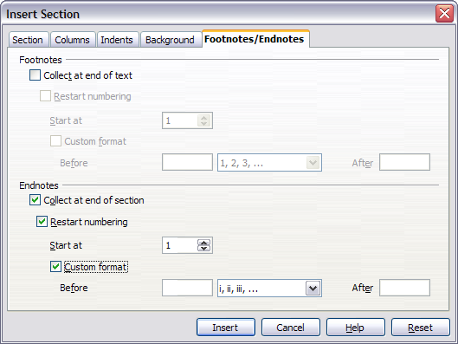

To edit the format of the section’s footnotes, follow these steps:

1. In the Footnotes area, make sure that the Collect at end of text and Restart numbering check boxes are checked.
2. Check the Custom format check box.
3. From the drop-down list under and to the right of the Custom format check box, select a numbering format for the footnotes.
4. To add text to the selected numbering format, use the Before and Afterfields. For example, if you want the footnote numbers to be preceded by the word “Note” and followed by a colon, fill the Before and Afterfields like this:

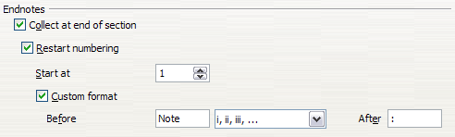

* + - 1. Customizing endnotes

If you want the current section’s endnotes to appear at the end of the section rather than at the end of the document, check the Collect at end of section check box in the Endnotes area.

To number the current section’s endnotes separately from the other endnotes in the document, follow these steps:

1. In the Endnotes area, make sure that the Collect at end of section check box is checked.
2. Check the Restart numbering check box.
3. If you want the section’s endnotes to start at a number other than 1, enter the desired starting number in the Start at spin box.

To edit the format of the section’s endnotes, follow these steps:

1. In the Endnotes area, make sure that the Collect at end of section and Restart numbering check boxes are checked.
2. Check the Custom format check box.
3. From the drop-down list under and to the right of the Custom format check box, select a numbering format for the endnotes.
4. To add text to the selected numbering format, use the Before and Afterfields, as shown above for footnotes ().
   * 1. Using the Background **page**

Use the Backgroundpage to add color or a graphic to the background of the current section. This page is similar to the Background pages for paragraphs, frames, tables, and other objects in OOo. For more information, refer to Chapter 7 (Working with Styles).

* + 1. Saving a new section

To save a new section so that it appears in your document, click the Insertbutton. The Insert Section dialog box closes and the new section appears in your document.

* + 1. Editing and deleting sections

You can edit a section’s attributes and formatting, and you can also delete sections.

* + - 1. Selecting a section

To select the section that you want to edit or delete, follow these steps:

1. From the main menu, choose Format > Sections. The Edit Sections dialog box () opens.
2. The name of the current section appears in the Section area, in the field above the list box. If you want to edit or delete a different section, click the name of the desired section in the list. The selected section becomes the current section, and its name appears in the field above the list box.

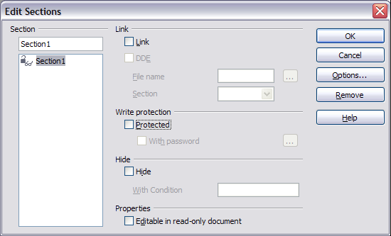

* + - 1. Editing section attributes

To rename the current section, simply type over its name in the Section area.

From the Edit Sections dialog box, you can also edit the current section’s link, write-protect, and hide attributes. To learn how to edit these attributes, see:

“” on page .

“” on page .

“” on page .

* + - 1. Deleting sections

To delete the current section, click the Removebutton.

|  |  |
| --- | --- |
| Note | Writer will not prompt you to confirm the delete! To undo a delete, click the Cancelbutton. |

* + - 1. Editing the format of a section

To edit the format of the current section, click the Options button. The Options dialog box () opens.

The Options dialog box has four tabbed pages: Columns, Indents, Background, and Footnotes/Endnotes. To learn how to use these pages, see:

“” on page .

“” on page .

“” on page .

“” on page .

To reset a page to its most recently saved settings, click the Reset button.

To save your Options settings and return to the Edit Sections dialog box, click OK.

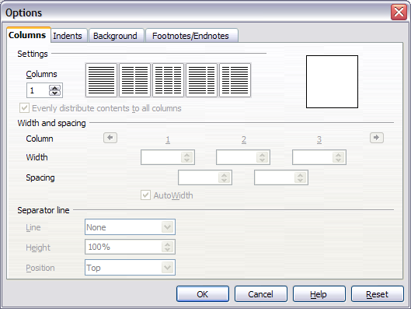

* + 1. Updating links

You can have Writer update linked sections automatically, and you can also update links manually.

* + - 1. Updating links automatically

The default behavior, whenever you open a document that contains links, is for Writer to prompt you to update the links. To have Writer update links without prompting you or to turn off automatic updating, follow these steps:

1. Choose Tools > Options > OpenOffice.org Writer > General. The dialog box displays general text document settings.
2. In the Update area (), under Update links when loading, select one of the following three options:

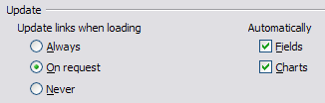

* Select Always if you want Writer to update links automatically, without prompting you, whenever you open a document that contains links.
* Select On request if you want Writer to prompt you before updating links.
* Select Never if you do not want Writer to update links.

1. Click OK to save your settings. The Options dialog box closes.
   * + 1. Updating links manually

To update a link manually:

1. Open the document that contains the link.
2. Choose Edit > Links. The Edit Links dialog box opens. (See .)
3. The list in the Edit Links dialog box displays the names of all the files that are linked to the current document. Click the file that corresponds to the link that you want to update.
4. Click the Update button. The most recently saved contents of the linked file appear in the current document.
5. To close the Edit Links dialog box, click Close.

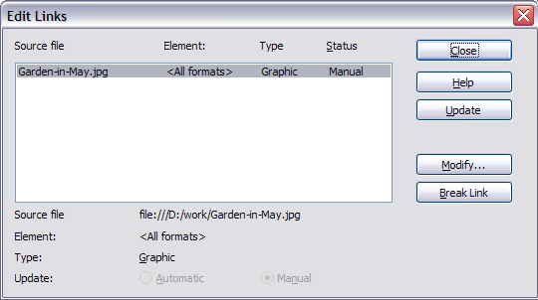

* 1. Creating headers and footers

Headers are portions of a document that always appear at the top of a page; footers appear at the bottom of a page. Typically, headers display the title or chapter name of a document. To insert a header, choose **Insert > Header**.

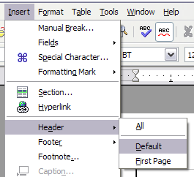

Similarly, to insert a footer, choose **Footer**.

Depending on which option you choose, an area will appear at the top or bottom of the page where you can enter text. This text will appear at the top or bottom of every page.

Items, such as document titles, chapter titles, and page numbers, which often go into headers and footers, are best added as fields. That way, if something changes, the headers and footers are all updated automatically.

Fields are covered in Chapter 14 (Working with Fields), but one example here may be useful. To insert the document title into the header:

1. Select File > Properties > Description, enter a title for your document in the Title area, and click OK to close the dialog box.
2. Add a header (Insert > Header > Default).
3. Place the cursor in the header part of the page.
4. Select Insert > Fields > Title. The title should appear on a gray background (which does not show when printed and can be turned off).
5. To change the title for the whole document, choose File > Properties > Description.
   * 1. Portrait headers on landscape pages

When you define a header and footer on a landscape page, they will be aligned with the long side of the page. If your landscape pages are going to be inserted between portrait pages, you might want the headers and footers to be on the short sides of the landscape pages, so the final printed product looks like the contents of the landscape pages have been rotated 90 degrees on portrait pages.

You can set up portrait headers and footers on landscape pages by using a trick involving frames. These are a bit tedious to set up, but once you have done so, you can copy and paste them to other landscape pages. There does not appear to be a way to make this part of the landscape page style.

To set up portrait headers and footers on landscape pages:

1. Calculate the required margins so the text area of the landscape page is the same size as the text area on the portrait pages, taking into account the space for headers and footers on the portrait pages. For example, this book uses the margins shown in the following table. The landscape right and left margins are 1 cm larger than the portrait top and bottom margins, respectively. This difference accounts for the extra space used by the portrait header and footer (0.5 cm for the height of the header or footer and a 0.5 cm gap between the header or footer and the main text).

|  |  |  |  |
| --- | --- | --- | --- |
| Portrait page (right page) | | Landscape page (right page) | |
| Top margin | 1.5 cm | Right margin | 2.5 cm |
| Bottom margin | 1.5 cm | Left margin | 2.5 cm |
| Left (inner) margin | 2.8 cm | Top margin | 2.8 cm |
| Right (outer) margin | 1.8 cm | Bottom margin | 1.8 cm |

1. Create the landscape page style.
2. Measure the distance from the upper and left edges of the page to the upper left-hand corner of the space where you want the footer to appear. Measure the width and length of the space the footer will occupy (to match footers on portrait pages). See .

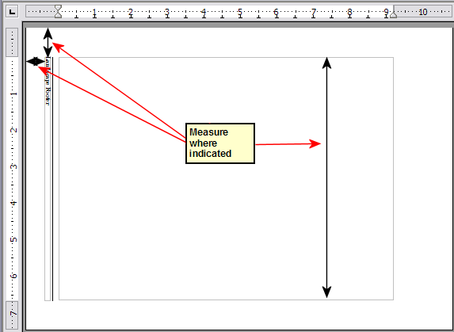

1. In a blank paragraph in the text, type the footer text or insert fields such as the page number or the chapter number and name—to match the footer text and fields on the portrait pages. Assign the Footer style to this paragraph so the typeface, font size, and tab settings match those of the footers on the portrait pages.
2. Select the text (including the fields) you just entered. Choose Format > Character. On the Character dialog box, choose the Positiontab () and set Rotation / Scaling to 270 degrees (counterclockwise). Click OK.

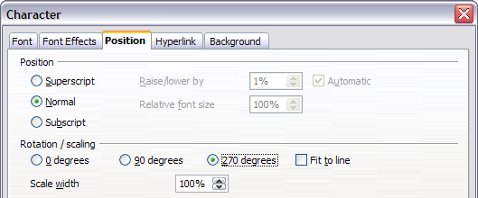

1. With the text still selected, choose Insert > Frame. In the Frame dialog box, choose the Typetab () and enter the width, height, and horizontal and vertical position for the footer.

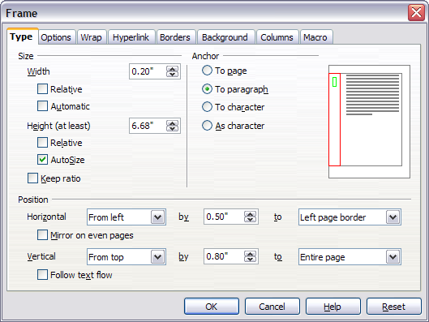

1. If your footer has a line above the text, as in this book, on the Borders page (), select a right border and specify the line width and spacing to the frame’s contents.

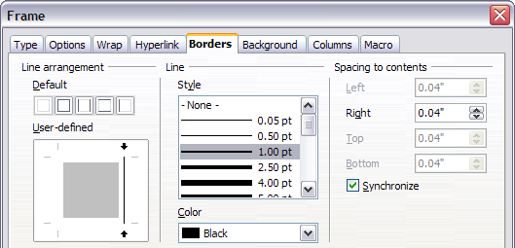

1. Click OK to save these settings. The footer should now appear in the required position and orientation.

Repeat these steps (using appropriate measurements) to set up a portrait header on the landscape page.

* 1. Numbering pages

To automatically number pages:

1. Insert a header or footer, as described in “” on page .
2. Place the cursor in the header or footer where you want the page number to appear and choose Insert > Fields > Page Number.
   * 1. Including the total number of pages

To include the total number of pages (as in page 1 of 12):

1. Type the word page and a space; then insert the page number as above.
2. Press the spacebar once, type the word of and add a space; then choose Insert > Fields > Page Count.

|  |  |
| --- | --- |
| Note | The Page Count field inserts the total number of pages in the document, as shown on the Statistics page of the document’s Properties dialog box (File > Properties). If you restart page numbering anywhere in the document, then the total page count may not be what you want. See “” on page . |

* + 1. Restarting page numbering

Often you will want to restart the page numbering at 1, for example, on the page following a title page or a table of contents. In addition, many documents have the front matter (such as the table of contents) numbered with Roman numerals and the main body of the document numbered in Arabic numerals, starting with 1.

You can restart page numbering in two ways.

Method 1:

1. Place the cursor in the first paragraph of the new page.
2. Choose Format > Paragraph.
3. On the Text Flow page of the Paragraph dialog box ( on page ), check Insert in the Breaks area.
4. In the Type drop-down list, select Page.
5. In the Position drop-down list, select Before or After to position where you want to insert the page break.
6. Check With Page Style and specify the page style to use.
7. Specify the page number to start from and then click OK.

Method 2:

1. Place the cursor in the first paragraph of the new page.
2. Choose Insert > Manual break.
3. Page break is the default selected on the Insert Break dialog box ().

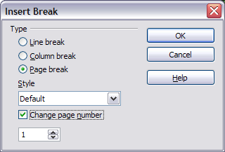

1. Choose the required page in the Style drop-down list.
2. Check Change page number.
3. Specify the page number to start from and then click OK.
   * 1. Changing the format of page numbers

To set the page number to display in Roman numerals, you need to specify the format of numbers in the page style. In the Styles and Formatting dialog (press F11 if not already displayed) select the Page Styles icon and right-click on the highlighted entry for the current style: select Modify... which brings up the Page Style dialog.

On the Page page of the Page Style dialog box, in the Layout settings section (), select i, ii, iii, ... from the Format drop-down list.

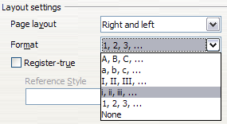

* + 1. Problems with restarting page numbering

Restarting page numbering may lead to two problems.

* The Statistics page in the document’s Properties (File > Properties) always displays the total number of pages in the document, which may not be what you want to appear in the Page Count field.
* When page numbering is restarted, OOo always make sure that an odd-numbered page is a right page and an even-numbered page is a left page. It does this by inserting a blank page, if necessary. Sometimes this blank page is not desired, particularly when creating PDFs or when printing single sided.
  + - 1. Solving the page count problem

Suppose you know exactly how many pages are not to be included in the page count. (You want one page to be excluded in the page count for the following example.)

Instead of inserting a Page Count field, you can do the following:

1. Position the cursor where you want the page count to appear.
2. Press F2 to open the formula bar, just above the horizontal ruler in the main Writer window (see ).
3. After the equal sign, type page –1. If you want to exclude multiple pages, substitute the number of excluded pages for 1 in the formula.
4. Press Enter to close the formula bar and insert the resulting field into the document.

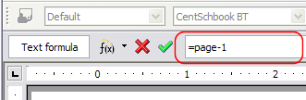

If you do not know the total number of pages in advance, then one approach is to create a set reference on the last page and then insert a cross reference to it. Refer to Chapter 14 (Working with Fields) for more information on setting references and inserting cross references.)

To create a set reference on the last page:

1. Go to the last page (Ctrl+End).
2. Choose Insert > Cross-reference.
3. On the References page of the Fields dialog box (), select Set Reference in the Type column.

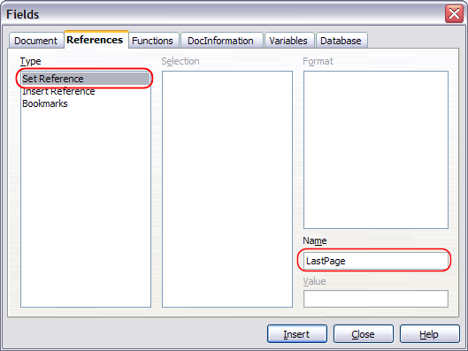

1. In the Name box, enter LastPage.
2. Click Insert. LastPage is now listed in the Selection column.

To insert a cross-reference to the last page in the header or footer where you want to refer to the total number of pages:

1. Position the cursor at the desired location—for example after the space added after of in the header or footer, as in page xx of yy.
2. Choose Insert > Cross-reference.
3. On the References page of the Fields dialog box (), select Insert Reference in the Type column and LastPage in the Selection column. LastPage now appears in the Name box.
4. In the Format column, select As page style. Click Insert.

|  |  |
| --- | --- |
| Notes | Do not delete the reference set at the end of the document. If you do, the cross-reference will not work.  If a field, such as a cross-reference, does not automatically update, select the text containing the field and press F9. |

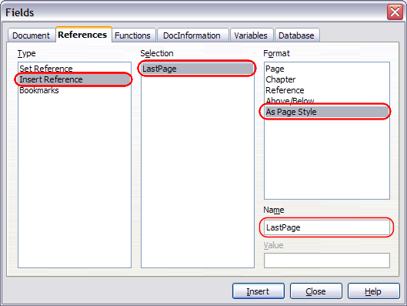

* + 1. Numbering portrait and landscape pages

To create page numbers on portrait and landscape pages in the same place and orientation:

1. Refer to “” on page to create a landscape page style and landscape header or footer styles. When creating the page style, check the Use dynamic spacing check box in the Spacing area in the Header or Footer pages of the Page Style dialog box.
2. Insert the page break and choose the landscape page style; do not change the page numbering.
3. In the relevant header or footer, insert the page number field (Insert > Fields > Page Number).
   * 1. Numbering the first page something other than 1

Sometimes you may want to start a document with a page number greater than 1. For example, you may be writing a book, with each chapter in a separate file. Chapter 1 may start with page 1, but Chapter 2 could begin with page 25 and Chapter 3 with page 51.

Follow these instructions to start the page numbering in a document at a number greater than 1. (These instructions are for a page number in a footer, but you could use a header instead.)

|  |  |
| --- | --- |
| Tip | Do not set a starting page number that is an even number because you will end up with a blank page before the first page when you print the file or export it as a PDF. |

1. Choose **Insert > Footer > [page style]** to activate the footer. (If the page style is already checked in the Footer menu, point to it and click OK in the OpenOffice.org 2.0 dialog box that appears. Then point to that page style again to select it.)
2. The cursor is now in the footer. To insert the page number, choose Insert > Fields > Page Number. The page number will be 1.
3. Click in the first paragraph in the text area or type a paragraph of text.
4. Choose Format > Paragraph (or right-click and choose Paragraph from the pop-up menu) to display the Paragraph dialog box.
5. On the Text Flow page ( on page ), in the Breakssection, select **Insert** and select Page in the Type drop-down list. Select **With Page Style** and the page style you are using for the first page of the document.
6. The Page number field is now active. Type the page number you want to start with. Click OK to close the Paragraph dialog box.
   * 1. Numbering pages by chapter

Technical documents often include the chapter number with the page number in the header or footer. For example, 1-1, 1-2, 1-3, ...; 2-1, 2-2, 2-3, ...

To set up this type of page numbering in OOo, you need to do three things:

1. Ensure that your chapter titles are all identified by the same paragraph style, for example, the Heading1 style.
2. Use Tools > Outline Numbering to tell OOo what paragraph style you are using for Level 1 in your outline, and specify “1,2,3” in the Number box. (See .)

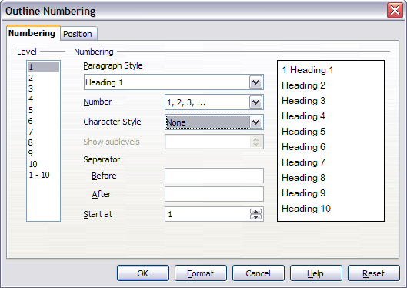

1. Insert the chapter number in your document. To do this:
   1. Place the cursor in the header or footer just before the page number you inserted earlier, and choose Insert > Fields > Other from the menu bar.
   2. On the Fields dialog (), go to the Document page. Select Chapter in the Type list, Chapter number in the Format list, and 1 in the Layer box. Click Insert.
   3. Type a hyphen or other punctuation between the chapter number and the page number.

For more information, see “Choosing paragraph styles for outline levels” and “Including chapter or section information in page headers” in Chapter 7 (Working with Styles).

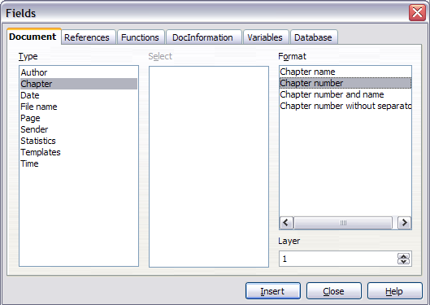



Writer Guide

1. Chapter 5  
    Printing, Faxing, Exporting, and E-mailing
   1. Introduction

General information about printing and faxing documents from OOo is provided in the Getting Started guide. This chapter describes some items of particular interest to users of Writer.

* 1. Quick printing

Click the Print File Directly icon  to send the entire document to the default printer defined for your computer.

|  |  |
| --- | --- |
| Note | (New in OOo 2.3) You can change the action of the Print File Directly icon to send the document to the printer defined for the document instead of the default printer for the computer. Go to Tools > Options > Load/Save > General and select the Load printer settings with the document checkbox. |

* 1. Controlling printing

For more control over printing, use File > Print to display the Print dialog box ().



On the Print dialog box, you can choose:

* Which printer to use (if more than one are installed on your system) and the properties of the printer—for example, orientation (portrait or landscape), which paper tray to use, and what paper size to print on. The properties available depend on the selected printer; consult the printer’s documentation for details.
* What pages to print, how many copies to print, and in what order to print them. Use dashes to specify page ranges and commas or semicolons to separate ranges; for example: 1, 5, 11–14, 34–40. Selection is the highlighted part of a page or pages.
* What items to print. Click the Options button to display the Printer Options dialog box ().
  + 1. Selecting print options for a document

Selections on the Printer Options dialog box () apply to this printing of this document only. To specify default printing options for Writer, see “” on page .

Some items of interest on the Printer Options dialog box include:

* In the Contents section, you might choose not to print graphics or page background in drafts, for example (to save toner or ink).
* In the Pages section, you can choose:
  + Print only left (even-numbered) pages or only right (odd-numbered) pages. These settings are useful when you want to print on both sides of the page, but do not have a printer that handles this automatically.
  + Print in reversed page order.
  + Brochure—the results of this selection are discussed in “” on page .
* In the Notes section, you can choose whether to print any notes that have been added to your document (using Insert > Note), and where to print the notes.

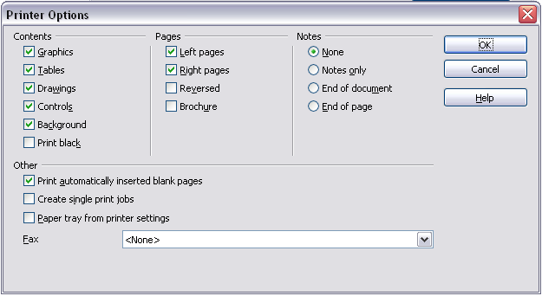

* + 1. Selecting default print options

Selections on the Printer Options dialog box over-ride any default settings. To specify default settings for printing, use Tools > Options > OpenOffice.org Writer > Print. The page displayed contains the same choices as the Printer Options dialog box.

Other printer settings are found in Tools > Options > OpenOffice.org > Print, as shown in . Use this page to specify quality settings for printing, and whether to have OOo warn you if the paper size or orientation of your document does not match the printer settings.

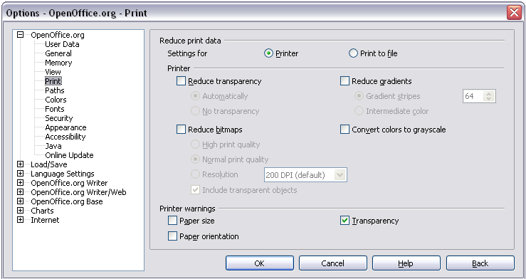

* + 1. Printing in black and white on a color printer

You may wish to print documents in black and white on a color printer, to save expensive color ink or toner. Common uses are for drafts or documents to be photocopied in black and white. Several choices are available.

To print the current document in black and white or grayscale:

1. Click File > Print to open the Print dialog box ().
2. Click Properties to open the properties dialog box for the printer. The available choices vary from one printer to another, but you should find an option for Color. See your printer’s help or user manual for more information.
3. The choices for color may include black and white or grayscale. Choose one of these. Grayscale is best if you have any graphics in the document. Click OK to confirm your choice and return to the Print dialog box, then click OK again to print the document.

To set up OOo to print all color text and graphics as grayscale:

1. Click Tools > Options > OpenOffice.org > Print to display the dialog box shown in .
2. Select the Convert colors to grayscale checkbox. Click OK to save the change.

To set up OOo Writer to print all color text as black, and all graphics as grayscale:

1. Click Tools > Options > OpenOffice.org Writer > Print.
2. Under Contents, select the Print black checkbox. Click OK to save the change.
   * 1. Previewing pages before printing

The normal page view in Writer shows you what each page will look like when printed, but it shows only one page at a time. If you are designing a document to be printed double-sided, you may want to see what facing pages look like. OOo provides a way to do this in Page Preview.

1. Click File > Page Preview, or click the Page Preview button .

The Writer window changes to display the current page and the following page, and shows the Page Preview toolbar () in place of the Formatting toolbar.



1. Click the Book Preview icon  to display left and right pages in their correct orientation.
2. To print the document in this page view, click the Print page view icon  to open the Print dialog box (). Choose your options and click OK to print as usual.
3. To choose margins and other options for the printout, click the Print options page view icon  to display the Print Options dialog box ().

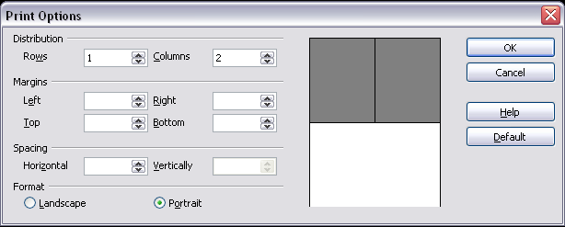

* 1. Printing a brochure

You can print a document with two pages on each side of a sheet of paper, arranged so that when the printed pages are folded in half, the pages are in the correct order to form a booklet or brochure.

To print a brochure on a single-sided printer:

1. Plan your document so it will look good when printed half size (choose appropriate margins, font sizes, and so on). Click File > Print. In the Print dialog box (), click Properties and be sure the printer is set to the same orientation (portrait or landscape) as specified in the page setup for your document. (Usually the orientation does not matter, but it does for brochures.)
2. Click Options. In the Pages section of the Printer Options dialog box (), choose Brochure and Right pages. Click OK twice to print the first side of each page.
3. Flip the pages and put them back into the printer, in the correct orientation to print on the blank side. You may need to experiment a bit to find out what the correct arrangement is for your printer.
4. Click File > Print and check **Properties** to make sure the printer setup is still correct.
5. Click Options again. In the Pages section of the Printer Options dialog box, choose Brochur**e** and Left page. Click OK twice to print the second sides.
6. If your printer can do double-sided, then click on the checkboxes for Left pages, Right pages, and Brochure, and it should not only do those but collate too.
   1. Printing envelopes

Printing envelopes involves two steps: setup and printing.

To set up an envelope to be printed by itself or with your document:

1. Click **Insert > Envelope** from the menu bar.
2. In the Envelope dialog box, start with the Envelope tab (). Verify, add, or edit the information in the Addressee and Sender boxes (the “from” on the envelope).

You can type information directly into the Addressee and Sender boxes, or use the right-hand drop-down lists to select the database or table from which you can draw the envelope information, if desired. See Chapter 11 (Using Mail Merge) for details on how to print envelopes from a database.

1. On the Format page(), verify or edit the positioning of the addressee and the sender information. The preview area on the lower right shows the effect of your positioning choices.

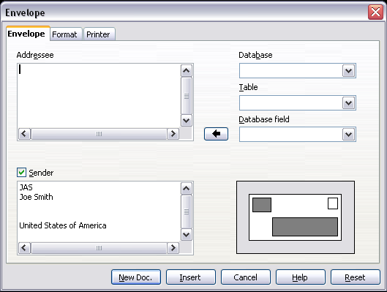

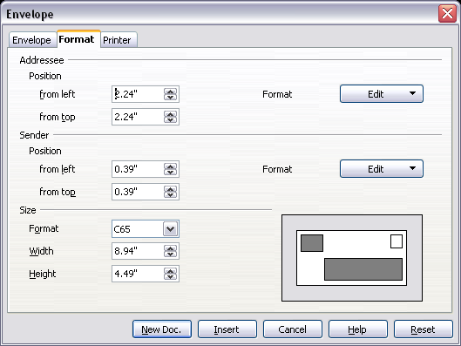

To format the text of these blocks, click the **Edit** buttons to the right. In the drop-down list you have two choices: Character and Paragraph.

* In Character, you can choose Fonts (Sizes...), Fonts Effects (Underlining, Color...), Position (Rotating/scaling...), Hyperlink, Background and more.
* In Paragraph, you can choose Indents & Spacing, Alignment, Text Flow, Tabs, Drop Caps, Borders and Backgrounds.

1. In the lower left of this page, choose the envelope format from the drop-down list. The width and height of the selected envelope then show in the boxes below the selected format. If you chose a pre-existing format, just verify these sizes. If you chose *User defined* in the Format list, then you can edit the sizes.
2. After formatting, go to the Printer page () to choose printer options such as envelope orientation and shifting. You may need to experiment a bit to see what works best for your printer.

You can also choose a different printer or alter printer setup (for example, specify the tray that holds envelopes) for this print job.

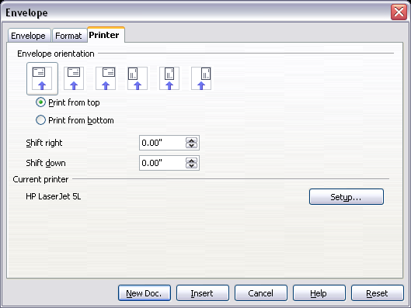

1. When you have finished formatting and are ready to print, click either the New Doc or Insert button to finish. New Doc makes only an envelope or starts a new document with the envelope. Insert inserts the envelope into your existing document as page 1.

To not proceed with this envelope, click Cancel or press the Esc key. You can also click Reset to remove your changes and return to the original settings when the dialog box opened.

When the Envelope dialog box closes, you are returned to your document, which now has the envelope in the same file as the document. Save this file before you do anything else.

To print the envelope:

1. Choose File > Print from the menu bar.
2. On the Print dialog box, under Print range, choose Pages and type 1 in the box. Click OK to print.
   1. Printing labels

Labels are commonly used for printing address lists (where each label shows a different address), but they can also be used for making multiple copies of one label only, for example return-address stickers.

To print labels:

1. Choose **File > New > Labels** on the menu bar. The Labels dialog box opens.
2. On the *Labels* page (), fill in your own label text in the Inscription box, or use the **Database** and Table drop-down lists to choose the required information, as described in Chapter 11 (Using Mail Merge).

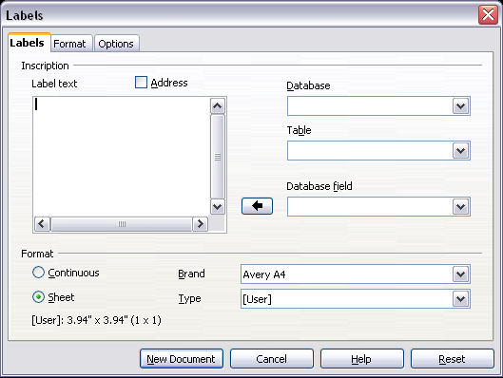

1. Select the label stock in the Brand drop-down list. The types for that brand then appear in the Type drop-down list. Select the size and type of labels required. You can also select User in the Type drop-down list and then make specific selections on the Format page ().
2. On the Format page (), choose the pitch, sizes, margins, columns and rows for user-defined labels, or just verify with a brand of label stock you have loaded into the printer.
3. When you have finished formatting, click **New Document** to make your sheet of labels or click **Cancel** (or press the *Esc* key). You can also click **Reset** to remove your changes and return to the original settings when the dialog box opened.

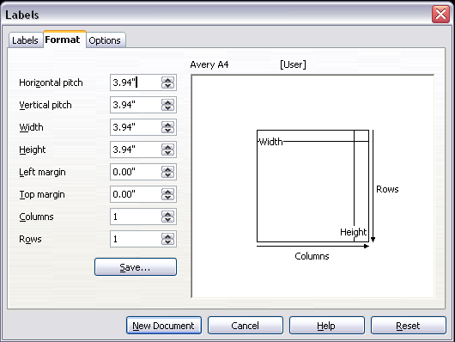

1. Click **Save** to save your new format.
2. On the *Options* page (), choose to print the entire page of labels or one single label, then select which one by the column and row. You can also change printer setup.

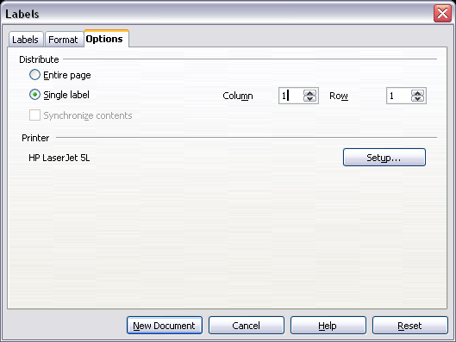

1. You can print right away using the Print File Directly icon on the toolbar or by choosing File > Print from the menu bar, or you can save the file to print later.
   1. Sending a fax

To send a fax directly from OpenOffice.org, you need a fax modem and a fax driver that allows applications to communicate with the fax modem.

* + 1. Sending a fax through the Print dialog box

1. Open the Print dialog box () by choosing File > Print and select the fax driver in the Name list.
2. Click OK to open the dialog box for your fax driver, where you can select the fax recipient.
   * 1. Adding a Fax icon to the toolbar (advanced)

You can configure OpenOffice.org so that a single click on an icon automatically sends the current document as a fax.

1. Be sure the fax driver is installed. Consult the documentation for your fax modem for more information.
2. Choose Tools > Options > OpenOffice.org Writer > Print. The dialog box shown in opens.

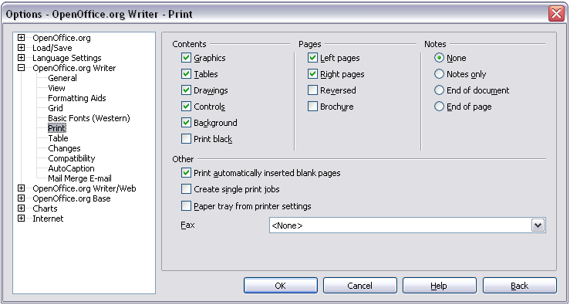

1. Select the fax driver from the Fax list and click OK.
2. Click the arrow icon at the end of the Standard toolbar. In the drop-down menu, choose Customize Toolbar. The Toolbars page of the Customize dialog box appears (). Click Add.

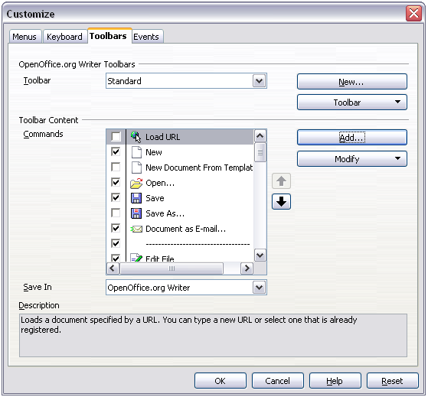

1. On the Add Commands dialog box (), select Documents in the Category list, then select Send Default Fax in the Commands list. Click Add. Now you can see the new icon in the Commands list.
2. In the Commands list, click the up or down arrow button to position the new icon where you want it. Click OK and then click **Close**.

Your toolbar now has a new icon to send the current document as a fax.

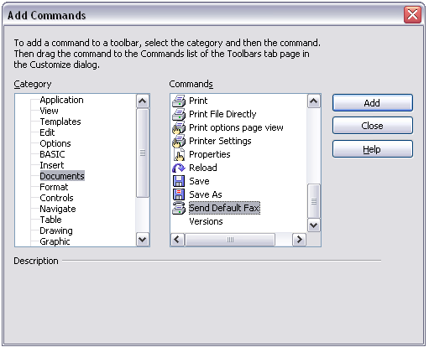

* 1. Exporting to PDF

OpenOffice.org can export documents to PDF (Portable Document Format). This industry-standard file format is ideal for sending the file to someone else to view using Adobe Reader or other PDF viewers.

* + 1. Quick export to PDF

Click the Export Directly as PDF icon  to export the entire document using the default PDF settings. You are asked to enter the file name and location for the PDF file, but you do not get a chance to choose a page range, the image compression, or other options.

* + 1. Controlling PDF content and quality

For more control over the content and quality of the resulting PDF, use File > Export as PDF. The PDF Options dialog box opens. This dialog box has four pages (General, Initial View, User Interface, and Security). Make your selections, and then click **Export**. Then you are asked to enter the location and file name of the PDF to be created, and click Save to export the file.

* + - 1. General page of PDF Options dialog box

On the General page (), you can choose which pages to include in the PDF, the type of compression to use for images (which affects the quality of images in the PDF), and other options.

Range section

* All: Exports the entire document.
* Pages: To export a range of pages, use the format 3-6 (pages 3 to 6). To export single pages, use the format 7;9;11 (pages 7, 9, and 11). You can also export a combination of page ranges and single pages, by using a format like 3-6;8;10;12.
* Selection: Exports whatever material is selected.

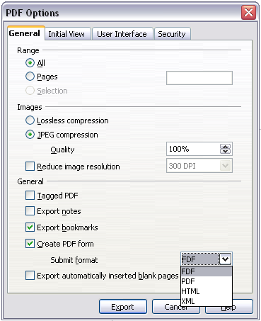

Images section

* **Lossless compression**: Images are stored without any loss of quality. Tends to make large files when used with photographs. Recommended for other images.
* **JPEG compression**: Allows for varying degrees of quality. A setting of 90% tends to work well with photographs (small file size, little perceptible loss).
* **Reduce image resolution**: Lower-DPI (dots per inch) images have lower quality.

|  |  |
| --- | --- |
| Note | EPS images with embedded previews are exported only as previews. EPS images without embedded previews are exported as empty placeholders. |

General section

* **Tagged PDF**: Includes special tags into the corresponding PDF tags. Some tags that are exported are table of contents, hyperlinks, and controls. This option can increase file sizes significantly.
* **Export notes**: Exports notes in Writer and Calc documents as PDF notes. You may not want this!
* **Export bookmarks:** Exports bookmarks.
* Create PDF **form - Submit format:** Choose the format of submitting forms from within the PDF file. This setting overrides the control’s URL property that you set in the document. There is only one common setting valid for the whole PDF document: PDF (sends the whole document), FDF (sends the control contents), HTML, and XML. Most often you will choose the PDF format.
* Export automatically inserted blank pages: If selected, automatically inserted blank pages are exported to the PDF. This is best if you are printing the PDF double-sided. For example, books usually have chapters set to always start on an odd-numbered (right-hand) page. When the previous chapter ends on an odd page, OOo inserts a blank page between the two odd pages. This option controls whether to export that blank page.
  + - 1. Initial View page of PDF Options dialog box

On the Initial View page (), you can choose how the PDF opens by default in a PDF viewer. The selections should be self-explanatory.

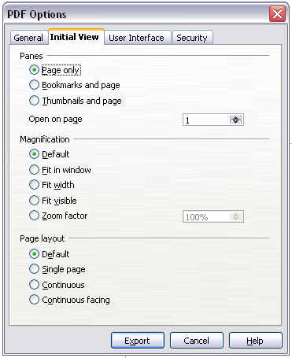

* + - 1. User Interface page of PDF Options dialog box

On the User Interface page (), you can choose more settings to control how a PDF viewer displays the file. Some of these choices are particularly useful when you are creating a PDF to be used as a presentation or a kiosk-type display.

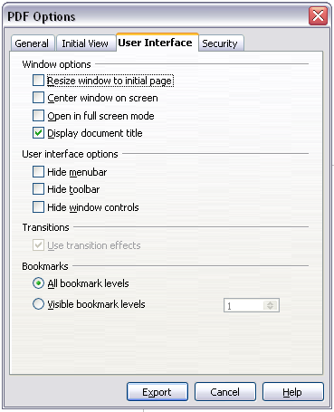

Window options section

* Resize window to initial page. Causes the PDF viewer window to resize to fit the first page of the PDF.
* Center window on screen. Causes the PDF viewer window to be centered on the computer screen.
* Open in full screen mode. Causes the PDF viewer to open full-screen instead of in a smaller window.
* Display document title. Causes the PDF viewer to display the document’s title in the title bar.

User interface options section

* Hide menubar. Causes the PDF viewer to hide the menu bar.
* Hide toolbar. Causes the PDF viewer to hide the toolbar.
* Hide window controls. Causes the PDF viewer to hide other window controls.

Transitions

* **Use Transition effects:** Not available in Writer; in Impress, this option displays slide transition effects as their respective PDF effects.

Bookmarks

* **All bookmark levels**: All bookmarks will be displayed.
* **Visible bookmark levels:** From the drop-down list you choose how many levels of bookmarks to display.
  + - 1. Security page of PDF Options dialog box

FromOOo 2.0.4, PDF export includes options to encrypt the PDF (so it cannot be opened without a password) and apply some digital rights management (DRM) features.

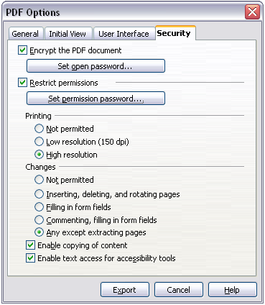

* With an open password set, the PDF can only be opened with the password. Once opened, there are no restrictions on what the user can do with the document (for example, print, copy, or change it).
* With apermissions password set, the PDF can be opened by anyone, but its permissions can be restricted. See .
* With both the *open password* and *permission password* set, the PDF can only be opened with the correct password, and its permissions can be restricted.

|  |  |
| --- | --- |
| Note | Permissions settings are effective only if the user’s PDF viewer respects the settings. |

shows the pop-up dialog box displayed when you click the Set open password button on the Security page of the PDF Options dialog box.

After you set a password for permissions, the other choices on the Security page (shown in ) become available. These selections should be self-explanatory.

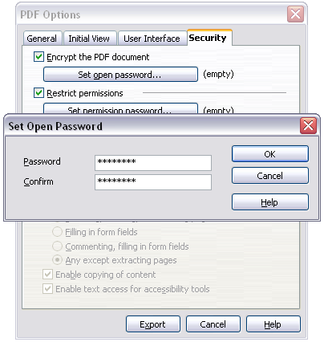

* 1. Exporting to other formats

Writer can export to XHTML (.xhtml), BibTeX (.bib), LaTeX 2e (.tex), and (new in OOo 2.3) MediaWiki (.txt).

To export to one of these formats, choose File > Export. On the Export dialog, specify a file name for the exported document, then select the required format in the File format list and click the Export button.

* 1. E-mailing Writer documents

OOo provides several ways to quickly and easily send a Writer document as an e-mail attachment in one of three formats: .ODT (OpenDocument Text, OOo’s default format), .DOC (Microsoft Word format), or PDF.

To send the current document in .ODT format:

1. Choose File > Send > Document as E-mail. OpenOffice.org opens the e-mail program specified in Tools > Options > Internet > E-mail. The document is attached.
2. In your e-mail program, enter the recipient, subject and any text you want to add, then send the e-mail.

File > Send > E-mail as OpenDocument Text has the same effect.

If you choose E-mail as Microsoft Word, OOo first creates a .DOC file and then opens your e-mail program with the .DOC file attached. Similarly, if you choose E-mail as PDF, OOo first creates a PDF using your default PDF settings (as when using the Export Directly as PDF toolbar button) and then opens your email program with the .PDF file attached.

* + - 1. E-mailing a document to several recipients

To e-mail a document to several recipients, you can use the features in your e-mail program or you can use OOo’s mail merge facilities to extract email addresses from an address book.

You can use OOo’s mail merge to send e-mail in two ways:

* Use the Mail Merge Wizard to create the document and send it. See Chapter 11 (Using Mail Merge) for details.
* Create the document in Writer without using the Wizard, then use the Wizard to send it. This method is described here.

To use the Mail Merge Wizard to send a Writer document:

1. Click Tools > Mail Merge Wizard. On the first page of the wizard (), select Use the current document and click Next.

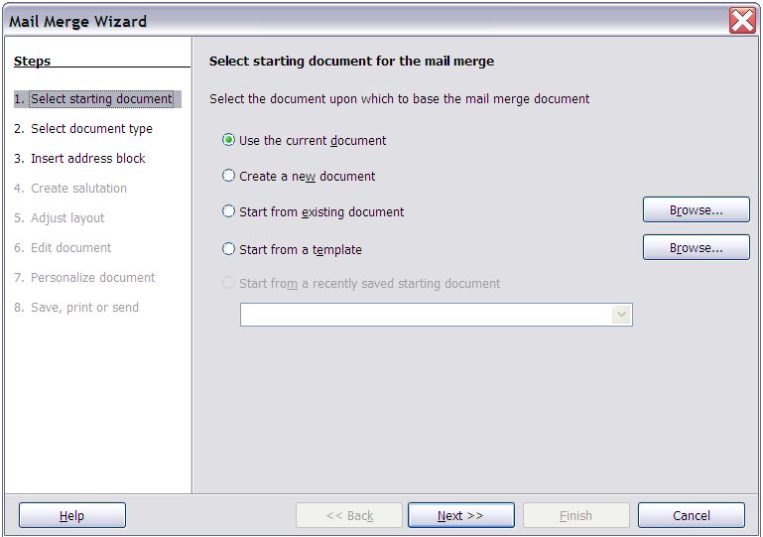

1. On the next page (), select E-mail message and click Next.

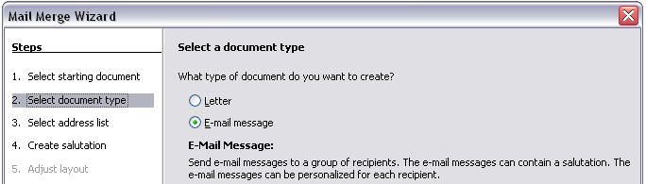

1. On the next page (), click the Select Address List button. Select the required address list (even if only one is shown) and then click OK. (If the address list you need is not shown here, you can click Add to find and add it to the list.)

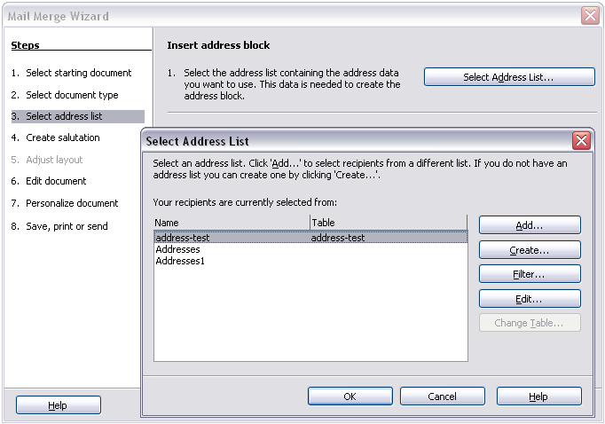

1. Back on the Select address list page, click Next. On the Create salutation page (), deselect the checkbox by This document should contain a salutation.

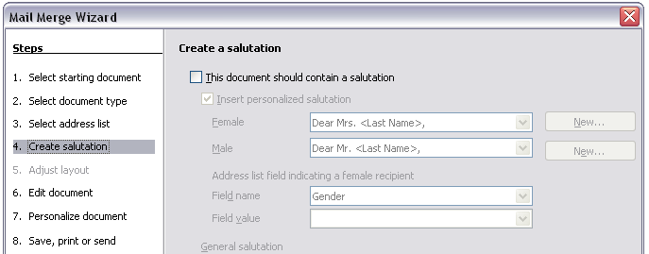

1. In the left-hand list, click 8 Save, print or send. OOo displays a “Creating documents” message and then displays the Save, print or send page of the Wizard.
2. Select Send merged document as E-Mail. The lower part of the page changes to show e-mail settings choices (see ).
3. Type a subject for your email and click Send documents. OOo sends the e-mails.

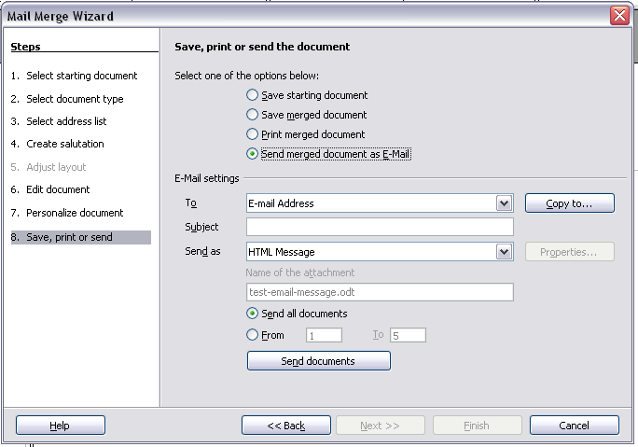

* 1. Digital signing of documents

To sign a document digitally, you need a personal key, the certificate. A personal key is stored on your computer as a combination of a private key, which must be kept secret, and a public key, which you add to your documents when you sign them. You can get a certificate from a certification authority, which may be a private company or a governmental institution.

When you apply a digital signature to a document, a kind of checksum is computed from the document’s content plus your personal key. The checksum and your public key are stored together with the document.

When someone later opens the document on any computer with a recent version of OpenOffice.org, the program will compute the checksum again and compare it with the stored checksum. If both are the same, the program will signal that you see the original, unchanged document. In addition, the program can show you the public key information from the certificate. You can compare the public key with the public key that is published on the web site of the certificate authority.

Whenever someone changes something in the document, this change breaks the digital signature.

On Windows operating systems, the Windows features of validating a signature are used. On Solaris and Linux systems, files that are supplied by Thunderbird, Mozilla or Firefox are used. For a more detailed description of how to get and manage a certificate, and signature validation, see “Using Digital Signatures” in the OOo Help.

To sign a document:

1. Choose File > Digital Signatures.
2. If you have not saved the document since the last change, a message box appears. Click Yes to save the file.
3. After saving, you see the Digital Signatures dialog box. Click Add to add a public key to the document.
4. In the Select Certificate dialog box, select your certificate and click OK.
5. You see again the Digital Signatures dialog box, where you can add more certificates if you want. Click OK to add the public key to the saved file.

A signed document shows an icon  in the status bar. You can double-click the icon to view the certificate.



Writer Guide

1. Chapter 6  
    Introduction to Styles

Paragraph, Page, Character, and List Styles

* 1. Introduction
     1. What are styles?

Most people are used to writing documents according to physical attributes. For example, you might specify the font family, font size, and weight (for example: Helvetica 12pt, bold).

Styles are *logical* attributes. We use styles every day. For example, there are two styles of personal computer: desktop and laptop. Each has its own distinctive set of properties. You never say “my computer is a low-weight, one-piece unit with an LCD screen attached to a rectangular casing containing the computing components and the keyboard”. Instead, you could say that you have a laptop.

OpenOffice.org (OOo) styles are a way to do the same thing for your document. Using styles means that you could stop saying—font size 14pt, Times New Roman, bold, centered—and, instead, you could start saying “title” for describing that particular font usage. In other words, styles means that you shift the emphasis from what the text looks like to what the text *is*.

* + 1. Why use styles?

OOo brings a powerful notion of styles. Styles help improve consistency in a document. They also make major formatting changes easy. For example, you may decide to change the indentation of all paragraphs or change the font of all titles. For a long document, this simple task can be prohibitive. Styles make the task easy.

* + 1. Types of styles

OpenOffice.org Writer has five types of styles:

* Paragraph styles affect entire paragraphs represented with those styles.
* Character styles affect a block of text inside a paragraph.
* Page styles affect page formatting (page size, margin, and the like).
* Frame styles affect frames and graphics.
* List styles affect outlines, numbered lists, and bulleted lists.

The first three styles are the most commonly used. These and one type of list style are covered in this chapter. Frame styles and more complex list styles are discussed in Chapter 7 (Working with Styles).

* + 1. Styles and Formatting window

These styles are available through a floating or dockable window called Styles and Formatting, shown in . (Press F11 to see it.) The use of the Styles and Formatting window is discussed in the next section.

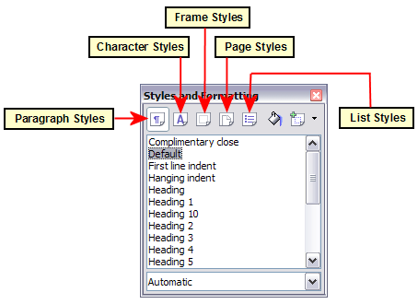

The default form for Styles and Formatting is a floating window. You can drag it around the screen using the mouse, or you can dock it to the left or right side of the main Writer window.

* 1. Using paragraph styles
     1. First steps

The concept of styles and how to use the Styles and Formatting window is best explained through an example.

1. Create a new document (choose File > New > Text Documentor press Control+N).
2. Type the words **First heading** in the new document, but do not press Enter so that the cursor remains in the same line where you entered the first-level subhead—First heading.
3. Click the **Styles and Formatting** icon  located on the Formatting Bar or press the F11 key. This opens the Styles and Formatting window ().
4. Make sure the window is showing the Paragraph Styles section (click on the top-left icon of the Styles and Formatting window ).

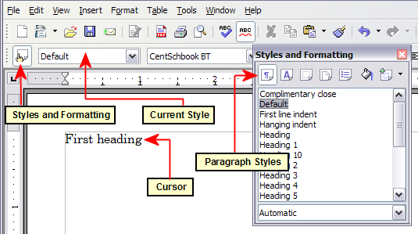

Double-click the Heading 1 entry of Styles and Formatting. This will do two things:

* Give the line (actually, its entire paragraph) you typed the Heading 1 style.
* Add Heading 1 to the Apply Stylelist and display it as the current style.

The Apply Style list is illustrated in . It provides direct access to the styles that are currently in use in the document.

* + 1. Using the Apply Style list

The Apply Style drop-down list, located next to the Styles and Formatting icon on the Formatting toolbar, shows the paragraph styles that are currently in use in the document. You can select styles from this list, just as you can from the Styles and Formatting window.

As an exercise, press Ente*r* in order to start a new paragraph, type some text, and select **Heading 1**in the **Apply Styles** list. The text acquires the properties of the **Heading 1** style. If the paragraph style you want is not in the **Apply Style** list, select **More** in order to bring up the Styles and Formatting window.

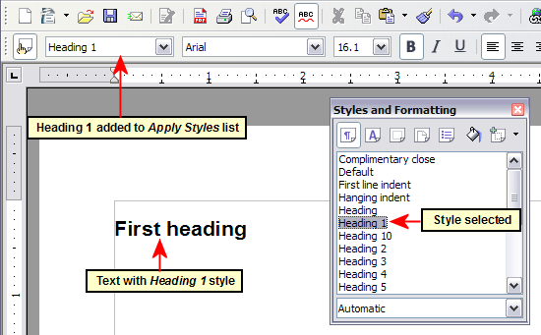

* + 1. Modifying paragraph styles

The power of styles lies in the ability to modify them to suit your needs.

For the next example, we will need three lines of text with three OOo-supplied paragraph styles: Heading 1, Heading 2, and Heading 3. These paragraph styles could be used in formatting headings in the framework for a document that will be “fleshed out” afterwards.

Open a new text document for this exercise and type Title on the first line, press the Paragraph Styles icon on the Styles and Formatting window, and double-click Heading 1 in the drop-down list. Repeat this procedure for the other entries of , using the proper paragraph style for each. The Heading 1 style should be applied to the “paragraph” containing the word “Title”, Heading 2 to “*Subtitle 1*”, and so on.

Your document should resemble .

|  |  |
| --- | --- |
| Note | Heading 1 uses a bold font typeface (with a 115% percentage size), Heading 2 uses a 14pt bold italic typeface, and Heading 3 uses a 14pt bold typeface. |

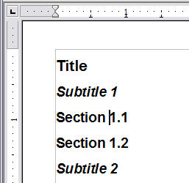

So far, you have introduced some basic formatting to your document, using the predefined default paragraph styles. Suppose you decide to add the following formatting changes to these styles:

* Heading 1should be centred
* Heading 3 should be indented.
  + - 1. Centre Heading 1

On the Styles and Formatting window, select the Paragraph Styles icon  (if it is not already chosen), right-click on Heading 1, and choose Modify (as shown in ).

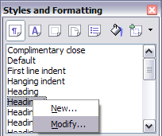

After the Paragraph Style window opens, choose the Alignment tab, select Center (as shown in ), and click OK.

Now, every paragraph marked as Heading 1 will be centered (as shown in ). If you make another Heading 1 entry, it will be centered as well.

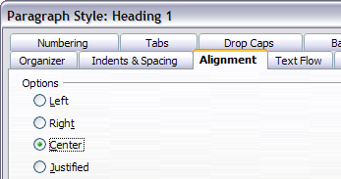

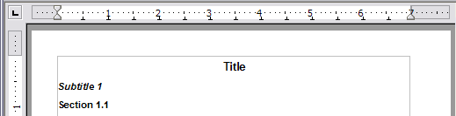

* + - 1. Indent Heading 3

On the Styles and Formatting window, right-click on the Heading 3 paragraph style and choose Modify (as before). After the Paragraph Style window opens, follow the steps below:

1. Click the Indents & Spacing tab.
2. Under the Indent section, set the indentation before the text to 0.60 in, as shown in . Your display might be different, depending upon what measurement unit was set in the options (Tools > OOo Writer > General > Settings). The inch is the basic typographic unit used in this chapter; writers and editors would probably use the more precise pica or point units.

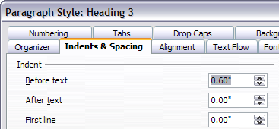

The result should resemble .

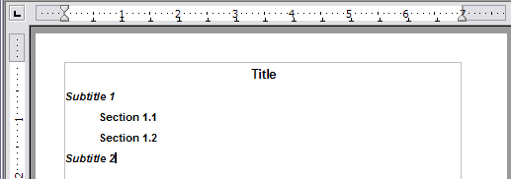

* + 1. Linked styles

Some OOo styles are linked together. This means that a change in one style affects every style linked to to it. For example, every Heading style (such as Heading 1, Heading 2) is linked with a style called Heading. This relationship is illustrated in .

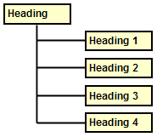

As an example, suppose you want to change the font of not only Heading 1 or Heading 2, but all headings. The easiest way to do that is to take advantage of this *linking*. Open the Styles and Formatting window (press *F11*) and select **Heading** (see ).

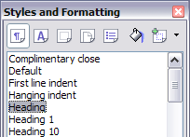

Open the Paragraph Style dialog box for the Heading style (right-click > Modify) and select the Font tab. Select a font and click OK (see ).

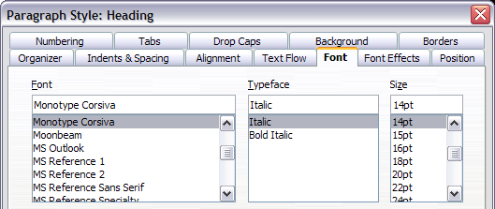

Now, the fonts of all the heading styles (Heading 1 through Heading 10) have been changed in a single operation. Your document should now resemble .

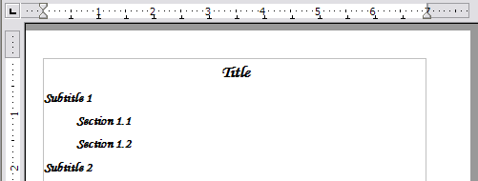

* 1. Creating custom styles

You have seen that the Styles and Formatting window provides several predefined styles, such as Heading 1 and Text body. But what if you need something different, like a poem style, that is not in Styles and Formatting? With OOo, you can make your own styles to suit your needs.

In this section, we will create a Poem paragraph style, and a Poem Header paragraph style, with the following properties:

* Poem: Centred, with font-size 10pt.
* PoemHeading: Centred, bold, with font-size 12pt.

In addition, a PoemHeading style is to be followed by a Poem style. In other words, when you press Enter, the next paragraph style in the document changes to Poem.

|  |  |
| --- | --- |
| Note | The keen reader may have noticed this behavior already. After you type a heading and press Enter, the next style switches to Text body. |

* + 1. Creating the Poem paragraph style

Our next example uses the *Poem* style. We use the *Default* style as a starting point.

1. Click the Styles and Formatting icon  or press F11.
2. Click the Paragraph Styles icon .
3. Right-click Default and choose New (see Figure ).

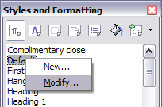

This opens the Paragraph Style dialog box, with the Organizer tab selected. To create a custom style, you have to understand and configure the top three entries.

|  |  |
| --- | --- |
| Style fields | Description |
| Name | This is the name of the style itself, like Heading 1 or Text body.  Set (type in the text box) the name to Poem. |
| Next Style | This is the default style that follows the Poem style. When you press Enter while typing text in the Poem style, this style is used.  Set this value to Poem. When you press Enter, the text will remain in the Poem style. |
| Linked with | If the Poem style is linked with another, say Default, then any change in Default will affect Poem, just as you saw with Heading in the previous section.  For our example, this is not the behaviour we want. Set this entry to  – None –. This means that *Poem* is not linked with any other style. |

After making these changes, your screen should look like Figure .

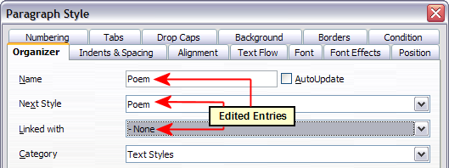

The next step is to configure the alignment and font properties of this style.

* On the Alignment page, select the Centre option.
* On the Font page, select 12ptfont-size.

Click **OK** to save the new Poem style.

Congratulations! You just made your very own style.

* + 1. Creating the PoemHeading style

Create a new PoemHeading style. Use the same procedure as before, with these changes:

* Next Style: Select Poem, not PoemHeading.
* Linked with: Heading.

The window should look like .

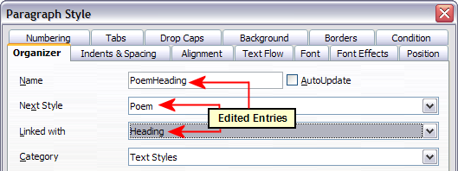

Now set the settings of the new style:

1. On the Alignment page, select Centre
2. On the Font page, choose Bold and size 14pt.

Click **OK** to save the new PoemHeading style.

* + 1. Sample poem

It is a good idea to test out your new styles and see if you are happy with them. Your poem should look similar to the one in Figure .

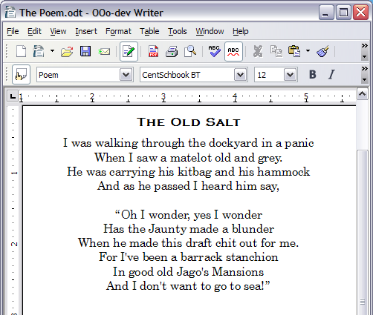

* + 1. Changing the formatting of your styles

One of the main advantages of styles is that they allow the document formatting to be changed after the content has been written. For example, suppose you have written a 100-page book of poetry. Then you decide you don’t like the way the poems look after all. Or, perhaps, your publisher doesn’t like it.

To learn about reconfiguring styles, we will make the following changes:

* The Poem style will be indented instead of centred
* Add a PoemAuthor paragraph style based on Poem, except it is bold and has more indentation.
  + - 1. Indent Poem and PoemHeading

First, set the Poem style to left alignment:

1. In the Styles and Formatting window, select Poem and right-click and select Modify.
2. On the Alignment page, select Left.

Set the indentation:

1. Click the Indents & Spacing tab.
2. Under Indent, set the indentation before the text to 2in.

Done! Click OK, and you should see the text change. Do the same thing for *PoemHeading*.

* + - 1. Create PoemAuthor style

The purpose of this style is to set apart the name of the author from the rest of the poem. You already know how to create a new style. Follow the same procedure as before (starting from the Poem style). Use the following configuration:

* Name: PoemAuthor
* Next style: Default
* Linked with: Poem

Now, configure PoemAuthor just as you configured Poem, with the following changes:

* Font: Bold
* On the Indents & Spacing page:
* Under Indent, set the Before text field to3.2 in.
* Under Spacing, set the spacing above the paragraph to 0.2 in. This adds extra space between the poem and the name of the author.

Figure shows how the Indents & Spacing page should look at this point. Click OK to save the style. Now set the author of the poem (in the example, Anon) to the newly created PoemAuthor style, as described in “” on page .

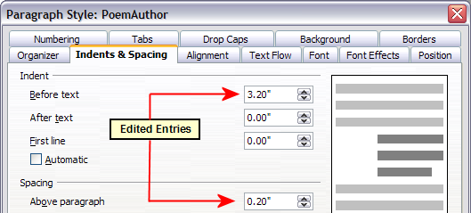

* + - 1. Final result

After all these changes, the poem should look similar to Figure .

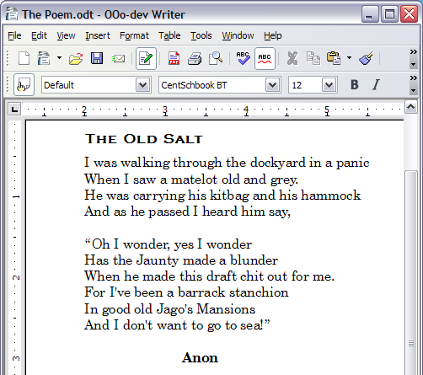

* 1. Using page styles

Page styles are to pages what paragraph styles are to paragraphs. Just as paragraph styles can define paragraph properties (font size, colour, and others), page styles can define page properties (margins, page size, header and footers, and others). However, unlike paragraphs, which can have directly applied properties, pages only have a page style and no directly applied properties.

* + 1. What page style does a page have?

The page style for the current page is displayed on the status bar ().

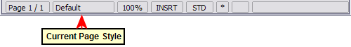

* + 1. Modifying a page style

Open the Styles and Formatting window and click the Page Styles button .

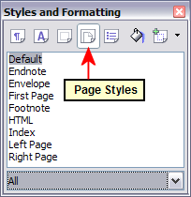

Right-click the currently active page style () and select Modify. The resulting window is shown in .

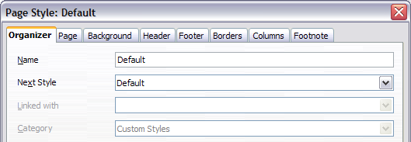

* + 1. Mirrored margins for facing pages

You can set up “mirrored” margins for facing pages within one page style. More complex differences between right and left pages may require separate page styles; these are discussed in Chapter 4 (Formatting Pages).

To set up “mirrored” facing pages, go to the Page page of the Page Style dialog box (). Choose Mirroredfor Page layout in the Layout settings section and set the inner and outer margins in the Margins section.

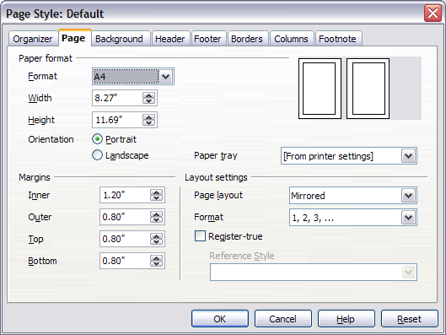

* + 1. The Next Style property

You have seen the Next Style property in the context of paragraph styles. This property is especially powerful in page styles.

* + - 1. Setting up a title page

Consider a common scenario: you want the document to have a title page that is different from the rest of the document:

* It should not have a header or page number.
* The left and right margins should be the same.

For the title page, we can use the First Page page style that comes with OOo, and for the rest of the document, we can use the Default page style.

shows the required flow of page styles. On the Organizer page of the Default page style, leave the Next Style property set to Default. On the Organizer page of the First Page style, make sure that the Next Style property is set to Default.

See “” on page for instructions on setting up the page header.

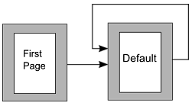

* + 1. Manual page breaks

The Next Style property is enough for projects with straightforward pagination requirements (for example, reports, letterheads, and small books). But more complex projects require more control over page styles. Manual page breaks provide this control.

The idea is simple: you break a sequence of page styles and start a new sequence. To insert a page break, choose Insert > Manual Break and choose Page break. This section illustrates two scenarios where page breaks are useful.

* + - 1. Example: Chapters

You are writing a book that is divided into chapters. Each chapter starts with a page style called New Chapter. The following pages use the Default page style. At the end of the chapter, we return to New Chapter for the next chapter.

OOo doesn’t have a New Chapter style, so you must create a custom style (see page ). Suppose that you already have the page styles with the following properties:

|  |  |
| --- | --- |
| Page style | Next Style |
| New Chapter | Default |
| Default | Default |

This can be seen in the flowchart in , but where the New Chapter style replaces the First Page style.

At some point, you will want to start a new chapter. Follow these steps:

1. Put the cursor at the end of the chapter, on a blank line of its own.
2. Choose Insert > Manual Break. The Insert Break dialog box () appears.
3. Under Type, choose Page break and under Style, select New Chapter.

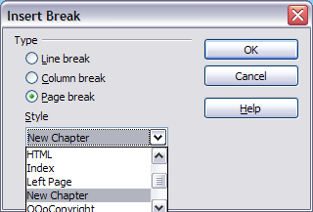

illustrates the flow of page styles when using page breaks.

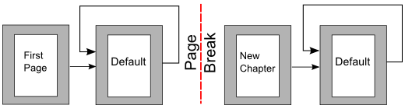

* + - 1. Example: Inserting a page with special formatting

Sometimes you may need to insert a page with special formatting. For example, a landscape page or a page with more columns. This can also be done with page breaks. Suppose that the current page has the Default page style.

1. Choose Insert > Manual Break.
2. Select the page style (say, Special Page, which was previously created) in the Insert Break dialog box.
3. Fill in the contents for this page. Then insert another page break.
4. Then select Default again. The pagination continues on as normal, except that one page has been replaced by a different page style.

This concept is illustrated in Figure .

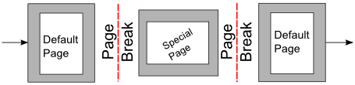

* 1. Page numbering

Many people first encounter page styles when they want to number pages. OOo has a powerful system for numbering pages.

* + 1. Preliminaries: fields

OOo uses a feature called fields to manage page numbers. To insert a page number field, position the cursor where you want to insert the number and choose Insert > Fields > Page Number. The page number appears with a grey background.

|  |  |
| --- | --- |
| Note | The grey background is simply there to denote a field. This background is not printed. Choose View > Field Shadings (or press Ctrl+F8) to toggle this feature on or off. |

If you have seen lists in OOo, you might have noticed this grey background; OOo lists use fields. The page number field always displays the page number for the current page. If you see the words “Page number” instead of a number, press Ctrl+F9. This shortcut key toggles OOo between displaying the field’s contents (what the field is used for) and the field’s results (what the field creates).

|  |  |
| --- | --- |
| Note | For a full introduction to fields, see Chapter 14 (Working with Fields). |

* + 1. Inserting a header

What’s so special about headers? The same text in the header appears on all pages with that page style. (You can experience this yourself by entering some text into the header.) This property of headers (or footers), along with fields, forms the basis of OOo page numbering.

In OOo, headers are specified by page styles.

1. Open the Page Style dialog box for the desired page style (right-click > **Modify**).
2. Select the Header tab.
3. Under Header, check Header on and click OK (see ).

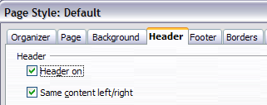

At this point you should see the header on the current page. In , the header area is identified, purely for illustrative purposes. It would normally be empty immediately after being turned on, until you insert your own header text and formatting.

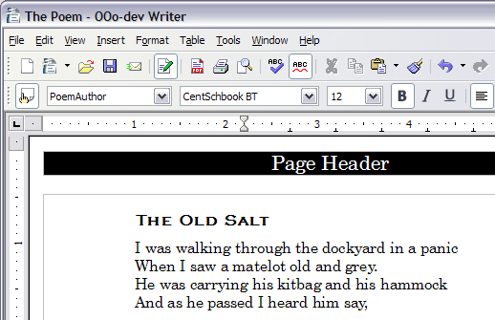

|  |  |
| --- | --- |
| Tip | You can also add a header through the Insert menu: Insert > Header > [page style]. Likewise, for footers: Insert > Footer > [page style]. |

|  |  |
| --- | --- |
| Caution | The Insert menu can also be used for deleting a pre-existing header or footer for a page style. If that page style has a check mark in front of it, pointing to it will open an OOo dialog box warning about this and asking whether you want to delete the header or footer for that particular page style. |

* + 1. Simple page numbering

The simplest case is to have the page number at the top of every page and nothing more. To do this, put the cursor on the header and select Insert > Fields > Page Number ().

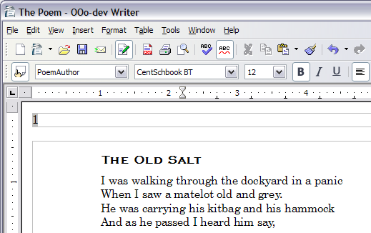

Now the correct page number appears on every page.

* + 1. More complex variations

There are a lot of interesting variations that you can apply without further knowledge of page styles. Here are some suggestions:

* Right-align the header to make the page number appear on the top-right:
  + Place the cursor in the header.
  + Click the Align Right icon (or right-click anywhere in the header and select Alignment > Right).
* Add (type) the word page so the header reads page 1, page 2, and so on. This also requires using the Page Number field, discussed earlier (page ).
* Add the document title so the header reads, for example: **Peter’s f**avourite poems, left justified, and page x with right justification, where x is the value of the Page Number field. Consider using a tab to separate the title from the page number or, better still, use a table to achieve separation of header elements.
* OOo also has a Page Count field (Insert > Fields > Page Count). Using it, you could, for example, have a header that reads page 1 of 4.

These variations are all illustrated in .

Many more variations are possible. For example, you can use a footer instead of a header to make the page number appear at the bottom of the page. You can also include the chapter number with the page number: see “Numbering pages by chapter” in Chapter 4 (Formatting Pages).

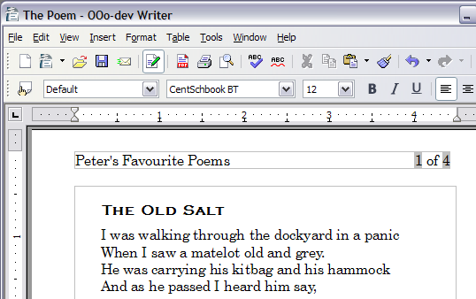

* + - 1. Example: Restart page numbering—a preface

Some times you want to reset the page number back to 1. A typical example is the preface for a book. A standard preface has the following properties:

* Page numbers are displayed in Roman numerals (i, ii, iii, iv, …).
* After the preface ends, the document starts on a Default page.
* The page number resets to 1, and the number format becomes Arabic (1, 2, 3, 4, …).

Resetting the page number requires page breaks.

First, let’s get the preliminary work done for the Preface style:

1. Create a new page style and name it Preface.
2. Set its Next Style to Preface because a preface could span multiple pages.
3. Add a header to Preface and insert the Page Number field. Make the page numbers display as lower-case Roman numerals (i, ii, iii, iv, …):
   1. Open the page style window for Preface (if not already open) and click the Header tab. Check Header on under Header.
   2. Click the Page tab. Under Layout settings, in the Format drop-down list, set the format to i, ii, iii, …. (See the bottom right of .) Click OK to close the dialog box.

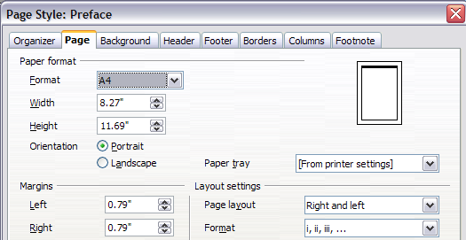

After the preface is written, we are ready to restart the page numbering in the main body of the document to Arabic numerals. Follow these steps:

1. Make an empty paragraph at the very end of the preface.
2. Put the cursor on the blank line.
3. Choose Insert > Manual Break.
4. Select Page break and choose the Default style.
5. Select the Change page numbercheck box and set the new value to 1. Click OK to close the dialog box.

These settings are shown in .

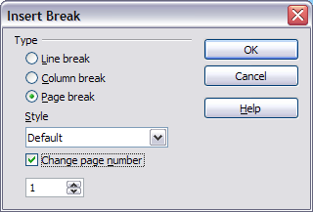

|  |  |
| --- | --- |
| Note | You cannot assign an odd page number to a left page or an even page number to a right page. OOo strongly adheres to the convention that odd page numbers go on right-hand pages and even page numbers on left-hand pages. |

This change is also reflected on the status bar. The Page section of the status bar now includes the entry from the page number field (1), the absolute page number relative to the document’s beginning (3) and the document’s total page count (5) ().

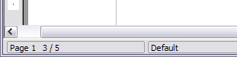

* + - 1. Example: Different headers on right and left pages

When you insert a header on a page style set up for mirrored pages or right-and-left pages, you can have the contents of the header be the same on all pages or be different on the right and left pages.

To allow different content in headers, clear the Same content left/right check box in the Header area on the Header page of the Page Style dialog box ().

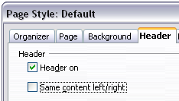

Now, you can put the page number on the left-hand edge of the left pages and on the right-hand edge of the right pages, put the document title on the right-hand page only, or make other changes. shows an example.

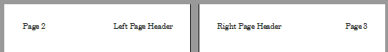

* 1. Using character styles

Character styles are a complement to paragraph styles. Like paragraph styles, they define text properties (font, weight, size), but they usually are applied to blocks of text smaller than a paragraph. For example, you can use the Emphasis character style to emphasize a word. A couple of character styles used in this document include:

* Key strokes use the custom OOoKeyStroke style. For example:

to set OOo to full screen, press Control+Shift+J.

* Menu paths use the custom OOoMenuPath style. For example:

to turn field shadings on or off, choose View > Field Shadings.

* + 1. Why use character styles?

Beginning OOo users often wonder, “Why use character styles?” or “How is this different from pressing the bold icon to change the font typeface?” The following real-life event illustrates the difference.

Character styles do not have as many options as paragraph styles or page styles. Their benefits are of a different nature:

* Formatting changes  
  As Jean’s story illustrates, the ability to make formatting changes throughout a document can be important. Character styles provide this.
* Consistency  
  Character styles help ensure that typesetting guidelines are applied consistently.
* Focus on content  
  “Was I supposed to bold keystrokes? How about menus?”  
  A writer shouldn’t have to remember the answers to these questions. Typesetting details distract you from the real content of your work. A properly named custom character style (such as OOoKeyStroke or OOoMenuPath) will remove this burden from you.

Other ways of using character styles are described elsewhere in the Writer Guide. These uses include making chapter numbers, page numbers, or list numbers larger than the surrounding text and formatting hyperlinks. When inserting words in different language or words you do not want the spell checker to detect as mistakes (for example programming code), character styles result quite useful since it is possible to define in the character style properties the language to be applied.

* + 1. Applying character styles

Open the Styles and Formatting window (press F11) and click the second button in the top bar . The list of available character styles is displayed. To apply a character style, follow these steps:

1. Select the block of text where you wish to apply the style.
2. Double-click the appropriate character style in the Styles and Formatting window.

Some examples include:

|  |  |
| --- | --- |
| Note | One difference between character styles and paragraph styles is the need for selecting text (highlighting). Character styles require you to select the text you want to apply them to; paragraph styles do not. |

* + - 1. Unset/undo character styles

Sometimes, you will want to remove the formatting from a block of text. You must resist the temptation to do this manually. This will only cause trouble down the road. There are three easy ways to remove character formatting:

* Select the block of text and right-click and choose Default Formatting.
* If you have the Styles and Formatting window open, select the block of text and double-click the Default character style.
* Select the block of text, then press Ctrl+Shift+Spacebar.

|  |  |
| --- | --- |
| Note | The first method also works for removing manual formatting. |

* + - 1. Migrating to character styles

For people accustomed to formatting text manually, character styles can take some getting used to. Here are some suggestions for making the transition easier:

* Never mix character styles and manual formatting. Manual formatting supersedes character styles. If you combine them, you may end up wasting hours in frustration trying to figure out why your character styles don’t work.
* Right-clicking and choosingDefault Formatting removes any text formatting (both manual and character styles).
* Realize that clicking the Bold icon in the toolbar is not easier than double-clicking on a character style that is preset for bolding the font typeface.
* Leave the Styles and Formatting window open to make character styles easy to access.
  1. Using list (numbering) styles

List styles (also called numbering styles) work with paragraph styles. They define indentation, alignment, and the numbering or bullet characters used for numbered or bulleted lists. You can define many list styles to use for different purposes, from simple bulleted lists to complex multi-level lists.

List styles offer so many choices that they can seem more complex than they really are, and new users may easily be confused about where to begin and how to proceed. This section introduces one very simple use of a numbered list style. A more complex example is given in “Defining the appearance of nested lists” in Chapter 7 (Working with Styles).

* + 1. Why use list styles?

As with other styles, the main reason is consistency and to speed up your work. Although you can create simple lists quickly by clicking the Numbering On/Off or Bullets On/Off icons on the Formatting toolbar, and use the icons on the Bullets and Numbering toolbar to create quite complex nested lists (as described in Chapter 3), the appearance of the resulting lists may not be what you want—and you might want to have more than one style of list. You can use the Bullets and Numbering choice on the Format menu to manually format the appearance of some or all of the lists, but what if you later need to change their appearance?

* + 1. Creating a simple list style

In this example we will create a numbered list style that can be used to number the songs on a CD. The numbers are right-aligned and some space is left between the number and the title of the track. The final result is illustrated in .

The process has two steps:

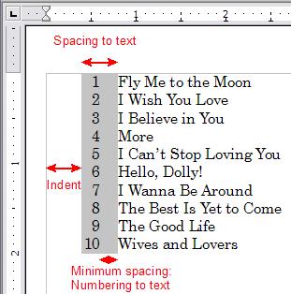

* + - 1. Step 1: Create the numbered list style.

Before you begin, press *F11* to open the Styles and Formatting window, if it is not already open.

1. Select the List Styles icon  at the top of the Styles and Formatting window (fifth from the left).
2. Right-click in the blank area below the list of styles and choose New; see . (You could modify one of the existing styles, but it’s easier to remember which style is for what special purpose if you create a new one.) The Numbering Style dialog box () is displayed. For the CD Tracks list style we need to customize fields in the Organizer, the Options and the Position pages.

|  |  |
| --- | --- |
| Note | Although the icon at the top of the Styles and Formatting window is labelled List Styles, the dialog that opens is labelled Numbering Style. |

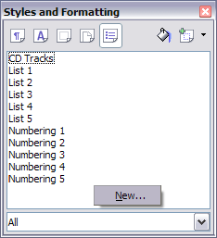

1. The Organizer page of the Numbering Style dialog serves the same purpose as in the Paragraph style dialog but has fewer options. Give the new list style a name, for example CDTracks.
2. On the Options page (shown in ) you can set up parameters for each individual level of the structure or for all the levels at once. In this example we need only one level (1). The right-hand side of the dialog box shows a preview of what the numbered list will look like.
   1. In the Level box, choose 1.
   2. In the Numbering list, choose 1,2,3.
   3. Leave the Before and After boxes blank, or delete anything that is in them.
   4. Leave Character Style as None.
   5. Make sure Start at is 1.
   6. Show sublevels should be greyed out. Do not select the checkbox for Consecutive numbering.

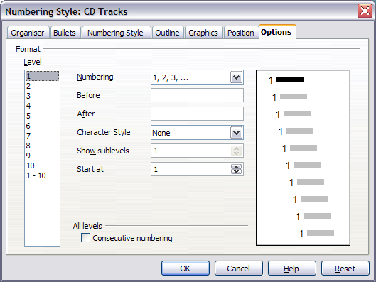

|  |  |
| --- | --- |
| Tips | The numbered list will adopt settings of the underlying paragraph style. If you want to use a special font, size, or colour for the numbers, you can create a character style and apply it on the Options page.  If you want the word Track to appear before the number, just add it to the Before field in the Options dialog. Do not forget to add a space character to separate the word from the number. |

1. The Position page () provides the following fields:

* Indent: Determines the indentation of the number or bullet area. The indentation is measured from the left margin of the paragraph linked to the numbering style. In other words, if the paragraph style already has an indentation, when the list style is applied the indentations are summed together. When a level different from Level 1 is selected, if the Relative checkbox is selected, the indentation is applied relative to the previous level.
* Spacing to text: This value determines how much space will be used by the numbering symbol. OOo will reserve this space even if only part of it is used.
* Minimum spacing numbering <-> text: This is the spacing between the right edge of the numbering symbol and the text. If the spacing to text is not sufficient, OOo will expand the numbering area. Setting the minimum spacing between numbering and text is very useful when right-aligning the numbering or when there is a long text before or after the numbering.
* Numbering alignment: Select in the drop-down menu how the numbering (including any text before or after) should be aligned: left, centred, or right.

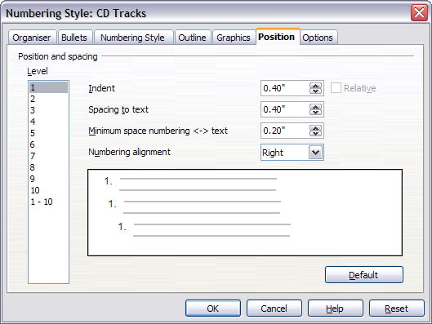

As we are creating a simple list, all we need to do in this page is:

* 1. In the Level box, choose 1.
  2. For Indent, choose 1.0cm. (You may need to adjust this later.)
  3. For Spacing to text, choose 1.0cm.
  4. For Minimum space..., choose 0.5cm.
  5. For Numbering alignment, choose Right.

1. Do nothing on the other pages of this dialog box.
2. Click OK to save this style.
   * + 1. Step 2. Apply the list style to the paragraphs you want numbered.

Now that the list style is available, it can be quickly applied to any list in the document:

* If starting a new list, before pressing Enter to start a new line double-click on the desired list style name in the Styles and Formatting window.
* If you already have a list, select it and then double-click on the desired list style name in the Styles and Formatting window.

|  |  |
| --- | --- |
| Notes | Remember that applying a list style does not affect the characteristics of the underlying paragraph, therefore you may want to check if you are satisfied with the paragraph style before applying the list style.  If you have previously applied manual formatting to these paragraphs, first select all the paragraphs, right-click, and choose Default Formatting; then apply the list style you have defined. |

* + - 1. Restarting numbering (if required)

If you have more than one list in a chapter, the second and subsequent lists may continue numbering from the previous list. To restart at 1, place the cursor anywhere in the paragraph you want numbered 1, right-click and choose Restart numbering.

To stop using numbering, click the Numbering On/Off icon on the Standard toolbar.



Writer Guide

1. Chapter 7  
    Working with Styles
   1. Introduction

A *style*is a set of formats that you can apply to selected pages, text, frames, and other elements in your document to quickly change their appearance. When you apply a style, you apply a whole group of formats at the same time.

OpenOffice.org Writer supports the following types of styles:

* Page styles include margins, headers and footers, borders, and backgrounds.
* Paragraph styles control all aspects of a paragraph’s appearance, such as text alignment, tab stops, line spacing, borders, and character formatting.
* Character styles affect properties of the selected text within a paragraph, such as the font and size of text and bold and italic formats.
* Frame styles are used to format graphic and text frames, including borders, backgrounds, columns, and how text wraps around the frame.
* List styles apply similar alignment, numbering or bullet characters, and fonts to numbered or bulleted lists.

OpenOffice.org (OOo) comes with many predefined styles. You can use the styles as provided, modify them, or create new styles, as described in this chapter.

The importance of styles in OpenOffice.org is covered in Chapter 6 (Introduction to Styles). That chapter also introduces three of the five types of styles in Writer (page, paragraph, and character), and it describes how and why to use them in Writer documents.

This chapter describes the general use of styles in Writer and provides more examples of using all five types of styles.

* 1. Applying styles

In order to use a style in OpenOffice.org , you need to apply it. OOo provides several ways to apply styles:

* Using the Styles and Formatting window.
* Using Fill Format mode.
* Using the Apply Style list.
* Assigning styles to shortcut keys.
* Using AutoFormat—see Chapter 3 (Working with Text).
* Using conditional styles—see page .
  + 1. Using the Styles and Formatting window

1. To open the Styles and Formatting window (), do any one of the following:
   * Click on the icon located at the left-hand end of the object bar.
   * Choose Format > Styles and Formatting.
   * Press F11.

|  |  |
| --- | --- |
| **Tip** | You can move the Styles and Formatting window to a convenient position on the screen or dock it to an edge. |

1. Click on one of the icons at the top left of the Styles and Formatting window to display a list of styles in a particular category, such as paragraph or character.
2. To apply a character style to existing text, select the text and then double-click on the name of the style in the Character Styles list. To apply any other style, put the cursor in the paragraph, frame, or page you want to modify and double-click on the name of the style. You can select more than one paragraph or frame and apply the same style to all of them at the same time.

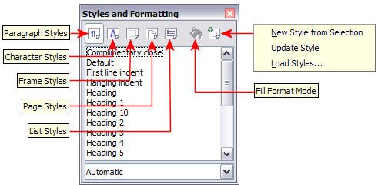

|  |  |
| --- | --- |
| **Tip** | At the bottom of the Styles and Formatting window is a drop-down list. In it shows **Automatic**, meaning the list shows only the styles that are applied automatically by OOo. You can choose to show all styles or other groups, such as custom styles. Starting with OOo2.3, your selection here is saved when you close OOo (previously this window always opened with Automatic showing). |

* + 1. Using Fill Format mode

Use Fill Format to apply a style to many different areas quickly without having to go back to the Styles and Formatting window and double-click every time. This method is useful for formatting many scattered paragraphs, words, or other items with the same style, and it may be easier to use than making multiple selections first and then applying a style to all of them.

1. Open the Styles and Formatting window () and select a style.
2. Click theFill Format Mode icon 
3. To apply a paragraph, page, or frame style, hover the mouse over the paragraph, page, or frame and click. To apply a character style, hold down the mouse button while selecting the characters, Clicking on a word applies the character style for that word. Repeat step 3 until you made all the changes for that style.
4. To quit the Fill Format mode, click the icon again or press the Esc key.

|  |  |
| --- | --- |
| Caution | When this mode is active, a right-click anywhere in the document undoes the last Fill Format action. Be careful not to accidentally right-click and mistakenly undo actions you want to keep. |

* + 1. Using the Apply Style list

When a style is in use in a document, the style name appears on the Apply Style list () at the left end of the formatting bar, to the right of the Styles and Formatting icon.

To apply a style from this list, click on the desired style or use the up or down arrow keys to move through the list, then press Enter to apply the highlighted style.

|  |  |
| --- | --- |
| **Tip** | Select **More...** at the bottom of the list to open the Styles and Formatting window. |

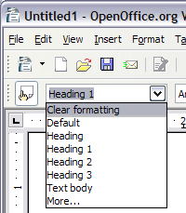

* + 1. Assigning styles to shortcut keys

You can configure shortcut keys to quickly assign styles in your document. Some shortcuts are predefined, such as **Ctrl+1** for the Heading 1 paragraph style and **Ctrl+2** for Heading 2. You can modify these shortcuts and create your own.

1. Click Tools > Customize > Keyboard.
2. On the Keyboard page of the Customize dialog box (), choose the shortcut keys you want to assign a style to. In this example, we have chosen Ctrl+9.

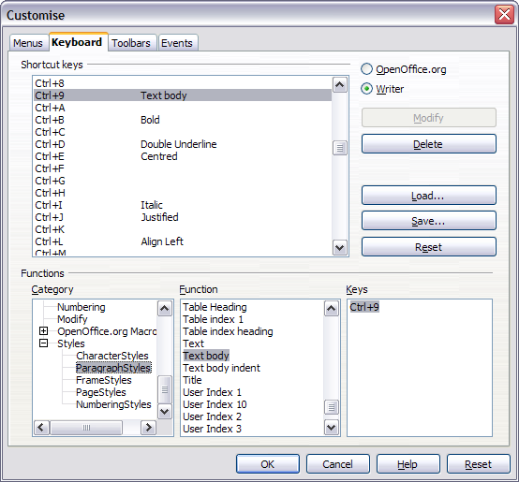

1. In the Functions section at the bottom of the dialog box, scroll down in the Category list to Styles. Click the + sign to expand the list of styles.
2. Choose the category of the style. The Function list will display the names of the available styles for the selected category. The example in shows some of OOo’s predefined paragraph styles.
3. To assign Ctrl+9 to the *Text Body* paragraph style, select Text Body in the Function list, and then click Modify. Ctrl+9 now appears in the Keys list.
4. When you are done assigning shortcuts, click OK to close the dialog box.

Currently, the only way to use Alt key or multi-key combinations is through a macro. See [AltKeyHandler.sxw](http://homepages.paradise.net.nz/hillview/OOo/AltKeyHandler.sxw) and [KeyHandler.sxw](http://homepages.paradise.net.nz/hillview/OOo/KeyHandler.sxw), available from <http://homepages.paradise.net.nz/hillview/OOo/>.

* 1. Modifying styles

OpenOffice.org provides several ways to modify styles:

* Change a style using the Style dialog box
* Update a style from a selection
* Use AutoUpdate (paragraph and frame styles only)
* Load or copy styles from another document or template

You can change both predefined and custom (user-created) styles.

|  |  |
| --- | --- |
| **Tip** | Any changes made to a style are effective only in the current document. To change styles in more than one document, change the template—see Chapter 10 (Working with Templates)—or copy the styles into the other documents as described in “” on page . |

* + 1. Changing a style using the Style dialog box

To change an existing style using the Style dialog box, right-click on the style in the Styles and Formatting window and select Modify from the pop-up menu.

The dialog box displayed depends on the type of style selected. shows an example of the dialog box for a paragraph style. Each style’s dialog box has several tabs. Some properties on these dialog boxes are described later in this chapter.

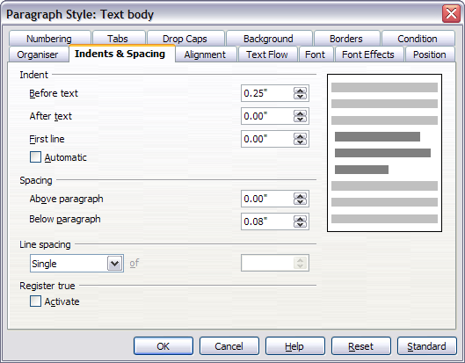

* + 1. Updating a style from a selection

Let’s use paragraph styles as an example.

1. Open the Styles and Formatting window.
2. Create a new paragraph (or modify an existing paragraph) and edit all the properties you want to go into the style (such as indentation, font properties, alignment, among others).

|  |  |
| --- | --- |
| Caution | Make sure that there are unique properties in this paragraph. For example, if there are two different font sizes or font styles, that particular property will remain the same as before. |

1. Select the paragraph by clicking anywhere in the paragraph.
2. In the Styles and Formatting window, select the style you want to update (single-click, not double-click) and then click on the **New Style from Selection** icon and select Update Style (see ).

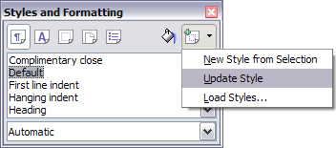

The procedure to update another type of style (like character, page, or frame styles) is the same. Just select the item in question, select the style you want to update, and choose Update Style.

* + 1. Using AutoUpdate (paragraph and frame styles only)

If the AutoUpdate checkbox is selected on the Organizer page of the Paragraph Style or Frame Style dialog box, applying direct formatting to a paragraph or frame using this style in your document automatically updates the style itself.

|  |  |
| --- | --- |
| **Tip** | If you are in the habit of manually overriding styles in your document, be sure that AutoUpdate is notenabled. |

* + 1. Updating styles from another document or template

You can update styles by copying or loading them from a template or another document. See “” on page .

* 1. Creating new (custom) styles

In addition to using the predefined styles provided by OOo, you can add new custom (user-defined) styles. OOo provides three ways to add styles.

* Create a new style using the Style dialog box.
* Create a new style from a selection.
* Drag and drop a selection to create a new style.
  + 1. Creating a new style using the Style dialog box

Open the Styles and Formatting window (). Right-click on a style and select New. The style that you choose will be the basis for this new style. If you do not want too many of the options preset for you, choose the Default style.

The dialog box displayed depends on the type of style selected. shows an example of a Style dialog box for a new paragraph style. The dialog boxes and choices for defining new styles are the same as for modifying existing styles.

|  |  |
| --- | --- |
| **Tip** | An exception to the above rule is conditional styles, which have a different dialog box. See page for more information. |

* + - 1. Linking styles

You can **link** a new style to an existing style. For example, suppose that the style MyStyle specifies a font size of 12. Then you create another style (MyStyle2) linked to MyStyle and specifies underlined text. If you modify MyStyle to font size 20, MyStyle2 inherits the new font size but still underlines the text.

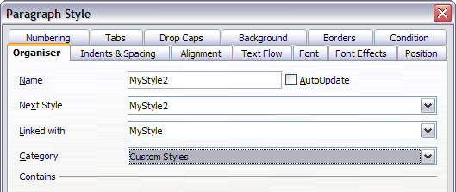

|  |  |
| --- | --- |
| **Tip** | If styles are linked, changing the base style changes all the linked styles. Sometimes this is exactly what you want; other times it is not. It pays to plan ahead. Many predefined styles are already linked to other styles. |

* + 1. Creating a new style from a selection

You can create a new style from the formatting of an object in the current document. For instance, you can change the formatting of a paragraph or frame until it appears as you like, and then you can turn that object’s formatting into a new style. This procedure can save time, because you do not have to create a new style as described above and remember all of the formatting settings.

1. Change the formatting of the object (paragraph, frame, etc.) to your liking.
2. Open the Styles and Formatting window. From the icons at the top of the window, choose the type of style to create (paragraph, character, and so on).
3. In the document, select the item to save as a style.
4. In the Styles and Formatting window, click the **New Style from Selection** icon.
5. In the Create Style dialog box, type a name for the new style. The list shows the names of existing custom styles of the selected type, if any. Click OK to save the new style.
   1. Dragging and dropping a selection to create a style

You can drag-and-drop a text selection into the Styles and Formatting window to create a new style.

1. Open the Styles and Formatting window.
2. Select some text and drag it to the Styles and Formatting window.
3. In the Create Style dialog box, type a name for the new style. The list shows the names of existing custom styles of the selected type, if any. Click OK to save the new style.
4. If the Paragraph Styles list is showing in the Styles and Formatting window, a new paragraph style will be added to the list. If Character Styles are active, the character style will be added to the list.
   1. Copying and moving styles

When you create a style in a document, it is available only within that document. Styles always stay with a document. So, for example, if you e-mail a document to another person, the styles go with it.

Having created a style, you may want to transfer the style to another document. You can copy or move styles from one template or document to another in two ways:

* Using the Template Management dialog box
* Loading styles from a template or document
  + 1. Using the Template Management dialog box

To copy or move styles using the Template Management dialog:

1. Click File > Templates > Organize.
2. At the bottom of the Template Management dialog box (), choose either Templates or Documents, as needed. For example, if you are copying styles between two documents, both entries should say Documents.
3. To load styles from a file, click the File button. When you return to this window, both lists show the selected file as well as all the currently open documents ().
4. Double-click on the name of the template or document, and then double-click the Styles icon to show the list of individual styles.

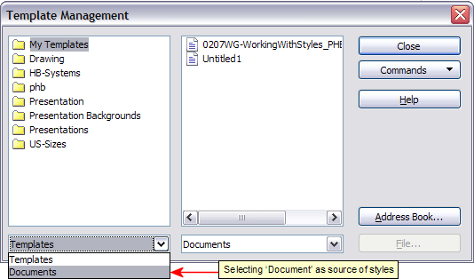

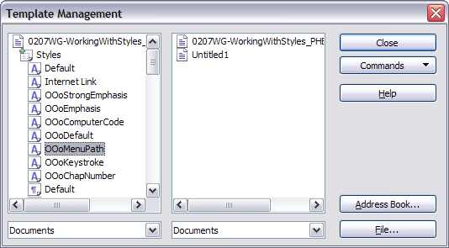

1. To copy a style, hold down the Control key and drag the name of the style from one list to the other.

|  |  |
| --- | --- |
| Caution | If you do not hold down the Control key when dragging, the style will be moved from one list to the other. The style will be deleted from the list you are dragging it from. |

1. Repeat for each style you want to copy or move. When you are finished, click Close.
   * 1. Loading styles from a template or document

You can copy styles by loading them from a template or another document. This method copies all styles, or groups of styles, at one time.

1. Open the document to copy styles into.
2. In the Styles and Formatting window, click on the New Style from Selection icon, and then on Load Styles (see ).
3. In the Load Styles dialog box (), find and select the template to copy styles from. Or click on From File and select a document.
4. Select the checkboxes for the types of styles to be copied. If you select Overwrite, the styles being copied will replace any styles of the same names in the target document.
5. Click OK to copy the styles.

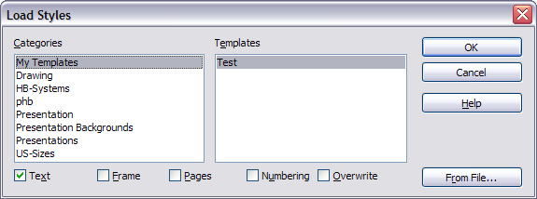

* 1. Deleting styles

It is not possible to delete OOo’s predefined styles from a document or template, even if they are not in use. However, custom styles can be deleted.

To delete an unwanted style, right-click on it in the Styles and Formatting window and choose Delete. If the style is in use, the message shown in appears.

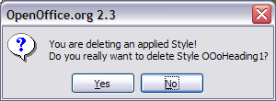

|  |  |
| --- | --- |
| Caution | Make sure the style is not in use before deletion. Otherwise, all objects with that style will return to the default style and retain their formatting as manual formatting. This can be very problematic in a long document. |

|  |  |
| --- | --- |
| **Tip** | If an unwanted style is in use, use **Find & Replace** to replace it with a substitute style before deleting it. |

If the style is not in use, the message shown in appears.

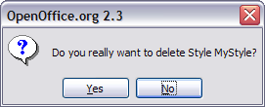

* 1. Working with paragraph styles

Chapter 6 (Introduction to Styles) covers the basics of using paragraph styles. This chapter looks at some advanced properties of paragraph styles and ways that you can use other features in OOo in conjunction with paragraph styles to do specific tasks like:

* Controlling page breaks
* Controlling tab stops
* Specifying a relative font size
* Selecting a language for a paragraph style
* Rotating the text in a paragraph style
* Kerning text (a feature that adjusts the letter spacing to make text more readable)
* Using styles in outlining
* Using conditional paragraph styles
  + 1. Controlling page breaks

Writer automatically flows text from one page to the next. If you do not like the default settings, you can change them on the Text Flow page of the Paragraph Style dialog box.

* + - 1. Automatic page or column breaks

The Options section of the Text Flow page () of the Paragraph Style dialog box provides settings to control what happens when a paragraph does not fit on the bottom of a page:

Do not split paragraph means that the paragraph is never split across two pages. If it does not fit on the bottom of one page, the entire paragraph moves to the top of the next.

Keep with next paragraph is appropriate for headings or the lead-in sentence to a list, to ensure that it is not the last paragraph on a page.

Orphan control and Widow control. Widows and orphans are typographic terms. An orphan is the first line of a paragraph printed alone at the bottom of a page or column. A widow is the last line of a paragraph which appears alone at the top of the next page or column. Use these options to allow paragraphs to split across pages or columns but require at least 2 or more lines to remain together at the bottom or top of a page or column. You can specify how many lines must remain together.

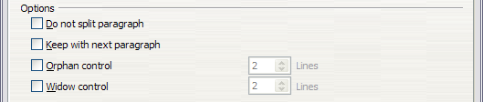

* + - 1. Required page or column breaks

You can require a paragraph to start on a new page or column and specify the style of the new page. A typical use is for chapter titles that you always want to start on a new page. This topic is covered in more detail in Chapter 4 (Formatting Pages).

On the Text Flow page of the Paragraph Style dialog box:

1. In the Breaks section, select Insert. Make sure that Type is set to Page and Position to Before.
2. Select With Page Style and choose the page style from the list.
3. To continue page numbering from the previous chapter, leave Page number set at 0. To start each chapter’s page numbering at 1, set Page number to 1.
4. Click OK.

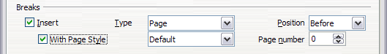

* + 1. Controlling tab stops

Using tabs to space out material on a page is not recommended (depending on what you are trying to accomplish, a borderless table is usually a better choice), but if you do use tabs, do not use the default tabs set in Tools > Options > OpenOffice.org Writer > General (); instead, define your own tab settings, as described in this section.

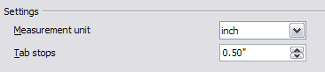

If you use the default tab interval and then send the document to someone else who has chosen a different default tab interval, tabbed material will change to use the other person’s tab settings. This may cause a major formatting problem, as illustrated in .

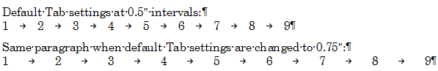

To avoid this problem, specify all the tab settings for the paragraph, using the Tabs page of the Paragraph Style dialog box ().

Here you can choose the type of tab: left, right, centered, or decimal; the character to be used as a decimal point; and the fill character—the characters that appear between the end of the text before the tab and the beginning of the text after the tab. A common use of a fill character is the dots between a heading and a page number in a table of contents.

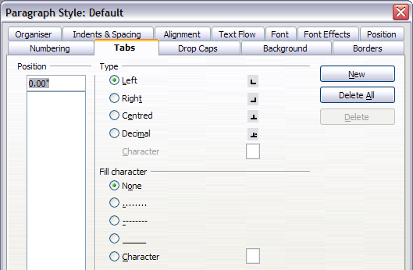

* + 1. Specifying a relative font size

If you are creating a style based on another style, you can specify a font size relative to that other style—either as a percentage or as a plus or minus point value (-2pt or +5pt). Relative font sizes are commonly used for Web pages.

For example, the paragraph style Heading 1 is based on the paragraph style Heading. The font size of the paragraph style Heading is 14pt, and the font size of paragraph style Heading 1 is specified as 115%. Thus the resultant font size of text in a paragraph formatted with paragraph style *Heading 1* is 14pt x 115% = 16.1pt.

To specify a percentage font size, in the Paragraph Style dialog box, go to the *Font* tab. In the *Size* box, enter the percentage amount followed by the symbol % (see ). Similarly, you can enter a plus or minus sign followed by the number of points to be added or subtracted from the base font size.

To change from a relative font size back to an absolute font size, enter the desired font size in points followed by the letters “pt”.

It is also possible to use a Percentage Font size for character styles. See the note on page .

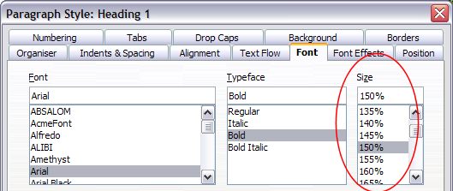

* + 1. Selecting a language for a paragraph style

The language you select for a document (on *Tools > Options > Language Settings > Languages*) determines the dictionary used for spell checking, thesaurus and hyphenation, the decimal and thousands delimiter used, and the default currency format.

Within the document, you can apply a separate language to any paragraph style. This setting has priority over the language of the whole document. On the *Font* tab of the Paragraph Style dialog box, languages with installed dictionaries are marked in the *Language* list by a small *ABC* icon (). When you check spelling, OOo will use the correct dictionary for paragraphs with this style.

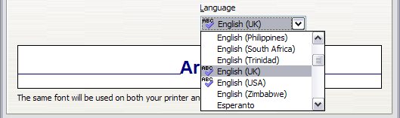

|  |  |
| --- | --- |
| Note | You can assign a language to selected pieces of text in a paragraph using character styles, also on the Font page. This assignment has priority over the paragraph style and document language. |

* + 1. Rotating the text in a paragraph style

Two common uses for rotated paragraphs are to put portrait headers and footers on a landscape page and to fit headings above narrow table columns (as shown in ).

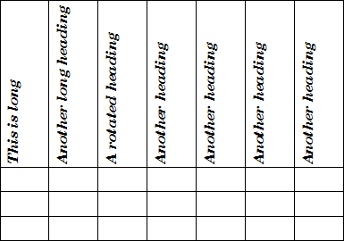

Chapter 4 (Formatting Pages) describes how to create portrait headers and footers on landscape pages by rotating characters. You can achieve the same effect by defining a separate header or footer paragraph style specifically for landscape pages.

As an example, we will apply rotated table headings to a pre-existing table.

1. Create a new paragraph style. Name it *Table Heading Rotated*.
2. On the *Position* page of the Paragraph Style dialog box (), in the *Rotation / scaling* section, select 90 degrees. Click OK to save the new style.

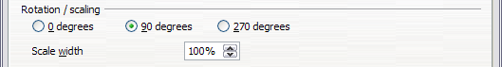

1. Select the heading row of the table and apply the new style. Any text in the cells of the heading row is now rotated.
2. If the headings are aligned to the top of the cells, you may want to change the alignment to the bottom of the cells, as shown in . To do this, click the Bottom button on the Table toolbar ().

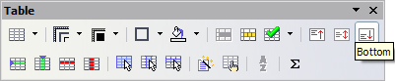

* + 1. Kerning text

Kerning means increasing or decreasing the amount of space between pairs of letters to improve the overall appearance of the text. Kerning automatically adjusts the character spacing for specific letter combinations (see ). It is only available for certain font types and, for printed documents, only works if your printer supports it.

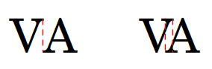

To turn kerning on, go to the Position page of the Paragraph Style dialog box. In the Spacing section, select the Pair kerning checkbox ().

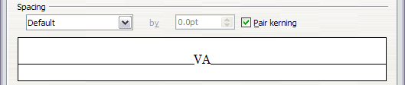

* 1. Outline numbering

OpenOffice.org provides two ways to do outline numbering. Although both methods are called outline numbering, they serve two quite different purposes:

* Tools > Outline Numbering is for defining the hierarchy of headings. This method requires a separate paragraph style for each level of the hierarchy. The paragraph styles specified on the Outline Numbering dialog box determine which headings appear in the table of contents. Despite the name, headings do not have to be numbered. See “” below.
* Numbering Styles are for defining the appearance of lists, both simple lists and outlines or nested lists—that is, numbered or bulleted paragraphs, some of which have numbered or bulletted sublists under them. This method requires only one paragraph style. These lists can be used for a variety of purposes. See “” on page .

A document can use both methods. One document can have only one hierarchy of headings, but it can use several numbering styles (both simple and nested) for different purposes.

* 1. Defining a hierarchy of headings

Tools > Outline Numbering defines the hierarchy of headings in a document. Headings can be numbered or not; typically the first-level headings in a book-length document are chapter titles, which may be numbered, but lower-level headings are not numbered. Some heading styles (such as those commonly used in engineering documents) number each heading level, for example 1, 1.1, 1.2, 2, 2.1, and so on. When chapters or sections are added or deleted, the numbering is automatically changed.

Paragraph styles are the key to OOo’s outline numbering feature. The default paragraph styles assigned to outline levels are the heading styles supplied with OOo: Heading 1, Heading 2, and so on. However, you can substitute any styles you wish, including custom (user-defined) styles.

The headings defined using the outline numbering feature can be used for more than the table of contents (described in Chapter 12). For example, fields are commonly used to display headings in headers and footers of pages (see [insert reference]), and Writer can send the outline to Impress.to use as the basis for a presentation (see the *Impress Guide* for details).

* + 1. Choosing paragraph styles for outline levels

If you are using the default heading styles for the headings in your outline, and you do not want to use heading numbering, you do not need to do anything on the Outline Numbering dialog box. The default outline numbering scheme uses the default heading styles (Heading 1, Heading 2, and so on).

To use custom styles in place of one or more of the default heading styles:

1. Click Tools > Outline Numbering to open the Outline Numbering dialog box ().
2. Click the number in the Level box corresponding to the heading for which you want to change the paragraph style.
3. In the Numbering: Paragraph Style section, choose from the drop-down list the paragraph style you want to assign to that heading level. For example, when setting up a chapter in the Writer Guide, you would click Level 1 and choose OOoHeading1 (a custom style defined for the OOoAuthors project) to replace Heading 1 and for Level 2, OOoHeading2 to replace Heading 2..

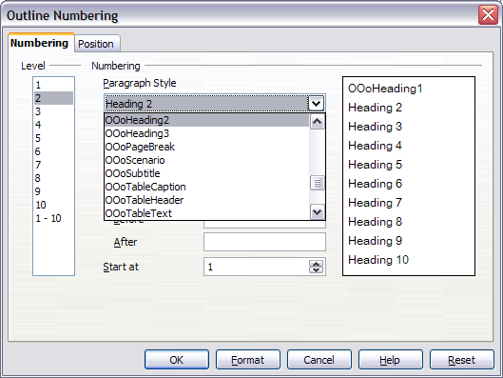

1. Repeat for each outline level that you want to change. Click OK when done.
   * 1. Setting up heading numbering

If you want one or more heading levels to be numbered, many choices are available; this example defines a scheme to create headings that look like those in .

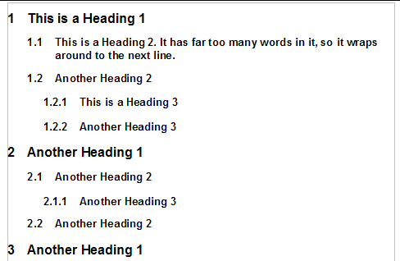

Use the Numbering page of the Outline Numbering dialog to define the numbering scheme and its appearance. shows the default settings in the Outline Numbering dialog.

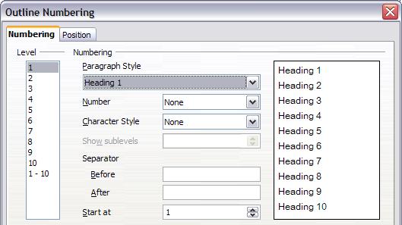

1. In the Level list, choose 1. In the Number list, choose 1, 2, 3, ... The result is shown in the preview box on the right (see ).

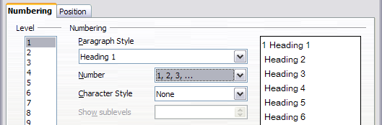

1. In the Level list, choose 2. In the Number list, choose 1, 2, 3, ... The Show sublevels list is now active; it should show 2 (if not, choose 2). The result is shown in .

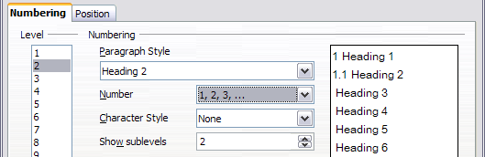

1. In the Level list, choose 3. In the Number list, choose 1, 2, 3, ... The Show sublevels list should show 3 (if not, choose 3). The result is shown in .

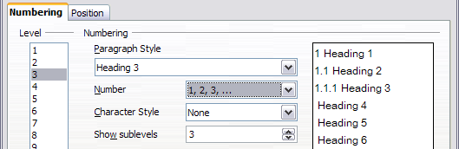

These choices produce the layout shown in .

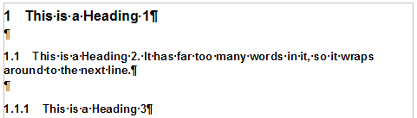

* + 1. Setting up the indentation of headings

Whether or not the headings are numbered, you may want to change some of their formatting. For example, you may want the second and third level headings to be indented from the margin. For numbered headings, you may also want the second line of long headings to line up with the first word of the heading, not the number. For these changes, use the Position page of the Outline Numbering dialog. shows the default version of this page.

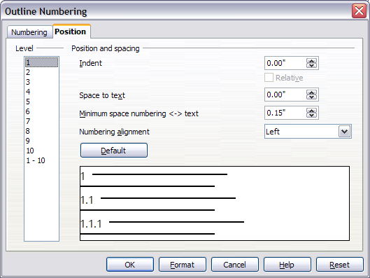

1. In the Level list, choose 2. Change the value for Indent as shown in . You may want to use a different value. Notice how the preview area at the bottom of the dialog has changed. This change indents the entire heading but does not affect the way long headings wrap around; see .

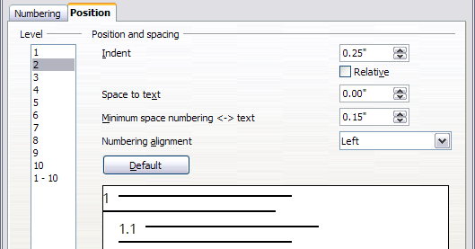

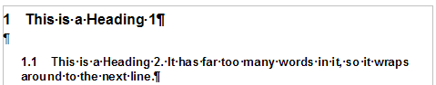

1. To change the wrapping behavior of long headings, change the value of Space to text, as shown in . The result is shown in .

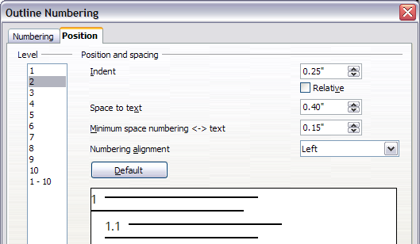

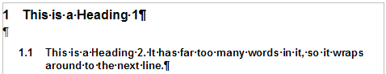

1. In the Level list, choose 3. Change the value for Indent as shown in . You may also wish to change the Space to text value. The final result is shown in .

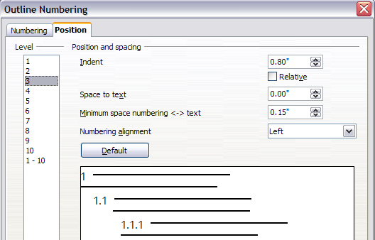

* + 1. Including chapter or section names in page headers

In addition to page numbers, headers and footers often include the name of the chapter or section. Because these names change from one chapter or section to the next, you need to use a field that displays information relevant to each page.

1. Click Insert > Fields > Other to open the Fields dialog box ().
2. On the Document page, select Chapter in the Type list. The Format list now shows four choices.

The Chapter field uses the headings defined in the Outline Numbering dialog. The Layer box determines which outline level is displayed in the field. For example, Layer 1 always displays the most recently found heading that has the paragraph style selected for Level 1 in the Outline Numbering dialog box, Layer 2 displays the most recent heading with the paragraph style selected for Level 2 in outline numbering, and so on.

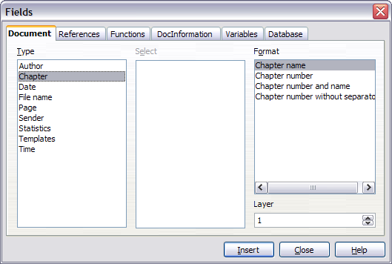

|  |  |
| --- | --- |
| Note | A Chapter field in a page header always picks up the highest heading level on a page, even if you have specified a lower level in the Layer box. For example, if a page has a Heading 1 and a Heading 2 on it, then a Layer 2 Chapter name field in the header of that page will display the Heading 1 paragraph, not the first Heading 2 paragraph, as intended.  In a footer, the layers work as intended. |

* 1. Working with list (numbering) styles

Use a numbering (list) style to define the appearance of a list, whether a simple list or an outline or nested list (sometimes called multi-level numbering). An example of setting up a simple list is given in Chapter 6. This section describes how to define a nested list.

|  |  |
| --- | --- |
| Note | OOo uses the terms “numbering style” and “list style” inconsistently, but they are the same thing. For example, the tooltip in the Styles and Formatting window says “List Styles”, but its style dialog box says “Numbering Style”. |

* + 1. Defining the appearance of a nested list

A nested list is a numbered or bulleted list with subordinate (usually indented) numbered or bulleted lists. Rather than just a list of numbered items (1,2,3...), a nested list may have item 1, then indented items numbered a,b,c or i,ii,iii or some other numbering method before the main number 2. With numbering styles you can achieve any combination of numbering formats you want.

As an example, we will use a numbering style to produce the following effect:

I. Level-1 list item

A. Level-2 list item

i. Level-3 list item

a) Level-4 list item

You can modify a predefined style, or define a new style. This example uses one of the supplied styles, Numbering 1.

1. In the Styles and Formatting window, choose Numbering Styles and select a style such as Numbering 1. Right-click on the style and select Modify.
2. On the Numbering Style dialog box, go to the Outline page (), where you will find that one style matches our requirements. Click once on that style.

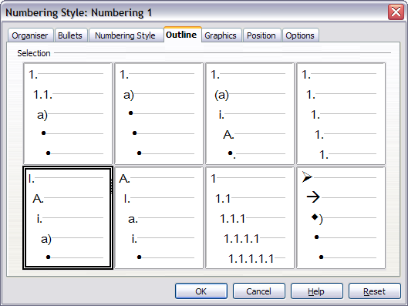

1. To modify the layout of the list, use the Options tab (Figures and ). Notice that the preview on the right shows the outline selected. In the Level box on the left, select 1, then 2, 3, and 4 and see how the information in the Numbering and After boxes changes.

Use the Options page to set different punctuation; for example, a period (full stop) after “a” on level 4 instead of a parenthesis.

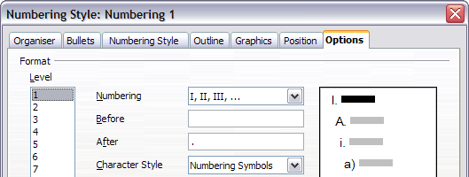

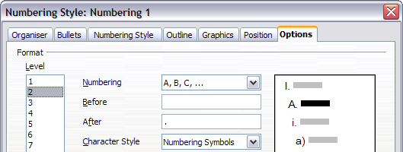

1. To make the indentation at each level greater or less than the default, change it on the Position page. Select the heading level, then make any changes in the indentation, spacing, or numbering alignment.
2. Repeat for each heading level as required, then click OK to save the style.

|  |  |
| --- | --- |
| **Tip** | With outline numbering you can define different bullet styles for the different levels of a bullet list. Use the Bullets tab of the Numbering Style dialog box (not shown) to select the basic style. Return to the Options tab to customize the bullet for each indent level. Here you can set bullets to any character. See the Graphics tab for more bullets. |

* + 1. Applying the different levels of a list-numbered paragraph style

To apply the different levels of a list-numbered paragraph style:

1. Type the first paragraph and apply the List 1 style. Notice that the level-1 list number is added automatically.
2. Select **View > Toolbars > Bullets and Numbering** to display the Numbering toolbar ().
3. Press Enter to start the next paragraph. To make it a level-2 list item, click the Demote one level icon on the object bar (). The number applied to this paragraph has changed to a level-2 number.
4. Continue typing list items, moving each paragraph up or down levels as needed.

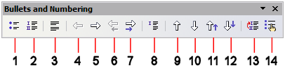

|  |  |
| --- | --- |
| **Tip** | One option is to enter all the list paragraphs first and apply the levels afterwards.  You can use keyboard shortcuts to move paragraphs up or down the outline levels. Place the cursor at the beginning of the numbered paragraph and press:  **Tab** Down a level **Shift+Tab** Up a level  To insert a tab stop at the beginning of a numbered paragraph (that is, after the number but before the text), press **Control+Tab**. |

* 1. Working with conditional paragraph styles

A conditional paragraph style is another way of formatting text differently in different parts of your document. In some cases, you may find it saves time to use conditional styles rather than switching between styles as you type.

Making a paragraph style conditional means it changes its formatting depending on where it is used. For example, you may want the style **MyTextBody** to be black by default but turn white when inside a frame with a blue background.

Probably the most common use for conditional formatting is with single style outlining. Single-style outlining is a type of outline numbering designed with a **Numbering** style, rather than with **Tools > Outline Numbering**. Instead of using different styles, it changes the number formatting whenever you press the **Tab** key to create a subordinate heading.

The only trouble with single-style outlining is that all levels look the same. That is where a conditional paragraph style comes in handy. Assign the paragraph style to an outline numbering style in the **Numbering** page and then open the **Condition** page (). There, you can assign the levels of the outline numbering style to other paragraph styles. Then, when you press the **Tab** key while using the paragraph style, each level of the outline takes on different formatting, making single-style outlining even more convenient than it is on its own.

|  |  |
| --- | --- |
| Note | Predefined styles (other than Text Body) such as Default, Heading 1, and Heading 2 cannot be set to be conditional. |

|  |  |
| --- | --- |
| Caution | If you want to make a style conditional, you have to do it while the style window still is open for the first time. After the window closes, the Condition tab no longer appears in the window. |

* + 1. Defining the conditional style

When you create a conditional style, you are saying “in this condition make this style look like that other style”. For example, “When typing into a footer, make this style look like the my_footer paragraph style; when typing into a table, make this style look like the table_text paragraph style”.

In addition to setting the normal (unconditional) properties of the style, you need to define which other style it will look like in different situations. You do this on the Condition tab.

To set up a conditional paragraph style:

1. Define a new paragraph style.
2. Select all the paragraph properties for the style. Do not click OK!
3. Click the Condition tab ().

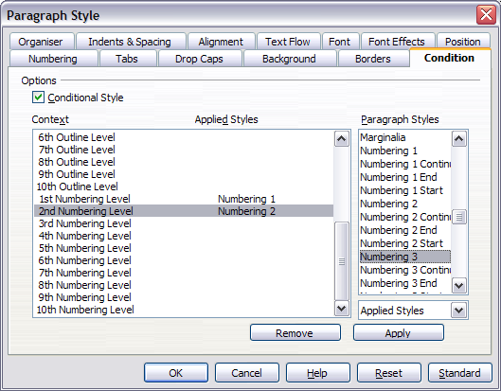

1. Select the Conditional Style checkbox.
2. Select the first condition in the Context list (left side of the dialog box) and select the style you want for this condition in the right-hand list.
3. Click Apply. The name of the paragraph style appears in the middle list.
4. Repeat steps 5 and 6 for each condition you want to have linked to a different style.
5. Click OK.

When the style is selected, you will see that the formatting of your text depends on the context.

* 1. Working with frame styles

Frames are often used as containers for text or graphics. To provide consistency in the appearance of frames used for similar purposes, it is a good idea to define styles for frames. For example, you might want photographs to be enclosed in a frame with a drop-shadowed border, line drawings in a frame with a plain border, marginal notes in a frame without a border but with a shaded background, and so on.

Writer provides several predefined frame styles, which you can modify as needed; and you can define other frame styles. The technique for defining and applying frame styles is similar to that for other styles.

|  |  |
| --- | --- |
| **Tip** | There is considerable overlap between the uses of frames and of sections for some page layout purposes. You may find it useful to take a look at Chapter 4 (Formatting Pages) for information about the use of frames and sections. |

* + 1. How frame styles work

When an object is added to Writer, it is automatically enclosed in a frame of a predetermined type. The frame sets how the object is placed on the page, as well as how it interacts with other elements in the document. You can edit the frame by modifying the frame style it uses or by using a manual override when a frame is added to the document.

Because frames and objects are used together, it sometimes is easy to forget they are separate elements. In some cases, such as charts, you can edit the frame and object separately, so the distinction is worth remembering.

Unlike other elements that use styles, frames can be defined only partly by their style because their use can vary so much. Several elements of frames, such as the anchor and protected elements, need to be defined manually for individual frames.

You can format a frame manually when you select **Insert > Frame**. The dialog box that opens contains all the settings available when frame styles are set up, as well as some only available when the frame is inserted. As with other styles, the most efficient way to format frames is in the Styles and Formatting window.

* + 1. Planning the styles

If you are using a mix of graphics, you may want to define two related styles, one with a border line for graphics with white backgrounds and one without a border for all other backgrounds. You also may want to design one or more frames for text only.

Otherwise, the default frame styles (listed in ) cover most users’ needs. The only significant addition that many users might need is one or more styles for text frames.

Table 2. Various frame styles and their uses

|  |  |
| --- | --- |
| Style | Comments and Use |
| Formula | The frame style used for formulas. The default includes AutoSize, which adjusts the size of the frame to the formula. |
| Frame | The default frame style. |
| Graphics | The default style for graphics. The defaults include autosizing to fit the graphic, no text wrap, and a thin border around the frame. These are reasonable defaults, except for the border. Unless the background of the graphic is white and the document’s background also is white, the border usually is unnecessary. |
| Labels | The default style for use with File > New > Labels. It seems to be used by OpenOffice.org automatically and is not intended for users at all. |
| Marginalia | A style for placing a frame beside the left margin. As the name suggests, the Marginalia style is intended for comments added in the margin of text. The style also is useful for creating sideheads—headings against the left margin, which often are used in technical documentation. To set up sideheads, create body text styles with two inches or more indentation from the left. Then, place the cursor at the start of a body text paragraph, add the frame, and apply the Marginalia style. |
| OLE | The default style for OLE objects and floating frames. The default places the frame at the top and center of a body of text. |
| Watermark | The default style for a watermark, a graphic placed as the background to a body of text. The default is a Through wrap, with text passing over the frame and anything in it. The graphic should be faint enough that text still is readable over top of it. |

* + 1. Formatting frames

You can access frame settings by selecting New or Modify in the Styles and Formatting window for a frame style or by selecting Insert > Frame from the menu. Once a frame is added to a document, you can double-click the frame to open the Frame dialog box or modify the style in the Styles and Formatting window.

Frame settings are available from the following tabbed pages:

* Type page: sets the size and position of the frame. One of the most useful options here is AutoSize, which automatically adjusts the frame to the object it contains. If the frame style is one used automatically, then this option should be selected.
* Options page: sets whether the contents of the frame are printed and able to be edited in a read-only document. The tab also sets the text direction, which is useful if you are using the frame for contents in a language that uses right-to-left text direction.
* Wrap page: sets how text is positioned in relation to the frame and how close text comes to a frame. If you want the frame contents to stand out from the paragraphs around it, set the wrap to None. This probably is the single most important tab for frames.
* Background page: sets the background color or graphic. This tab is useful mostly for text frames in complex page layouts, in which a text frame has an appearance different from the general background of the page.
* Border page: sets the line around the frame, if any. Many beginning designers make the mistake of adding a border to every frame. However, when a colored background distinctly marks the division between the frame’s contents and the rest of the page, borders are unnecessary.
* Columns page: sets the number of columns used in the frame. This tab can be ignored unless the frame is being used for text.
* Macro page: sets a macro to use with the frame. These options are useful only in an on-line Writer or HTML document.
  + 1. Applying frame styles

Whenever you insert an object into a document, it will automatically have a frame around it. Some designers like to add frame styles to introduce variation. For example, you could have two different frame styles for graphics: one that is centered for small graphics and another that is left-aligned for graphics that take up the entire width of the main frame. In such a case, you will need to add at least one frame style.

To apply a style to a frame:

1. Select the frame.
2. Bring up the Styles and Formatting window (for example, by pressing F11).
3. Click the Frame Styles icon (the third one from the left).
4. Double-click the frame style you want.

|  |  |
| --- | --- |
| **Tip** | When a frame is selected, the Apply Style list at the left of the formatting toolbar displays frame styles. You can use this to change the style of a frame. |

Most of a frame’s design can be set in the style. However, the following options must be set manually:

* Anchoring: how the frame is positioned in relation to the rest of the page’s contents (Format > Anchor).
* Arrangement: the frame’s position in a stack of objects (Format > Arrange).
* Adding a hyperlink: so that a click on the frame opens a Web page or another document in an HTML file (Insert > Hyperlink).

The right-click menu also has items for anchoring and arrangement, as well as for wrap and alignment ().

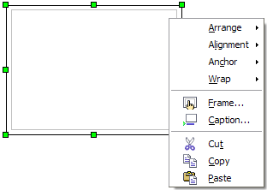

* 1. Working with page styles

In Writer, page styles define the basic layout of pages, including page size, margins, headers and footers, borders and backgrounds, number of columns, and so on.

Writer comes with several page styles, which you can modify as you wish, and you can define your own. You can have one or many page styles in a single document.

|  |  |
| --- | --- |
| Note | All pages in a Writer document are based on styles. If you do not specify a page style, Writer uses the Default page style. |

To change the layout of individual pages, either define a new page style or use one of the techniques (sections, frames, or tables) described in Chapter 4 (Formatting Pages).

This section describes one use of page styles. Other uses are discussed in Chapter 6 (Introduction to Styles) and Chapter 4 (Formatting Pages).

|  |  |
| --- | --- |
| **Tip** | Any modifications of page styles, including the **Default** page style, apply only to the document you are working on. If you want the changes to be the default for all documents, you need to put the changes into a template and make that template the default template. See Chapter 10 (Working with Templates) for details. |

* + 1. Setting up a book chapter sequence of pages

Book chapters typically start on a right-hand page, with the first page of the chapter having a different layout from the rest of the pages. The other pages in the chapter are “mirrored” for double-sided printing. For example, page numbers in the header or footer may be positioned on the outside edge of pages and a wider margin (allowing for binding) may be placed on the inside edge.

shows the properties of two page styles (**Right Page** and **Default**) set up for a typical book chapter’s sequence of pages.

Table 3. Properties of customized page styles to be used in a book chapter

|  |  |  |
| --- | --- | --- |
| ***Page Style*** | ***Desired effect*** | ***Property: setting*** |
| Right Page | |  |  | | --- | --- | | First page always on the right (an odd numbered page) | Page > Page layout > Only right | | No header or footer | Header > Header > Header on: Not selected | | Top margin of page larger than on other pages | Page > Margins > Top: 6.00cm | | |
| Default | |  |  | | --- | --- | | Mirrored margins | Page > Page layout: Mirrored | | Header with page number on the top outside of the page and chapter title in the top middle center of the page | Header > Header on: Selected  Header > Header > Same content left/right: Not selected | | |

illustrates the transitions from Right Page to Default, with the change of header between left and right pages shown by the # symbol.

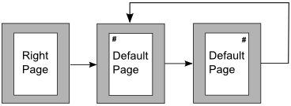

To apply this page scenario:

1. Set up the page styles.
   1. On the Styles and Formatting window, click the **Page Styles** icon  (fourth from left) to display a list of page styles.
   2. Right-click on Right Page and select Modify from the pop-up menu.
   3. On the Organizer page of the Page Style: Right Page dialog box (), change Next Style to Default.

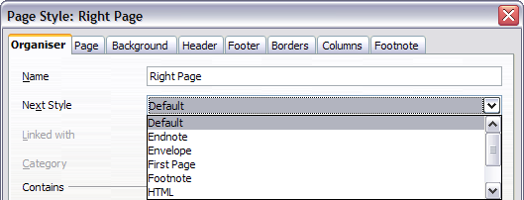

* 1. On the Page page (), specify a larger left margin for binding, and a larger top margin to move the chapter title down the page.
  2. On the Header and Footer pages, be sure the Header on and Footer on checkboxes are not selected. Click OK to save your changes.
  3. On the Styles and Formatting window, in the list of page styles, right-click on Default and select Modify from the pop-up menu.
  4. On the Organizer page of the Page Style: Default dialog box, be sure Next Style is Default.

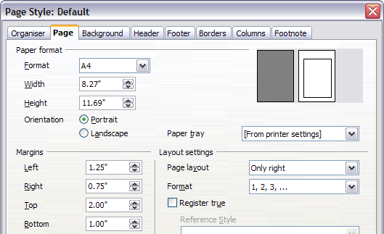

* 1. On the Page page of the Page Style: Default dialog box (), select Mirrored for Page layout and set the Inner and Outer margins to the same width as the Left and Right margins, respectively, on the Right Page style.

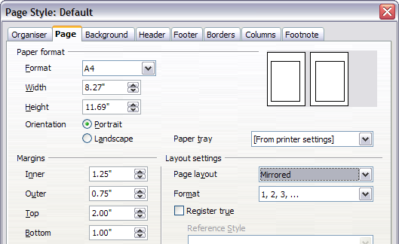

* 1. On the Header page of the Page Style: Default dialog box (), select the Header on checkbox and deselect the Same content left/right checkbox. Click OK to save your changes.

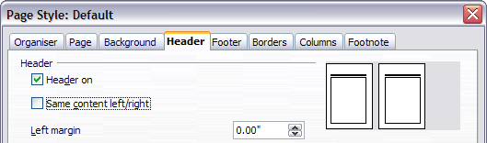

1. Set up the Heading 1 paragraph style to start on a new right-hand page.
   1. In the Styles and Formatting window, right-click on Heading 1 and select Modify.
   2. On the Text Flow page of the Paragraph Style dialog box (), in the Breaks section, select Insert,With Page Style, and Right Page. Click OK to save your changes.

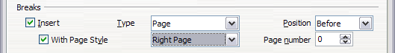

1. To start a new chapter, apply the paragraph style Heading 1 to the first paragraph, which will be the title of the chapter.

|  |  |
| --- | --- |
| Note | By default, paragraph style Heading 1 is assigned to Outline Level 1. The assignment of paragraph styles to outline levels is done through Tools > Outline Numbering. |

1. To set up the headers:
   1. On a left page, put the cursor in the header and insert a page number field on the left (Insert > Fields > Page Number).
   2. Press Tab to put the cursor in the middle and insert a Chapter reference:

Press Control+F2 to display the Fields dialog box ().

On the Document page, for Type select Chapter and for Format select Chapter name. Make sure that Layer is set to 1, and then click Insert.

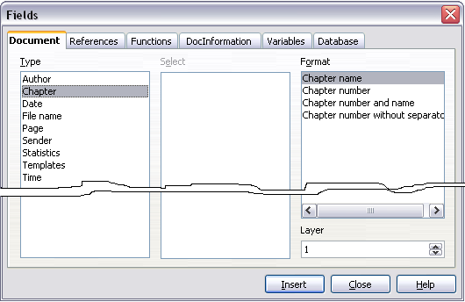

* 1. On a right page, put the cursor in the header, press Tab, insert a Chapter reference, press Tab again, and insert a page number field.

1. If you need to adjust the tab stops for the header, modify the Header paragraph style. Do not manually adjust the tab stops.



Writer Guide

1. Chapter 8  
    Working with Graphics
   1. Graphics in Writer documents

When you create a text document using OpenOffice.org Writer, you may need to include some graphic illustrations.

Graphics in Writer are of three basic types:

* Graphic and image files, including photos, drawings, scanned images, and others
* Diagrams created using Writer’s drawing tools
* Charts created using OOo’s Chart facility

This chapter covers the first two types of graphic illustrations. Most parts of this chapter also apply to the other components of OOo.

* 1. How to add a graphic from a file

OpenOffice.org can import various vector (line drawing) and raster (bitmap) file formats. The most common are GIF, JPEG or JPG, PNG, and BMP. See “” on page for a full list of supported graphic file types.

Graphics may bedownloaded from the Internet, scanned, created with a graphics program, or they may be photos taken with a digital camera. Some questions come to mind:

* How is a graphic inserted?
* Should the graphic be includedin the document, or should it be linked to the file?
* How can the size of the graphic be adjusted?
* How can the relative position between the graphic and the text be changed?

These questions will be discussed in order.

* + 1. Inserting a graphic from a file

To insert a graphic image from a file, the file must be already stored in a directory (folder) on the computer.

Proceed as follows:

1. Determine the destination for the image. For example, place the cursor at the appropriate location in the document.
2. On the main menu, select Insert > Picture > From File. This displays the dialog box shown in .
3. Navigate to the file to be inserted.
4. Select the file to insert and click **Open**.

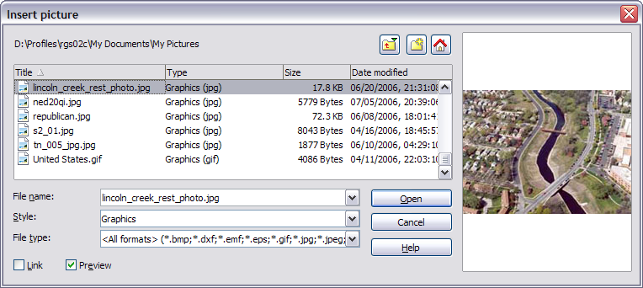

|  |  |
| --- | --- |
| Note | At the bottom of the Insert picture dialog box () are two check boxes. If the Preview checkbox is checked, the selected graphic file is previewed in a pane, as shown in , so you can verify that you have the correct file. The **Link** checkbox is discussed below. |

* + - 1. Linking a graphic file

If the **Link** checkbox in the Insert picture dialog box is checked, OOo will create a link to the file containing the graphic, instead of saving a copy of the graphic in the document. The result is that the figure will be displayed in the document, but when the document is saved, it will contain only a reference to the graphic file but not the graphic itself. The document and the image remain as two separate files, and they are merged together only when you open thedocument again.

Linking an image has two advantages and one disadvantage:

* Advantage – Linking can reduce the size of the document when it is saved because the image file itself is not included.
* Advantage – You can modify the image file separately without changing the document because the link to the file remains valid, and the modified image will appear when you next open the document.
* Disadvantage – If you send the document to someone else, you must also send the image file, or the receiver will not be able to see the linked image.
  + 1. Resizing a graphic

It is possible, and quite likely, that the inserted image will not fit perfectly into the document because it is too big or too small. Therefore, you will probably need to resize the image.

The position of the image is not relevant for now. Changing the position of an image relative to the text is discussed in “” on page .

You can modify the size of a graphic in two ways:

* Unscaled resize
* Scaled resize

shows three examples of an image inserted into a document and resized.

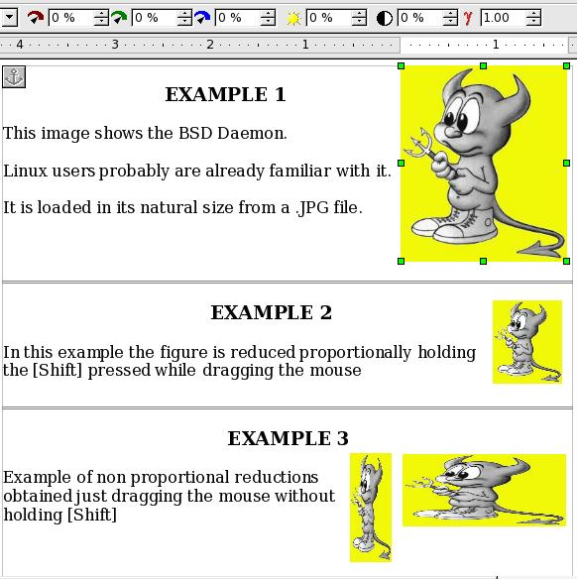

* + - 1. Unscaled resize

In Example 1, the image is in its natural size. When you add a new graphic (and also when you select an existing one by clicking on it), it displays some square points along its perimeter; these are called handles. To resize the graphic:

1. Move the cursor onto a point.
2. Click the left mouse button.
3. Drag the mouse to modify the size of the figure.

This basic resizing process is useful if you need to specify the size and the height independently of each other. The problem with this method, as demonstrated in Example 3, is that when the graphic is not changed to scale, it will be distorted.

You need to either carefully measure and calculate how much the image needs to be adjusted in both the horizontal and vertical directions in order to maintain the correct proportions or use the scaled resize method described below.

* + - 1. **Scaled resize**

A scaled resize is usually the best option, because it automatically maintains the proportions of the graphic. To perform a scaled resize:

1. Press and hold the Shift key.
2. Click and drag a handle of the graphic. It will resize proportionally, as shown in EXAMPLE 2.
3. Release the mouse button to complete the resize.
   * 1. **Inserting images from other sources**

You can insert images from sources other than a file. The possible sources for images are:

* Graphics program
* Scanner
* OOo Gallery
  + - 1. **From a graphics program**

You can use many different graphics programs to edit a graphic file. Inthese programs, you can select, copy, and paste an image or part of a graphic into an OpenOffice.org document. shows an example of this procedure, which can be recreated with these steps:

1. In the imaging program window, select an area of the image to be copied. (The program used in the example is Paint Shop.)
2. Move the cursor over the selected area and press Control+C to copy.

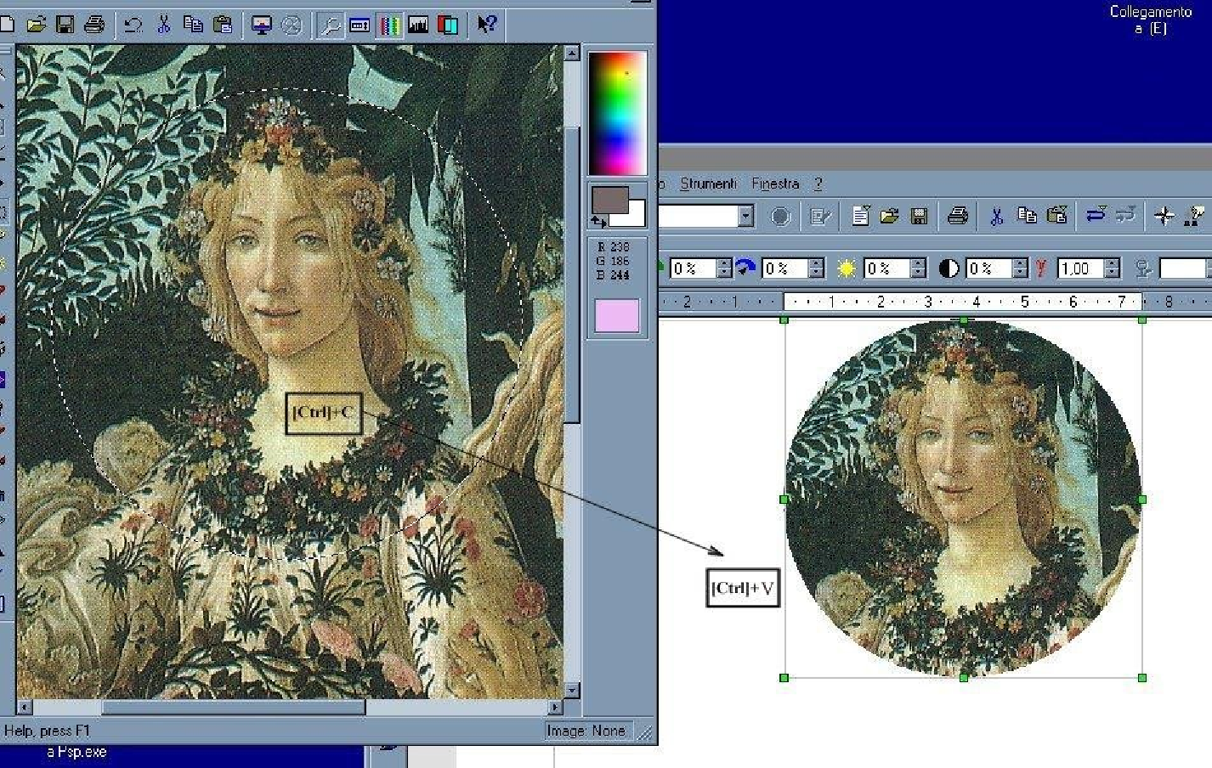

1. Switch to the OpenOffice.org Writer window.
2. Click to insert the cursor where the graphic is to be inserted.
3. Press Control+Vto paste.
   * + 1. **Scanner**

If a scanner is connected to your computer, OpenOffice.org can call the scanning application. The scanned item will then be added into the OOo document page as an image. To start this procedure, on the main menu select Insert > Picture > Scan > Select Source.

* + - 1. **OpenOffice.org Gallery**

The Gallery is available in all components of OpenOffice.org. For an introduction to the Gallery, see Chapter 14 (Working with the Gallery) in the *Getting Started* guide.

You can select a graphic from the Gallery and drag it into the document. The Gallery icon is located in the right side of the Function Bar.Proceed as follows:

1. Click on the **Gallery** icon .
2. Select the theme containing the image you want to insert.
3. Click on the image with the left mouse button and, holding the button pressed, drag the image into the document.
4. Release the mouse button.

shows an example of an image dragged from the Gallery.

* 1. **Adding an image to the Gallery**

You may wish to add to the Gallery any images that you use frequently, for example, a company logo. You can then very easily insert these graphics into a document later.

To add images to the Gallery, proceed as follows:

1. Open the Gallery.
2. Select the theme where you want to add images, or you can create a new theme. To create a new theme:

* Click the New Theme button above the list box of Themes. The Properties of New Theme dialog box opens, which is similar to the one shown in .
* Select the General tab and enter an appropriate name for the new theme in the text box.
* Select the Files tab, skip step 3, and continue with step 4.

1. Right-click on the desired theme and select **Properties** in the pop-up menu. This will display a window from which to select the files to be added (see ).
2. On the Files page, click the **Find Files** button. The Select path dialog box opens.
3. You can enter the path for the file's directory in the Path text box, or you can navigate to locate the file's directory.
4. Use the File type drop-down list to help limit the search.
5. Press the **Select** button to start the search.
6. A list of graphic files will be displayed in the window. You can use the File type filter again to further limit the search.
7. Select the files to add. To select more than one file, hold the *Control* key down while you click on each file.
8. Finally, click **Add**.
9. When you have finished working with the Gallery, you can click on its icon  to close it.

|  |  |
| --- | --- |
| Note | This procedure assumes that the graphic files for the themes already exist. You may need to import some graphics or to create your own onto your computer if the existing files are insufficient. |

|  |  |
| --- | --- |
| Note | Similar to the file search function on various operating systems, Find Files searches for graphic files in any subfolders of the directory selected in step 5. |

* 1. **Modifying an image**

When you insert a new imageor select one already present in the document, the Picture toolbar appears. This toolbar can be either floating or docked. shows what the Picture toolbar looks like when it is floating. Two other toolbars can be opened from this one: the Graphic Filter toolbar, which can be torn off and placed elsewhere on the window and the Color toolbar, which opens as a separate floating toolbar.

From these toolbars, you can apply small corrections to the graphic or obtain special effects.

|  |  |
| --- | --- |
| Note | For more sophisticated adjustments, it is better to use an image manipulation program, such as GIMP. GIMP is an open-source graphics program which can be downloaded from <http://www.gimp.org/downloads/>. |

You can find out more information about the graphic filter and what its elements do by selecting the Find tab in Help (Help > OpenOffice.org Help), pressing the F1 key, or by clicking on an element that has a dialog box and selecting Help. Then, type Graphic Filter Bar into the Search termtext box and press Find.

|  |  |
| --- | --- |
| **Note:** Graphics mode (3) can be Default, Grayscale, Black/White, or Watermark.  Figure 258. Picture toolbar plus tear-off Graphic Filter toolbar and floating Color toolbar | **1** From File  **2** Filter  **3** Graphics mode  **4** Color  **5** Transparency  **6** Flip Horizontally  **7** Flip Vertically  **8** Graphics Properties  **9** Invert  **10** Smooth  **11** Solarization  **12** Aging  **13** Charcoal Sketch  **14** Relief  **15** Mosaic  **16** Posterize  **17** Pop Art  **18** Sharpen  **19** Remove Noise  **20** Red  **21** Green  **22** Blue  **23** Brightness  **24** Contrast  **25** Gamma |

provides examples of some of the changes available on the Picture toolbar.

|  |  |  |  |
| --- | --- | --- | --- |
| Original Image | Mirrored Vertically | Mirrored Horizontally | Light 50% |
|  |  |  |  |
| Contrast 50% | Red 50% | Green 50% | Blue 50% |
|  |  |  |  |

Figure 259. Some graphic effects that can be changed from the Picture toolbar

* 1. Positioning graphics within the text

When you add a graphicto a text document, you need to choose how to position the graphic with respect to the text and other graphics.

Graphic arrangement refers to the placement of a graphic behind or in front of other graphics or text. Alignment refers to the vertical or horizontal placement of a graphic in relation to the page, frame, paragraph, or character to which it is anchored. Text wrapping refers to the relation of graphics to surrounding text, which may wrap around the graphic on one or both sides, be overprinted behind or in front of the graphic, or treat the graphic as a separate paragraph or character.

* + 1. **Arranging and aligning graphics**

You can arrange and align graphics using commands from:

* The main menu: Format > Alignment (or **Arrange**, **Wrap**, **Anchor**, **Flip**,**...)**
* By right-clicking on the picture, then Format > Alignment (or **Arrange**, **Wrap**, or **Anchor**)
* Frame (with the Graphics frame style applied) toolbar
* Picture dialog box
  + - 1. **Frame toolbar**

When you select a graphic, the Frame toolbar (shown in ) may be displayed.

Here you can click icons to apply many arrangement, alignment, wrapping, anchoring, formatting, and other choices.

* + - 1. **Picture dialog box**

Click on the graphic to select it and then click **Format > Picture**, or right-click on the graphic and then click **Picture**on the pop-up menu, to display the Picture dialog box (). Here you can specify the characteristics of the graphic and its placement in detail.

* + 1. **Wrapping text around graphics**

On the main menu, click **Format>Wrap**. The Wrap menu options provide several possibilities:

* Alternate paragraphs and graphics, maintaining a separation between them (Wrap Off).
* Wrap text around the graphics (Page Wrap or Optimal Page Wrap).
* Put a semi-transparent graphic over the text (Wrap Through).
* Add a graphic in the background (In Background).

Often you need to insert graphics with no text around them, as in this chapter. To set the position of an image to the Wrap Off format,follow these steps:

1. Select a graphic by clicking on it.
2. Right-click to display the context menu and move the mouse pointer to Wrap to display the various wrap modes.
3. Select No Wrap.

shows an example of this operation.

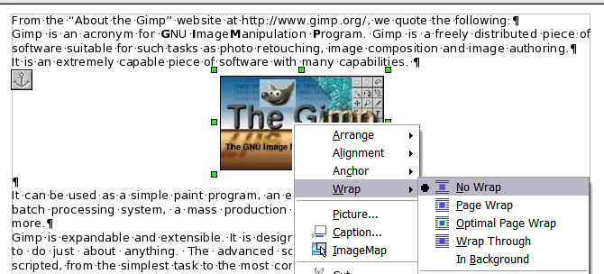

When formatting some documents, such as newsletters, you may want to put photos mixed with text or just want to add some decorative images. The Page Wrap option may satisfy this need. shows an example of a graphic insertion with the Page Wrap option.

When an image is inserted with the Page Wrap option, you can move it anywhere on the page. The text will be automatically adjusted around the image, like water around a sailing boat.

The Optimal Page Wrap option is similar to Page Wrap, but it maintains the text positioned beside the image. The position is decided automatically in order to optimize the relative position between text and image.

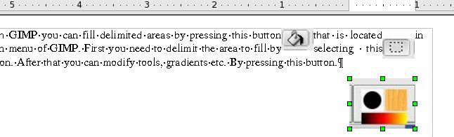

Double-clicking on an image pops up the Picture dialog box where you can set all the parameters affecting the image (see ). On the Wrap page, you can change the setting for the optimal page wrap.

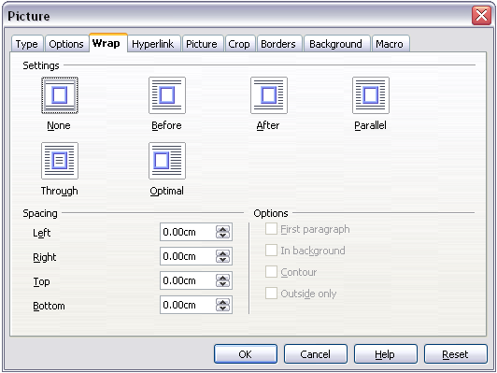

The Wrap Throughoptionlets you also insert an image overlapping the text. In this case, some part of the text will be hidden, unless you change the transparency of the image.

After changing the transparency, the final result looks like a decal applied over the text, as in , where the transparency has been set to **48%** in the Transparency spinbox in the Picture toolbar. The words under the image are visible but appear lighter than the rest of the text.

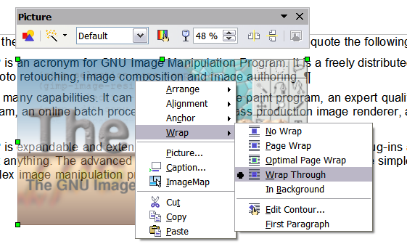

You can obtain a similar result if you set a graphic’s wrap to the In Background format. In this case all the text will be clearly readable, with characters that have the same intensity. However, the background graphic should not be dark; otherwise, the text could be difficult to read. You can also use the Transparency spinbox to control the “transparency”.

* 1. **Anchoring graphics and drawing objects**

You can anchor graphics as a character or to a page, paragraph, or character. You can also place graphics in a frame and anchor the frame to a page, paragraph, or character. Which method you choose depends on what you are trying to achieve.

Here are the ways you can anchor graphics or drawing objects:

**To Page**The graphic keeps the same position in relation to the page margins. It does not move as you add or delete text or other graphics. This method is useful when the graphic does not need to be visually associated with a particular piece of text. It is often used when producing newsletters or other documents that are very layout intensive.

|  |  |
| --- | --- |
| Caution | If you plan to use a document within a master document, do not anchor graphics To Page, because the graphics will disappear from the master document. See Chapter 13 (Working with Master Documents) for more information. |

**To Paragraph**The graphic is associated with a paragraph and moves with the paragraph. It may be placed in the margin or another location. This method is useful as an alternative to a table for placing icons beside paragraphs.

**To Character**  
The graphic is associated with a character but is not in the text sequence. It moves with the paragraph but may be placed in the margin or another location. This method is similar to anchoring to a paragraph but cannot be used with drawing objects.

**As Character**The graphic is placed in the document like any other character and, therefore, affects the height of the text line and the line break. The graphic moves with the paragraph as you add or delete text before the paragraph. This method is useful for keeping screenshots in sequence in a procedure or for adding a small icon in sequence in a sentence.

**To Frame**If the graphic has been placed in a frame, you can anchor the graphic in a fixed position inside the frame. The frame can then be anchored to the page, a paragraph, or a character, as required.

* 1. **Adding captions to graphics**

You can add captions to graphics in three ways: automatically, by using the Caption dialog box, or manually.

* + 1. **Adding captions automatically**

You can set up OOo to add captions automatically whenever you insert a graphic, a table, or other objects into a document. You can choose which objects are captioned automatically, what the sequence name is for each caption (for example, “Table” or “Illustration”), and the position of the caption.

To set up automatic captions:

1. Click **Tools > Options > OpenOffice.org Writer**. Click on the **+** sign to open the different options. The Options – OpenOffice.org Writer – AutoCaption dialog box opens.
2. Select **AutoCaption**. Now you can see several choices at the right of the dialog box for adding captions automatically.
3. On the AutoCaption dialog box, choose which objects will be automatically captioned and specify the characteristics of the captions.

For more information, see “AutoCaption options” in Chapter 2 (Setting up Writer).

When you insert a graphic, if automatic captioning is enabled, the graphic will be placed in a frame along with a caption containing the default sequence name for graphics―Illustration. Position the cursor in the caption area and type the text for the caption. You can change the sequence name by selecting one from the drop-down Category list.

|  |  |
| --- | --- |
| Note | You can specify where to place an automatic caption for any object except a picture; picture captions can only be automatically placed below the picture. If you need a caption above the picture (for example, for data plots in scientific publications), you must add the captions manually, as described in “” on page . |

|  |  |
| --- | --- |
| **Tip** | A common sequence name—Figure—is not one of the names provided: **<None>**, **Drawing**, **Illustration**, **Table**, and **Text**. If you want a custom name for your graphics, do the following:   1. Open the Options – OpenOffice.org Writer—AutoCaption dialog box, described above. 2. Under the Add captions automatically when inserting section, check OpenOffice.org Writer Picture. 3. With the mouse, highlight the text Add captions automatically when inserting, if it is not already highlighted. This actives the Caption area in the dialog box for pictures (graphics). 4. Under the Category drop-down list, enter the name that you want added (say, Figure), by overwriting any sequence name in the list. (Overwriting the term will not delete it from the drop-down list.) You can also set some options for the number style and for a separator between the name and the number, if desired. Click **OK** to save the changes. |

* + 1. **Using the Caption dialog box**

To add captions using the Caption dialog box:

1. Insert the graphic, then select it and click **Insert > Caption**.
2. Under Properties on the Caption dialog box (), make your selections for the Category, Numbering, and Separator fields (**Illustration**, **Arabic (1 2 3)**, and a colon (**:**), respectively, for the example in ) and type your caption text in the Caption text box at the top. Whatever text you enter for the caption appears in the box at the bottom, after the sequence name, number, and separator.
3. Click **OK**. The graphic and its caption are placed in a frame, as shown in .

|  |  |
| --- | --- |
| **Tip** | In the Category box, you can type any name you want, for example, Figure. OOo will create a numbering sequence using that name. |

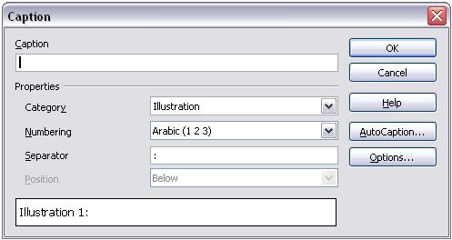

|  |  |
| --- | --- |
| **Tip** | In the Category box, you can type any name you want, for example, Figure. OOo will create a numbering sequence using that name. |

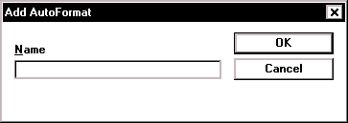

Figure 266. An example of a graphic and its caption contained in a frame. The outer box shows the edge of the frame; this border is normally set to be invisible.

* + 1. **Adding captions manually**

You can add a caption to a graphic manually in two ways.

* + - 1. Method 1: Override the category and positioning defaults for captions

1. Select the picture, right-click on it, and select **Caption**.
2. On the Caption dialog box (), select <None> in the Category list and click **OK**.
3. Right-click on the picture and select Caption. Now you can select a caption type (or type your own sequence category) in the Category drop-down list and, optionally, select Above in the Position list. (If you want the caption to appear at the top, you must add the caption manually.) You can type the actual caption in the box under Caption or you can fill it in later—after the (incomplete) caption is inserted.
4. Click **OK**.

|  |  |
| --- | --- |
| Note | If you want the caption to appear at the bottom, you can skip skip 2 and the first part of step 3. |

* + - 1. Method 2: Place the graphic and its caption in separate paragraphs

1. Insert the graphic and anchor it to its paragraph as a character. Press Enter to create a new paragraph for the caption.
2. In the caption paragraph, type, for example, ***Figure*** and add a space.
3. To insert the figure number, click **Insert > Fields > Other** and select the Variablestab.
4. Select Number range in the Type list. Select Figure in the *Selection*list and choose, for example, **Arabic (1 2 3)** in the *Format* drop-down list. Click the **Insert** button.
5. A number will appear after the word “Figure” in the caption. Now, type the text of the caption.

|  |  |
| --- | --- |
| Tips | If you are manually adding captions to a lot of figures using Method 2, you might want to make an AutoText entry containing, for example, Figure and a space, the figure-number field, and an optional separator and a space after it.  You can also place the caption paragraph before (above) the picture paragraph. Using AutoText can be a convenient way to deal with the lack of automatic captioning above pictures. |

* 1. Using Writer’s drawing tools

You can use Writer’s drawing tools to create graphics, such as simple diagrams using rectangles, circles, lines, text, and other objects. Group the drawing objects to make sure they stay together the way you intended.

You can use the drawing tools to place drawing objects directly on a page in your document, or you can insert the drawing objects into a frame.

You can also use the drawing tools to annotate photographs, screen captures, or other illustrations produced by other programs, but this is not recommended because:

* You cannot include graphics in a group with drawing objects, so they may get out of alignment in your document.
* If you convert a Writer document to another format, such as HTML, the drawing objects and the graphics will not remain associated; they will be saved separately.

Instead, use OOo Draw or another graphics program to annotate illustrations.

* + 1. **Creating drawing objects**

To begin using the drawing tools, display the Drawing toolbar (), by clicking   
**View** > **Toolbars** > **Drawing**.

If you are planning to use the drawing tools repeatedly, you can tear off this toolbar and move it to a convenient place on the window.

To use a drawing tool:

1. Click in the document where you want the drawing to be anchored. You can change the anchor later, if necessary.
2. Select the tool from the Drawing toolbar (). The mouse pointer changes to a drawing-functions pointer .
3. Move the cross-hair pointer to the place in the document where you want the graphic to appear and then click-and-drag to create the drawing object. Release the mouse button. The selected drawing function remains active, so you can draw another object of the same type.
4. To cancel the selected drawing function, press the Esc key or click on the Select icon (the arrow) on the Drawing toolbar.
5. You can now change the properties (fill color, line type and weight, anchoring, and others) of the drawing object using either the Drawing Object Properties toolbar () or the choices and dialog boxes reached by right-clicking on the drawing object.
   * 1. **Setting or changing properties for drawing objects**

To set the properties for a drawing object before you draw it:

1. On the Drawing toolbar (), click the Select tool.
2. On the Drawing Object Properties toolbar (), click on the icon for each property and select the value you want for that property.
3. For more control, or to define new attributes, you can click on the Area or **Line**icons on the toolbar to display detailed dialog boxes.

The default you set applies to the current document and session. It is not retained when you close the document or close Writer, and it does not apply to any other document you open. The defaults apply to all the drawing objects except text objects.

To change the properties for an existing drawing object:

1. Select the object.
2. Continue as described above.

You can also specify the position and size, rotation, and slant and corner radius properties of the drawing object:

1. Right-click on the drawing object and then click **Position and Size**from the pop-up menu. The Position and Size dialog box is displayed.
2. Choose any properties, as required.
   * 1. **Grouping drawing objects**
3. Select one object, then hold down the *Shift* key and select the others you want to include in the group. The bounding box expands to include all the selected objects.
4. With the objects selected, hover the mouse pointer over one of the objects and click either **Format > Group > Group** or right-click and then click **Group > Group** on the pop-up menu.

|  |  |
| --- | --- |
| Note | You cannot include an embedded or linked graphic in a group with drawing objects. |

* 1. Graphic file types supported

OpenOffice.org Writer can open the file types listed in . Many of these file types are hyperlinked to Wikipedia for their definitions and other information.

Table 4. Graphic file types supported by OpenOffice.org Writer

|  |  |
| --- | --- |
| File extension | File type |
| BMP | [Windows Bitmap](http://en.wikipedia.org/wiki/Windows_bitmap) |
| DXF | [AutoCAD Drawing Interchange (Exchange) Format](http://en.wikipedia.org/wiki/AutoCAD_DXF) |
| EMF | [Enhanced Metafile](http://en.wikipedia.org/wiki/Enhanced_Metafile) |
| EPS | [Encapsulated PostScript](../Encapsulated%20PostScript) |
| GIF | [Graphics Interchange Format](http://en.wikipedia.org/wiki/GIF) |
| JPG, JPEG, JFIF, JIF | [Joint Photographic Experts Group](http://en.wikipedia.org/wiki/JPEG) |
| MET | OS/2 Metafile |
| PBM | [Portable Bitmap](http://en.wikipedia.org/wiki/Portable_pixmap) |
| PCD | [Kodak Photo CD](http://en.wikipedia.org/wiki/Photo_CD) |
| PCT | [Macintosh QuickDraw PICT](http://en.wikipedia.org/wiki/PICT) |
| PCX | [Zsoft PC Paintbrush](http://en.wikipedia.org/wiki/PCX) |
| PGM | [Portable Graymap](http://en.wikipedia.org/wiki/Portable_Graymap_File_Format) |
| PNG | [Portable Network Graphics](http://en.wikipedia.org/wiki/.PNG) |
| PPM | [Portable Pixelmap](http://en.wikipedia.org/wiki/Portable_pixmap) |
| PSD | [Adobe Photoshop Document](http://en.wikipedia.org/wiki/Photoshop#File_formats) |
| RAS | Sun Raster Image |
| SGF | StarWriter Graphics Format |
| SGV | StarDraw 2.0 |
| SVM | StarView Metafile |
| TGA | [Truevision Targa](http://en.wikipedia.org/wiki/TGA) |
| TIF, TIFF | [Tagged Image File Format](http://en.wikipedia.org/wiki/TIF) |
| WMF | [Windows Metafile](http://en.wikipedia.org/wiki/Windows_Metafile) |
| XBM | [X Bitmap](http://en.wikipedia.org/wiki/X_BitMap_Format) |
| XPM | [X PixMap](http://en.wikipedia.org/wiki/XPM_(image_format)) |



Writer Guide

1. Chapter 9  
    Working with Tables

Using OpenOffice.org Writer

* 1. Introduction

Tables are a useful way to organize and present large amounts of information, for example:

* Technical, financial, or statistical reports
* Product catalogs showing descriptions, prices, characteristics, and photographs of products
* Bills or invoices
* Lists of names with address, age, profession, and other information

Tables can often be used as an alternative to spreadsheets to organize materials. A well-designed table can help readers understand better what you are saying. While you would normally use tables for text or numbers, you could put other objects, such as pictures, in cells.

Tables can also be used as a page-layout tool to position text in areas of a document instead of using several Tab characters. For example, the descriptions under were created in a table with invisible borders. Another, perhaps better example would be in headers and footers to support independent positioning of different elements, such as page number, document title etc. This use of tables is described in Chapter 4 (Formatting Pages).

* 1. The Table menu and toolbar

Table commands are located in the main **Table**menu and on the Table toolbar, shown in . describes the functions of these commands and icons. When you create a table or select an existing table, the Table toolbar may be displayed automatically, or you can manually display the Table toolbar by clicking View > Toolbars > Table. The toolbar can float on top of the main Writer window (as illustrated in ), or it can be docked along any edge of the main window.

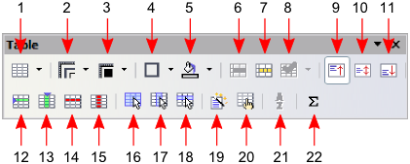

Table 5: Functions of the icons on the Table toolbar

|  |  |
| --- | --- |
| Icon Name | Description |
| Table | Opens the Insert Table dialog box where you can set up and insert a table into the document, name the table for use with the Navigator, and set some options. You can also use the mouse to click the arrow at the right, drag to select the number of rows and columns to include in the table, and then release the mouse button on the last (lower right) cell. |
| Line Style | Opens the Border Style toolbar where you can modify the border line style. |
| Line Color (border) | Opens the Border Color toolbar where you can modify the border color. |
| Borders | Opens the Borders toolbar where you can select sides to have a border. |
| Background Color | Opens the Background toolbar where you can select the background color. |
| Merge Cells | Combines the selected cells into a single cell. Refer to “” on page for an example of using this button. |
| Split Cells | Opens the Split Cell dialog box where you can define how to split a cell. Refer to “” on page for an example of using this button. |
| Optimize | Opens the Optimize toolbar where you can distribute the columns or rows evenly or optimize the row height or column width. |
| Top | Aligns the contents of the selected cells to the top of the cell. |
| Center (vertical) | Aligns the contents of the selected cells to the vertical center of the cell. |
| Bottom | Aligns the contents of the selected cells to the bottom of the cell. |
| Insert Row | Inserts a row below the selected row. |
| Insert Column | Inserts a column after the selected column. |
| Delete Row | Deletes the selected row(s) from the table. |
| Delete Column | Deletes the selected column(s) from the table. |
| Select Table | Selects the entire table. |
| Select Column | Selects the column in which the cursor is positioned. |
| Select Row | Selects the row in which the cursor is positioned. |
| AutoFormat | Opens the AutoFormat dialog box where you can select among several predefined formatting sets. Each set is characterized by its own fonts, shading, and borders styles. You can also select AutoFormat from the Insert Table dialog box. |
| Table Properties | Opens the Table Format dialog box where you can modify various properties for the table—for example: name, alignment, spacing, column width, borders, and background. |
| Sort | Opens the Sort dialog box where you can specify the sort criteria for the selected cells. |
| Sum | Activates the sum function. Refer to “” on page for an example of using this function. |

* 1. Creating a table

Before you insert a table into a document, it is beneficial to have an estimate of the number of rows and columns required. However, if necessary, you can easily make changes later.

* + 1. Inserting a new table

To insert a new table, position the cursor where you want the table to appear, then use any of the following methods to open the Insert Table dialog box (shown in ):

* From the main menu, select Table > Insert > Table.
* Press Control+F12.
* From the Standard toolbar, click the Table icon .

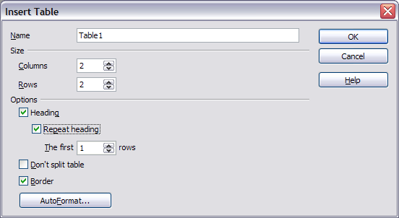

Here you can specify the properties for the new table.

Under Name, you can enter a different name than the OOo-generated default for the table. This might come in handy in case you want the tables displayed in the Navigator in a certain (sorted) way.

Under Size, specify the initial number of columns and rows for the new table. You can change the size of the table later, if necessary.

Under Options, set up the initial table characteristics. Selecting the check boxes in this section of the dialog produces the following results:

* Heading— Defines the first row(s) in the table as headings. The default Table Heading paragraph style is applied to the heading rows and thus makes the text centered, bold, and italic. The OOo predefined Table Heading paragraph style may be modified in the Styles and Formatting window, if desired.
* Repeat heading— Repeats the heading row(s) of the table at the top of subsequent pages if the table spans more than one page.

The first ... rows—Specifies the number of rows to be repeated. Default is 1.

* Don’t split table— Prevents the table from spanning more than one page. This can be useful if the table starts near the end of a page, and would look better if it were completely located on the following page. If the table becomes longer than would fit on one page, you will need to either de-select this check box or manually split the table.
* Border— Surrounds each cell of the table with a border. This border can be modified or deleted later.

The AutoFormat button opens a dialog from where it is possible to select one of the many predefined table layouts. See “” on page for more information.

After making your choices, click OK. Writer creates a table as wide as the page margins, with all columns the same width and all rows the same height. You can then adjust the columns and rows later to suit your needs.

|  |  |
| --- | --- |
| Tip | To directly insert a table with the default properties, click on the little arrow next to the Table icon on the Standard toolbar. A graphic appears where you can choose the table’s size (rows and columns). To create the table, click on the cell that you want to be on the last row of the last column. Holding down the mouse button over the Table icon will also display the graphic. |

* + 1. Creating nested tables

With OpenOffice.org 2.0 it became possible to create tables within tables, nested to a depth only limited by imagination and practicality. demonstrates a simple, 2 level example.

To achieve this, simply click in a cell of an existing table and use any of the methods mentioned in “” above.

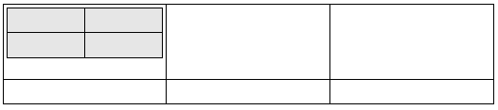

* + 1. Using AutoCorrect to create a table

You can also create a table by typing a series of hyphens (-) or tabs separated by plus signs. For example, type: +------+---+ and then press Enter. Plus signs indicate column dividers, while hyphens and tabs indicate the width of a column.

For example, this character sequence:

+-----------------+---------------+------+

creates a table like this:

|  |  |  |
| --- | --- | --- |
|  |  |  |

|  |  |
| --- | --- |
| Note | This function can be disabled or enabled in Tools > AutoCorrect. On the Options tab, deselect or select the Create table check box. This function does not operate when creating nested tables. |

|  |  |
| --- | --- |
| Caution | Always be careful when using tabs that you (a) know how wide they are set and (b) make sure that the tabs are set to the same values if used with other documents or by other users. |

* 1. Formatting a table
     1. Default parameters

If you create a table using the Insert Table dialog box or the Table icon on the Standard toolbar, the following defaults are set:

* The cells in the first row use the Table Heading paragraph style. In the default template, the text is centered and set with a bold and italic font.
* The remaining cells use the Table Contents paragraph style, which, in the default template, is identical to the Default paragraph style.
  + 1. Formatting individual cells

You can format each cell independently of other cells. For example, you can:

* Format the characters — change the font, the font style, and the background colors.
* Set different indentation values — when you select a cell, the horizontal ruler shows the indentation points with gray pentagons. Vary the indentation by clicking and dragging these points.
* Change the text alignment — for example, a number can be aligned to the right, while text on another line in the cell is aligned to the left or centered.

To change the format of a cell or range of cells:

1. Select the cell or range of cells to be modified. You can select a single cell by clicking in it, select a range with click and drag, or select a row or column using menu or toolbar choices.
2. Right-click the selection and select Table, or select Table > Table Properties from the menu bar.
3. From the Table Format dialog box, select the property to modify.

shows some examples.

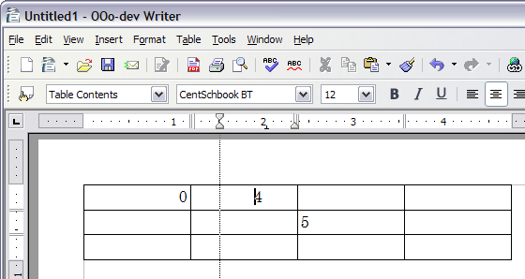

* + 1. Inserting rows and columns

To insert any number of rows or columns:

1. Place the cursor in the row or column where you want new rows or columns to be inserted and right-click. On the pop-up menu, select Row > Insert or **Column > Insert**. This will display a dialog box where you can select the number of rows or columns to add before or after the selected one.
2. Set Amount to the number of rows or columns to insert and Position to Before orAfter. Click OK to close the dialog box.

|  |  |
| --- | --- |
| Notes | Clicking on the Insert Row icon on the Table toolbar inserts one row below the selected one. Clicking on the Insert Column icon on the Table toolbar inserts a column after (to the right of) the selected one.  Regardless of how they are inserted, new rows or columns have the same formatting as the row or column where the cursor was when the insert command was issued. |

* + 1. Merging and splitting cells

To merge a group of cells into one cell:

1. Select the cells to merge.
2. Right-click and select Cell > Merge on the pop-up menu, or select Table > Merge Cells from the menu bar.

To split a cell into multiple cells:

1. Position the cursor inside the cell.
2. Right-click and select Cell > Split on the pop-up menu, or select Table > Split Cells from the menu bar.
3. Select how to split the cell. A cell can be split either horizontally (create more rows) or vertically (create more columns), and you can specify the number of new cells to create.
   * 1. Merging and splitting tables

A whole table can be split into two tables, and two tables can be merged into a single table. Tables are split only horizontally (the rows above the split point are put into one table, and the rows below into another).

To split a table:

1. Place the cursor in a cell which will be in the top row of the second table after the split (the table splits immediately above the cursor).
2. Right-click and select Split Table in the pop-up menu. You can also use Table > Split Table from the menu bar.
3. A Split Table dialog box will pop up regarding the heading. You can select No headingor an alternative formatting for the heading—the top row(s) of the new table.

The table is then split into two tables separated by a blank paragraph.

To merge two tables:

1. Delete the blank paragraph between the tables. You must use the Delete key (not the Backspace key) to do this.
2. Select a cell in the second table.
3. Right-click and select Merge Tablesin the pop-up menu. You can also use **Table > Merge Table** from the menu bar.

|  |  |
| --- | --- |
| Tip | To see clearly where the paragraphs are and to delete them easily, select View > Nonprinting Characters (Ctrl+F10) or click the¶button in the Standard toolbar. |

* + 1. Choosing table spacing and alignment

You can specify how the table is aligned on the page and what space to leave around the table.

Right-click anywhere in the table and select Table from the pop-up menu or select Table > Table Properties from the menu bar. On the Table Format dialog box, select the Table tab.

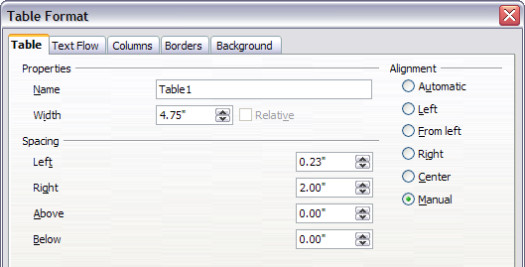

On this page, you can:

* Set a name for the table. This has no effect on the display but makes the table easier to find when using the Navigator. This can be very useful if your document has a number of tables. A table name cannot have any spaces. To make a meaningful name, you could use underscores or hyphens (for example, Table-1_Doll_House_Inventory).
* Set the overall width of the table, either absolute or relative to the page width. This option is available only if the Alignment is not set to Automatic. (See below.)
* Specify how the table is aligned if it does not fill the width of the page (between the margins). Under Alignment:
* Left aligns the table with the left margin.
* Right aligns the table with the right margin.
* From Left lets you specify under Spacing exactly how far from the left margin the table is placed.
* Center aligns the table in the middle between the left and right margins. If the table width is less than the space between the margins, the excess is evenly distributed on both sides of the table. If the table width is greater, the table will extend outside of the margins.
* Manual lets you specify the distances from both left and right margins under Spacing.
* Under Spacing: AboveandBelow, specify the distances to leave above and below the table.
  + 1. Specifying text flow

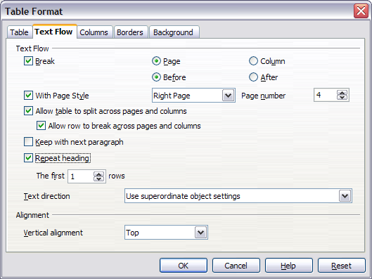

On the Text Flow page of the Table Format dialog box (), you can:

* Insert a page or column break either before or after the table. Use the Text Flow:Break check box, combined with the Page or Column and the Before or After buttons.

If you insert a page break before the table (that is, start the table on a new page), you can also change the page style that will go with it by checking the With Page Style box and selecting a new page style. As with any page break, you can also reset the page numbers using the Page number box.

* Keep a table on one page by deselecting the Allow table to split across pages and columns check box. If this item is deselected, the next item is not active.
* Keep each row on one page by deselecting the Allow row to break across pages and columnscheck box.
* Use the Repeat heading check box and the numbers box to select the number of table heading rows that will be repeated on each page. A complicated table may need two or three heading rows to be easily read and understood.
* Use the *Text direction* list to select the direction for the text in the cells. The most common setting is Left to right for Western languages. Note: The phrase Use superordinate object settings means “use the formatting settings from the paragraph before the table.”
* Select the vertical alignment of the text in the table or the selected cells; the choices are to align with the top of the cell, the center of the cell, or the bottom of the cell. This alignment is in addition to the Left-Right alignment options available under Table > Table Properties > Table or by right-clicking and choosing Table > Table.

|  |  |
| --- | --- |
| Note | A Table Heading row may not span two pages, but any other row may. A one-row table (often used for page layout purposes), if set up with the default of including a heading, will not break across pages. The cure is to make sure the table is defined without a heading row. |

* + 1. Resizing rows and columns

You can adjust the height of rows and the width of columns in a table in several ways.

You can manually resize rows and columns by dragging them to the desired size. When the cursor is in the table, a pair of thin gray lines (||) appear in the rulers.

The horizontal ruler shows the column dividers, and the vertical ruler shows the row dividers.

To change the width of a column or height of a row, use one of these methods:

* Hold the mouse button down on a cell border, so a double-headed arrow appears, and and drag the border to the desired position.
* To change the column width using the ruler, hold the mouse button down on the appropriate column divider (double vertical line) so that a double-headed arrow appears and drag the divider to a new location.
* To change the row height using the ruler, hold the mouse button down on the appropriate row divider (double horizontal line) so that a double-headed arrow appears and drag the divider to a new location.

Selecting Table > Autofitfrom the main menu offers some shortcuts to resizing:

* Optimal column width or row height will make the columns or rows as narrow as possible while still fitting their contents.
* Columns and rows can be distributed evenly to quickly bring them back to all being the same width or height.

For greater control over the width of each column, use the Columns page of the Table format dialog box ().

Right-click on the table and select Table from the pop-up menu or select Table > Table Properties from the menu bar. On the Table Format dialog box, select the Columns tab.

* Adapt table width: If a table already stretches to the page margins, it cannot stretch any wider and the Adapt table width option is not available. If the table is narrower, increasing the width of a column will increase the width of the whole table.

If the table width already extends pasts the margins with the Adapt table width option checked, attempting to change a column width will automatically decrease that column’s size so that the table will now shrink to the page margins while keeping any other column sizes intact.

* Adjust columns proportionally results in all columns changing their widths by the same amount when one is changed.
* Remaining space shows how much farther the table can expand before hitting the limit of the margins. This value cannot be edited and will not be negative in the event that the table width is already larger than the space between the left and right margins.
* Under Column width, each individual column can be adjusted. If you have more than six columns, use the arrows at the right and left to view them all.

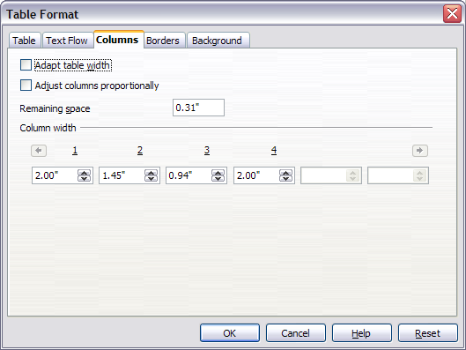

* + 1. Specifying table borders

On the Table Format dialog box, select the Borders tab ().

Here you can set borders for a whole table or groups of cells within a table. In addition, a shadow can be set for the whole table.

Borders have three components: where they go, what they look like, and how big a space is left around them.

* Line arrangement specifies where the borders go. If a group of cells is selected, the border will be applied only to those cells. You can specify no border or any combination of border for the outside edges and the cell divisions—either by selecting a default arrangement or by clicking on the lines in the User-defined area to get exactly what you want.
* Line specifies what the border looks like: the style and color. There are a number of different styles and colors to choose from.
* Spacing to contents specifies how much space to leave between the border and the cell contents. Spaces can be specified to the left, right, above, and below. Check Synchronize to have the same spacing all the way round.

Shadows always apply to the whole table. A shadow has three components: where it is, how thick it is, and what color it is. Set each of these under Shadow style on the dialog box.

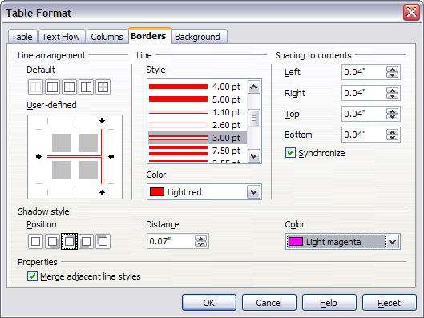

If Merge adjacent line styles is checked, two cells sharing a common border will have their borders merged, rather than being side by side.

|  |  |
| --- | --- |
| Tip | To reset everything if you are having problems with borders, right-click in the table and select Table > Borders or select Table > Table Properties > Borders and then select the Set no **borders** icon under Line arrangement: Default (the box on the left). |

* + 1. Selecting background colors and graphics

The background of a table, a cell, or a group of cells can be set to a color or a background graphic. If you select an image, you can position it in the cell (or group of cells), stretch it to fill the space, or tile the image across the cells. You can set the background for the whole table in the same way.

To set the background for a cell, row, or table:

1. Select the cells you wish to work with. If you are changing the background for a row or table, just place the cursor anywhere inside the row or table to be changed.
2. Right-click and select Table from the pop-up menu, or select Table > Table Properties from the main menu.
3. In the Table Format dialog box, select the Background tab.
4. In the For section, chose whether to apply the settings to cell, row, or table. If you choose Cell, any changes apply to all the selected cells.
5. In the As section, choose whether the background is a color or a graphic.
6. To apply a color, select the color and click OK.
7. To apply a graphic, first select the graphic to use. This must be a graphic file accessible from your computer. (Writer supports a large number of graphics formats.)
   * You have the option with the Link check box to link the graphic file. If it is linked, changes to the graphic (for example, if you edit it in a different package) will be reflected in your document. However, you also need to keep the linked graphic file with the document file. If, for example, you email the document without the graphic file, the graphic will no longer be visible.
   * Under Type, select the type of placement for the graphic. If you choose Position, you can select where to position the graphic within the cells, row, or table. If you choose Area, the graphic is stretched to fill the whole area. If Tile, the graphic is tiled (repeated horizontally and vertically) to fill the area.
   * If the Preview check box is checked, the graphic displays in the pane above the check box.
   * To apply the graphic, click OK.

See for an example of a background for a cell using an unlinked graphic which can be viewed in the Preview pane.

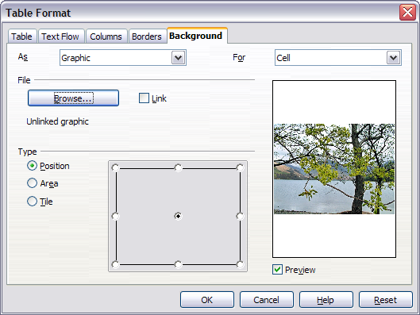

* + 1. Vertical alignment

The default for text entered into table cells is for it to be aligned horizontally to the left, and numbers are aligned to the right. In addition, if more than one row of text is entered or if a graphic is used, text aligns vertically to the top of the cell and numbers to the bottom.

To vertically center align all of the text and numbers in the table:

1. Move the cursor to the upper left-hand cell under the table heading and click and drag to the lower left hand cell.

|  |  |
| --- | --- |
| Note | By selecting all cells, the images will also be aligned. |

1. Right-click in the selected area and select Cell > Center in the pop-up menu.
   * 1. Number formats

The number format can be set for a whole table or group of cells. For example, cells can be set to display in a particular currency, to four decimal places, or in a particular date format.

**Number recognition** specifies that numbers in a text table are recognized and formatted as numbers. If number recognition is not selected, numbers are saved in text format and are automatically left-aligned. Number recognition can be set on or off under Tools > Options > OpenOffice.org Writer > Table.

Select the cells to format, then right-click and select Number Format from the pop-up menu. The Number Format dialog box opens for you to set options for various categories of numerical data.

* In the Category drop-down list, select the category you want, such as currency, date, or text.
* In the Format drop-down list, choose a format for the category you just selected.
* For some categories, such as date, you may wish to change the language using the Language list.
* Additional options are available for different categories.
  + 1. Adding a caption

You can easily add a caption to any table. Writer will keep track of all your captioned tables, automatically number them, and update any links to them.

To add a caption to a table:

1. Place the cursor in the table.
2. Right-click and select Caption from the pop-up menu.
3. Enter the text for your caption, the numbering style, and separator.
4. Click OK.

To automatically caption all your tables:

1. Place the cursor in a table.
2. Right-click and select Caption from the pop-up menu.
3. Select AutoCaption.
4. Select OpenOffice.org Writer Table and select the settings you want and click OK. This dialog box is covered in more detail in Chapter 2 (Setting up Writer).

When AutoCaption is enabled for tables, all tables will be captioned; you will need to add the text for each caption onto the table manually.

Writer supplies five different category labels:

* <None>
* Drawing
* Table
* Illustration
* Text

You can create your own category labels, formating, and separators—either under Insert > Caption or under Tools > Options > OpenOffice.org Writer > AutoCaption > OpenOffice Writer Table.

In either case, simply highlight a label and type in the new name. In the example below, we used Fantasia.

You can also change the separator or the format of the category label. For example, you might want your tables to be labeled as Fantasia and formated in bold type and using a period (‘.’) as a separator, as follows:

**Fantasia 1.** Interesting data

**Fantasia 2.** More interesting data

**Fantasia 3**. Yet more interesting data

To do this, you can highlight and replace a separator and then select Insert > Caption > Options > Character Style and assign a style, or you can set this up in the AutoCaption dialog box.

The format and separator if used under Insert > Caption only works for that specific table. However, it will work for that and all following tables if it is set up under AutoCaption.

When using AutoCaption, you need to remove the ‘.’ under Numbering captions by chapter > Separator if you are *not* using Chapter numbering to avoid having an extra punctuation mark added to the category label.

* + 1. Cross-referencing a table

You can insert a cross-reference to a captioned table. Clicking on the cross-reference takes the reader directly to the table.

1. Position the cursor where you want the cross reference.
2. Select Insert > Cross-reference from the main menu.
3. Set the Type to Table. A list of captioned tables will be shown in the Selection panel; select the one you want to reference.
4. In the Format pane, choose how the cross reference will appear. For example, Category and Number will show up as Table 1 for the first table, while Numbering produces only 1, and Above/Below inserts one of those words as the reference.
5. Click Insert to add the cross-reference and click Close to exit the dialog box.
   * 1. AutoFormatting tables

You can use AutoFormat to make your table formats consistent. You can also create and add your own table autoformats. Here is how:

1. Create a table and manually format it as you wish, including borders, spacing of text from the top and bottom borders, fonts to be used in the table heading and data cells, and background colors.

|  |  |
| --- | --- |
| Note | To use background colors in a new format, color the cells rather than the table. That is, select the cell or cells you wish to color, select Table > Table Properties > Background (or right-click Table > Background), choose a color, and specify *As*:Color*, For*:Cell. |

1. Position the cursor anywhere in the table and then click Table > AutoFormat.
2. On the AutoFormat dialog box (), click Add and give the table format a name in the AddAutoFormat dialog box and click OK.
3. The newly named autoformat now appears as an available format. Click OK to close the AutoFormat dialog box.

|  |  |
| --- | --- |
| Tip | This technique does not include table and column widths in the table format. To insert a table with predefined full formatting, save it as AutoText. |

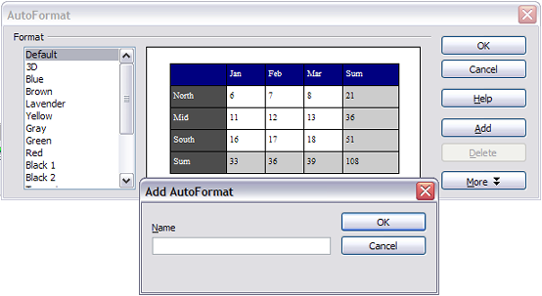

* + 1. Create a heading row in an existing table

To create a heading row in an existing table that does not have one, you need to apply an autoformat that does have a heading defined. (Here is where having some personalized table formats could come in very handy.) Place the cursor anywhere in the table and then click Table > AutoFormat. Choose a format. Click OK.

* + 1. Rotating text in a table cell

You can rotate text in a table cell by 90 or 270 degrees. Text rotation is useful when you have long headings for narrow columns. Select the text to be rotated and then click Format > Character. On the Position page, in the Rotation / scaling section, choose the rotation angle and click OK.

* + 1. Displaying or hiding table boundaries

A table boundary is a set of pale (usually gray) lines around the cells when viewed on‑screen in OOo. These boundaries do not print and do not appear in PDFs; their only function is to help you see where the table cells are.

To display the table the same way on the screen as on the printed page, with no boundary lines, right-click on the table and select Table Boundaries from the pop-up menu. Repeat this to have the boundaries appear again.

|  |  |
| --- | --- |
| Note | Turning boundaries off does not hide the borders that the table may have. |

|  |  |
| --- | --- |
| Tip | You can also turn table boundaries on and off through Tools > Options > OpenOffice.org > Appearance. On that page, you can display or hide boundaries around text, pages headers and footers, figures, and other parts of a document. |

* 1. Data entry in tables
     1. Moving between cells

Within a table, you can use the mouse, the cursor keys, or the Tab key to move between cells.

The cursor keys move to the next cell only if there is no text in the way. For example, pressing the right cursor key will move the cursor to the right within the text in the current cell, then to the next cell.

The Tab key moves directly to the next cell and, if the cursor is in the last cell in the table, creates a new row. Pressing Shift+Tab moves the cursor back a cell.

|  |  |
| --- | --- |
| Tip | To enter a Tab character as part of the text of the cell, press the Control and Tab keys at the same time. |

* + 1. Number recognition

If number recognition is turned on, when you type a number in a table, Writer aligns it to the right of the cell and strips off any trailing zeros. For example, 4.0 is changed to 4 and aligned to the right.

To turn number recognition on or off, right-click on the table and select Number Recognition in the pop-up menu.

* + 1. Converting between table and text

Writer makes it easy for you to convert from a table to text (that is, replace a table with its data) or vice versa.

To convert plain text data into a table, select the data and then select Table > Convert > Text to Table from the main menu bar. In the Convert Text to Table dialog box, you must select the field delimiter (tab, paragraph marker, comma, or other printing or non-printing character) that Writer should use to divide data into different cells. Click OK to perform the conversion.

To convert from a table to plain text, select the table and then select Table > Convert > Table to Text. The data in the table will be converted to plain text with the field delimiter of your choice. ClickOK to perform the conversion.

* + 1. Sorting data in a table

Just as in a spreadsheet, Writer allows data in a table to be sorted. Up to three levels of sorting can be specified (for example, sort first by age, then by name within each age).

To sort data in a table:

1. Select the table (or part of the table) to be sorted.
2. From the menu bar, select Table > Sort.
3. In the Sort dialog box:
   * Decide whether you want to sort in the direction of rows or columns. The default sorting direction is by rows, which results in sorting the data in a column.
   * Select up to three keys to sort on, in the correct order.
   * For each key, select which column or row to sort on, whether the sort is Numeric or Alphanumeric and whether it is Ascending or Descending.
   * Click OKto perform the sort.

|  |  |
| --- | --- |
| Note | You have to select all cells that might be affected by the sorting. For example, if you select only the cells of one column, the sort affects that column only, while the others remain unchanged. In such a case, you risk mixing the data of the rows. |

* 1. Deleting, copying, and moving a table
     1. Deleting a table

To delete a table:

1. Click somewhere in the table.
2. Select Table > Delete > Table from the main menu.

Or:

1. Select from the end of the paragraph before the table to the start of the paragraph after the table.
2. Press the Delete or the Backspace key.

|  |  |
| --- | --- |
| Note | The second method also merges the paragraph after the table with the paragraph before the table, which may not be what you want. |

* + 1. Copying a table

To copy a table from one part of the document and paste it into another part:

1. Click somewhere in the table.
2. From the main menu select Table > Select > Table.
3. Press Control+C or click the Copy icon on the Standard toolbar.
4. Move the cursor to the target position and click on it to fix the insertion point.
5. Press Control+V or click the Paste icon in the Standard toolbar.
   * 1. Moving a table

To move a table from one part of a document to another part:

1. Click somewhere in the table.
2. From the main menu, select Table > Select > Table.
3. Press Control+X or click the Cut icon in the Standard toolbar.
4. Move the cursor to the target position and click on it to fix the insertion point.
5. Press Control+V or click the Paste icon in the Standard toolbar.
6. Return to the original table, click somewhere in it and then select Table > Delete > Table from the main menu.
   1. Using tables as a page layout tool

Tables may be used as a page layout tool to position text in a document instead of using tabs or spaces. For example, the Tips below are formatted as a table.

For more information and tips about using tables in page layout, see Chapter 4 (Formatting Pages).

|  |  |
| --- | --- |
| Tips | When inserting a table used for layout, you may wish to deselect the check boxes for Heading and Border (see on page ).  To remove the borders from an existing table, right-click on the table, select Table from the pop-up menu, select the Borders tab (see on page ), and select the icon for no borders. |

* 1. Using spreadsheet functions in a table

In a table in a Writer document, you can use some of the mathematical functions that are normally implemented by OpenOffice.org Calc. For many simpler functions, Writer tables can be used as a basic spreadsheet.

Just as in a spreadsheet, each table cell is identified by a letter (for the column) and a number (for the row). For example, cell C4 is the cell in the third column from the left and fourth row from the top. When the cursor is in a cell, this cell reference is displayed on the status bar (in its default position at the bottom right corner of the screen).

|  |  |
| --- | --- |
| Tip | Basic spreadsheet functions in tables are much the same as in OpenOffice.org Calc. The main difference is that cell references are formatted differently. Cell A2 (first column, second row) is referred to in Calc as A2 (or $A$2 for an absolute reference). In Writer tables, it is referred to as <A2>. |

For example, suppose you had two numbers in cells <B1> and <C2> and wanted to display the sum of the two in cell <A1>, as shown in .

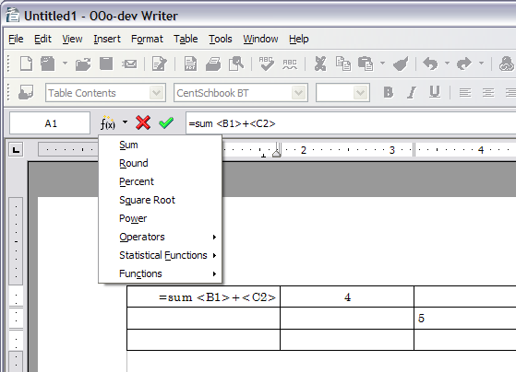

Do the following:

1. Click in cell <A1> and press the = key. The Formula bar appears automatically, near the top of the screen. In the leftmost side of the bar, you can see the coordinates of the selected cell.
2. Click in cell <B1>. The identifiers of this cell are automatically displayed in the Formula bar and inserted into cell <A1>.
3. Press the + key.
4. Click on cell <C2>. You can see the final formula = <B1>+<C2> displayed both in the selected cell and in the Object bar.
5. Press the Enter key or click the green tick (checkmark) on the Formula Bar.

|  |  |
| --- | --- |
| Tip | To display the list of the mathematical functions that you can use in a table:   1. Display the Formula toolbar by pressing F2 or select a blank cell and press the = key. 2. Click and hold the Formula**f(x)** icon. |

In our example, this gives the result 9 in the top left cell. For contiguous cells, you can simply select the cells in the row, column, or the rectangle of rows and columns. Thus, for example, to add a column of numbers, do this:

1. Type an equals sign = in an empty cell.
2. Select the cells to be added together—in this case the cells from A2 to A5. The formula should be something like =<A2:A5>.
3. Press the *Enter* key or click the green tick (checkmark) on the Formula Bar.
4. The answer appears in the cell you have selected.

When using a function, you can enter the cells manually or by selecting them. Thus, to add up the four numbers that we added above (A2, A3, A4, A5), do this:

1. Type an equals sign = in an empty cell.
2. Type sum or select it from the function list **f(x)**.
3. Select the cells to be added together. The formula should be something like =sum<A2:A5>.
4. Press the *Enter* key or click the green tick (checkmark) on the Formula Bar.
5. The answer appears in the cell you have selected.



Writer Guide

1. Chapter 10  
    Working with Templates
   1. Introduction

A template is a model that you use to create other documents. For example, you can create a template for business reports that has your company’s logo on the first page. New documents created from this template will all have your company’s logo on the first page.

Templates can contain anything that regular documents can contain, such as text, graphics, a set of styles, and user-specific setup information such as measurement units, language, the default printer, and toolbar and menu customization.

All documents in OpenOffice.org (OOo) are based on templates. If you do not specify a template when you start a new Writer document, the document is based on the default template for text documents. If you have not specified a default template, Writer uses the blank template for text documents that is installed with OOo. See “” on page for more information.

This chapter shows you how to:

* Use a template to create a document.
* Create a template.
* Edit a template.
* Set a default template.
* Organize templates.
  1. Using a template to create a document

To use a template to create a document:

1. From the main menu, choose File > New > Templates and Documents. The Templates and Documents dialog box opens. (See .)
2. In the box on the left, click the **Templates**icon if it is not already selected. A list of template folders appears in the center box.
3. Double-click the folder that contains the template that you want to use. A list of all the templates contained in that folder appears in the center box.
4. Click the template that you want to use. You can preview the selected template or view the template’s properties:

* To preview the template, click the **Preview** icon. (For the location of the Preview icon, see .) A preview of the template appears in the box on the right.
* To view the template’s properties, click the **Document Properties** icon. (For the location of the Document Properties icon, see .) The template’s properties appear in the box on the right.

1. Click Open. The Templates and Documents dialog box closes and a new document based on the selected template opens in Writer. You can then edit and save the new document just as you would any other document.

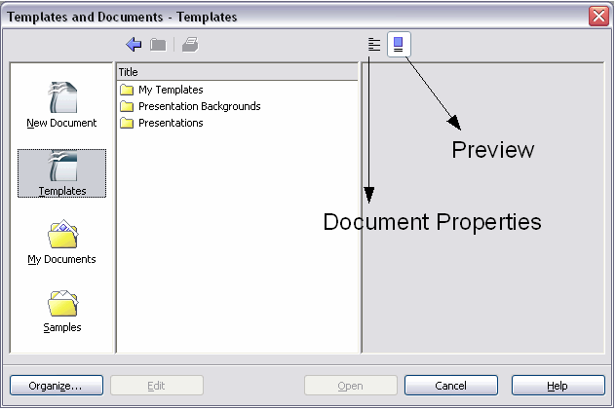

* 1. Creating a template

You can create your own templates in two ways:

* From a document
* Using a wizard
  + 1. Creating a template from a document

To create a template from a document:

1. Open a new or existing document you want to make into a template.
2. Add the content and styles that you want.
3. From the main menu, choose File > Templates > Save. The Templates dialog box opens (see ).
4. In the New template field, type a name for the new template.
5. In the Categories list box, click the category to which you want to assign the template. (The category is simply the template folder in which you want to save the template. For example, to save the template in the “My Templates” folder, click the **My Templates**category.)

To learn more about template folders, see “” on page .

1. Click OK. Writer saves the new template and the Templates dialog box closes.

|  |  |
| --- | --- |
| Note | OOo 1.X used a “Default” folder in place of the 2.x “My Templates” folder. |

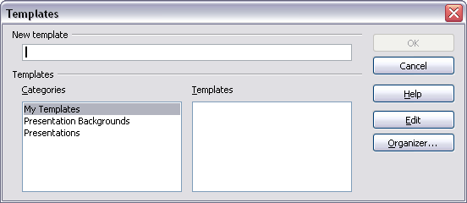

Any settings that can be added to or modified in a document can be saved in a template. For example, below are some of the settings (although not exhaustive) that can be included in a Writer document and then saved as a template for later use:

* Printer settings: which printer, single-sided or double-sided, paper size, etc.
* Styles to be used, including character, page, frame, numbering, and paragraph styles.
* Format and settings regarding indexes, tables, bibliographies, table of contents.
  + 1. Creating a template using a wizard

You can use wizards to create these types of Writer templates:

* Letter
* Fax
* Agenda

For example, the Fax Wizard steps you through the following choices:

* Type of fax (business or personal)
* Document elements like the date, subject line (business fax), salutation, and complimentary close
* Options for sender and recipient information (business fax)
* Text to include in the footer (business fax)

To create a template using a wizard:

1. From the main menu, choose File > Wizards >type of template required ().

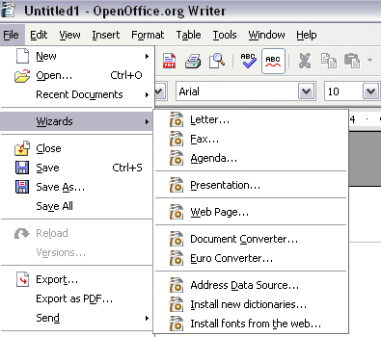

1. Follow the instructions on the pages of the wizard. This process is slightly different for each type of template, but the format is similar for all of them.
2. In the last section of the wizard, you can specify the name and location for saving the template. The default location is your user templates directory, but you can choose a different location if you prefer.
3. Finally, you have the option of creating a new document from your template immediately, or manually changing the template. For future documents, you can re-use the template created by the wizard, just as you would use any other template.
   1. Editing a template

You can edit a template’s styles and content, and then, if you wish, you can reapply the template’s styles to documents that were created from that template.

|  |  |
| --- | --- |
| Note | You can only reapply styles. You cannot reapply content. |

To edit a template:

1. From the main menu, choose File > Templates > Organize. The Template Management window opens (see ).

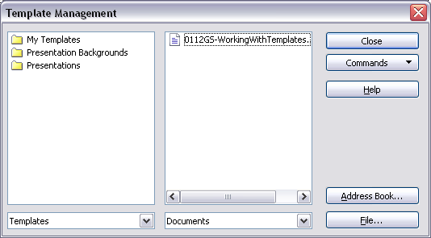

1. In the box on the left, double-click the folder containing the template that you want to edit. A list of all the templates contained in that folder appears underneath the folder name.
2. Click the template that you want to edit.
3. Click the Commands button.
4. From the drop-down menu, choose Edit. The Template Management window closes and the selected template opens in Writer.
5. Edit the template just as you would any other document. To save your changes, choose File > Save from the main menu.

The next time that you open a document that was created from the changed template, the following message appears.

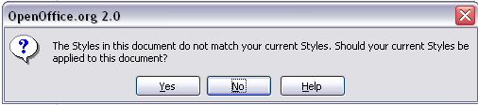

Click Yes to apply the template’s changed styles to the document. Click No if you do not want to apply the template’s changed styles to the document. Whichever option you choose, the message box closes and the document opens in Writer.

|  |  |
| --- | --- |
| Note | Automatic updating from a template did not work in OOo2.0.2. This bug was fixed in OOo 2.0.3. To re-enable updating in files created using OOo 2.0.2:   1. Use Tools > Macros > Organize Macros > OpenOffice.org Basic. Select the document from the list, click the +, and select Standard. If Standard has a + beside it, click that and select a module. 2. Name the macro. For example, you could call it FixDocument. If the **Edit** button is active, click it. If the Edit button is not active, click **New**, type a module name in the pop-up dialog, and click **OK**. 3. In the Basic window, enter the following:   Sub FixDocument  TemplateName = ThisComponent.DocumentInfo.Template  if TemplateName <> "" then  ThisComponent.DocumentInfo.Template = TemplateName  end if  End Sub   1. Click the Run BASIC icon, then close the Basic window. 2. Save the document.   Next time when you open this document you will have the update from template feature back. |

* 1. Adding templates with Extension Manager

A new feature in OOo 2.0.4 was the Package Manager, called the Extension Manager in OOo 2.1. This feature provides an easy way to install collections of templates, graphics, macros, or other add-ins that have been “packaged” into files with a .OXT extension.

1. After you download a package, select Tools > Extension Manager from the menu bar. In the Extension Manager dialog (), click Add.

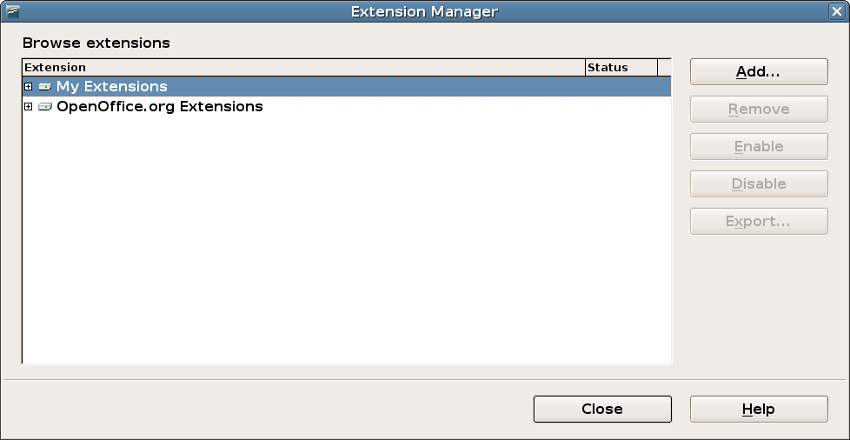

1. A file browser window opens. Find and select the package of templates you want to install and click Open.
2. On the Extension Manager dialog (), select the package you just added and click Enable.

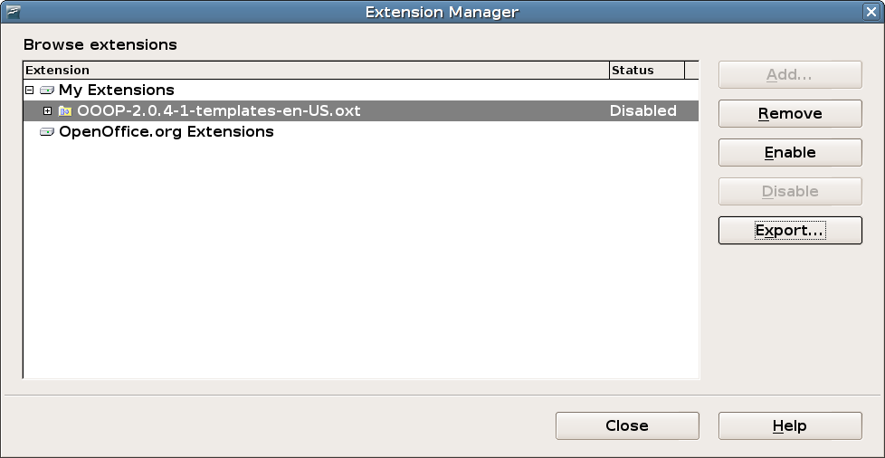

* 1. Setting a default template

If you create a document by choosing File > New > Text Document from the main menu, Writer creates the document from the Default template. You can, however, set a custom template to be the default. You can reset the default later if you choose.

* + 1. Setting a custom template as the default

You can set any template to be the default, as long as it is in one of the folders displayed in the Template Management window.

To save a template in one of these folders, do one of the following:

* Create and save the template as described in “” on page .
* Import the template into the desired folder as described in “” on page .

To set a custom template as the default:

1. From the main menu, choose File > Templates > Organize. The Template Management window () opens.
2. In the box on the left, double-click thefolder that contains the template that you want to set as the default.
3. Click the template that you want to set as the default.
4. Click the Commands button.
5. From the drop-down menu, choose Set as Default Template. The next time that you create a document by choosing File > New > Text Document, the document will be created from this template.
   * 1. Resetting Writer’s Default template as the default

To reset Writer’s Default template as the default:

1. From the main menu, choose File > Templates > Organize. The Template Management window () opens.
2. In the box on the left, click any folder.
3. Click the Commands button.
4. From the drop-down menu, choose Reset Default Template > Text Document. The next time that you create a document by choosing File > New > Text Document, the document will be created from Writer’s Default template.
   1. Organizing templates

Writer can only use templates that are in OOo template folders. You can, however, create new OOo template folders and use them to organize your templates. For example, you might have one template folder for report templates and another for letter templates. You can also import and export templates.

To begin, choose File > Templates > Organize from the main menu. The Template Management window () opens.

* + 1. Creating a template folder

To create a template folder:

1. In the Template Management window, click any folder.
2. Click the Commands button.
3. From the drop-down menu, choose New. A new folder called Untitled appears.
4. Type a name for the new folder, and then press Enter. Writer saves the folder with the name that you entered.
5. To close the Template Management window, click Close.
   * 1. Deleting a template folder

To delete a template folder:

1. In the Template Management window, click the folder that you want to delete.
2. Click the Commands button.
3. From the drop-down menu, choose Delete. A dialog box appears and asks you to confirm the delete.
4. Click Yes. The dialog box closes and the selected folder is deleted.
   * 1. Moving a template

To move a template from one template folder to another template folder:

1. In the Template Management window, double-click the folder that contains the template that you want to move. A list of all the templates contained in that folder appears underneath the folder name.
2. Click the template that you want to move and drag it to the desired folder.
   * 1. Deleting a template

To delete a template:

1. In the Template Management window, double-click the folder that contains the template that you want to delete. A list of all the templates contained in that folder appears underneath the folder name.
2. Click the template that you want to delete.
3. Click the Commands button.
4. From the drop-down menu, choose Delete. A dialog box appears and asks you to confirm the delete.
5. Click Yes. The dialog box closes and the selected template is deleted.
   * 1. Importing a template

If the template that you want to use is in a different location, you must import it into an OOo template folder.

|  |  |
| --- | --- |
| Tip | When you download a template from a website or CD, you can save it anywhere on your computer and then import it into OOo as described here. |

To import a template into a template folder:

1. In the Template Management window, double-click the folder into which you want to import the template.
2. Click the Commands button.
3. From the drop-down menu, choose Import Template.The Open dialog box opens.
4. Find the template that you want to import and click Open. The Open dialog box closes and the template appears in the selected folder.
5. If you want, type a new name for the template, and then press Enter.
   * 1. Exporting a template

To export a template from a template folder to another location:

1. In the Template Management window, double-click the folder that contains the template that you want to export. A list of all the templates contained in that folder appears underneath the folder name.
2. Click the template that you want to export.
3. Click the Commands button.
4. From the drop-down menu, choose Export Template.The Save dialog box opens.
5. Find the folder into which you want to export the template and click Save. Writer exports the template to the selected folder, and the Save dialog box closes.

|  |  |
| --- | --- |
| Note | All the actions made by the **Commands** button in the Template Management window can be made as well by simply right-clicking on the templates or the folders. |



Writer Guide

1. Chapter 11  
    Using Mail Merge

Form letters, mailing labels, and envelopes

* 1. What is mail merge?

OpenOffice.org (OOo) Writer provides very useful features to create and print:

* Multiple copies of a document to send to a list of different recipients (form letters)
* Mailing labels
* Envelopes

All these facilities, though different in application, are based around the concept of a registered “data source”, from which is derived the variable address information necessary to their function.

This chapter describes the entire process. The steps include:

1. How to create and register a data source.
2. How to create and print form letters, mailing labels, and envelopes.
3. Optionally, how to save the output in an editable file instead of printing it directly.
   1. Creating the data source

A data source is a database containing the name and address records (and optionally other information) from which a mailing list may be derived. Although you can create and print mailing labels and envelopes without using a data source, in most cases using one is the best approach. This chapter assumes that you are using a data source.

OOo can access a wide variety of data sources, including spreadsheets, text files and databases such as MySQL, Adabas, and ODBC.If the information to be used in the mail merge is currently in a format that OOo cannot access directly, you need to convert it, for example by exporting it to a comma-separated values (CSV) file.

For the following example we use a spreadsheet with the following column (field) headers: Title, First name, Last name, Address, State/County, Country, Post Code, Sex, Points. A sample data source is shown in .

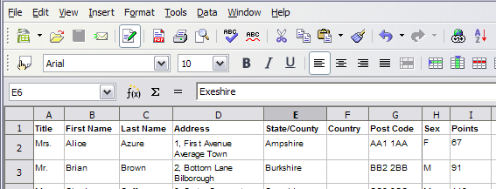

* 1. Registering a data source

For a data source to be directly accessible from within an OOo document, it must first be registered as described below.

1. Click File > Wizards > Address Data Source.

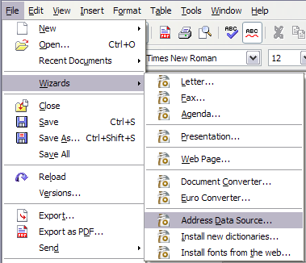

1. Select the appropriate type of external address book (in this case, Other external data source). Click Next.

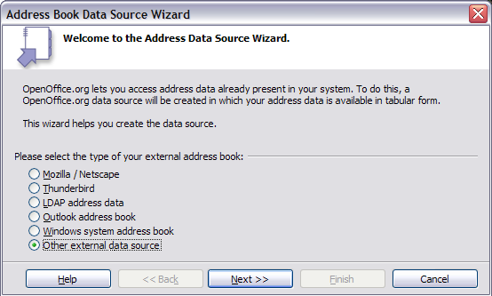

1. On the next page of the Wizard (), click Settings.

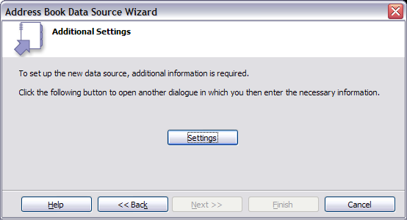

1. In the Data Source Properties dialog (), select the Database type (in this case, Spreadsheet). Click Next.

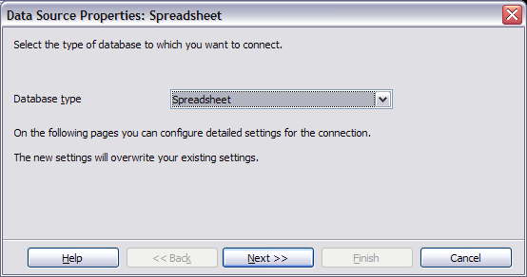

1. In the next dialog (), click Browse and navigate to the spreadsheet that contains the address information. Select the spreadsheet and click Open to return to this dialog. At this time you may wish to test that the connection has been correctly established by clicking on the Test Connection button.

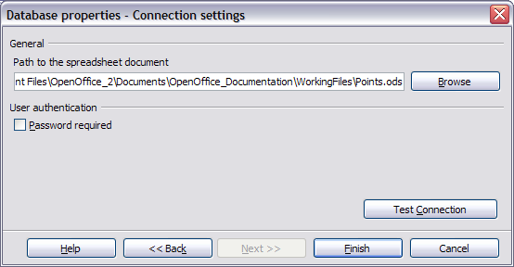

1. Click Finish.
2. In the following dialog (), click Next. (Do not click Field Assignment.)

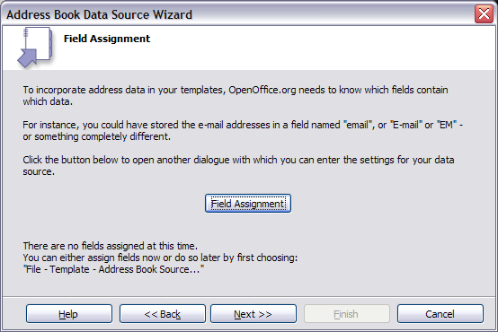

1. Name the file in the Location field. The default is ...\Addresses.odb; but you may replace Addresses with another name if you wish. You may also change the name in the “Address book name” field. In our example, the name “Points” was used for both.

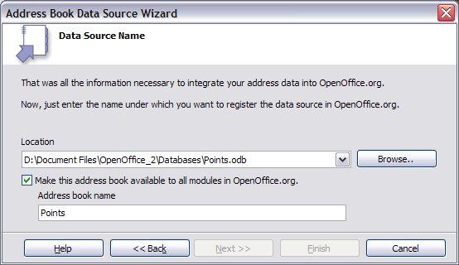

1. Click Finish. The data source is now registered.
   1. Creating a form letter

You can create a form letter manually, which is the simplest and most comprehensive method and is described here, or you can use the Mail Merge wizard as described in “” starting on page . If you elect to use the wizard, pay close attention to its current (OOo V2.3) limitations, as identified within its description.

1. Create a new text document: File > New > Text Document, or open a pre-existing form letter with **File Open**.
2. Display the registered data sources: View > Data sources (or press F4).
3. Find the data source that you wish to use for the form letter, in this case Points. Expand the Points and Tables folders, and select Sheet1. The address data file is displayed. (See .)

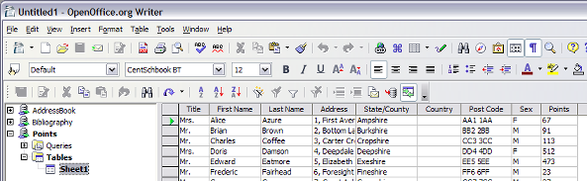

1. Now create or modify the form letter by typing in text, punctuation, line breaks, and so on that will be present in all of the letters, and adding fields where needed by clicking in the field heading and dragging to the appropriate point in the letter. (See .)

Note that address lines should be in individual paragraphs, not separated by line breaks as might seem preferable. The reason for this will be made clear in the next paragraph.

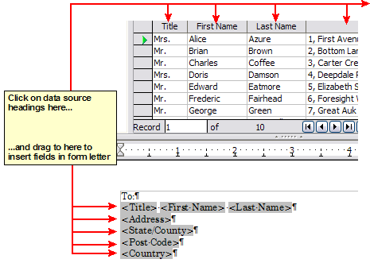

1. Continue until you have composed the entire document. (See for an example.) At this time you may wish to consider suppressing any blank lines that may appear in the resulting letters. If not, skip ahead to Step 7.

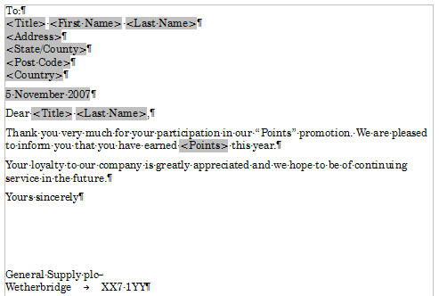

1. To suppress blank lines:
   1. Click at the end of the first paragraph to be suppressed and then select Insert > Fields > Other.
   2. Select the Functions tab and then click on Hidden Paragraph in the Type column.
   3. Now click in the Condition box and enter the details of the condition that defines a blank address field. It has the general form of:  
      ![Database.Table.Database field]  
      where the ‘!’ (NOT) character indicates the negative case and the square brackets delineate the condition.

For example, in our Points database the condition to test if the Last Name field is empty would be:  
![Points.Sheet1.Last Name] as illustrated in

* 1. To test for multiple conditions use the operators AND and/or OR between the conditional statements, for example:  
     ![Points.Sheet1.Title]AND![Points.Sheet1.Last Name].
  2. Click Insert, but do not close the dialog until all lines have been amended.

1. The document is now ready to be printed. Click File > Print and respond with Yes in the resulting dialog.

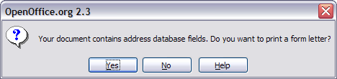

1. In the Mail Merge dialog (), you can choose to print all records or selected records. To select records to be printed, use *Ctrl+click* to select individual records. To select a block of records, select the first record in the block, scroll to the last record in the block, and *Shift+click* on the last record.

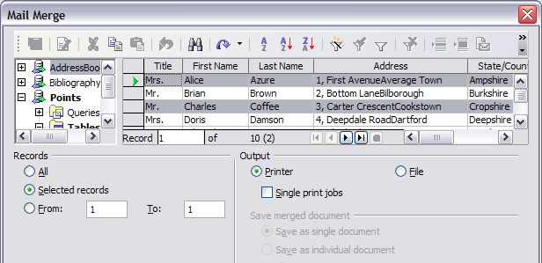

1. Click **OK** to send the letters directly to the printer.

If you prefer to save the letters to a file, perhaps to allow proofreading or some later editing such as changing the typeface or paragraph format, then you should select File in the output section of the Mail Merge dialog, instead of using the default Printer selection. This changes the dialog to display the Save merged document section, where Save as single document is pre-selected. You can choose to save each letter as a single, individual document, if preferred.

In this case, clicking OK brings up the Save as dialog (), where a file name can be entered for the saved letters. They will be saved consecutively in the single document, or numbered consecutively in individual files if saved as single documents.

If you have not saved the original, prototype form letter document (template) previously, then you will be prompted to do so now by another Save as dialog. This could greatly simplify the creation of other form letters in the future and is highly recommended.

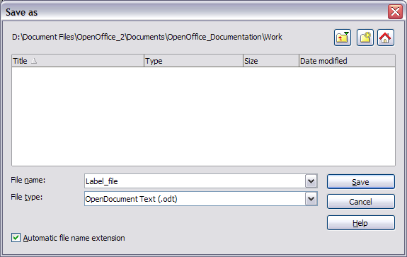

* 1. Printing mailing labels

Before beginning this process, note the brand and type of labels you intend to use.

To print mailing labels:

1. Click **File > New > Labels**.
2. On the Options tab, ensure that the Synchronise contents checkbox is selected.
3. On the **Labels** tab (), select the Database and Table. Select the Brand of labels to be used, and then select the Type of label.

|  |  |
| --- | --- |
| Tip | If the type of label you wish to use is not on the list, you need to use the Format tab to define a new Brand and Type. This is beyond the scope of this document, but is relatively simple to implement, given knowledge of the dimensions of the label . |

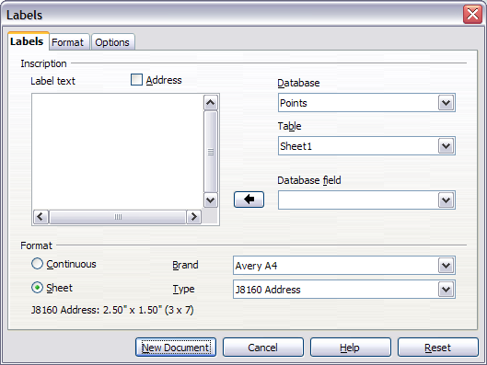

1. Click the dropdown arrow under Database field**.** Select the first field to be used in the label (in this example,Title). Click the left arrow button to move this field to the **Label text** area ().

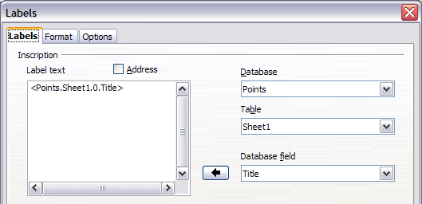

1. Continue adding fields and inserting desired punctuation, spaces, and line breaks until the label is composed. shows the completed label.

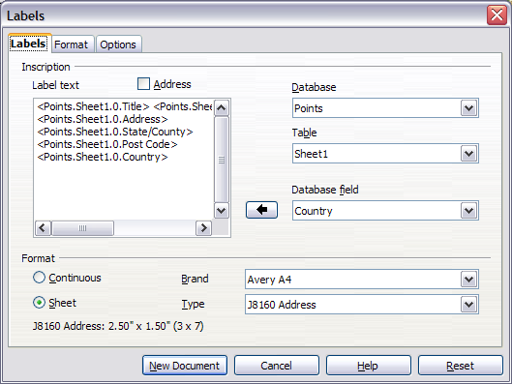

1. Click **New Document**. You now have a new, single‑page document containing a series of frames, one for each label of the selected type and filled with the data source address fields that you selected. Quite often some of the fields in your address data source will be unused, leading to blank lines in your labels. If this is not important, you can skip the next few paragraphs and go straight to Step 7, otherwise continue as described here.
   1. First ensure that the label frames are showing the field contents (data source headings), rather than their underlying field names. If this is not the case, then either press Ctrl+F9 or select View>Field Names to toggle the view.
   2. Next, ensure that you can see non‑printing characters, such as paragraph marks, line breaks and so on. If these are not already visible, select View > Nonprinting Characters from the menu bar, or press Ctrl+F10, or click on the paragraph icon  in the Standard toolbar.

You will now see that address field separation is created by line breaks , rather than paragraphs . As the suppression of blank address fields depends on hiding paragraphs, not lines, you need to replace line breaks with paragraphs as follows.

* 1. Click in the first label, at the end of the first data source address field. Press Delete to remove the new line and then press Return (or the Enter key) to insert a paragraph. Repeat this action for each data source address field.

If the line spacing in the first label is not satisfactory, you may wish to correct this before proceeding, by modifying the paragraph style associated with the address. Unless you have changed it, the address uses the Default style.

|  |  |
| --- | --- |
| Caution | The objective of step c) is to replace all line breaks at the end of data source address fields with paragraphs. Sometimes the address data field may be longer than the width of the label and will wrap to the next physical line: make sure that you are not misled by this into deleting and replacing anything other than line break characters. |

* 1. Click again at the end of the first paragraph to be suppressed and then select Insert > Fields > Other. Select the Functions tab and then click on Hidden Paragraph in the Type column. Now click in the Condition box and enter the details of the condition that defines a blank address field. It has the general form of:  
     ![Database.Table.Database field]  
     where the ‘!’ (NOT) character indicates the negative case and the square brackets delineate the condition.

For example, in our Points database the condition to test if the Last Name field is empty would be ![Points.Sheet1.Last Name] as illustrated in .

To test for multiple conditions, use the operators AND and/or OR between the conditional statements, for example:  
![Points.Sheet1.Title]AND![Points.Sheet1.Last Name].

Click Insert, but do not close the dialog until all lines have been amended.

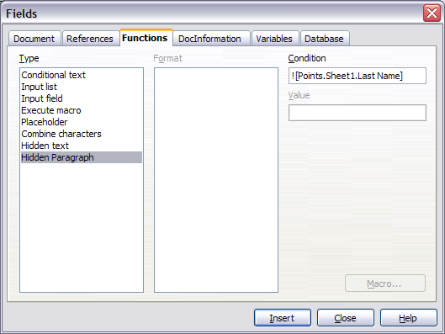

* 1. Repeat for each paragraph to be conditionally suppressed, remembering to advance the cursor to the end of the line in question before changing the last element of the condition and Inserting the result.

|  |  |
| --- | --- |
| Caution | The last paragraph of the label address block ends with a special field, Next record:Database.Table (Next record:Points.Sheet1 in our example), and the Hidden paragraph field MUST be inserted before this field. This can generally be accomplished by clicking at the end of the paragraph and then using the Left Arrow key once to skip back over it.  A clue that you omitted this action is the observation that some records have been skipped and are missing from the final output. |

* 1. 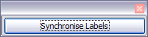Remembering that we selected Synchronise contents earlier, you should now be able to see a small window containing a button labelled Synchronise Labels. Click on this button and the hidden paragraph fields are propagated to all the labels in your document.

You now have a template suitable for future use with the same data source and type of label. If you wish to save it, use either File > Templates > Save as, or save it as an Open Document Text Template (.ott) into the private template directory (folder) that you have previously defined in Tools > Options > OpenOffice.org > Paths > Templates.

1. Click **File > Print.** The following dialog appears. Click **Yes**.



1. In the Mail Merge dialog (), you can choose to print all records or selected records. To select records to be printed, use *Ctrl+click* to select individual records. To select a block of records, select the first record in the block, scroll to the last record in the block, and *Shift+click* on the last record.

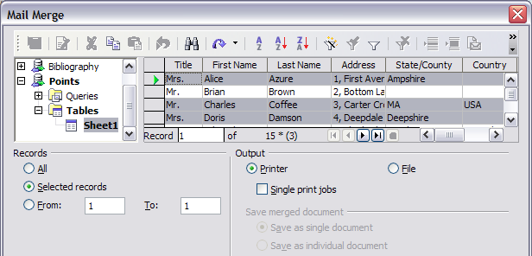

1. Click **OK** to send the labels directly to the printer.

If you prefer to save the labels to a file, perhaps to allow some later editing such as changing the typeface or paragraph format, then you should select File in the output section of the Mail Merge dialog, rather than using the default Printer selection. This changes the dialog to highlight the Save merged document section, where Save as single document is pre-selected.

In this case, clicking OK brings up the Save as dialog shown in , where a file name can be entered for the saved labels.

If you did not save the prototype label fields document (template) in step 6f, then you are prompted to do so now by another Save as dialog.

In either case, whether printing or saving to file, despite there apparently being only one page of labels, the printed or saved output will be expanded to include all of the selected records from the data source.

* + 1. Editing a saved file of mailing labels

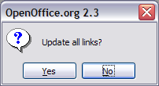To edit a saved file of mailing labels, open the saved label file in the normal way. You will be prompted as to whether you wish to update all links. Choose No for the following reason: The first label on the page is termed the “Master Label” and all other labels are linked to it: if you update the links then all labels will end up containing the same data, which may not be what you want.

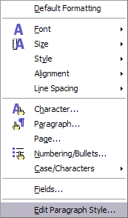You can edit individual records in the normal way, by highlighting and changing the font name, for example.

However, you cannot edit all labels globally (for example, to change the font name for all records) by the technique of selecting the entire document. To achieve this result you have to edit the paragraph style associated with the label records as follows:

1. Right-click any correctly spelled word in a label record. Select Edit Paragraph Style from the pop-up menu. (Note: If you click on a misspelled word, a different menu appears.)
2. Then from the Paragraph Style dialog, you can make changes to the font name, the font size, the indents, and other attributes.
   1. Printing envelopes

Instead of printing mailing labels, you may wish to print directly onto envelopes. There are two basic ways to create envelopes, one where the envelope is embedded within a letter, generally as the first page (Insert in the Envelope dialog), and another where the envelope is an independent document (New Doc. in the dialog). In each case the addressing data may be manually entered, for example by copying and pasting from the letter with which it is associated, or it may originate within an address data source.

This section assumes the use of an address data source and, for convenience, a free-standing envelope.

The production of envelopes involves two steps, set-up and printing, as described in this section.

* + 1. Setting up envelopes for printing

1. Click **Insert > Envelope** from the menu bar.
2. In the Envelope dialog, select the Format tab (), where you can select the envelope format to use. You can then arrange the layout of the envelope to suit your requirements, together with the character and paragraph attributes to be used in the Sender and Addressee areas. These attributes are accessed using the Edit buttons to the right of the dialog, next to the word Format.

|  |  |
| --- | --- |
| Tip | At this stage it is not possible to vary the dimensions of the frames that will hold the Sender and Addressee information, but once the envelope has been created this will become possible and you may wish to make some cosmetic adjustments. |

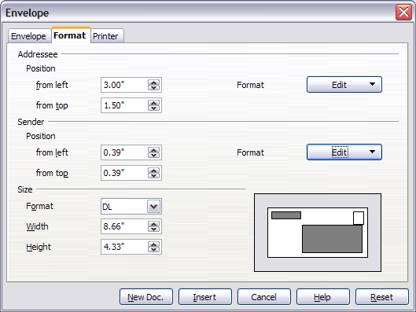

1. The next step is to select the Printer tab (), from where you may choose the printer you intend to use, its setup—for example, specification of the tray holding envelopes--and other printer-related options such as envelope orientation and shifting. You may need to experiment with these settings to achieve the best results with your printer.
2. You now have the choice of creating the Addressee fields by dragging and dropping from the data source headings (as described in “” on page , and in particular in ) or using the facilities of the Envelope tab.

If you prefer dragging and dropping, than click New Doc., drag your data source headings into the Addressee area on your new envelope and skip to step 7), otherwise continue with steps 5 and 6.

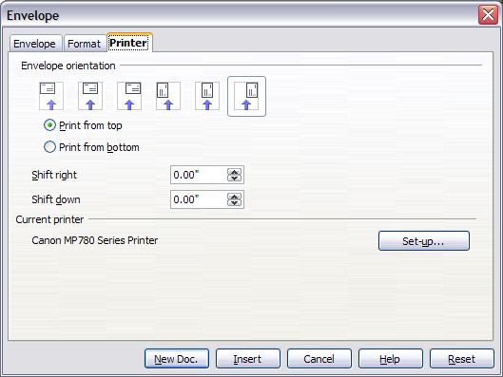

1. Select the **Envelope** tab (). Verify, add, or edit the information in the Addressee and Sender boxes (Sender is the “from” on the envelope). You can use the right-hand dropdown lists to select the database and table from which you can access the Addressee information, in a similar fashion to that described for “”, paragraphs 3, 4 and 5 on page . The similarity of the method with and will be clear.
2. When you have finished formatting, click either the **New Doc.** or **Insert** button to finish. As might be expected, **New Doc** creates only the envelope template in a new document, whereas **Insert** inserts the envelope into your current document as page 1.

If you don’t want to proceed with this envelope, click **Cancel** or press the *Esc* key. You can also click **Reset** to remove your changes and return to the original settings extant when the dialog opened.

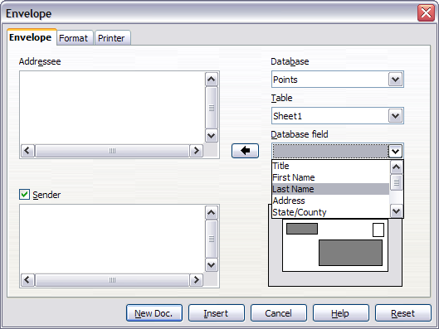

1. Quite often some of the fields in your address data source will be unused, leading to blank lines in your envelope Addressee area. If this is not important, you can skip the next few paragraphs and go straight to “” on page , otherwise continue as described here.

|  |  |
| --- | --- |
| Tip | The following procedure is very similar to that used for a similar purpose in the section on printing mailing labels. It is reproduced here for purposes of clarity. |

* 1. First ensure that the envelope is showing the field contents (data source headings), rather than their underlying field names. If this is not the case, then either press Ctrl+F9 or select View > Field Names to toggle the view.
  2. Next, ensure that you can see non‑printing characters, such as paragraph marks, line breaks and so on. If these are not already visible, select View > Nonprinting Characters from the menu bar, or press Ctrl+F10, or click on the large paragraph icon  in the Standard toolbar.

You will now see that address field separation is created by line breaks , rather than paragraphs . As the suppression of blank address fields depends on hiding paragraphs, not lines, you need to replace line breaks with paragraphs as follows.

* 1. Click at the end of the first data source address field. Press Delete to remove the new line and then press Return (or the Enter key) to insert a paragraph. Repeat this action for each data source address field.

If the line spacing in the Addressee area is not satisfactory, you may wish to correct this before proceeding, by modifying the paragraph style associated with the address. Unless you have changed it, the address uses the Default style.

|  |  |
| --- | --- |
| Caution | The objective of c) above is to replace all line breaks at the end of data source address fields with paragraphs. |

* 1. Click again at the end of the first paragraph to be suppressed and then select Insert > Fields > Other. Select the Functions tab and then click on Hidden Paragraph in the Type column. Now click in the Condition box and enter the details of the condition that defines a blank address field. It has the general form of:  
     ![Database.Table.Database field]  
     where the ‘!’ (NOT) character indicates the negative case and the square brackets delineate the condition.

For example, in our Points database the condition to test if the Last Name field is empty would be: ![Points.Sheet1.Last Name] as illustrated in .

To test for multiple conditions, use the operators AND and/or OR between the conditional statements, for example:  
![Points.Sheet1.Title]AND![Points.Sheet1.Last Name].

Click Insert, but do not close the dialog until all lines have been amended.

* 1. Repeat for each paragraph to be conditionally suppressed, remembering to advance the cursor to the end of the line in question before changing the last element of the condition and Inserting the result.
     1. Merging and printing the envelopes

To merge addresses and print the envelopes:

1. Choose File > Print. The following dialog appears. Click **Yes**.



1. The Mail Merge dialog () appears. As with form letters and mailing labels, you can choose to print envelopes for one, several or all address records in the database.
2. Make your selections and then click **OK** to print direct to the printer. If you wish to check the envelopes before printing them, see Step 9) of “” on page for instructions.



* 1. Using the Mail Merge Wizard to create a form letter

The recommended way to create a form letter is the manual method described in ““ on page . If however you prefer to use the Mail Merge wizard, the technique is described below.

Before starting you should note the following limitations, current in OOo V2.3:

* In Step 4 creating the salutation will only allow the sex-related Mr. and Mrs. It makes no allowance for Miss, nor does it permit sexless addressing such as Dr., or The Right Honourable.
* Still in Step 4, it is possible to bodge something like Dr. Crippen, but only by creating an impossible trigger for recognising a female recipient, such that the merge defaults to male. Of course one cannot have a prefix such as ‘Dear’ in this case and it has to be manually entered in Step 6.
* Again in Step 4, the General salutation is not editable and the default values are somewhat limited.
* In Step 5 the layout is idiosyncratic, with paragraph marks all over the place so as to space the address block frame and salutation. To create a professional looking document will require significant editing.

If the above limitations are not a hindrance to you, then open a new document with File > New > Text Document and start the Mail Merge wizard using **Tools > Mail Merge Wizard**. The wizard opens, as shown in .

* + 1. Step 1: Select starting document

The wizard gives various options to select your starting document:

* Use the current document.
* Create a new document.
* Use a template.
* Use an existing document.

For the purposes of this description we assume that you opened a new text document. This will ensure that all the steps in the wizard are fully explored, although with experience you may find it more practical to use a draft you prepared earlier, which will allow skipping some steps.

Select Use the current document and click Next.

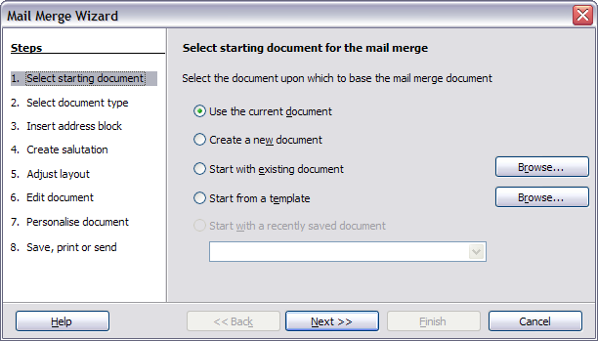

* + 1. Step 2: Select document type

The wizard can produce letters or, if a Java Mail connection exists, email messages.You can see these options in . In this example, we are producing a letter.Select **Letter** and click **Next**.

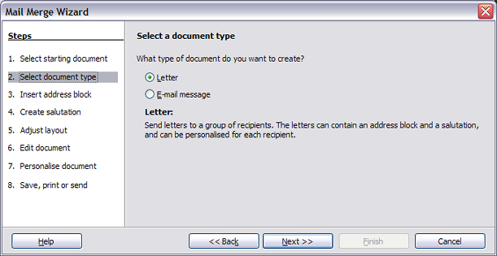

* + 1. Step 3: Insert address block

This is the most complex step in the wizard.In this step () you will do three things:

1. Tell the wizard which data source to use.The data source must be an existing file; in this example it is the “Points” spreadsheet created earlier.
2. Select the address block to use in the document.This means choosing which fields appear (for example, whether the country is included) and how they look.
3. Make sure that the fields all match correctly.This is very important.For example, the wizard has a field called <Last Name>.If your spreadsheet has a column called “Surname”, you need to tell the wizard that <Last Name> and “Surname” are equivalent. This is described in “” on page .

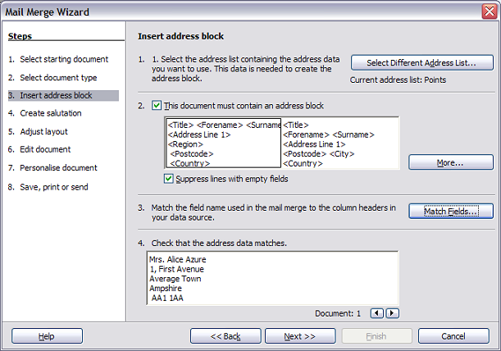

* + - 1. Selecting the data source (address list)

1. If the current address list, identified beneath the “Select Different Address List...” button in section 1, is not the one you wish to use click the button to open the Select Address List dialog () for choosing a data source.
2. If you have not already created the address list, you may click **Create** to do so now. This step will allow you to create a CSV (Comma Separated Values) file with a new list of address records.

If you already have an address list, as we have in the “Points” spreadsheet example, but which is not the one you wish to use, click **Add** and select the file in which it resides.

In each of the above cases a new data source will be created and registered.

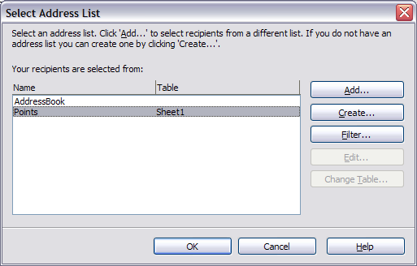

1. Select the address list and click **OK** to return to step 3 of the wizard. For this example, the preceding steps are all you need to do. The wizard can also exclude certain records; click **Filter** to choose them.
   * + 1. Selecting the address block
2. In step 3 of the wizard (shown in ), look at section 2.This is where you select the address block to appear on the letter, and define its appearance and the fields it contains.The main page gives two examples.If neither of those is exactlywhat you want, click **More** to see more choices, in the Select Address Blockdialog (shown in ).
3. The Select Address Blockdialog offers six choices for the format of the address block (scroll down to see the last two choices). You can also optionally include or exclude the country (for example, only include the country if it is not England). The six formats provided are relatively common, but they might not exactly match your preference. If this is the case, select the address block that is closest to what you want and click **Edit**, which opens the New Address Block dialog.

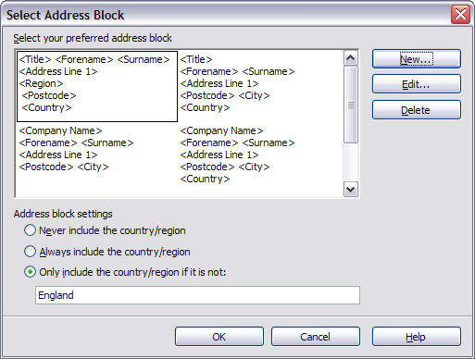

1. In the New Address Block dialog (), you can add or delete address elements using the arrow buttons on the left. To move elements around, use the arrow buttons on the right.For example, to add an extra space between first and last names in , click <Last Name> and then click the right arrow button.

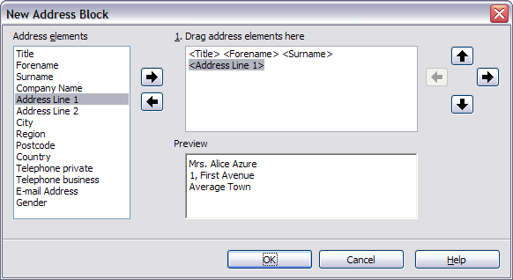

* + - 1. Matching the fields

Finally, it is time to match the wizard’s fields with the spreadsheet fields, so that items like <Last Name> and “Surname” match correctly.

1. Look at section 3 of step 3 of the wizard (shown in on page ). The box at the bottom displays one record at a time, using the address block format you selected.Use the right and left arrow buttons below that address box to step through the addresses, checking that they display correctly.Do not assume that all the records display correctly, just because one or two do. Check them all if you can, or at least a good proportion.
2. If the addresses do not display correctly (and they probably will not right away), click **Match Fields**. The Match Fields dialog opens, as shown in .

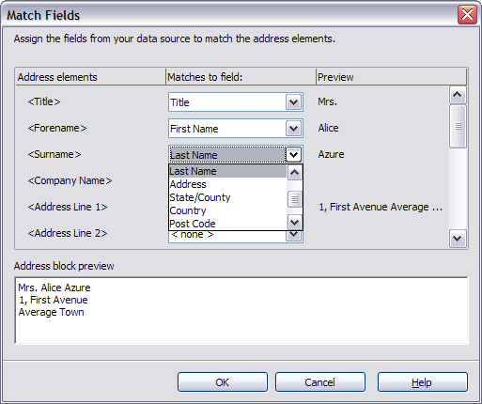

The Match Fields dialog has three columns.

* Address Elements are the terms the wizard uses for each field, such as <First Name> and <Last Name>.
* The Matches to Field column allows you to select, for each address element, the field from your data source that matches it.
* The Preview column shows what will be shown for this field from the selected address block, so you can double-check that the match is correct.

1. When you have matched all the fields, click **OK** to return to step 3 of the wizard. Now, when you use the arrow buttons to look at all the addresses, they should all look correct.If not, go back and change anything you’re not happy with, before clicking **Next** to move to step 4.

Note that you will not be able to continue until you have correctly matched all the fields in your chosen address block. If you see <not available> in a field position it indicates that the field in question is not correctly matched.

* + 1. Step 4: Create salutation

The salutation is the initial greeting, for example, *Dear Mr Jones****.***In step 4, select the salutation that will appear in the letter.

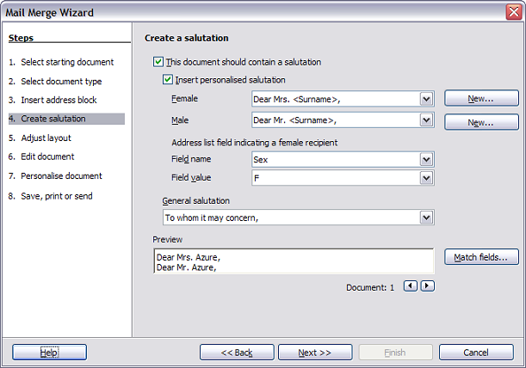

You can use a different greeting for men and women.To do this, Writer must have some way of knowing whether a person is male or female. In our spreadsheet we had a column called Sex.In the section Address list field indicating a female recipient, set the field name to Sex and the field value to F. The male salutation is then printed for all men and the female salutation for all women.

|  |  |
| --- | --- |
| Note | You do not need to tell OOo who is a male, because it assumes that all non-female records are males. |

If you do not select **Insert Personalized Salutation**, you can use a more general salutation without referring to the recipient directly, such as “To whom it may concern”.

As in step 3, step 4 of the wizard has a preview pane at the bottom. You should check more than one record to ensure that other records look the way you expect.

* + 1. Step 5: Adjust layout

In step 5, you can adjust the position of the address block and salutation on the page. You can place the address block anywhere on the page. The salutation is always on the left, but you can move it up and down the page. Use the buttons shown in to move the elements.

A point to note here is that the address block positional dimensions are shown in the Metric system, irrespective of the chosen measurement system in the rest of OOo. This is a reported error in V2.3.

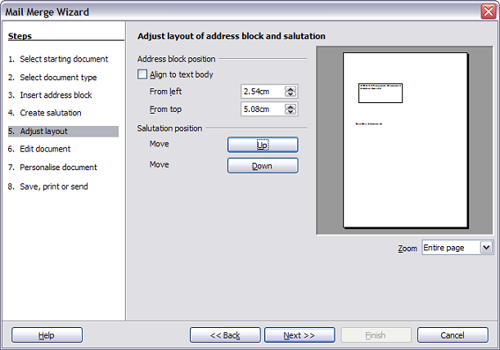

* + 1. Step 6: Edit document and insert extra fields

In step 6 you have another opportunity to exclude particular recipients from the mail merge, as shown in .

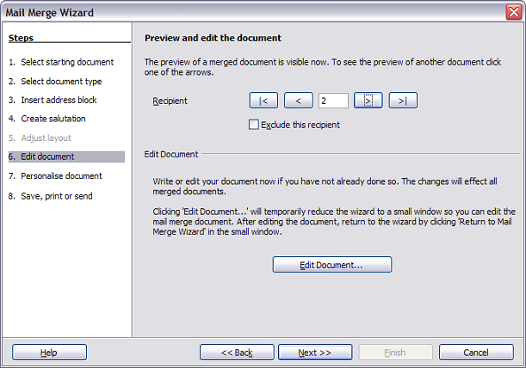

You can also edit the body of the document.If you started with a blank document, you can write the whole letter in this step.Click **Edit Document** to shrink the wizard to a small window () so you can easily edit the letter.

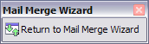

You need to perform another important task in this step. The wizard only inserts information from the name and address fields, but you may wish to add additional data.In our example, we want to tell each person how many points they had accumulated during the year; that information is in the spreadsheet.

To do this:

1. Click **Edit Document** in step 6 of the wizard.
2. Select **Insert > Fields > Other**. The Fields dialog opens, as shown in .

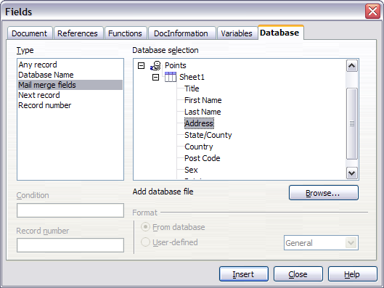

1. Click the **Database** tab.
2. On the left hand side, select **Mail merge fields**.
3. Under **Database selection** find your data source (in this example, it is a spreadsheet).Expand it to see the fields.
4. Click the field you want to insert, then click **Insert** to insert the field.

You can insert any number of fields any number of times into your mail merge document.

1. Click **Close** when you are done.

|  |  |
| --- | --- |
| Note | The Database selection lists the data source you selected in step 3. All the information you need for the letter must be contained in that data source. |

* + 1. Step 7: Personalize documents

In step 7, OOo creates all your letters, one per recipient.

Clicking the **Edit individual Document** button here is similar to step 6.The difference is that you now edit a long file containing all of the letters, so you can make changes to a particular letter to one person. In this step of the Mail Merge wizard (), click **Find** to open a dialog that allows searches within the document, perhaps for an individual addressee.

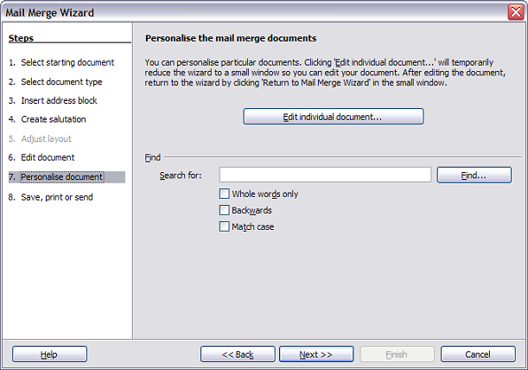

As with step 6, when editing the document, the wizard shrinks to small window.Click on this window (see on page ) to expand the wizard to its full size.

* + 1. Step 8: Save, print or send

You have now completed the mail merge process. The last step is to do something with it.In step 8, you can save the original sample letter, save the merged document, print the letters right away or, if you created email messages, send them.

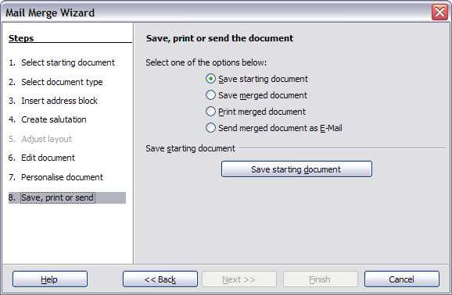

You probably want to save the starting (prototype) document and the merged document. To do this, select Save starting document to reveal the Save starting document section containing the Save starting document button. This button will be active only if the document has not already been saved. Clicking on this button brings up the standard Save as dialog. Once you have named and saved the document you return to the Step 8 dialog as shown in .

The merged document can now be saved by selection of Save merged document. This will reveal the Save merged document settings section, from which you can select to save either as one large file containing all the individual, generated letters or as a separate file for each letter.

When you have saved the merged document, you can print the final letters now or later; and you can still manually check and edit the letters if necessary. If you elect to print at this stage, the dialog shown in appears; it should be self-explanatory.

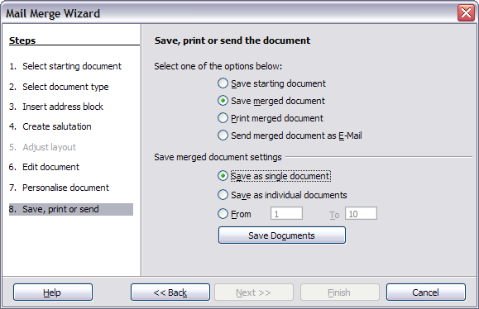

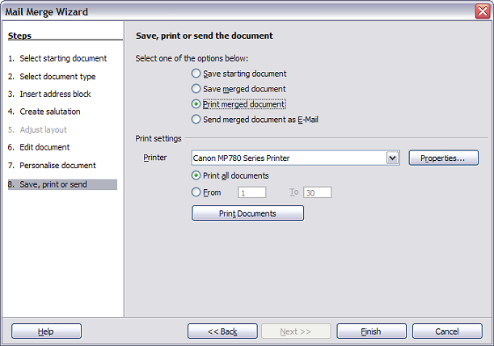



Writer Guide

1. Chapter 12  
    Creating Tables of Contents, Indexes and Bibliographies
   1. Introduction

This chapter shows you step-by-step how to create and maintain a table of contents, an index, and a bibliography for a text document using OpenOffice.org Writer. To understand the instructions, you need to have a basic familiarity with Writer and styles.

* 1. Creating a table of contents

Writer’s table of contents feature lets you build an automated table of contents from the headings in your document. Before you start, make sure that the headings are styled consistently. For example, you can use the Heading 1 style for chapter titles and the Heading 2 and Heading 3 styles for chapter subheadings.

This section shows you how to:

* Create a table of contents quickly, using the defaults.
* Customize a table of contents.

|  |  |
| --- | --- |
| Note | You can use custom styles for the different levels in the table of contents as well. This document uses the default styles for simplicity. |

* + 1. Creating a table of contents quickly

Although tables of contents can be customized extensively in Writer, most of the time you will probably find the default to be fine. Creating a quick table of contents is simple:

1. When you create your document, use the following paragraph styles for different heading levels (such as chapter and section headings): Heading 1, Heading 2, and Heading 3. These are what will appear in your table of contents. You can use more levels of headings, but the default setting is to use only the first three levels in the table of contents. It could look like if you used the default styles.
2. Place the cursor where you want the table of contents to be inserted.
3. Select Insert > Indexes and Tables > Indexes and Tables.

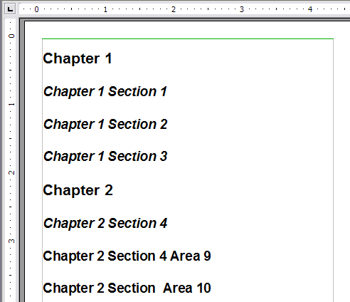

1. Change nothing in the Insert Index/Table dialog box (). Click OK. The result will look like .

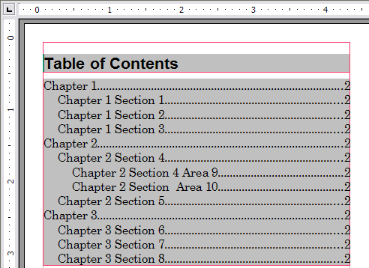

If you add or delete text (so that headings move to different pages) or you add, delete, or change headings, you need to update the table of contents. To do this:

1. Place the cursor within the table of contents.
2. Right-click and select Update Index/Table from the pop-up menu.

|  |  |
| --- | --- |
| Note | If you cannot place your cursor in the table of contents, choose Tools > Options > OpenOffice.org Writer > Formatting Aids, and then select Enable in the Cursor in protected areas section. |

|  |  |
| --- | --- |
| Tip | You can customize an existing table of contents at any time. Right-click anywhere init and select EditIndex/Table from the pop-up menu. Continue as described in the next section, “”. |

* + 1. Customizing a table of contents

To insert a customized table of contents into your document:

1. Place the cursor where you want to insert the table of contents.
2. From the main menu, choose Insert > Indexes and Tables > Indexes and Tables.The Insert Index/Table dialog box opens.

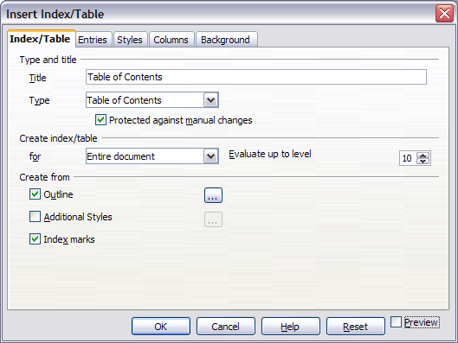

The Insert Index/Table dialog box () has five pages. Any or all of them can be used when creating or editing a table of contents:

* Use the Index/Table page to set the attributes of the table of contents.
* Use the Entriesand Styles pages to format the entries in the table of contents.
* Use the Columns page to put the table of contents into more than one column.
* Use the Backgroundpage to add color or a graphic to the background of the table of contents.

You can display a preview box, located on the left-hand side of each tab, to show as you work how the table of contents will look. (If you do not see the preview box, select the Previewcheckbox in the lower right-hand corner of the dialog box.) The illustrations in this chapter show the dialog box as it appears with the preview box hidden.

After making all your changes, click OK to save the table of contents so it appears in your document.

* + 1. Using the Index/Table page

Use the Index/Table page, pictured in , to set the attributes of the table of contents.

* + - 1. Adding a title

To give the table of contents a title, type it in the Titlefield. (You can change an existing title by typing over it.) To delete the title, clear the Titlefield.

* + - 1. Setting the type of index

You can create several types of indexes. They include:

* Table of Contents
* Alphabetical Index
* Illustration Index
* Table of Objects
* Bibliography

You can also create user-defined indexes.

|  |  |
| --- | --- |
| Note | You can only change the type of index when you first create it. Once you define an index type (for example, make a table of contents) you cannot change the type. |

* + - 1. Choosing the scope of the table of contents

From the for drop-down list in the *Create index/table* area, select *Entire document*. There is an additional option to create a table of contents for just the current chapter. For more information, refer to **Help > OpenOffice.org Writer > Contents**.

* + - 1. Creating a table of contents from an outline

This selection creates the table of contents using outline levels; that is, paragraphs formatted with one of the predefined heading styles (**Heading 1-10**) are added to the table of contents in order.

Click on the (...) button next to the checkbox to change the numbering properties of the table of contents. This can be useful if you want to put numbers in front of each level of the contents, as in .

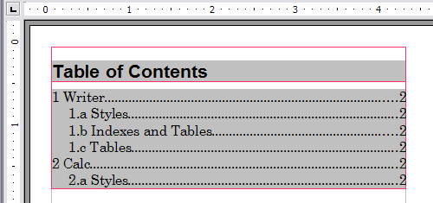

* + - 1. Creating from index marks

This selection adds any index entries that you have inserted into the document by using **Insert > Indexes and Tables > Entry**. Normally you would not use this selection for a table of contents.

* + - 1. Protecting against manual changes

To stop the table of contents being changed accidentally, select the **Protected against manual changes**checkbox. If this box is checked, the table of contents can only be changed using the context menu or the Insert Table/Index dialog box. If the box is not checked, the table of contents can be changed directly on the document page, just like other text.

|  |  |
| --- | --- |
| Tip | Any manual changes to a table of contents are lost when you update it. |

* + - 1. Changing the number of levels included

Writer displays a default setting of 10 levels of headings when it builds the table of contents (or the number of levels used in the document, whichever is smaller). To change the number of levels, enter the required number in the Evaluate up to levelbox.

* + - 1. Creating from additional styles

Writer automatically assigns to the table of contents all paragraphs formatted with the default heading styles (Heading 1, Heading 2, and so on). To assign paragraphs formatted with other styles, including custom styles:

1. In the *Create from* area, select the Additional Stylescheckbox.
2. Click the(...)button to the right of the checkbox. The Assign Styles dialog box () opens.

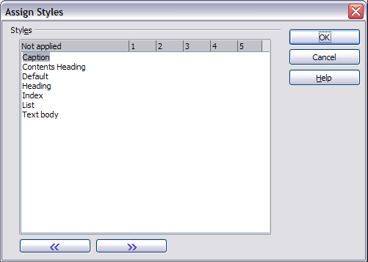

1. In the Not appliedcolumn, click the style that you want to assign to the table of contents.
2. Use the >>button to move the selected style to the desired outline level. For example, to have paragraphs formatted with the selected style to appear as top-level entries in the table of contents, click the >>button once to move the style into the 1column. To move the style in the opposite direction, use the <<button.
3. Click OKto save your changes and return to the Index/Table tab or click Cancelto return without saving your changes.

|  |  |
| --- | --- |
| Note | If the Outline box is checked, any changes you make to the position of one of the predefined Heading styles will be superseded by the default outline structure. |

* + 1. Using the Entries page

Use the Entries page, pictured in , to define and format the entries in the table of contents. For each outline level, you can add and delete elements such as chapter (heading) numbers, and you can also apply character styles to individual elements.

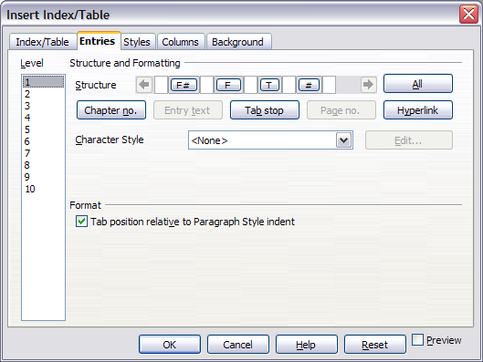

To begin, click a level number in the *Level*column to select the outline level whose elements you want to format. (You will be able to apply changes to all outline levels later.) The Structure line displays the elements for entries in that level. Each button on the Structure line represents one element:

* The E#button represents the “chapter number”, which means the heading number, not just for chapters but also for other levels of headings.
* The Ebutton represents the entry text.
* The Tbutton represents a tab stop.
* The #button represents the page number.
* The LSbutton represents the start of a hyperlink. (This button does not appear on the default Structure line.)
* The LEbutton represents the end of a hyperlink. (This button does not appear on the default Structure line.)

Each white field on the Structure line represents a blank space. You can add custom text if you desire.

|  |  |
| --- | --- |
| Note | On some operating systems, such as Windows XP, the **E#** and **E** buttons display as **F#** and **F**, and the **LS** and **LE** buttons display as **IS** and **IF** (the bottom of the displayed **E** or **L** character is cut off). This problem will be fixed in a future release of OpenOffice.org. |

|  |  |
| --- | --- |
| Note | If the chapter number defined for your document includes the word “Chapter” before the number itself, then the **E#** field in the table of contents will also include the word “Chapter”. If you want to include the chapter number with the page number (for example, in the style “1-1, 1-2, ...”) , you will find that the page number appears in the table of contents as “Chapter 1-1”, which is probably not what you want. |

* + - 1. Changing elements

To change an element in the Structure line, click the button representing that element and then click the element that you want to substitute in the row of buttons just below the Structure line. For example, to change a chapter number to a tab stop, click the E# button on the Structure line (it shows then as being pressed) and then click the Tab stop button in the row of available elements.

* + - 1. Deleting elements

To delete an element from the Structure line, click the button representing that element and then press the *Delete* key on your keyboard. For example, to delete a tab stop, click the *T*button and then press the *Delete* key.

* + - 1. Adding elements

To add an element to the *Structure* line:

1. Place the cursor in the white field to the left of where you want to insert the element.
2. Click one of the five buttons just below the Structure line. (For example, to add a tab stop, click the Tab stopbutton.) A button representing the new element appears on the Structure line.
   * + 1. Hyperlinking an entry

To change the default Structure line so that the chapter number and the entry text form a hyperlink, follow these steps:

1. On the Structure line, place the cursor in the white field to the left of the E#button.
2. Click the Hyperlinkbutton. An LSbutton, representing the start of the hyperlink, appears on the Structure line.
3. On the Structure line, place the cursor in the white field to the right of the Ebutton.
4. Click the Hyperlinkbutton again. An LEbutton, representing the end of the hyperlink, appears on the Structure line.

represents the completion of the above steps. The number and the text of the entries on that level will now be hyperlinks.

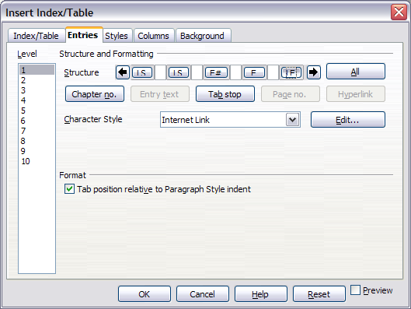

* + - 1. Applying character styles

To apply a character style to an element:

1. On the Structure line, click the button representing the element to which you want to apply a style.
2. From the Character Styledrop-down list, select the desired style. Writer applies the selected style to the selected element.

To view or edit the attributes of a character style, select the style from the Character Styledrop-down list and then click the Editbutton.

|  |  |
| --- | --- |
| Tip | The default character style for hyperlinks is Internet Link, which by default is underlined and shown in blue. If you want the table of contents entries to work as hyperlinks, but not have them underlined and blue, you can change the attributes of the Internet Link character style. However, this changes the attributes of all hyperlinks in the document.  If you want other hyperlinks (for example, website addresses) to remain in the default style, change the character style selection for table of contents entries to Index Link (in ). If necessary, change the attributes for Index Link to what you want. |

* + - 1. Applying changes to all outline levels

To apply the displayed structure and formatting to all outline levels, click the Allbutton.

* + - 1. Tab position relative to Paragraph Style indent

When this checkbox is selected, entries are indented according to the settings of their individual formats. Where a paragraph style with an indent on the left is in use, tab stops will be relative to this indent. If this checkbox is not selected, tab stops will be relative to the left margin position.

* + 1. Using the Styles page

Use the Styles page, pictured in , to apply paragraph styles to the table of contents. You can apply a different paragraph style to each outline level of the table.

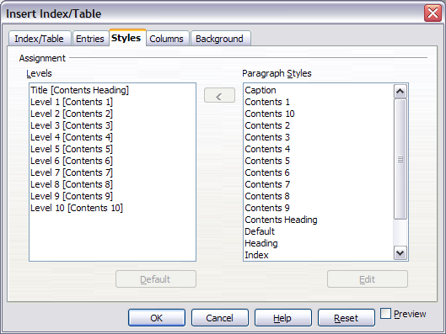

To apply a paragraph style to an outline level:

1. In the Levelslist box, select the desired outline level by clicking it.
2. In the Paragraph Styleslist box, click the paragraph style to apply.
3. Click the <button to apply the selected paragraph style to the selected outline level.

The styles of the level appears in the square brackets in the Levels list.

To remove paragraph styling from an outline level:

1. In the Levelslist box, select the desired outline level by clicking it.
2. Click the Defaultbutton.

To view or edit the attributes of a paragraph style, click the style in the Paragraph Styleslist box and then click the Editbutton.

|  |  |
| --- | --- |
| Note | Changes to a paragraph style will affect any text in the document that is formatted using this style, not just the format of the table of contents. |

* + 1. Using the Columns page

Use the Columns page () to change the number of columns for the table of contents.

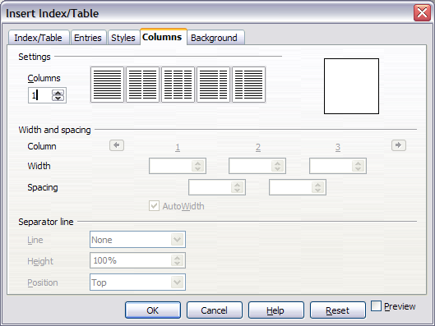

* + - 1. Adding multiple columns

To display the table of contents in more than one column:

1. Either enter the number of columns desired in the box labeled Columns or select the icon representing the number of columns.
2. To evenly distribute the columns according to the page width, check the **AutoWidth**box. If it is unchecked, you can manually set each of the following by altering the associated spin box:
   * + Width between each of the columns
     + Spacing between each of the columns
3. You can choose to have a separator line between the columns:
   * + Line: The width of the line.
     + Height: The height of the line.
     + Position: Relative position of the line to the table (top, middle, or bottom) if the height is less than 100%.
     1. Using the Background page

Use the Background page, pictured in , to add color or a graphic to the background of the table of contents.

* + - 1. Adding color

To add color to the background of the table of contents, select from the color grid.

|  |  |
| --- | --- |
| Note | Even though the table of contents may have ashade behind it while editing, it is actually not shaded by default. It appears shaded because it is a field and will appear to have the same shading all fields have. |

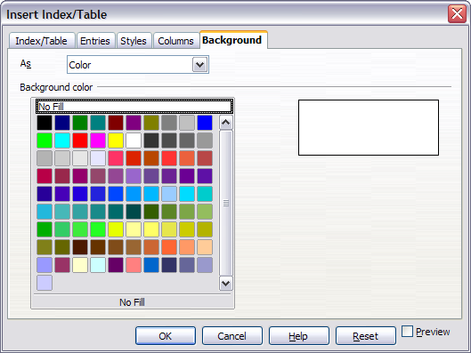

* + - 1. Adding a graphic

To add a graphic to the background of the table of contents:

1. From the Asdrop-down list, select Graphic. The Background tab now displays the graphics options, as shown in .
2. Click the Browsebutton. The Find graphics dialog box opens.
3. Find the graphic file you want and then click the Openbutton. The Find graphics dialog box closes and the selected graphic appears in the graphic preview box on the right-hand side of the Backgroundtab. (If you do not see the graphic, select the Previewcheckbox.)
4. To embed the graphic in your document, clear the Link checkbox. To link the graphic to the document but not embed it, select the Link checkbox.
5. In the Type area of the Background tab, choose how you want the background graphic to appear:

* To position the graphic in a specific location, select Positionand then click the desired location in the position grid.
* To stretch the graphic to fill the entire background area, select Area.
* To repeat the graphic across the entire background area, select Tile.

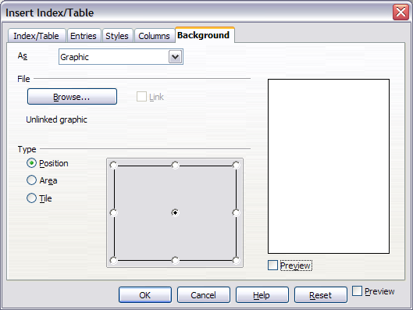

* + - 1. Deleting color or graphics

To delete color or graphics from the table background:

1. From the Asdrop-down list, select Color.
2. Click No Fillon the color grid.
   * 1. Maintaining a table of contents

This section shows you how to:

* Edit an existing table of contents.
* Update a table of contents when changes are made to the document.
* Delete a table of contents.
  + - 1. Editing a table of contents

To edit an existing table of contents:

1. Click anywhere in the table of contents and then right-click.

|  |  |
| --- | --- |
| Tip | If you cannot click in the table of contents, it is probably because it is protected. To disable this protection, choose Tools > Options > OpenOffice.org Writer > Formatting Aids, and then select Enable in the Cursor in protected areas section. If you wish to edit the table of contents without enabling the cursor, you can access it from the Navigator as explained on page . |

1. From the pop-up menu, choose Edit Index/Table. The Insert Index/Table dialog box ( on page ) opens and you can edit and save the table as described in the previous section.

You can also access the Index/Table dialog box from the Navigator ().

1. Open the Navigator (press F5).
2. Click the + sign next to Indexes.
3. Right-click on the desired index.
4. Select Index > Edit.
   * + 1. Updating a table of contents

Writer does not update the table of contents automatically, so after any changes to the headings, you must update it manually. To update a table of contents when changes are made to the document:

1. Click anywhere in the table of contents and then right-click.
2. From the pop-up menu, choose Update Index/Table.Writer updates the table of contents to reflect the changes in the document.

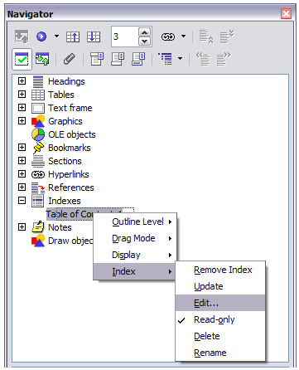

|  |  |
| --- | --- |
| Note | You can also update the index from the Navigator by selecting Index > Update from the menu in . |

* + - 1. Deleting a table of contents

To delete the table of contents from a document:

1. Click anywhere in the table of contents and then right-click.
2. From the pop-up menu, choose Delete Index/Table.Writer deletes the table of contents.

|  |  |
| --- | --- |
| Note | Writer will not prompt you to confirm the delete! Use caution when deleting a table of contents.  You can also delete the index from the Navigator by selecting Index > Delete from the menu shown in . |

* 1. Creating an alphabetic index

An alphabetical index (referred to as an index) is a list of keywords or phrases used throughout a document that, if listed in order, may help the reader find information quickly. Generally an index is found in the back of book or document and lists several keywords or phrases in alphabetical order with page numbers.

This section describes how to:

* Add index entries.
* Create an alphabetic index quickly.
* Customize the display of index entries.
* View and edit existing index entries.
  + 1. Adding index entries

Before you create an index, you must create some index entries.

1. Either highlight the word or phrase to add to the index or place the cursor at the beginning of the word or phrase. (If you want to add multiple words as one entry it will generally be better to highlight the entire phrase.)
2. Click **Insert > Indexes and Tables > Entry** to display a dialog box similar to that shown in . You can accept the word or phrase shown in the *Entry* box or change it to whatever you want. If you placed the cursor at the beginning of a word, clicking on the *Entry* text box inserts the word into the text box.
3. Click **Insert** to create the entry.

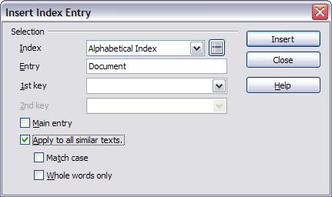

1. You can create multiple entries without closing the dialog box. For each one:
   * Click at the location in the document that you want to index.
   * Click again on the dialog box.
   * Change the entry if needed, and click **Insert**.
2. When you are satisfied with the entries, click **Close**.

|  |  |
| --- | --- |
| Note | If field shading is active (see Tools > Options > OpenOffice.org> Appearance > Text Document > Field shadings), when a selected word or phrase has been added to the index, it is shown in the text with a gray background. Index entries whose text is different from the text in the document are marked by a small gray rectangle. |

|  |  |
| --- | --- |
| Tip | You can also open the Insert Index Entry dialog box by clicking the Entry icon on the Insert toolbar, as shown in . |



* + 1. **Creating an alphabetic index** quickly

Now that there are index entries, you can create the index.

Although indexes can be customized extensively in Writer, most of the time you will need to make only a few choices. To create an index quickly:

1. Place the cursor where you want to add the index and click **Insert > Indexes and Tables > Indexes and Tables**.
2. In the *Type* box on the Index/Table page of the Insert Index/Table dialog box ( on page ), select **Alphabetical Index**.
3. In the *Options* section, you may want to uncheck the **Case sensitive** checkbox.
4. Click **OK**.

If you add, delete, or change the text of index entries, you need to update the index. Writer does not update an index automatically. To do this, follow the steps outlined in “” on page .

* + 1. Customizing index entries

Below is a brief explanation of the fields in the Insert Index Entry dialog box and how to use them.

* *Index* – The type of index this entry is for. The default is Alphabetical Index, but you can use this field to create extra entries for a table of contents or user-defined indexes or lists of almost anything. For example, you might want an index containing only the scientific names of species mentioned in the text, and a separate index containing only the common names of species. See “” on page .
* *Entry* – The word or phrase to be added to the selected index. This word or phrase does not need to be in the document itself; you can add synonyms and other terms that you want to appear in the index.
* *1st key* – An *index key* is an index entry that has no associated page number and has several subentries that do have page numbers. Keys are useful ways of grouping related topics. (See “” on page .)
* *2nd* Key – You can have a three-level index, where some of the first-level keys have level-2 entries that are also keys (without page numbers). This degree of index complexity is not often necessary.
* *Main entry* – When the same term is indexed on several pages, often one of those pages has more important or detailed information on that topic, so it is the main entry. To make the page number for the main, or most important, entry stand out,select this checkbox and then define the character style for the page number of a main index entry to be bold, for example.
* *Apply to all similar texts* – Select this checkbox if you want Writer to automatically identify and mark any other word or phrase that matches the current selection. The Match case and Whole words only checkboxes become available if this checkbox is selected.
  + - 1. Example of using an index key

An *index key* is a primary entry under which subentries are grouped. For example, you might want to create a grouping similar to this:

OpenOffice.org

Writer 5

Calc 10

Impress 15

In this example, *OpenOffice.org* is the *1*st *key*. The subentries (with the page numbers showing) are the indexed entries. To insert an index entry for the topic *Writer*, on the Insert Index Entry dialog box ( on page ), type “Writer” in the Entry box and “OpenOffice.org” in the 1st keybox.

* + 1. Customizing the appearance of an index

The Insert Index/Table dialog box ( on page ) has five pages. Any or all of them can be used to customize the appearance of an index.

* Use the Index/Tablepage to set the attributes of the index.
* Use the Entriesand Stylespages to format the entries in the index.
* Use the Columns tab to put the index into more than one column.
* Use the Background tab to add color or a graphic to the background of the index.

The preview box, located on the left-hand side of the dialog box, shows as you work how the index will look. (If you do not see the preview box, select the Previewcheckbox in the lower right-hand corner of the dialog box.)

After making your changes, click OK to save the index so it appears in your document.

* + - 1. Using the Index/Table page

Use the Index/Table page () to set the basic attributes of the index.

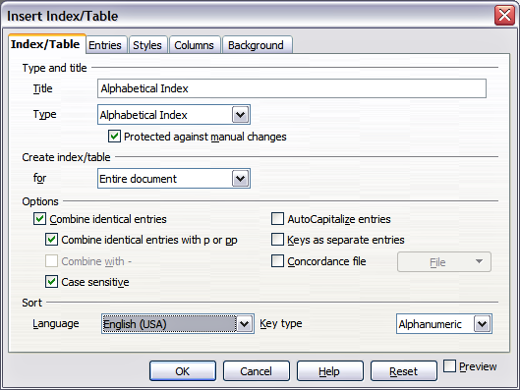

1. To give the Index a title, type it in the **Title** field. (You can change an existing title by typing over it.) To delete the title, clear the **Title** field.
2. To prevent the index from being changed accidentally, check the **Protected against manual changes**checkbox. If this box is checked, the index can only be changed using the context menu or the Insert Table/Index dialog box. If the box is not checked, the index can be changed directly on the document page, just like other text.

|  |  |
| --- | --- |
| Tip | Any manual changes to an index are lost when you update it. |

1. From the drop-down list in the Create index/table area, select Entire document. You can also choose to create an index for just the current chapter.
2. Various other options determine how the index handles entries:
   * + **Combine identical entries.** Defines how identical entries are dealt with. Normally each page number of an indexed word or phrase will be shown in the index; however these can be combined using the **Combine identical entries with p or pp**. If you want a page range displayed, select **Combine with –** (which will produce something similar to 23–31). If you want different entries based on what letters are capitalized, select **Case sensitive**.
     + **AutoCapitalize entries.** Automatically capitalizes the first letter of each entry regardless of how they show within the document itself.
     + **Keys as separate entries.** For the keys to have their own page numbers, select this option.
     + **Concordance file**. Enables a list of words in an external file to be imported (select using the **File** button) and then used within the index. The concordance file has a special file format; for further information, refer to *concordance file* in**Help > OpenOffice.org Help**. Using a concordance file can speed up production of an index, but unless the words are very carefully selected and you edit the index afterwards, the resulting index can be full of entries for minor mentions of a term, making it less useful than a more selective index.
     + **Sort**. Defines how the entries are sorted when displayed. The only option is alphanumeric, but you can define which language alphabet will be used.
       1. **Using the Entries page**

Use the *Entries* page to set exactly how and what will be displayed for each of the entries. The dialog box is similar to .

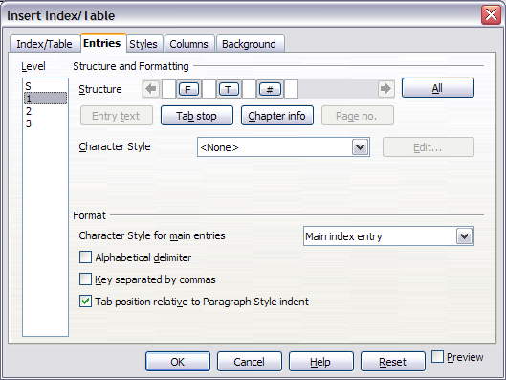

To begin, click a number in the Levelcolumn to select the index level whose elements you want to format. (You will be able to apply your changes to all index levels later.) The Structure line displays the elements for entries in that level. Each button on the Structure line represents one element:

* The Ebutton represents the entry text.
* The Tbutton represents a tab stop.
* The #button represents the page number.
* The **CI** button represents chapter information. This may not be displayed immediately, but can be added.

Each white field on the Structure line represents a blank space. You can add custom text if you desire.

|  |  |
| --- | --- |
| Note | On some operating systems, the **E#** and **E** buttons display as **F#** and **F**, and the **LS** and **LE** buttons display as **IS** and **IF** (the bottom of the **E** and **L** are cut off). This problem will be fixed in a future release of OpenOffice.org. |

* + - 1. Changing elements

To change an element in the **Structure** line, click the button representing that element and then click the element that you want to substitute in the row of buttons just below the **Structure** line. For example, to change entry text to a tab stop, click the **E#** button on the **Structure** line (it shows then as being pressed) and then click the **Tab stop** button in the row of available elements.

* + - 1. Deleting elements

To delete an element from the **Structure** line, click the button that represents that element and then press the *Delete* key on your keyboard. For example, to delete a tab stop, click the *T*button and then press the *Delete* key.

* + - 1. Adding elements

To add an element to the Structure line:

1. Place the cursor in the white field to the left of where you want to insert the element.
2. Click one of the buttons below the Structure line. (For example, to add a tab stop, click the Tab stopbutton.) A button representing the new element appears on the Structure line.
   * + 1. Applying character styles

Each of the items that can be added to the Structure line may have additional formatting. For example, you may want the page number to be a different size from the rest of the index text. To do this, apply a character style to one of the elements in the Structure line.

To apply a character style to an element:

1. On the **Structure**line, click the button representing the element to which you want to apply a style.
2. Select the desired style from the Character Style drop-down list. Writer applies the style to the selected element.

To view or edit the attributes of a character style, select the style from the Character Styledrop-down list and then click the Editbutton.

* + - 1. Formatting entries

Apply additional formatting using the options in the **Format** section.

* **Alphabetical delimiter**. This will display, as a means of separating index entries, the first letter of all the subsequent index entries. For example:

**A**

apple, 4

author, 10

**B**

break, 2

bus, 4

* **Key separated by commas**. Arranges the entries in the index on the same line but separated by commas.
* **Tab position relative to Paragraph Style indent**. When checked, entries are indented according to the settings of their individual formats. Where a paragraph style with an indent on the left is in use, tab stops will be relative to this indent. If this checkbox is not selected, tab stops will be relative to the left margin position.
  + - 1. **Using the Styles, Columns and Background pages**

Refer to “” on page , “” on page , and “” on page .

* + 1. **Maintaining an index**

To modify the appearance of an index:

1. Click anywhere in the index and then right-click.
2. From the pop-up menu, choose Edit Index/Table. The Insert Index/Table dialog box opens and you can edit and save the index using the five tabs described in the previous section.

To update or delete an index, follow the process described in the sections “” and “” on page .

* + 1. **Viewing and editing existing index entries**

Once you have added the initial entries, you can make some amendments or add some new ones. You can view and edit these using the following steps:

1. Ensure that field shading is active (**Tools > Options > OpenOffice.org> Appearance > Text Document > Field shadings**), so you can locate index entries more easily.
2. Place the cursor immediately to the left of an existing index entry in the body of your document and select **Edit > Index Entry**. Alternatively, right-click on the word or phrase and from the context menu select **Index Entry**.
3. A dialog box similar to appears. You can move through the various index entries using the forward and back arrow buttons. If there is more than one entry for a single word or phrase, then you can scroll through each of the entries.
4. Make the necessary modifications or additions to the index entries and, when finished, click OK.

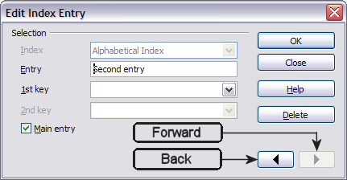

* 1. **Creating and using other types of indexes**

An alphabetical index is not the only type of index that you can build with Writer. Other types of indexes supplied with Writer include those for illustrations, tables, and objects, and you can even create a user-defined index. For example, you might want an index containing only the scientific names of species mentioned in the text, and a separate index containing only the common names of species.

To create other indexes:

1. Place the cursor where you want the index created.
2. Select Insert > Indexes and tables > Indexes and tables from the menu bar.
3. On the Insert Index/Table dialog box (), in the **Type** dropdownlist, select the index wanted.
4. Modify the various pages, which are very similar to those discussed in previous sections.
5. Select OK when everything has been set.

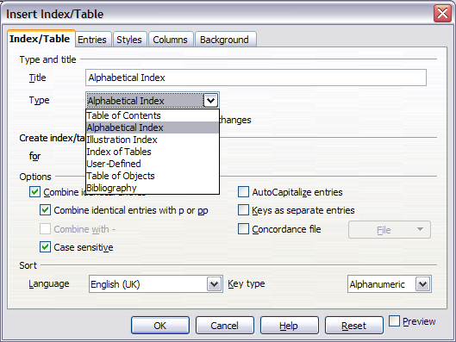

* 1. **Creating a bibliography**

A bibliography is useful for displaying references used throughout a document. These references are either stored in a bibliographic database or within the document itself.

This section shows you how to:

* Create, add, and maintain entries within a bibliographic database.
* Add a reference into a document.
* Format the bibliography.
* Update and edit an existing bibliography.

For most of this section, the database table used is the sample one that comes with Writer. For information on creating a new table in the bibliographic database, see Chapter 10 (Getting Started with Base) in the Getting Started book.

* + 1. Creating a bibliographic database

Although you can create references within the document itself, creating a bibliographic database allows reuse in other documents and saves a lot of time.

Follow these steps to create a bibliographic database:

1. Select **Tools > Bibliography Database**. A window similar to that in is shown.

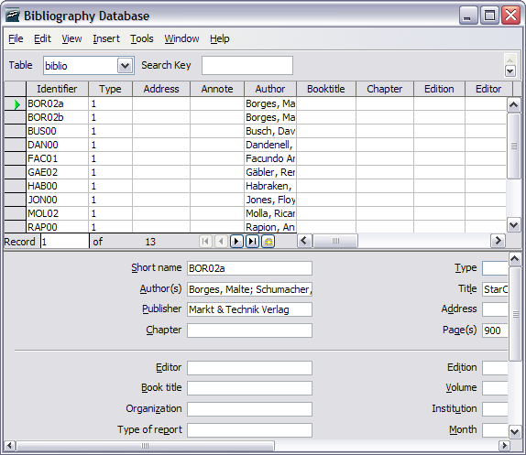

1. You can use the top portion of this window to:
   * Filter for specific records within the database (see “” below).
   * Change some details of columns in the database (see “”).
   * Select an alternative data source (another database or table) or change details of the fields in the database.

The middle portion of the window shows each of the records in a table layout similar to that of a spreadsheet. Additional fields can be viewed by scrolling the table to the right.

The bottom portion of the window shows the contents of the selected record.

* + - 1. Filtering records

To set up a filter for specific records within the bibliographic database, select Tools > Filter from the Bibliographic Database menu bar. On the Standard Filter dialog box (), choose the fields, conditions and values for the filter and click OK.

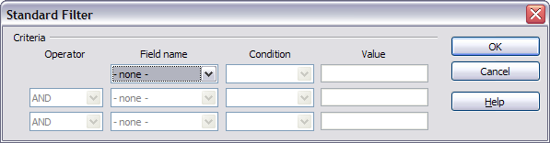

* + - 1. Changing column details

To change the details of columns in the bibliographic database, select the **Column Arrangement** button near the top of the window. The Column Layout for Table biblio dialog box ()is displayed.

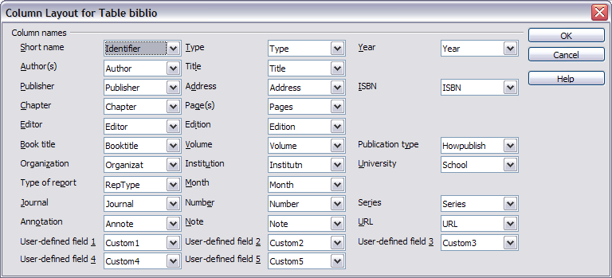

* + - 1. Changing field details

You can make changes to the bibliography database (for example, rename fields or change the length of fields) by doing the following:

1. In the main document (not the Bibliography Database screen), press F4 or click View > Data Sources to open the data source window, similar to .
2. Make sure that the Bibliography database is selected as well as the correct table. You may have to expand some levels to be able to select the correct ones.

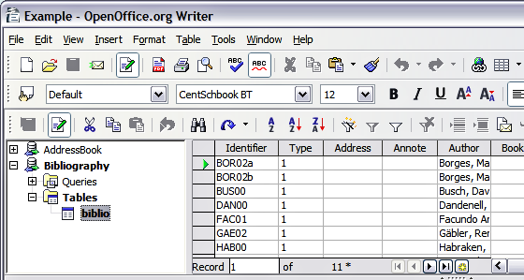

1. Right-click on the table entry (*biblio* in the example) and select **Edit Database File** from the pop-up menu. This opens a window similar to , which is the main menu for Base, the database component of OpenOffice.org.

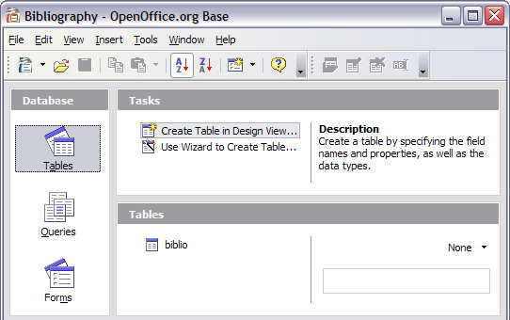

1. If **Tables** (under the **Database** view) is not selected, select it now.
2. Right-click on the biblio table name in the Tables section and select Edit from the context menu to display a window similar to that shown in .
3. You can now select each of the rows and modify the Field Properties as required.
4. When finished, you will be asked to confirm that you want the changes saved.

|  |  |
| --- | --- |
| Note | For more information on how to use OOo’s database features, see Chapter 10 (Getting Started with Base) in the Getting Started book. |

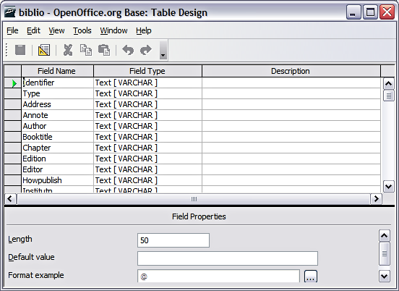

* + 1. Adding entries to the database

To add entries to the database:

1. You can add records directly into the database using the lower portion of the window shown in on page .
2. Complete each of the fields as required. Use the Tab key to move between fields.
3. It is best to use a unique name in the Short name field. This is used when inserting entries into documents.
4. To complete the entry move to the last field and press Tab once more.

|  |  |
| --- | --- |
| Notes | The Identifier column in the upper portion of the Bibliography Database window is labeled Short name in the lower portion of the window.  If your document requires [Author, date] style citations, use the Identifier (Short name) field of the database to record the information in the required format. If you are using a simple citation numbering system (e.g., [1],[2],...), use a unique reference of some sort in the Identifier (Short name) field. Writer will auto-number entries based on the position within the document. |

* + 1. Maintaining entries in the database

To maintain entries in the database, use the Bibliography Database window as in the previous section. Click on the appropriate field and modify the text as appropriate.

Modified entries will be saved automatically to the database when the cursor moves off the record.

* + 1. Adding a reference (citation) into a document

Writer supports two ways of showing references (citations) in the text of a document:

* Using authors’ names and dates of the referenced documents, for example [Smith, 2004], as recorded in the Identifier (Short name) of each bibliographic entry.
* By numbering the referenced documents in the sequence they occur in the text, for example [1].

|  |  |
| --- | --- |
| Tip | To specify which citation style is used in the document, use the Index/Table page on the Insert Index/Table dialog, described on page . |

To add references from the bibliographic database into a document:

1. Place the cursor where you want the reference to appear.
2. From the main menu, choose **Insert > Indexes and tables > Bibliographic entry**.
3. In the Insert Bibliographic Entry dialog box, shown in , choose **From bibliography database** at the top of the dialog box. (You can also insert a reference from the document itself by selecting **From document content**, but that method is not covered in this chapter.)

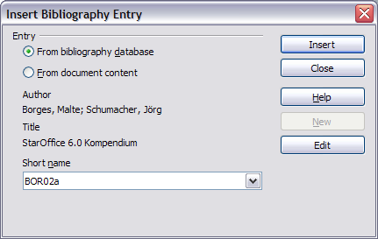

1. Select the reference from the **Short name**dropdown list near the bottom of the dialog box. The Author and Title of the selected reference are shown in the middle of the dialog box, to help you verify that it is the reference you want.
2. To insert the reference into the document, click **Insert**.
3. You can keep the dialog box open and insert another reference into the document; you don’t need to close and reopen it.
4. When you have finished inserting all the references, select **Close**.
   * 1. Formating the bibliography

Formatting the bibliography involves choices made in two places:

* Insert Index/table dialog (covered in this section)
* Bibliography 1 paragraph style (see page )

To create the bibliography:

1. Place the cursor at the point where you wish to insert the bibliography.
2. Select **Insert > Indexes and tables > Indexes and tables**and change the *Type* to**Bibliography**, to see a dialog box similar to that shown in .

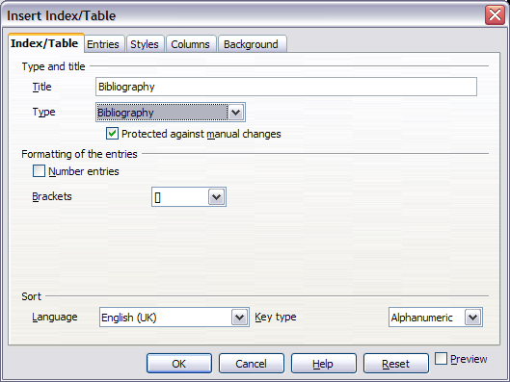

The Insert Index/Table dialog box has five pages.

* + - 1. Using the Index/Table page

The basic settings are selected on this page.

1. To give the bibliography a title, enter it in the **Title** field. (A title is not required.)
2. You can protect the bibliography from being changed accidentally, by checking the **Protected against manual changes**checkbox. If this box is checked, the bibliography can only be changed using the context menu or the Insert Table/Index dialog. If the box is not checked, the bibliographycan be changed directly on the document page, just like other text.
3. To have the bibliographic entries numbered within the body of the document (for example, [1], [2], ...), select **Number entries**. If, however, you wish to have the field *Identifier*(from the database) appear in the document, clear this checkbox.
4. Select the type of brackets that you want for the referenced entries shown within the body of the document.
5. Define the sorting you require. Currently only alphanumeric sorting is supported. Sorting by the the sequence that entries appear in the text is done on the Entries tab.
   * + 1. Using the Entries page

The structure of this page is similar to that of the previous sections (see ).

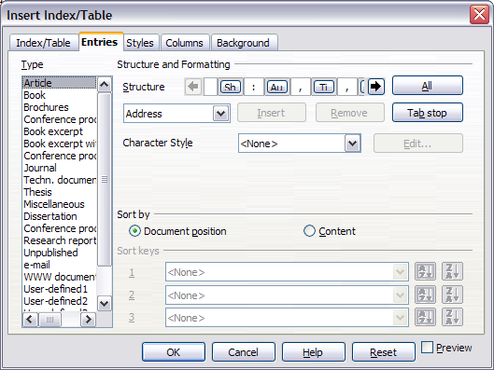

You can define how the entry will appear based on the *Type*of the entry, or simply apply the same format to all entries by selecting the **All** button.

The Structure of the entry is based on the fields available in the bibliographic database. The ones shown by default are:

* **Au** – Author
* **Ti** – Title
* **Ye** - Year

To determine how entries are sorted, modify the Sort by options. To sort by the sequence that entries appear in the text, choose *Document position*. To sort alphanumerically, choose *Content*. Use **Sort keys** to group similar references.

* + - 1. **Using the Styles, Columns and Background pages**

Refer to “” on page , “” on page , and “” on page .

* + - 1. Generating the bibliography

To generate the bibliography so that it appears in your document, click **OK.**The Insert Index/Table dialog box closes and the bibliography appears in your document.

* + 1. Defining the paragraph style for the bibliography

You can modify the Bibliography 1paragraph style to suit your requirements. For example, tonumber the entries in the bibliography list, you need to define a numbering style and link that numbering style to the Bibliography 1 paragraph style. To do this:

1. On the Styles and Formatting window, click on the List Styles icon. You can either define a new list style or modify one of those supplied. In this example, we will modify the Numbering 1 style. Right-click on Numbering 1 and choose Modify from the pop-up menu. (See .)

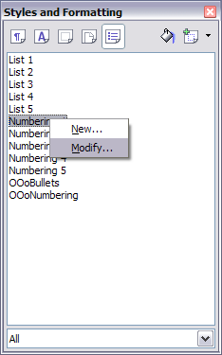

1. On the Numbering Style dialog, go to the Options page. In our example we want to have the numbers enclosed in square brackets. To do this, type [ in the Before box and ] in the After box, as shown in .

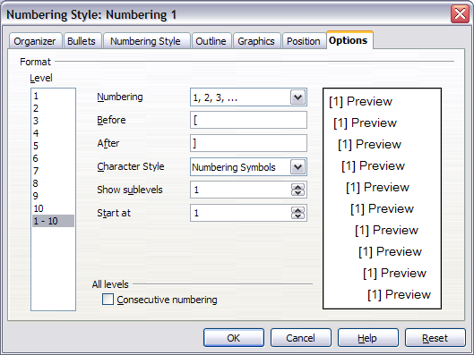

1. Now go to the Position tab of the Numbering style dialog. In the Spacing to text box, specify how much indentation you want for the second and following lines of any item in the bibliography list of your document. Often you will need to experiment a bit to see what is the best setting. In our example (), we have chosen 0.80 cm.

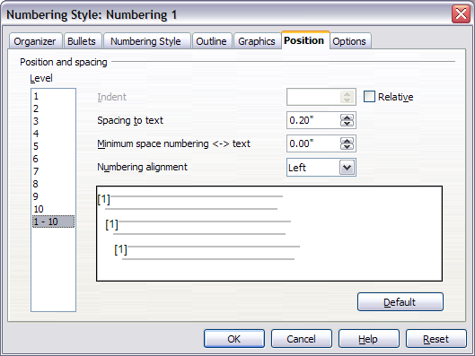

1. Click OK to save these settings and close the Numbering Style dialog. Return to the Styles and Formatting window, click on the Paragraph Styles icon, choose All Styles from the list at the bottom of that window, then right-click on Bibliography 1 and choose Modify.
2. On the Paragraph Style dialog, go to the Numbering tab and select Numbering 1 from the drop-down list. (See .) Click OK to save this change to the Bibliography 1 paragraph style.

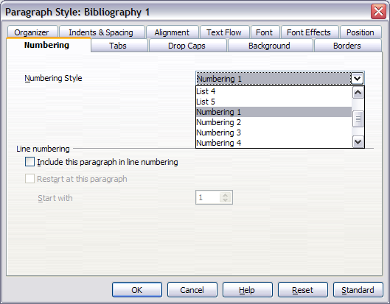

Now when you generate the bibliography, the list will look something like the one shown in .

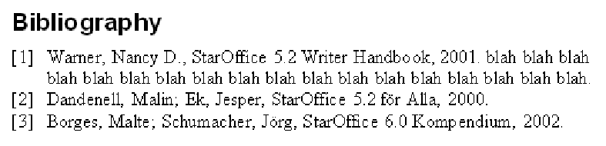

* + 1. Updating and editing an existing bibliography

To modify the display of bibliography entries:

1. Click anywhere in the bibliography and then right-click.
2. From the pop-up menu, choose Edit Index/Table. The Insert Index/Table dialog box opens and you can edit and save the table using the five pages described in the previous section.

To update or delete the bibliography, follow the same process as described in the sections “” and “” on page .



Writer Guide

1. Chapter 13  
    Working with Master Documents
   1. Why use a master document?

Master documents are typically used for producing long documents such as a book, a thesis, or a long report. A master document is especially useful when graphics, spreadsheets, or other material causes the file size to become quite large. Master documents are also used when different people are writing different chapters or other parts of the full document, so you don’t need to share files. A master document joins separate text documents into one larger document, and unifies the formatting, table of contents (ToC), bibliography, index, and other tables or lists.

Yes, master documents do work in OOoWriter. However, their use is full of traps for inexperienced users. Until you become familiar with the traps, find out whether they affect what you are doing, and learn how to avoid (or work around) them, you may think that master documents are unreliable or difficult to use. In fact, avoiding or working around most of the traps is quite easy to do.

You can use several methods to create master documents. Each method has its advantages and disadvantages. Which method you choose depends on what you are trying to accomplish. The different methods are described in this chapter, along with suggestions on when to use each one.

* 1. Styles and master documents

Styles that are used in subdocuments, such as paragraph styles, are automatically imported into the master document after you save the master document. When you modify the style in the master document, the style in the subdocument remains unaffected. That is, the style in the master document takes precedence over the style in the subdocument.

|  |  |
| --- | --- |
| Note | Use the same document template for the master document and its subdocuments. When you modify or create a style, add it to the document template, and then reload the styles from the template into the master document and the subdocuments. This way the subdocuments will look the same when they are loaded into the master document as they do when viewed as individual files. |

* 1. Using the Navigator

The Navigator is a very useful tool that helps you move quickly to specific parts of your document. It also provides information about the content of the document and enables you to reorganize some of the content. For example, if each chapter in your final book is a separate document, then in the master document they can be reordered, and the references are renumbered automatically and the table of contents and index can be updated.

In Writer, the Navigator has two distinct forms. One form is used in ordinary text documents and the other in master documents.

In an ordinary text document, the Navigator displays lists of the graphics, tables, index entries, hyperlinks, references, and other items in the document, as shown in . Click the + sign by any list to display the contents of the list. You can double-click an entry in the Navigator and jump immediately to that place in the document.

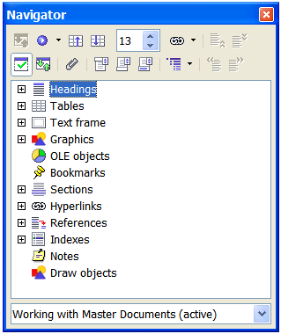

In a master document, the Navigator lists the subdocuments and text sections, as shown in . The use of the Navigator in a master document is covered in more detail later in this chapter (see “” on page and “” on page ).

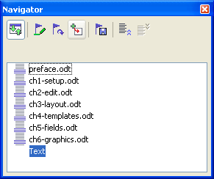

* 1. Creating a master document

The three most common scenarios for creating a master document depend on the current state of your document:

* You have one existing document (a book) that you want to split into several subdocuments (chapters) that will be controlled by the master document.
* You have several existing documents (chapters) by one or more authors that you want to combine into one book, controlled by the master document.
* You have no existing documents but intend to write a long book containing several chapters, possibly by multiple authors.

We will look at each of these scenarios in turn.

* + 1. Splitting one document into a master document and subdocuments

When you have one existing document that you want to split into several subdocuments that will be controlled by the master document, you can split the document automatically.

Use this method if the original document uses only the Default page style, is numbered sequentially from the first page, and uses the Heading 1 style to identify the start of each chapter. In these conditions, this method will work well.

Advantages: This method is quick and easy, and any existing cross-references between chapters are preserved. Although cleanup work may be necessary, once you have done the cleanup, the document will behave itself.

Disadvantages: If the original document was complex, you may have major cleanup work to do because some formatting will be lost—for example, page styles, page breaks, restarted page numbering.

How to do it: Open the document and click File > Send > Create Master Document to split the document. You will find that each of the subdocuments begins with a Heading 1 and the file names are all maindocnameX.odt, where X is 1, 2, 3, and so on. If you have a Preface or other “chapter” starting with a Heading 1 before Chapter 1, the file names will not directly correspond to the chapter numbers.

* + 1. Combining several documents into a master document

This method works best when all of the documents were created from the same template, but you can also use it when the documents were created from different templates.

Use one of the techniques described in “” to create a blank master document and insert the other documents as subdocuments of the master document.

This method is especially useful if the subdocuments are created or maintained by multiple writers. All writers on the project can work on their subdocuments without fear of version control issues that can occur when multiple people work on the same document.

* + 1. Starting with no existing documents

The ideal situation is to start with no existing documents, because you can do everything the way you want from the beginning. Writer provides three ways to create a master document:

In each case, you need to have a disciplined approach to make sure the master document works correctly and reliably. Each method below describes the steps to take. Be sure to do the steps in the order given.

* + - 1. Method 1. Quick and easy, but not recommended

Writer provides a quick and easy way to create a master document, but the master document is not associated with a template, so changes to styles and formatting are more difficult to apply reliably.

|  |  |
| --- | --- |
| Note | If the subdocuments were all created with the same template and the styles were not modified in the documents, then the styles are imported into the master document with the subdocuments, and styles and formatting should be correct in the master document. This method works best when these conditions are met. |

How to do it:

1. Click File > New > Master Document.
2. Use the Navigator to insert new documents or existing files into the master document, as described in “” on page .
   * + 1. Method 2. Not too complicated, but with restrictions

This technique works well if you want to use sequential page numbering throughout the final document (not restarting at 1 at any point), and each chapter starts with a Heading 1 on a new page. If you want to restart page numbering anywhere in the document, use Method 3.

How to do it: Follow the instructions in the next section (), but do not put in the text sections between the subdocuments or try to change the page numbering.

* + - 1. Method 3. Complete control

This method gives you complete control over complex documents with several page styles or restarted page numbering. It is a bit more work to set up, but works reliably.[1]1

How to do it: Follow these steps, in the order given. Each step is explained in detail in the following subsections.

* + - 1. Step 1. Plan the project

Although you can make changes at most steps in this process, the more you can plan before you start, the less work you will have to do to correct any problems later. Here are some things you need to plan:

* Parts of book or report required, and the page numbering to be used in different parts of the book. Consider as an example a book with these parts:

|  |  |  |
| --- | --- | --- |
| Part | Length | Page numbering |
| Title (cover) page | 1 page | no page number |
| Copyright page | 1 page (back of title page) | no page number |
| Table of Contents | unknown length | start with i |
| Preface (Foreword) | 2 pages | continue from ToC |
| Chapters 1 to 8 | unknown length | start with 1 |
| Appendixes A, B | unknown length | continue from Chapter 8 |
| Index | unknown length | continue from Appendix B |

* What pages will be in the master document and what will be in the subdocuments. The ToC and index must be in the master document. A typical arrangement would be:

|  |  |
| --- | --- |
| Part | Location |
| Title (cover) page | In master document |
| Copyright page | In master document |
| Table of Contents | In master document |
| Preface (Foreword) | Subdocument |
| Chapters 1 to 8 | Subdocuments |
| Appendixes A, B | Subdocuments |
| Index | In master document |

* Page, paragraph, character, frame, and numbering styles. See Chapter 6, “Introduction to Styles” and Chapter 7, “Working with Styles” for instructions on how to create or modify styles. Some styles for the example book are:

**Page styles**

|  |  |  |
| --- | --- | --- |
| Name | **Characteristics** | **Next page style** |
| Title page | No header, footer or page numbers; layout different from other pages | Copyright page |
| Copyright page | No header, footer or page numbers; layout different from other pages | Front matter first page |
| Front matter first page | No header; page number in footer, Roman numbers (i, ii, iii); layout different from following pages | Front matter left page |
| Front matter left page | Header and footer, one containing the page number (Roman) | Front matter right page |
| Front matter right page | Margins mirrored from Front matter left page; Roman page number | Front matter left page |
| First page | No header; page number in footer, Arabic numbers (1, 2, 3); layout same as Front matter first page | Left page |
| Left page | Layout as for Front matter left page, but Arabic page numbers | Right page |
| Right page | Layout as for Front matter right page, but Arabic page numbers | Left page |

**Paragraph styles**

|  |  |  |
| --- | --- | --- |
| **Name** | **Characteristics** | **Next paragraph style** |
| Heading 1 | 18 pt, bold, 0.30” above, 0.15” after, page break before | Body text |
| Heading 2 | 14 pt, bold, 0.30 “ above, 0.15” below | Body text |
| Body text | 12 pt, double space, 0.25” indent before | Body text |
| Page break | 6 pt, no space before or after, page break before | Body text |

**Character styles**

|  |  |
| --- | --- |
| **Name** | **Characteristics** |
| Emphasis | 12 pt, italic |
| Body text | 12 pt |

* Insert fields and AutoText entries as required. See other chapters in this book for ideas.
  + - 1. Step 2. Create a template containing the required styles, fields, and other elements

You can create your template from an existing document or template that contains some or all of the styles you want for this document, or you can create the template from a blank document. For more about templates, see Chapter 10, “Working with Templates”.

If you use an existing document or template, delete all the text from it except for fields in headers and footers before saving it as the template for this project. It will still have all the styles you defined, even if the text is not there. You can change the styles in the template as your project develops.

Be sure to use **File > Templates > Save** when creating the template.

* + - 1. Step 3. Create the master document and subdocuments from the same template

If you are starting a new project, create the master document and all the subdocuments from the same template. Not using the same template could create style inconsistencies that require time and effort to correct. For example, if two subdocuments have a style with the same name that is formatted differently in each document, the master document will use the formatting from the first subdocument that was added. This could cause your document not to look like you expect. Using the same template for all subdocuments saves time and frustration.

It does not matter in what order you create the master and subdocuments, and you do not have to create all the subdocuments at the same time, when you are starting the project. You can add new subdocuments at any time, as you need them—as long as you always create them from the same template.

Create the master document

Follow this process to create the master document. You can use other methods, but each method (including this one) has its drawbacks.

1. Open a new document from the template you created in Step 2, by clicking New > Templates and Documents, then selecting the template you created. Be sure the first page of this new document is set to the page style you want for the first page of the final document; if it is not, change it. In our example, the style for the first page is Title page.
2. If any text or page breaks came into this document from the template, delete the text. (Fields in headers and footers can stay.)
3. Click **File > Send > Create Master Document**. Save the master document in the folder for this project, not in the templates foldert. We will return to this master document later. For now, you can either leave it open or close it, as you prefer.

Create subdocuments

A subdocument is no different from any other text document. It becomes a subdocument only when it is linked into a master document and opened from within the master document. Some settings in the master document will override the settings in a subdocument, but only when the document is being viewed, manipulated, or printed through the master document.

Create a subdocument in the same way as you create any ordinary document:

1. Open a blank document based on the project template (very important) by clicking New > Templates and Documents, then selecting the template.
2. Delete any unwanted text, and set the first page to the page style you specified for the first page of a chapter.
3. Click File > Save As. Give the document a suitable name and save it in the folder for this project.

If you already have some of the chapters written, the files are probably not based on the template you just created for this project. You will need to change the template attached to the existing files. The only way to do this is:

1. Open a blank document based on the project template.
2. Copy the contents of the original document into this new document. Use File > Paste Special to avoid copying the styles from the original documents to the new document.
3. Apply the template styles throughout the document.
4. Click **File > Save As** and save the new document in the project folder with a suitable name.
5. Rename the original chapter file so you do not use it by mistake.
   * + 1. Step 4. Insert some information directly into the master document

The instructions in steps 4 and 5 use the page numbering requirements given in Step 1. If your book has different requirements, change these instructions to suit.[2]2

These instructions are fairly tedious, but once you have the master document set up, you should not have to change it, and with a bit of practice setting it up goes quickly.

1. Open the master document and do the following.

* Make sure paragraph marks are showing (you can set them in **Tools > Options > OpenOffice.org Writer > Formatting Aids**, or click the **Nonprinting characters** icon ).
* Show text boundaries, table boundaries, and section boundaries (**Tools > Options > OpenOffice.org > Appearance**).

1. Type the contents of the title page (or leave placeholders and fill in later). With the insertion point in the last blank paragraph on the page, click **Insert > Manual Break**. On the Insert Break dialog box (), select **Page break** and the page style for the second page (Copyright page in our example), and leave the **Change page number** checkbox deselected. Click **OK**.

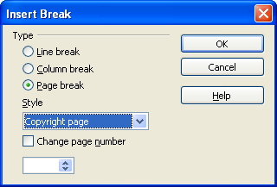

Figure 362. Inserting a page break between the title page and the copyright page

1. Type the contents of the copyright page (or leave placeholders). Insert another manual page break, this time setting the page style to Front matter first page. Select the Change page number checkbox and choose 1 in the box below that, as shown in . This number 1 will show in your document as i, because the page style is defined to use Roman numerals.

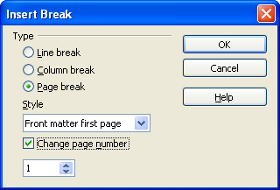

Figure 363. Inserting a page break before the first page of the front matter

1. Let’s assume the third page is for the Table of Contents. Leave a blank paragraph or two on this page and insert another page break, with the next page again set to the Front matter first page style, which we want to use for the first page of the Preface. Because we want the page numbering for the Preface to continue from the page numbers of the Table of Contents, do ***not*** select the **Change page number** checkbox this time. Notice that the Navigator shows one item, labeled **Text**.
   * + 1. Step 5. Insert the subdocuments into the master document

At last we are ready to add the subdocuments.

|  |  |
| --- | --- |
| Tip | Subdocuments are inserted into a master document before whatever item is highlighted in the Navigator. If you insert the last subdocument first, and then insert the other subdocuments before the last one, they will end up in the correct sequence without the necessity of moving them up or down in the list. |

1. Display the Navigator (click **Edit > Navigator**, or press F5, or click the **Navigator** icon  .
2. On the Navigator, select **Text**, then long-click on the **Insert** icon and click **File**.

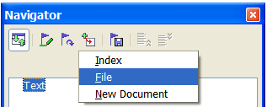

Figure 364. Inserting a subdocument into a master document using the Navigator

A standard File Open dialog box appears. Select the required file (which you created in Step 3) and click **OK**. This example uses six chapters and a preface; we will load Chapter 6 first, as suggested in the Tip above.

The inserted file is listed in the Navigator *before* the Text item, as shown in .

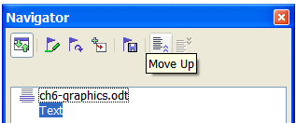

Figure 365. Navigator after inserting one subdocument

1. Because the Text section contains the title page and other material you have already inserted, highlight it and click the Move Up icon to move it to the top of the list.
2. Highlight the subdocument you just inserted (Chapter 6), then long-click on the **Insert** icon and click **File** to insert the first subdocument; in this example, Preface. Chapter 6 remains highlighted. Repeat with Chapter 1, Chapter 2, and so on until all the subdocuments have been added to the list. The Navigator will now look something like .

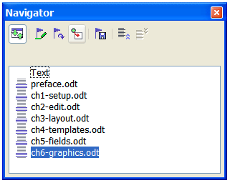

1. Save the master document again. Now highlight each chapter in turn and insert a Text section before it. When you are done, the Navigator should look like .

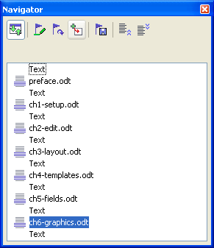

|  |  |
| --- | --- |
| Tip | You can define your Heading 1 paragraph style to start on a new page, and thus avoid inserting manual page breaks between chapters, but this causes a page numbering problem if you want to restart page numbering at the beginning of Chapter 1.  To restart page numbering, you must insert a manual page break; but because the Heading 1 style on the first page of Chapter 1 forces yet another page break, you end up with one or more unwanted blank pages before the first page of Chapter 1. The technique described in this chapter avoids this problem. |

1. Check whether the first page of the master document has the correct page style. If not, change it to the correct style (Title page in this example).

Scroll to the place where the first subdocument begins. Check whether its page style is correct, and change it if necessary (Front matter first page in this example).

The first subdocument () has a blank paragraph at the top of the page; this was inserted as part of the manual page break. Set this paragraph to the PageBreak style you created in Step 2.



Figure 368. Page break before subdocument, which is in a protected section

1. Notice that the document is in a protected section. That means you cannot change any of the contents of this subdocument from within the master document. (If you remove the section, the contents become part of the master document itself; they are no longer in a subdocument. If you make changes in either the master document or the subdocument, those changes are not made in the other document. For more about sections, refer to the online help or to Chapter 4, “Formatting Pages”.)

Scroll down until you find the beginning of Chapter 1. You will find that it is on the same page as the end of the Preface, and there is a blank paragraph in the text area between the two sections (the Preface and Chapter 1), as shown in .

Click on this blank paragraph and insert a page break, specifying the First Page style and the page number to start at 1. Click **OK**.



Figure 369. A text area between two sections of a master document

1. Scroll to the first page of Chapter 2. You’ll find that it is on the same page as the end of Chapter 1, and there is a blank paragraph in the text area between the two chapters.

Click on this blank paragraph and insert a page break, specifying the First Page style, but do *not* select the Change page number checkbox.

Repeat for all of the chapters, so that each chapter starts on a new first page.

1. Save the master document again.
   * + 1. Step 6. Add a table of contents, bibliography, or index

You can generate a table of contents, bibliography, or index for the book, using the master document. You must insert these items into a text section in the master document. For more about these document elements, see Chapter 12, “Creating Tables of Contents, Indexes, and Bibliographies”.

Put the insertion point on the page in the first text section where the table of contents is to go and create the table of contents.

If you do not have a Text section at the end of the master document, insert one before the last subdocument, then move it down so it is after the last subdocument. Now, if you have included bibliographic entries in your subdocuments, you can put the insertion point on the page in this last text section where the bibliography is to go and create the bibliography.

If you have included index entries in your subdocuments, put the insertion point on the page in the last text section where the index is to go and create the index.

* 1. Editing a master document

After creating a master document, you may want to change its appearance or contents.

* + 1. Changing the appearance of the document

You can change the styles in the template as your project develops. Do not make changes to styles in the master document or in any of the subdocuments—make those changes in the template.

To update the master document (and all of the subdocuments) with changes to the template, just open the master document. You will get two messages: first, to ask if you want to update all links; and second, if you want to apply the changed styles. Answer Yes to both of these messages.

* + 1. Editing subdocuments

You cannot save edits made to a subdocument from within the master document. Instead, you must open the subdocument, either by double-clicking on it in the master document’s Navigator, or by opening it from outside the master document. Then you can edit it just as you would edit any other document. Just one rule: if you make any changes to the styles while editing a subdocument, you must copy those changed styles to the template so they are available to all of the subdocuments and to the master document.

If you change the contents of any subdocument, you need to manually update the table of contents, bibliography, and index from within the master document.

* 1. Cross-referencing between subdocuments

The methods described earlier in this chapter are all most writers will need when using master documents. However, you might need to automatically update cross-references between subdocuments. This section describes how to do this.

The process to create cross-references between subdocuments is tedious, but it works. (An alternative is to use Ian Laurenson’s OutlineCrossRef3 macro, available from <http://homepages.paradise.net.nz/hillview/OOo/OutlineCrossRef3-fr-3.odt>.)

1. First set references in each subdocument, just as you would when you are cross-referencing within a single document. When you do this, select the entire text you want to use as the reference, such as a a heading or figure number. Keep a list of what you have named the reference fields, and be sure every name is unique. One way to keep track of this information is by putting it in a separate text file or a spreadsheet.

The field names are case-sensitive. You can check the field name by holding the cursor over the referenced item. In our example (), the heading has the field name *word count*.



Figure 370. Finding the field name for a heading

1. Open the master document. In the Navigator (), select a subdocument and click the **Edit** icon (or right-click and choose **Edit** from the pop-up menu). The subdocument opens for editing.
2. In the subdocument, place the cursor where you want the cross-reference to appear. Click **Insert > Cross Reference**.
3. In the Fields dialog box, on the References page, select **Insert Reference** in the Type list on the left hand side (). The Selection list in the middle column shows only the reference field names for the subdocument you are using, so ignore that list and check the list you created manually in step 1.

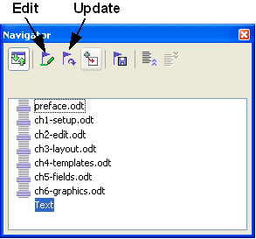

Figure 371. Selecting a subdocument in the Navigator

1. In the **Name** field in the lower right hand column, type the name of the reference you set in the subdocument you are referring to. In our example, the reference is in Chapter 3, and its name is *word count*.

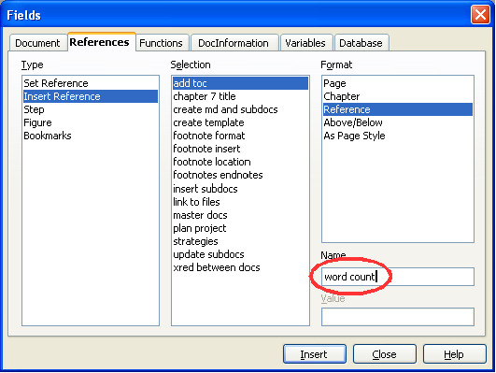

1. Click **Insert,** type any text you want to appear between the reference and page number (such as “on page”), and then insert another reference with the **Page** format. Nothing will appear in the subdocument except tiny gray bars indicating the fields. If you hover the mouse pointer over one of these fields, you should see the field name ().



Figure 373. Viewing the field name

(You can turn on the display of field codes by clicking **View > Field Names.** The two fields shown as gray lines in now look like .)



1. After you have inserted all the cross-references required in the subdocument, save and close it and return to the master document window.

Within the master document, navigate to the page of the subdocument on which you inserted the cross-reference field. You should now see the text of the cross-reference appear in the spot where you inserted it (), because within the master document, the subdocument can find the target of that field reference.



This technique also works if you open a subdocument directly in step 2 (that is, not from within the master document) and insert a cross-reference field.

* 1. Creating one file from a master document and its subdocuments

Master documents are .odm files containing linked subdocuments, which are in .odt format. Although linked files are very useful when writing and editing a large document such as a book, sometimes you might need to have a copy of the entire book in one file.

To export a master document to a .odt file (without affecting the original .odm file), do this:

1. Open the master document and choose File > Export from the menu bar.
2. On the Export dialog (), type a name for the exported .odt file and choose OpenDocument Text (.odt) from the File format list. Click Export. This step changes the .odm file into a .odt file.

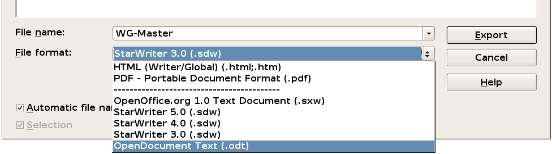

1. Close the master document and open the new .odt file, updating all links.
2. Choose Edit > Links from the menu bar.
3. The Edit Links dialog () shows all the linked files. Select all the files in the Source file list and click Break Link. This step embeds (includes) the contents of all the subdocuments into one single file.

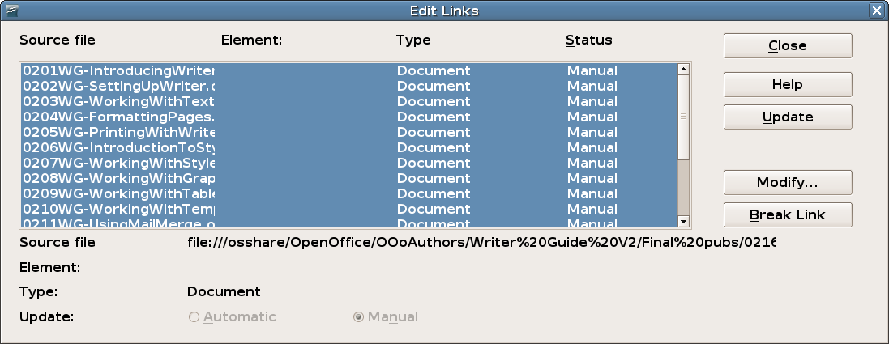

* 1. Problem solving

Some combinations of choices do not work together. This section describes some problems and what to do about them.

* + 1. Including a chapter reference in the header of the first page
       1. The problem

If you use the method described in “” beginning on page (putting a page break paragraph into the master document between the subdocuments), **and** you put a cross-reference to the chapter name and number in the header of the **first** page of each chapter, then the cross-reference field on the first page will pick up the chapter name and number from the previous chapter. This happens because with this method the first (blank) paragraph on those pages is actually the **last** paragraph of the previous chapter. The example did not include a cross-reference to the chapter name and number in the header of the first page, so it did not have this problem.

First page **footers** do not have this problem; they correctly pick up the current chapter’s name and number.

* + - 1. The solution

The cure for this problem is as follows:

1. Use File > Templates > Edit to open the template used for the master document and its subdocuments.
2. Modify the style for the chapter title (usually Heading 1) to enable a page break before, using the page style you want for the first page of each chapter. Save and close the template.
3. When you reopen the master document, it should ask two questions: “Update all links?” and “Your styles don’t match the template. Do you want to update your files?” Be sure to answer Yes to both questions.
4. Modify the chapter title style (Heading 1) in the master document file as you did in the template file in step 2. Save the master document.
5. Open the Navigator in Master Document view and delete the Text sections between the chapters. Update all links.

The headers on the first page of each chapter will now display the correct chapter name and number.

* + - 1. The problem with the solution—and a workaround

This solution creates another problem, **if** you want to restart page numbering at 1 on the first page of the first chapter **and** have pages numbered sequentially through all the chapters.

Normally you would restart numbering by specifying the starting page number when you modify the Heading 1 style to start on a new page. However, if you do that, then each chapter restarts page numbering at 1. (Sometimes this is what you want, but often it is not.)

In this case, you will have to include an “offset” in the page number field—that is, you tell OOoWriter how many pages to subtract to make the first page of the first chapter to be page number 1. Of course, to make this work, you need to know how many pages are in the front matter, and you may not know that until after you have finished the entire book. If you add or delete some pages (for example, if the table of contents grows from 4 pages to 5), you will need to adjust the offset accordingly. Therefore, this adjustment is best made at the end of the project.

Here is how to do it.

1. In the master document itself—not in the subdocument—place the cursor just in front of the Page field on the first page of the first chapter. Right-click and choose Fields from the pop-up menu.
2. In the Edit Fields dialog box (), type a negative even number (–2, –4, etc.) in the *Offset* box. Click **OK** to save this change.

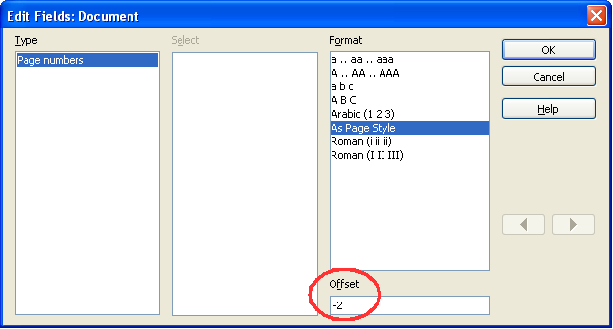

1. You might need to make the same change on the second page of the first chapter.
   * 1. Including landscape pages in a portrait-oriented master document
        1. The problem

Master documents ignore manual page breaks in subdocuments **if** the manual break specifies the following page style. Landscape pages are inserted into portrait-oriented documents by inserting a manual page and specifying a landscape page style (and then changing back to portrait orientation by inserting another manual break and specifying the following page style). This technique works fine until the document becomes a subdocument within a master document. At that point the landscape pages become portrait pages and the page break itself is ignored.

* + - 1. The solution

1. Remove the landscape pages from the subdocument and put them in a separate document. Note that if the landscape pages are in the middle of the original subdocument, you will end up with at least three documents: (a) the portion of the subdocument before the landscape pages, (b) the landscape pages themselves, and (c) the portion of the subdocument after the landscape pages.
2. Insert documents (a) and (c) individually into the master document.
3. Then do one of the following:

* Insert a text section into the master document itself between documents (a) and (b). In the text section, insert a manual page break (specifying the landscape page style), and then paste the contents of document (b)—the landscape pages—into the master document. If necessary, insert another manual page break (specifying one of the relevant portrait page styles) before document (b).

or

* Insert document (b) into the master document as a subdocument, using the method described on page to include a manual page break in a text section before and after the landscape document.

When deciding which method to use, you need to consider the placement of headers and footers (if any) that appear in your document. If you want portrait headers and footers on the landscape pages, use the technique described in Chapter 4, “Formatting Pages”.

* + 1. Anchoring pictures to a page
       1. The problem

A picture (graphic) anchored “to page” in a subdocument is not displayed in the master document although it always appears correctly in the subdocument.

Because the master document reorganizes the page flow, page numbers, and cross-references when it collates all the subdocuments together, the absolute reference to a page X in a subdocument is lost in the master document. The picture loses its anchor reference and simply disappears.

* + - 1. The solution

To avoid this problem but keep pictures positioned precisely on a particular page, anchor the pictures as follows:

1. Right-click on the picture and choose Picture from the pop-up menu.
2. On the Type tab of the Picture dialog box (), set the anchor to To character or To paragraph.

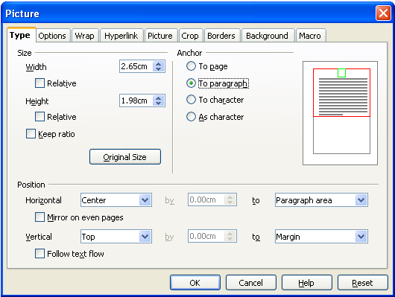

1. Under Position, choose suitable horizontal and vertical references to the page.



Writer Guide

1. Chapter 14  
    Working with Fields
   1. Introduction to fields

Fields are extremely useful features of Writer. They are used for data that changes in a document, such as the current date or the total number of pages. This chapter describes how to use a few of them.

|  |  |
| --- | --- |
| Tip | Fields have a gray background when viewed on screen, unless you have deselected the **Field shadings**checkbox or changed the color of field shadings on the **Appearance** page of the Options – OpenOffice.org dialog box. This gray background will not show when you print the file to hardcopy or PDF.  To turn field shadings on or off quickly, choose **View > Field Shadings** or press *Control+F8*. |

* 1. Quick and easy field entry

You can quickly insert common fields into your document by choosing **Insert > Fields** from the menu bar and selecting the required field from the list, as shown in .

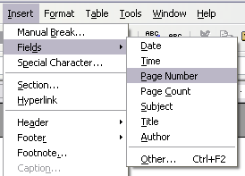

* 1. Using document properties to hold information that changes

The Properties dialog box for any document contains locations on the Descriptiontab () and the User Definedtab () for information that you might want to include in your document, especially if it is information that might change during the course of the project. To display this dialog box, click **File > Properties**.

Later in this chapter, we will see how to use this information in fields. You can return to this dialog box at any time and change the information you entered. When you do so, all of the references to that information will change wherever they appear in the document. For example, you might need to change the contents of the **Title** field from the draft title to the production title.

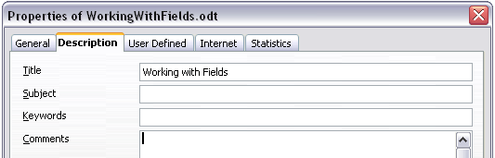

The User Definedtab provides four fields for you to use, as required. You can change the default names for these fields to more meaningful names. The example in shows that three of the defaults have been changed: **Info 1** to **Chapter subtitle**, **Info 2** to **Chapter number,** and **Info 3** to **Name of guide**.

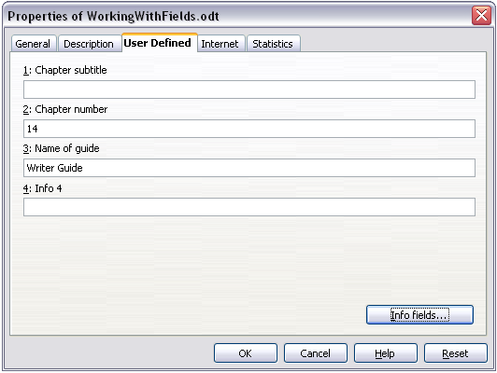

To change these field names, click the **Info fields**button near the bottom of the dialog box. In the small pop-up dialog box (Edit Field Names**,** not shown here), type the field names you want and then click **OK**.

* 1. Using other fields to hold information that changes

One way that people use fields is to hold information that is likely to change during the course of a project. For example, the name of a manager, a product, or even your entire company may change just before the document is due to be printed. If you have inserted the changeable information as fields, you can change the information in one place, and it will automatically change in all the places where that field occurs.

Writer provides several places where you can store the information referred to by a field. We will look at some of them here.

Seven document properties (Time, Date, Title, Subject, Author, Page Number, and Page Count) are on the **Insert > Fields** menu (). To insert one of these fields, click on it in the menu.

Other document properties are on the **DocInformation** and **Document** tabs of the Fields dialog box ( and ), reached by clicking **Insert > Fields > Other**.

To insert one of these fields, select it in the Typelist and then select from the Selectand Formatlists if choices appear. Finally, click **Insert**.

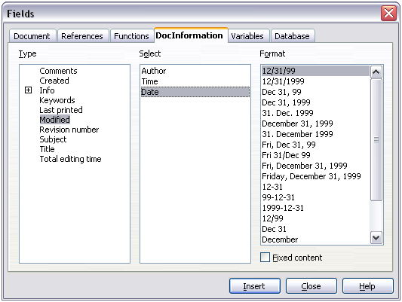

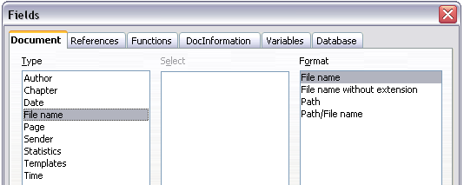

Some of these items are picked up from the User Datapage of the Options dialog box, so make sure the information on that page is correct.

|  |  |
| --- | --- |
| Tip | Although these fields are often used to hold information that changes, you can make the content unchangeable by selecting the Fixed contentcheckbox (visible in ) when inserting the field. If necessary, you can come back to this dialog box later and deselect this checkbox to make the field variable again. |

* 1. Using AutoText to insert often-used fields

If you use the same fields often, you will want a quick and easy way to insert them. Use AutoText for this purpose. To define an AutoText entry for a field:

1. Insert a field into your document, as described previously.
2. Select the field, and then click **Edit > AutoText**(or press Ctrl+F3).
3. On the AutoText dialog box (), choose the group where this new entry will be stored (in this example, it is going into My AutoText), type a name for the entry, and change the suggested shortcut if you wish.
4. Click the **AutoText**button and click New to have the entry inserted as a field. Do not choose New (text only) because the AutoText entry will be plain text, not a field. Click Close to close the AutoText dialog box.
5. Now whenever you want to insert this field at the cursor position, type the shortcut, and then press F3.

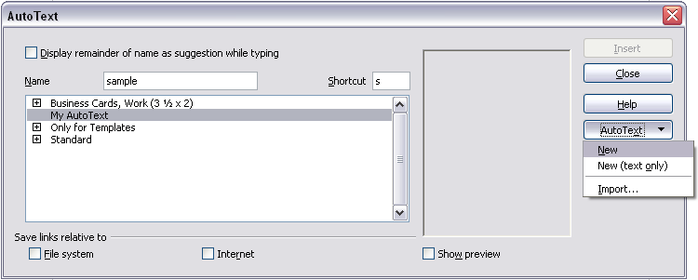

* 1. Defining your own numbering sequences

You may want to define your own numbering sequences to use in situations where you do not always want the number at the start of the paragraph or where you want more control than the built-in numbering choices give you.

This topic describes how to create and use a numbering sequence, using a “number range variable” field.

* + 1. Create a number range variable

To create a number range variable using Arabic (1, 2, 3) numbers:

1. Place the insertion point in a blank paragraph in your document.
2. Click **Insert > Fields > Other** and select the Variablestab ().
3. In the Typelist, select **Number range**. In the Formatlist, select **Arabic (1 2 3)**. Type whatever you want in the Namefield. (I have used **Step**in this example.)
4. Click **Insert**. The name of the variable (Step) now appears in the Selection list, and a number field (showing 1) appears at the insertion point in your document. The Fields dialog box remains open, so you may need to move it out of the way to see the field in the document.
5. Hover the mouse pointer over this number field and you will see the field code of   
   **Step = Step+1**. If you click several more times on the **Insert**button in the Fields dialog box, the numbers 2, 3, 4, and so on will appear in the document.
6. Now you may want to create another field to restart the Step sequence at 1, so you can use the same sequence name more than once in your document (for example, to begin each set of instructions).

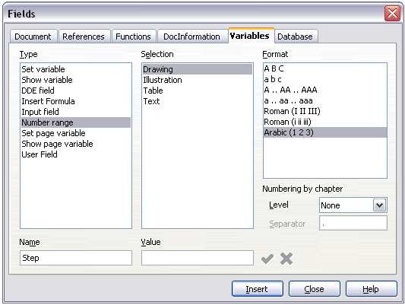

1. To create this new field, open the Fields dialog box to the Variables tab. Make sure the variable name Step appears in the Name box. In the Valuebox, type **Step=1**, as shown in . Click **Insert**. Now hover the mouse pointer over the new field in your document and you will see the field code of **Step = Step=1**.

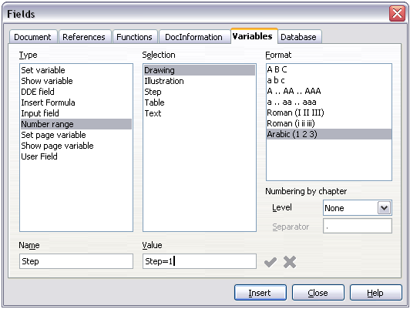

* + 1. Use AutoText to insert a number range field

You certainly do not want to go through all of that every time you want to put in a step number. Instead, create two AutoText entries, one for the Step = Step=1 field (call it Step1, for example) and one for the Step = Step+1 field (StepNext). See “” on page .

You can create similar fields for substeps or other sequences that you want to be numbered with letters (a, b, c), Roman numerals (i, ii, iii), or some other sequence. In the Fields dialog box, choose the required format in the Format list when creating the field codes.

|  |  |
| --- | --- |
| Tip | If a user-defined variable is not in use in the document, the  icon next to the Value box is active. You can delete the variable by clicking this icon. To remove a variable that is used in the current document, first delete from the document all fields using that variable, and then remove the variable from the list. |

* 1. Using automatic cross-references

If you type in references to other parts of the document, those references can easily get out of date if you reword a heading, add or remove figures, or reorganize topics. Replace any typed cross-references with automatic ones and, when you update fields, all the references will update automatically to show the current wording or page numbers. The References tab of the Fields dialog box () lists some items, such as bookmarks, figures, tables, and user-defined number range variables. Other items that you might expect to be listed, such as headings, are not shown.

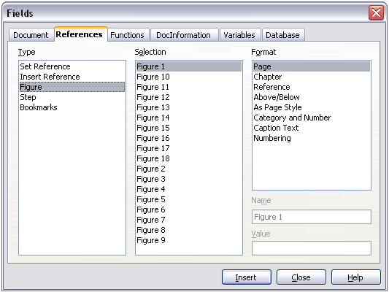

* + 1. Prepare items as targets for cross-referencing

Before you can insert a cross-reference to anything that is not automatically shown on the References tab, such as a heading, you must prepare or “set” that heading as an item to be referenced. To do this, you can either use bookmarks or set references.

* + - 1. Using bookmarks

Bookmarks are listed in the Navigator and can be accessed directly from there with a single mouse click. In HTML documents, bookmarks are converted to anchors that you can jump to via hyperlink.

1. Select the text you want to bookmark. Click **Insert > Bookmark**.
2. On the Insert Bookmark dialog box (), the larger box lists any previously defined bookmarks. Type a name for this bookmark in the top box. Click **OK**.

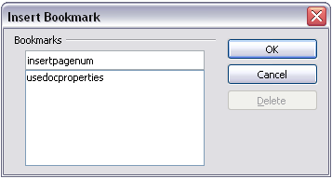

* + - 1. Setting references

1. Click Insert > Cross reference.
2. On the References tab of the Fields dialog box (), click Set Referencein the Type list. The Selection list shows any references that have been defined.

You can leave this page open while you set many headings as references.

1. Click in the document and highlight the text of the first heading to be used as a target for a cross-reference. Click on the Fields dialog box. The text of the heading will appear in the Value box in the lower right of the dialog box. In the Name box, type some text by which you can identify this heading.
2. Click Insert. The text you typed in the Name box now appears in the Selection list.
3. Repeat steps 3 and 4 as often as required.

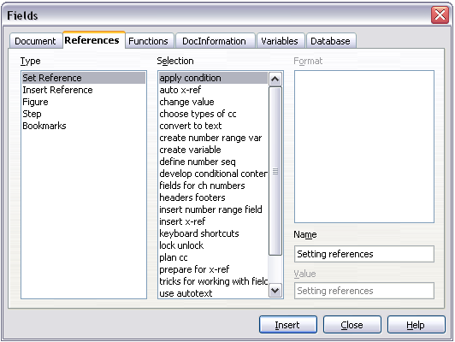

* + 1. Insert cross-references

To insert a cross-reference to a heading or other text:

1. In your document, place the cursor where you want the cross-reference to appear.
2. If the Fields dialog box is not open, click Insert > Cross Reference. On the Referencestab of the Fields dialog box (), in the Typelist, click **Insert Reference**or **Bookmarks** (depending on how you set your references).

You can leave this page open while you insert many cross-references.

1. Click on the required item in the Selectionlist, which shows the bookmarks or references that have been defined. In the Formatlist, choose the type of reference required. Usually this will be Reference (to insert the full text of the reference or bookmark) or Page(to insert the number of the page the referenced or bookmarked text is on). Click **Insert**.

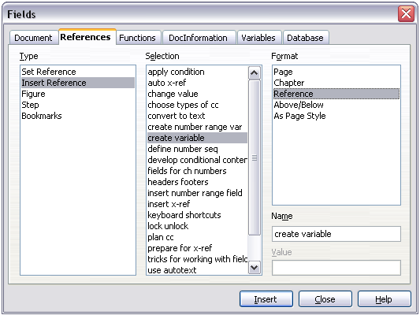

To insert a cross-reference to an item (such as a figure caption) that you have previously inserted into the document as a numbering-sequence field:

1. In your document, place the cursor where you want the cross-reference to appear. If the Fields dialog box is not already open, click **Insert > Cross-reference**.
2. On the Referencestab of the Fields dialog box (), select **Figure**in the Typelist.
3. Click on the required item in the Selectionlist, which shows the list of figures that have previously been inserted into the document. The Formatlist shows different choices from those given for headings. Choose the type of reference required. Usually this will be **Category and Number**(to insert the word “Figure” and its number), **Reference** (to insert the word “Figure” with its number and the full text of the caption), or **Page**(to insert the number of the page the figure is on).
4. Click **Insert**.
   1. Using fields in headers and footers

You can insert fields into headers or footers, using techniques described earlier in this chapter:

* To insert a page number, document title, author, creation date and time, current date and time, or total page count field, use document properties (see page ).
* You can insert a cross-reference to a bookmark or a set reference.
* If you have used Heading 1 for your chapter titles, you can use a document field to insert the current chapter title, so it changes from one chapter to the next. See , which calls chapter titles “names”. If you have used outline numbering on your Heading 1, you can choose whether to include these numbers in the field.
* You can insert cross-references to other heading levels by specifying a value in the Layerbox in the lower right of the Document tab of the Fields dialog box (). That is, Layer 1 = Heading 1, Layer 2 = Heading 2, and so on.

A cross-reference field in the header of a page picks up the *first* heading of that level on the page, and a field in the footer picks up the *last* heading of that level.

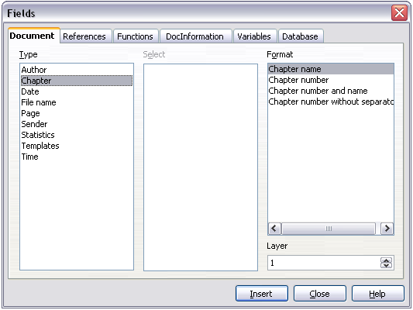

* To include the chapter number with the page number, position the cursor just before the Page field you inserted. Click **Insert > Fields > Other**. On the Document tab of the Fields dialog box, select **Chapter** in the Typecolumn and **Chapter number without separator** in the Format column. Click **Insert**.

Go to the header or footer where you inserted this field, type the character you want to appear between the chapter number and the page number—for example, a period or a dash.

The table of contents will not automatically pick up these chapter numbers, so you will need to make a change on the Indexes and Tables menu item, as described in Chapter 12, “Creating Tables of Contents, Indexes, and Bibliographies”.

* You can add a page count to the footer—for example “Page 9 of 12”. Type the word “Page” and a space in front of the Page field. Type a space, the word “of”, and a space after the Page field. Then click **Insert > Fields > Page Count**.
  1. Using fields instead of outline numbering for chapter numbers

The technique in “” on page , combined with outline-numbered chapter headings (described in Chapter 7, “Working with Styles”), works well when you want the field to show information for the current chapter. But what if you want to use a cross-reference to refer to a different chapter? You cannot bookmark or set a reference to the chapter number part of a heading created using outline numbering.

|  |  |
| --- | --- |
| Tip | If you use this technique, some other features will not work because Writer does not recognize the field as chapter numbers. For example, you will not be able to include chapter numbers with the page numbers in headers or footers, or the table of contents, using the technique described in “” on page . |

To have chapter numbers that update automatically and can be used in cross-referencing, use a number range field.

1. Define your number range variable, as described in “” on page . I have called this variable Chapter.
2. To insert the field into your Heading 1, type Chapter<space>. Click **Insert > Fields > Other**. On the Variablestab, pick **Number range**, **Chapter**, **Arabic (1 2 3)**. Click **Insert**. You will need to do this manually for each Heading 1.
3. Select the entire text of the first Heading 1, including the word “Chapter” and the chapter number, and set a reference to it.
4. You can now insert a cross-reference to this heading anywhere in your document.

|  |  |
| --- | --- |
| Tip | You can also use this technique for easier management of appendix numbering. Keep your appendix headings in the Heading 1 style, define a separate number range sequence for appendix numbers (choosing “A,B,C” for the number format), and type Appendix<space><insert appendix number field> in the Heading 1 paragraph. You can then use the same page styles for chapters and appendixes, and the same field in the header or footer of chapters and appendixes. |

* 1. Tricks for working with fields
     1. Keyboard shortcuts for fields

Here are some handy keyboard shortcuts to use when working with fields:

Ctrl+F2Open the Fields dialog box.

Ctrl+F8 Field shadings on/off.

Ctrl+F9 Show/hide field names.

F9 Update fields.

* + 1. Fixing the contents of fields

You can specify Fixed content for many items on the Document and DocInformation tabs so the field contents do not update. For example, you might use a field to insert the creation date of a document, and you would not want that date to change. In another place you might use a date field to show the current date, which you do want to change; in that case, deselect Fixed content when you insert the field.

* + 1. Converting fields into text

Writer does not provide any easy way to convert field contents into text. To do this, you need to copy the field contents and paste them back as unformatted text. This is not a very good solution if you have hundreds of fields that you want to change, but you could use a macro to automate the process.

* 1. Developing conditional content

Conditional content is text and graphics that are included or excluded depending on a condition you specify.

A simple example is a reminder letter for an overdue account. The first and second reminders might have a subject line of “Reminder Notice”, but the third reminder letter might have the subject “Final Notice” and a different final paragraph.

A more complex example is a software manual for a product that comes in two versions, Pro and Lite. Both product versions have much in common, but the Pro version includes some features that are not in the Lite version. If you use conditional content, you can maintain one file containing information for both versions and print (or create online help) customized for each version. You do not have to maintain two sets of the information that is the same for both versions, so you will not forget to update both versions when something changes.

* + 1. Choose the types of conditional content to use

This section describes several Writer features that can help you design and maintain conditional content. You can use one or any combination of these features in the same document.

* + - 1. Conditional text

With conditional text, you can have two alternative texts (a word, phrase, or sentence). One text will be displayed and printed if the condition you specify is met, and the other will be displayed and printed if the condition is not met. You cannot include graphics or edit the text except in the field dialog (not in the body of the document). You also cannot format part of the text (for example, bolding one word but not the others), but you can format the field to affect all of the field contents (for example, bolding all of the words). You cannot include a cross-reference or other field in the text.

* + - 1. Hidden text

With hidden text(a word, phrase, or sentence), you have only two choices: show or hide. If the condition you specify is met, the text is hidden; if the condition is not met, the text is displayed. The disadvantages are the same as for conditional text: you cannot include graphics, edit the text in the body of the document, format part of the text, or include a field.

* + - 1. Hidden paragraphs

Hidden paragraphs are like any other paragraogs, but you can specify a condition under which the paragraph is not displayed or printed. A blank paragraph can also be hidden—for example, if a database field has no content for the current record. This is very useful when merging an address into a letter: if you allow two lines for the street address and the database record uses only one line, you can prevent the blank line from appearing in your document. You can include graphics, edit the text in the body of the document, format any part of the text, and include fields.

* + - 1. Hidden sections

Hidden sections are like hidden paragraphs, but they can include more than one paragraph—for example, a heading plus one or more paragraphs. However, a section cannot contain less than a paragraph, so you cannot use this method for single words or phrases. The contents of a hidden section behave just like the contents of any other part of the document, but you can specify a condition under which the section is not displayed or printed. In addition, you can password protect a section.

* + 1. Plan your conditional content

Conditions are what programmers call *logical expressions*. You must formulate a logical expression for each condition because a condition is always either true (met) or false (not met). You can use the same condition in many places in your document, for different types of conditional content.

To make conditional content work, you need to:

1. Choose or define a variable.
2. Define a logical expression (condition) involving the selected variable.
   * + 1. Choose or define a variable

You can use the following variables in your condition:

* User-defined variables
* Predefined OpenOffice.org variables, which use statistical values from the document properties
* User data
* Database field contents—for example from your address book

You cannot use internal variables (for example, page number or chapter name) to formulate conditions.

The examples in this chapter use user-defined variables.

* + - 1. Define a logical expression (condition) involving the selected variable

The condition compares a specified fixed value with the contents of a variable or database field.

To formulate a condition, use the same elements as you would to create a formula: operators, mathematical and statistical functions, number formats, variables, and constants. The possible operators are given in the online help; look in the index under “operators: in formulas”. You can define quite complex expressions, but in most cases a simple condition will do the job.

* + 1. Create the variable

To create your variable, click **Insert > Fields > Other**. You can use choices found on the DocInformation, Variables, and Database tabs.

* + - 1. DocInformation fields

“” on page described how to set up a user-defined document property. You can use that document property as the variable in your condition statement, or you can create another document property field specifically for conditions.

* + - 1. User-defined variable field

To set up a variable or user field:

1. Place the cursor where you want the field to be inserted.
2. On the Fields dialog box, select the Variablestab ().
3. Select **Set variable** in the Typelist and **Text**in the Formatlist. Type a name for the variable in the Namebox, and a value in the Valuebox. I have chosen “ProLite” for the name (to remind me that this variable is related to the two product versions), and I set the value as “Lite” because I can remember “If it is the Lite version, then this text should be hidden.”
4. Select **Invisible**so the field does not show in the document. Click **Insert**, then click **Close**.

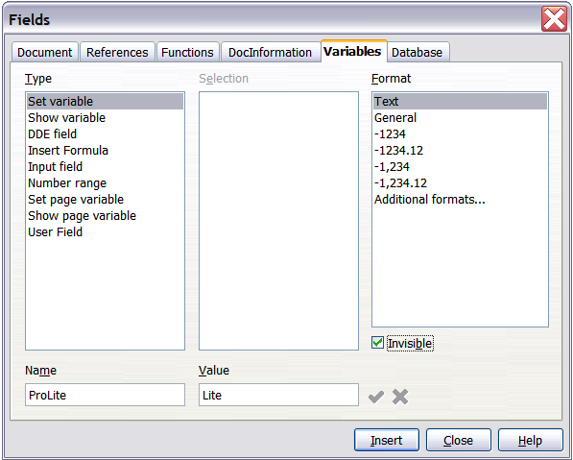

1. A small gray mark should be visible where you inserted the field. Hover the mouse pointer over this mark and you will see the field formula *ProLite = Lite*. We will come back to this field later.

|  |  |
| --- | --- |
| Tips | Because the gray mark is so small, you may have trouble finding it again, especially if you have other fields in the document. You may prefer to leave the variable field visible while you work, and change it to invisible just before you create final copy.  At any time, you can place the insertion point just before the field and click **Edit > Fields** or right-clickthe field, and then click **Fields**on the pop-up menu. On the Edit Fields dialog box (), select or deselect theInvisiblecheckbox. |

* + 1. Apply the condition to the content

Now that you have defined the variable, you can use it in a condition statement. This topic describes some of the possibilities.

* + - 1. Conditional text

First, let us set up some conditional text that will insert the words “Great Product Lite” into the Lite version and “Great Product Pro” into the Pro version of the manual. You would use this field whenever you want to mention the name of the product.

1. Place the cursor where you want one of these phrases to appear. (You can move or delete it later, if you wish.)
2. Open the Fields dialog box by clicking **Insert > Fields > Other**, select the Functionstab, and select **Conditional text**in the Typelist.
3. As shown in , type ProLite EQ "Lite" in the Conditionbox, **Great Product Lite**in the Thenbox, and **Great Product Pro**in the Elsebox.

|  |  |
| --- | --- |
| Note | These fields are case-sensitive, and quotation marks are required around a text value such as Lite. |

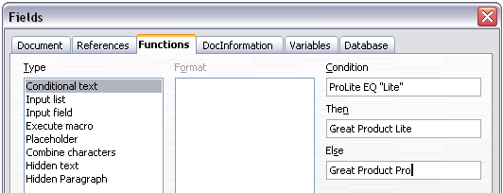

1. Click **Insert**to insert the field, then click **Close**. You should see Great Product Litein your text.

|  |  |
| --- | --- |
| Tip | If you want to insert this field into your text in many places (as you probably would for a product name), create an AutoText entry for it. See “” on page for instructions. |

* + - 1. Hidden text

You might use hidden text for words or short phrases that describe features of Great Product Pro that are not found in the Lite version. You can reuse the same field in several places in your document—for example, by copying and pasting it.

To create a hidden text field:

1. Click **Insert > Fields > Other**and select the Functionstab.
2. Select **Hidden text**in the Typelist, as shown in .
3. Type **ProLite EQ "Lite"** in the Conditionbox and type the required text in the Hidden textbox. Remember, this is the text that is *hidden*if the condition is true.
4. Click **Insert**to create and insert the field.

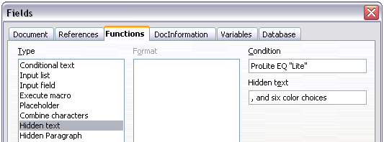

* + - 1. Hidden paragraphs

|  |  |
| --- | --- |
| Tip | To enable hidden paragraphs, remove the check mark from View > Hidden Paragraphs. When this option is selected, you cannot hide any paragraph. |

A paragraph is hidden if the condition is true. To hide a paragraph:

1. Click in the paragraph to be hidden.
2. Click Insert > Fields > Other and select the Functions tab ().
3. Select Hidden paragraph in the Type list.
4. For this example,type **ProLite EQ "Lite"** in the Conditionbox.
5. Click **Insert**to create and insert the field. If an extra paragraph mark appears, delete it.
   * + 1. Hidden sections

A conditional section is hidden if the condition is true. To create a conditional section:

1. Select the text that you want to be included in the conditional section. (You can edit this text later, just as you can edit any other text.)
2. Click **Insert > Section**. On the Insert Section dialog box (), select the Hide checkbox and enter the condition in the with Conditionbox. You can also give the section a name, if you wish. Click **Insert** to insert the section into your document.

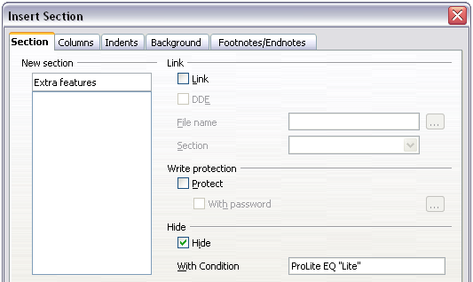

To show the hidden section so you can edit it:

1. Click **Format > Sections**.
2. On the Edit Sections dialog box, select the section from the list.
3. Deselect the Hide checkbox, and then click **OK**. You can now edit the contents of the section. Afterwards, you can click **Format > Sections** again and select the Hide checkbox to hide the section again.

To make the hidden section a normal part of the document (that is, to remove the section markers, but not the contents of the section):

1. Show the hidden section, as described above.
2. On the Edit Sections dialog box, select the section from the list.
3. Click **Remove**. The contents of the section are now a normal part of the document.
   * 1. Change the value of the variable
4. Find the variable field you created in “” on page .
5. Click once just in front of this field, then right-click and click **Fields**on the pop-up menu.
6. On the Edit Fields: Variables dialog box (), change the value of the variable to Pro.
7. If you have set fields to update automatically, all of the conditional and hidden text that uses this variable as a condition will change.

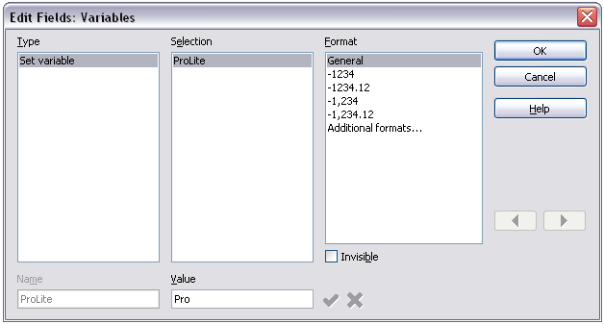

|  |  |
| --- | --- |
| Tip | To turn on automatic updating of fields, click **Tools > Options > OpenOffice.org Writer>General**, and select **Fields**under **Update: Automatically**. |

* + 1. Editing hidden paragraphs and sections

To show all the hidden paragraphs and sections so you can edit their contents, change the value of the variable to something that the conditions will not recognize. In our example, you could change the value to 1.

The technique does not affect the display of hidden and conditional text, which can only be edited in the Edit Fields dialog.

* 1. Using placeholder fields

A placeholder field prompts you to enter something (text, a table, a frame, a graphic, or an object).

To insert a placeholder field into a document:

1. On the Functions tab of the Fields dialog box, select **Placeholder** in the *Type* column and select what the placeholder is for in the *Format* column.
2. In the Placeholder box, type the text that you want to appear in the placeholder field.
3. In the Reference box, type the text that you want to display as a help tip when you rest the mouse pointer over the field.

shows the results of inserting a placeholder field for a graphic.

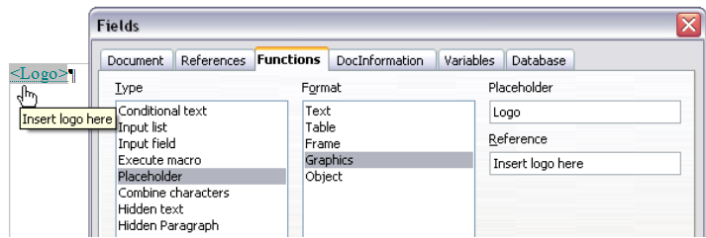

Because the <Logo> field is a graphics placeholder, when you click on the field in the document, the Insert picture dialog box opens, prompting you to select a graphic (picture). When you select a picture and click Open, the picture replaces the field in the document.

Similarly, clicking on a table placeholder field opens the Insert Table dialog box, clicking on a frame placeholder field opens the Frame dialog box, and clicking on an object placeholder field opens the Insert OLE Object dialog box. The text placeholder field is different: you simply click on it and type some text in the Placeholder box, which replaces the field.



Writer Guide

1. Chapter 15  
    Using Forms in Writer
   1. Introduction

This chapter covers the use of forms within Writer documents. Most of the information here also applies to forms in other OpenOffice.org components, but there are some differences.

The chapter presents information on using forms in four main sections: setting up a basic form, an example for creating a form, linking a form to a data source and finally some advanced techniques.

OpenOffice.org forms cover a lot of ground and not everything is included here. Notable omissions are using forms in HTML documents and writing macros to link to form controls.

* 1. When to use forms

A standard text document displays information: a letter, report or brochure, for example. Typically the reader may edit everything or nothing in any way. A form has sections that are not to be edited, and other sections that are designed for the reader to make changes. For example, a questionnaire has an introduction and questions (which do not change) and spaces for the reader to enter answers.

OpenOffice.org offers several ways to fill information into a form, including checkboxes, option buttons, text boxes, pull-down lists and spinners.

Forms are used in three ways:

* To create a simple document for the recipient to complete, such as a questionnaire sent out to a group of people who fill it in and return it.
* To link into a database or data source and allow the user to enter information. Someone taking orders might enter the information for each order into a database using a form.
* To view information held in a database or data source. A librarian might call up information about books.

Using forms to access a database offers a fast and easy way to build up complex graphical front ends. Your form can include not only the fields that link up to the data source but also text, graphics, tables, drawings and other elements.

* + 1. Alternatives to using forms in Writer

In OpenOffice.org version 1.x, forms were the only way to access a data source. In version 2.0 the Base component provides an alternative way of achieving this. There are a lot of similarities between forms in Base and Writer, but it may be that one is better for a particular task than the other. Base is appropriate only if the form accesses a data source; you would not use it for simple forms.

Most other OpenOffice.org components—Calc, Impress and Draw—also support forms in almost exactly the same way as Writer does.

* 1. Creating a simple form

This section explains how to create a simple form without any links to a data source or database and without advanced customization.

* + 1. Create a document

There is nothing special to be done when creating a document to use as a form. Create a new Writer document with File > New > Text document.

* + 1. Form toolbars

Two toolbars control form creation: Form Controls and Form Design. Select View > Toolbars > Form Controls and View > Toolbars > Form Design to show them both. See “” on page for a summary of the tools on these toolbars.

|  |  |
| --- | --- |
| Tips | The Form Design toolbar can also be launched from the Form Controls toolbar. Some of the less commonly used controls are on a third toolbar—More Controls—also launched from the Form Controls toolbar.  You can dock these toolbars in different places on the Writer window, or leave them floating. |

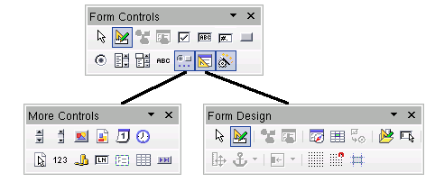

The Form Controls toolbar has a button for each of the most commonly used types of control.

|  |  |
| --- | --- |
| Note | In OpenOffice.org form controls are the text boxes, list boxes, option buttons, push buttons and other items that can be placed in forms. |

* + 1. Design Mode

When creating a form, you will want to check that all the parts of the form work correctly. If design mode is off, the form behaves as it would for the end user. Buttons can be pressed, checkboxes checked and list items selected. If design mode is on, clicking on a control item selects it for editing.

Click the **Design Mode On/Off** button on the Form Controls toolbar to turn design mode on and off.

|  |  |
| --- | --- |
| Tip | If the Design Mode button is not available, click on the Select button. This activates most of the tools on the three toolbars. |

* + 1. Insert form controls

1. To insert a form control into the document, click the control’s icon to select it. The mouse pointer changes to look like this: 
2. Click in the document where you want the control to appear. (You can move it later.)
3. Holding the left mouse button down, drag the control to size it.
4. The control button remains active, so you can insert several controls of the same type without needing to go back to the toolbar.
5. To change to another tool, click its icon on the toolbar.

To stop inserting controls, click on the Select button  on the Form Controls toolbar, or click on any of the controls you have just inserted. The mouse pointer changes back to its normal appearance.

|  |  |
| --- | --- |
| Tip | Holding down Shift when creating a form control makes the control square. If you press Shift when resizing an existing control, its proportions are kept the same. |

|  |  |
| --- | --- |
| Note | When you insert a group box, list box or combo box, a wizard is launched to guide you through the setup. If you prefer not to run the wizard, click the **Wizards On/Off** button  on the Form Controls toolbar. |

* + 1. Configure controls

Having inserted the controls, you need to configure them to look and behave as you want. Right-click on a form control within your document and select **Control from the pop-up menu.**

**The Form Control** dialog box () has three pages: General, Data and Events. For simple forms, only the General page is of any interest. On this page you can set the look and feel of the control.

Some controls have other useful options:

* Some controls have visible labels, such as Push Button and Option Button. The label text can be set.
* The List Box contains a list of options to choose from. Set these in the List entries box.

|  |  |
| --- | --- |
| Tip | Double-clicking on a control also brings up the Control Properties dialog box. |

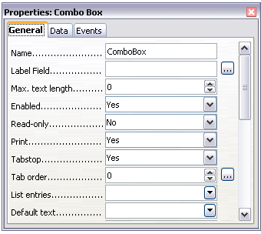

* + 1. Using the form

To use the form, leave design mode by clicking the Design Mode On/Off button .

A typical way to use a form is:

1. You design the form, then save it when you are happy with it.
2. You send the form to others (for example, by email).
3. They fill in the form, save it and send it back to you.
4. You open the form and see what their answers are.

|  |  |
| --- | --- |
| Tip | By using a data source, or setting a form to update over the web, you can automatically gather data. However, both of those are more complex and you might prefer to keep things simple. |

* + 1. Form controls reference

|  |  |
| --- | --- |
| Form Control toolbar |  |
| Select | Select a form control to perform some other action on it. |
| Design mode on/off | Toggle between design mode on (to edit forms) and design mode off (to use forms). |
| Control | Launch form control properties dialog box. This dialog box can be kept open as different controls are selected. |
| Form | Launch form properties dialog box, controlling properties for the form as a whole, such as which data source it connects to. |
| Check Box | A box that can be selected or deselected on the form. You can label the box. |
| Text Box | Control to create a box into which the form user can type any text. |
| Formatted Field | Control allowing numeric formatting options. For example, you can set maximum and minimum values for the number entered, or the number type (decimal places, scientific, currency). |
| Push Button | Creates a button that can be linked to a macro. The label is the name that appears on the button. |
| Option Button | Creates an option or radio button. When multiple buttons are grouped together, only one can be selected at a time. The easiest way to group multiple buttons is to use the Group Box button on the More Controls toolbar, with wizards enabled. |
| List Box | Creates a list of options, as a pull-down menu, that the user can choose from. If wizards are on, creating a list box launches the List Box Wizard. This wizard is only useful if your form is linked to a data source.  If not linked to a data source, turn wizards off and create an empty list box. Then click the Control button and, in the List Entries option on the General tab, enter the options you want to appear on the list. |
| Combo Box | As with a List Box, you set up a list of choices. In addition a panel at the top either displays the choice made or allows the form user to type in something else. Otherwise this works the same as the List Box. |
| Label Field | A text label. The difference between this and just typing on the page is that, as a control, you can link a label field to macros so, for example, something happens when the mouse passes over it or clicks on it. |
| More Controls | Launch the More Controls toolbar. |
| Form Design | Launch the Form Design toolbar (which can also be opened with View > Toolbars > Form Design). |
| Wizards On/Off | Some form controls (List Box and Combo Box) have optional wizards. If you do not want the wizard to launch when you create one of these controls, use the Wizards On/Off button to switch wizards off. |

|  |  |
| --- | --- |
| More Controls toolbar |  |
| Spin Button | A spin button allows form users to choose a number by cycling through the numbers. Specify maximum, minimum, default and the step between numbers.  This control is not commonly used in Writer, as the number is not displayed. In Calc, however, a Data tab appears on the Control Properties dialog box, allowing you to link the spin button to a cell. |
| Scrollbar | Creates a scrollbar, with a number of options to define the exact appearance.  This control is not commonly used in Writer. In Calc, a Data tab appears on the Control Properties dialog box, allowing you to link the scroll bar to a cell. |
| Image Button | Behaves exactly like a push button, but displays as an image. Choose the image in the Graphics option on the General tab in the Control Properties dialog box. |
| Image Control | Only useful when the form is connected to a data source and a field in the data source exists that can hold images. You can add new images to the database or retrieve and display images from it. |
| Date Field | Holds a date. Configure the earliest and latest dates the field will accept, the default date and the date format. You can add a spinner. |
| Time Field | Works like a date field, specifying a time. |
| File Selection | Allows a user to select a file, either by typing the path and name directly or by clicking on a Browse button and choosing the file from a dialog box. |
| Numeric Field | Displays a number. Specify formatting, maximum, minimum and default values. You can add a spinner. |
| Currency Field | Works like a numeric field; additionally you can add a currency symbol. |
| Pattern Field | Pattern fields are useful when the form links into a data source. Specify an Edit Mask to restrict what a user can enter into the field. Specify a Literal Mask to restrict which data is displayed from the data source. |
| Group Box | The group box control has two different uses depending on whether wizards are on or off.  If wizards are on, creating a group box launches the Group Element wizard. This creates a group of option buttons (in which only one may be selected at a time). In most cases, using a group box is the best way to create a set of option buttons.  If wizards are off, a group box is simply a visual box to group together different controls. It has no effect on the way the controls operate. |
| Table Control | Table Control is only useful with a data source. If no data source is specified, you will be prompted to choose one in the Table Element Wizard.  You then pick the fields to display and, when design mode is off, the data appears in the table. The table also includes controls to step through the records.  Records can be added, deleted and modified in the table. |
| Navigation Bar | A navigation bar is the same as the Form Navigation toolbar (View > Toolbars > Form Navigation), but can be placed anywhere in the document and be resized. |

|  |  |
| --- | --- |
| Form Design toolbar |  |
| Select | Select a form control to perform an action on it. |
| Design mode on/off | Toggle between design mode on (to edit forms) and design mode off (to use forms). |
| Control | Launch form control properties dialog box. This dialog box can be kept open as different controls are selected. |
| Form | Launch form properties dialog box, controlling properties for the form as a whole, such as which data source it connects to. |
| Form Navigator | The Form Navigator is a nice utility, displaying all the forms and controls in the current document, allowing you to edit and delete them easily.  If you use the Form Navigator, it's a good idea to give your controls names (in the properties dialog box). The name appears in the navigator so, for example, if you have ten text boxes, you can tell which is which. |
| Add Field | Add Field is only useful if you have specified a data source for the form. If no data source is specified, an empty box opens.  If you have specified a data source, Add Field opens a list of all the fields in the specified table, which you can then drag and drop onto the page. The fields are placed on the page with the name of the field before them.  This is a quick and easy way to create a form from a data source. |
| Activation Order | Allows you to specify the order in which focus shifts between controls. You can test the order by leaving design mode and using Tab to switch between the controls. |
| Open in Design Mode | Open the current form in design mode (to edit the form rather than entering data into it). |
| Automatic Control Focus | If activated, focus is set to the first form control. |
| Position and Size | Launches the Position and Size dialog box, allowing you to specify both by typing in precise values, rather than dragging the control. You can also lock the size or position, so they do not get changed accidentally. For some controls, you can rotate and set the slant and corner radius. |
| Change Anchor | Just as with a frame, any form control can be anchored to page, paragraph or character and also anchored as a character (meaning that it behaves like any other character on the page). |
| Alignment | The Alignment button is disabled unless the control is anchored as a character. You can align a control in different ways, for example so the top of the control lines up with the top of the text or the bottom lines up with the bottom of the text. |
| Display Grid | Display a grid of dots on the page, to help you line up controls. |
| Snap to Grid | When a control is brought close to a grid point or line, it will snap to the grid. This makes it easier to line up controls. |
| Guides when Moving | When a control is being moved, lines extend from the control horizontally and vertically to help you position it accurately. |

* 1. Example: a simple form
     1. Create the document

Open a new document (File > New > Text Document). It is a good idea to write down the outline of the document, without form controls, though of course it can easily be changed later.

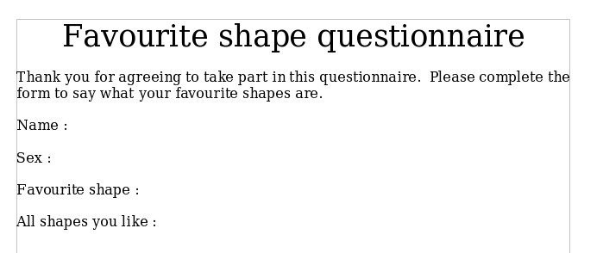

* + 1. Add form controls

The next step is to add the form controls to the document. We will have four controls:

* **Name** is a text box
* **Sex** is two option buttons, male or female.
* **Favourite shape** is a list of options.
* **All shapes you like** is a series of check boxes.

To add these controls:

1. Select View > Toolbars > Form Controls to open the Form Control toolbar.
2. If the tools are not active, click the **Form Navigator** button (on the Form Control toolbar) to activate them. If necessary, also click the **Design Mode On/Off** button.
3. Click the Text Box button , then click in the document and, with the left mouse button held down, drag the shape of the Name text box to approximately the size you want.
4. Make sure the **Wizards On/Off** button is on (shaded with a border). Click the More Controls button  to launch the More Controls toolbar.
5. On the More Controls toolbar, click the Group Box button . Draw a group box by the Sex: entry to launch the Group Element Wizard.
6. On the first page of the wizard, enter two names for the options fields: Male and Female. Click **Next>>** three times, delete the caption and click **Finish**.
7. Now create the list box. On the Form Controls toolbar, click the **Wizards On/Off** button  to turn wizards off. Click the **List Box** button  and draw a list box by Favourite Shape: in the document. This will just be an empty pane for now.
8. Finally create four check boxes by All the shapes you like. Click on the **Check Box** button  and then draw out four check boxes, side by side across the page.

You should now have a document looking something like this:

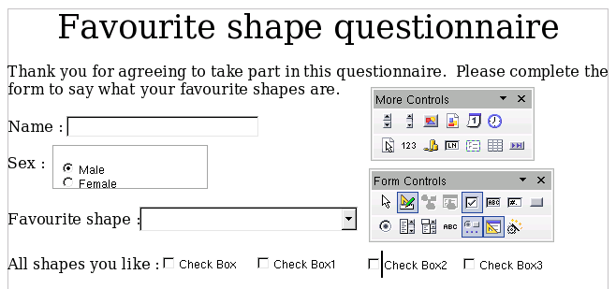

* + 1. Configure form controls

No further configuration is required to the Name and Sex fields (though, of course, there is configuration that could be done if you wanted, such as giving a name to each control and changing the appearance of the controls).

The list box must be configured to add the list of options. The check boxes must be configured to add in the names (instead of Check Box, Check Box1...)

1. Click on the List Box control within the document and then the Control button  on the Form Design toolbar to launch the control properties dialog box. Select the General tab.
2. In the List Entries box, enter the names of the shapes: Circle, Triangle, Square and Pentagon. Type in one shape and press *Enter*. Then position the cursor at the end of the line to type in the next shape. You should end up with a line saying “Circle”;”Triangle”;”Square”;”Pentagon”.
3. Click on the first Check Box. The Properties dialog box stays open but changes to show the properties for the check box.
4. Change the Label to Circle and press *Enter*. The label on the check box will change immediately.
5. Click on each of the other three check boxes in turn. Change the Label in the Properties dialog box to Triangle, Square and Pentagon in turn.
6. Close the Properties dialog box.
7. Turn Design Mode off  and close the two Controls toolbars.

You have now completed the form and your form hopefully looks something like this:

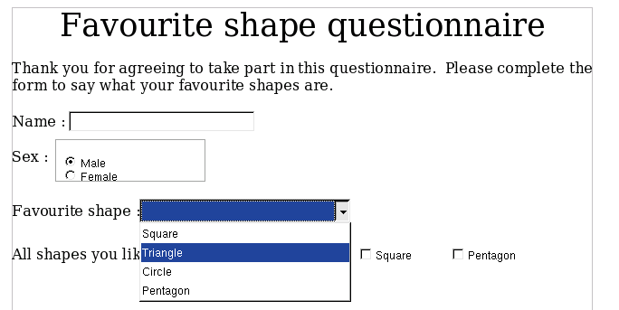

* + 1. Finishing touches

The form is complete, but you are free to make further changes to the document. If you were sending this out to other people to complete, you would probably want to make the document read-only. The effect would be that users would be able to fill in the form, but not to make any other changes to the document.

To make the document read-only, select Tools > Options > OpenOffice.org > Security > Open this document in read-only mode.

|  |  |
| --- | --- |
| Note | If the document is read-only, anyone filling in the form will need to use File > Save as to save the document. |

* 1. Accessing data sources

The most common use for a form is as the front end of a database. You can provide a form that allows users to enter information into a contacts database and, because it is part of a Writer document, the form can contain all the graphics, formatting, tables and other elements to make it look just the way you want. Even better, modifying the form is as simple as editing a document.

OpenOffice.org can access numerous data sources. These include ODBC, MySQL, Oracle JDBC, spreadsheets and text files. As a general rule, databases can be accessed for read and write; other data sources (such as spreadsheets) are read-only.

|  |  |
| --- | --- |
| Tip | To see the full list of supported data source types, select File > New > Database. Click Connect to an existing database and then click the triangle next to the list box. |

* + 1. Creating a database

Chapter 10 (Getting Started with Base) in the *Getting Started*guide covers in more detail how to create a database. We will give a short guide here to creating a very simple database with OOo Base.

1. Select File > New > Database to start the Database Wizard ().
2. Select Create a new database and click Next.
3. On the next page, select Yes, register the database for me and Open the database for editing. Registering the database just means that it can be accessed from other OOo components such as Writer and Calc. You need to do this if you want to link your forms into it.
4. Click **Finish** and save your new database, giving it a name. Unlike creating other documents in OOo, databases must be saved when you first create them.

After saving the database, you should see the main Base window (), which contains three panels. The left-hand panel is Database, with icons for Tables, Queries, Forms and Reports.

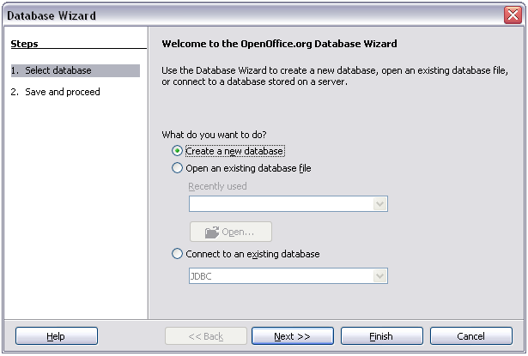

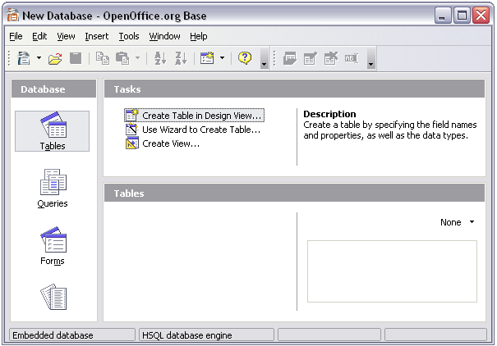

The next step is to create a table. Again, this is covered in more detail in Chapter 10 (Getting Started with Base) in the *Getting Started guide. Here we are going to create a small table as an example.*

1. Choose Tables in the left-hand column, then choose Create Table in Design View under Tasks.
2. Use the Table Design window () to tell Base which fields to create. We will have just three fields: Name, Address and Telephone.
3. On the first line, enter under Field Name ID and set the Field Type to Integer [INTEGER]. In the gray box at the left of the line, right-click and select Primary Key, bringing up a key icon in the box. In the Field Properties at the bottom of the window is an Auto Value option; change this to Yes.

|  |  |
| --- | --- |
| Tip | Setting up the Primary Key field with Auto Value set to Yes is an important step. If this is not done, the form you create later will be much trickier to use and may generate errors for the user. Make sure you get this step right! |

1. On three lines, enter under Field Name Name, Address and Telephone. Accept the default Field Type of Text [VARCHAR] and leave Description blank.
2. Save the table (File > Save). You will be prompted to name it (the name can be anything you like).
3. Finally, save the whole database from the main Base window (File > Save).

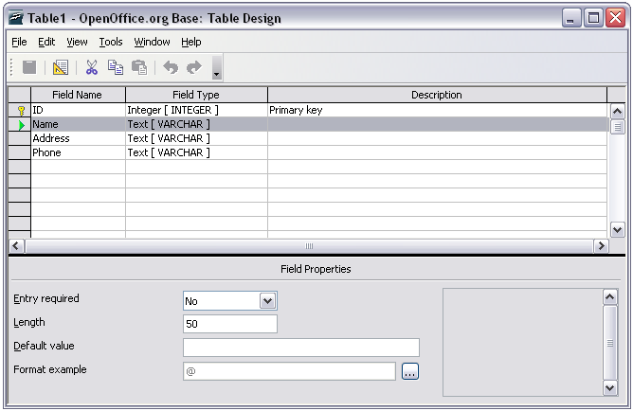

* + 1. Accessing an existing data source

If you have an existing data source, such as a spreadsheet or database, you simply need to tell OpenOffice.org about it. This is called registering a data source.

To register an existing data source:

1. Select File > New > Database to launch the Database Wizard ().
2. Select Connect to an existing database and choose the type from the drop-down list.

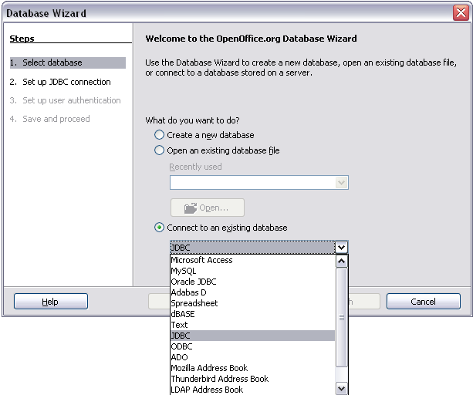

1. Click Next and follow the instructions to select the database to register (the exact process varies between different types of data source).
2. In Step 3: Save and proceed, check that Yes, register the database for me is selected. Deselect Open the database for editing – you just need to register it, not edit it through Base.
   * 1. Creating a form for data entry

Whether you created a new database, or already had a data source, it must be registered with OpenOffice.org (see above). Once it is registered, linking your form to the data source is simple. Follow these steps to create a new form and link it to a registered data source.

1. Create a new document in Writer (File > New > Text Document).
2. Design your form, without putting in the actual fields (you can always change it later).
3. Show the Form Controls toolbar (View > Toolbars > Form Controls).
4. Click the Design Mode On/Off button  to put the document into design mode, if necessary. With design mode off, most of the toolbar buttons are greyed out. If the Design Mode button is also grayed out, click on the Select button to activate it.
5. Click the Text Box button . Click in the document and, holding down the left mouse button, drag the mouse to create a text box for the first form field (for example, Name, if you are linking to the database created above).
6. Click the Text Box button again and drag the mouse to draw another field. Additional fields, of any type, can be added in the same way (click and drag).

So far you have followed the same steps you used before when you created your first form. Now you link your form with the data source you registered.

1. Launch the Form Properties dialog box. You can do this by clicking on the Form button  in the Form Controls toolbar or by right-clicking on any of the fields you inserted and selecting Form.The form button is grayed out unless you have one of the form elements selected. As soon as you select a form element in your document, the Form button becomes clickable.
2. In the Form Properties dialog box, click on the Data tab ().
   * Set Data Source to be the data source you registered.
   * Set Content Type to be Table.
   * Set Content to be the name of the table you want to access.
   * Close the dialog box.
3. For each form control in turn, launch the Properties dialog box. Click on the control to select it (so small green boxes appear around it). Then either right-click and select Control or click on the Control button  on the Form Controls toolbar.

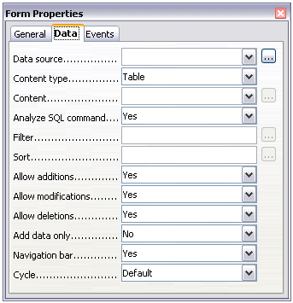

1. In the Properties dialog box, click on the Data tab (). If you set up the form correctly, the Data Field option will contain a list of the different fields in the data source (for example, Name, Address and Telephone). Select the field you want.

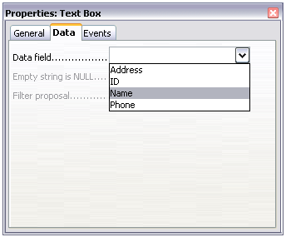

1. Repeat for each control in turn until every control that should be has been assigned to a field.

|  |  |
| --- | --- |
| Tip | If you created a database in OOo Base and your Primary Key field had Auto Value set to Yes, that field does not need to be part of the form. If Auto Value was set to No, you will have to include it and have your users enter an unique value into that field whenever they make a new entry—not something you want. |

* + 1. Entering data into a form

Once you have created a form and tied it to a database, you want to use it to enter data into your data source, or modify data already there.

1. Make sure that the form is not in design mode. In the Form Controls toolbar, click on the Design Mode On/Off button . If design mode is off, most of the buttons on the toolbar will be grayed out.
2. Make sure that the Form Navigation toolbar is on (View > Toolbars > Form Navigation). This toolbar normally appears at the bottom of the window.



1. If there is existing data in the data source, use the control buttons on the Form Navigation toolbar to look at different records. You can amend data in a record by editing the values in the form. To submit the changes, press the *Enter* key with the cursor in the last field. The record is saved and the next record is displayed.
2. If there is no data in the form, you can enter it. To submit the new record, press the *Enter*key with the cursor in the last field.
3. Other functions can be performed from the Form Navigation toolbar, including deleting a record and adding a new record.
   1. Advanced form customization
      1. Linking a macro to a form control

You can set any form control (for example, text box or button) to perform an action when triggered by some event. To see the full list of events, right-click on the form control when the design mode is on, select Control and click on the Events tab ().

To assign a macro to an event:

1. Create the macro. (See Chapter 17, “Getting Started with Macros” in the *Getting Started* guide.)
2. Right-click on the form control, select Control and click on the Events tab.
3. Click the ... button to the right of the event to bring up the Assign action dialog box ().
4. Click Assign and select the macro.

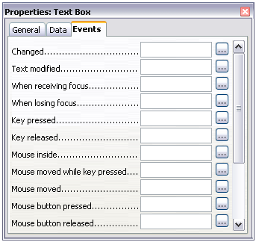

Macros can also be assigned to events relating to the form as a whole. To assign these, right-click on a form control in the document, select Form and click on the Events tab.

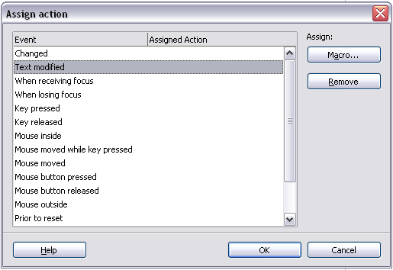

* + 1. Read-only documents

Having created your form, you want whoever is using it to be able to access the information stored in the database, or complete the form, without changing the layout. There is an easy way to do this: make the document read-only.

Select Tools > Options > OpenOffice.org > Security> Open this document in read only mode.

* + 1. Fine-tuning database access permissions

By default, when a database is accessed from a form, any changes can be made to it: records can be added, deleted and amended. You may not want that behaviour. For example, you may want users to be able only to add new records or to be prohibited from deleting existing records.

In design mode, right-click on a form control and select Form from the pop-up menu. On the Data tab of the Form Properties dialog box are a number of options: Allow additions, Allow deletions, Allow modifications and Add data only. Set each of these to Yes or No to control the access users have to the data source.

Individual fields can also be protected. This might be useful if you wanted a user to be able to modify some parts of a record but only view others, such as a stock list where item descriptions are fixed and quantities can be modified.

To make an individual field read-only, in design mode, right-click on the form control within the document and select Control from the pop-up menu. Select the General tab and set Read-only to Yes.

* + 1. Form control formatting options

You can customize the way form controls look and behave in a number of ways. These are all accessed in Design mode. Right-click on the form control, select Control from the pop-up menu and select the General tab in the Properties dialog box.

* Set a label for the control in the Label field. Some form controls, such as push buttons and option buttons, have visible labels that can be set. Others, such as text boxes, do not.
* Set whether the form control will print out if the document is printed with the Print option.
* Use the Font setting to set the font, typeface and size for a field.
* For a text box, you can set the maximum text length. This is very useful when adding records into a database. Every database text field has a maximum length and, if the data entered is too long, OOo displays an error message. By setting the maximum text length of the form control to be the same as that of the database field, this error can be avoided.
* You can set the default option for a form control. By default, a control is blank, or has every option unselected. You can set the control to start with a particular option or list item selected.
* For controls where a password is being entered, setting the Password character (for example to *) displays only that character, but saves what the user really types.
* You can add additional information and help text for a form control.
* Other formatting controls such as background color, 3-D look, text formatting, scroll bars and borders allow you to further define how the control appears.
  1. XForms

XForms are a new type of web form, developed by the World Wide Web Consortium (W3C). OpenOffice.org 2.0 supports the XForms 1.0 open standard for creating web forms with XML.

In OpenOffice.org, an XForms document is a special type of Writer document. XForms use the same controls as the ordinary forms described in this chapter.

After you create and save an XForms document, you can open the document, fill out the form, and submit the changes to a server.

A detailed discussion of XForms is beyond the scope of this chapter.



Writer Guide

1. Chapter 16  
    Math Objects

The OpenOffice.org Equation Editor

* 1. Introduction

OpenOffice.org (OOo) has a component for mathematical equations. It is most commonly used as an equation editorfor text documents, but it can also be used with other types of documents or stand-alone. When used inside Writer, the equation is treated as an object inside the text document.

|  |  |
| --- | --- |
| Note | The equation editor is for writing equations in symbolic form (as in equation ). If you want to evaluate a numeric value, see the Calc Guide. |

|  |  |
| --- | --- |
|  | (1) |

* + 1. Getting started

To insert an equation, go to Insert > Object > Formula.

The equation editor opens at the bottom of the screen, and the floating Selection window appears. You will also see a small box (with a gray border) in your document, where the formula will be displayed.

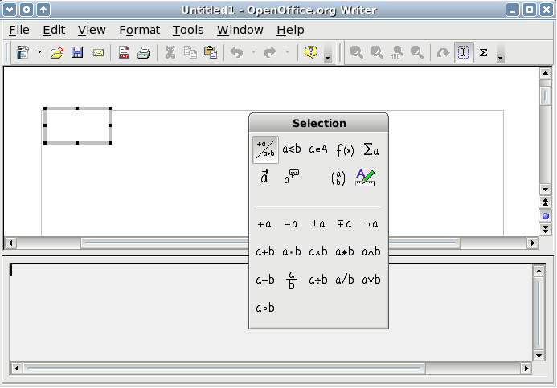

The equation editor uses a markup language to represent formulas. For example, %beta creates the Greek character beta ($$β$$). This markup is designed to read similar to English whenever possible. For example, a over b produces a fraction: .

* 1. Entering a formula

There are three ways to enter a formula:

* Select a symbol from the Selection window.
* Right-click on the equation editor and select the symbol from the context menu.
* Type markup in the equation editor.

The context menu and the Selection window insert the markup corresponding to a symbol. Incidentally, this provides a convenient way to learn the OOoMath markup.

|  |  |
| --- | --- |
| Note | Click on the document body to exit the formula editor.  Double-click on a formula to enter the formula editor again. |

* + 1. The Selection window

The simplest method for entering a formula is the Selection window, shown in .

The Selection window is divided into two main portions.

* The top shows the symbol categories. Click on these to change the list of symbols.
* The bottom shows the symbols available in the current category.

|  |  |
| --- | --- |
| Tip | You can hide (or unhide) the Selection window with View > Selection. |

* + 1. Example 1: $$5×4$$

For this example we will enter a simple formula: $$5×4$$ On the Selection window:

1. Select the top-left button of the categories (top) section ().
2. Click on the multiplication symbol (shown in ).

When you select the multiplication symbol on the Selection window, two things happen:

* The equation editor shows the markup: $$\text{<?> times <?>}$$
* The body of the document shows a gray box with the figure:

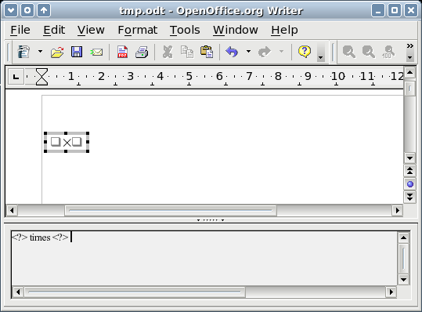

The “ <?> ” symbols () are placeholders that you can replace by other text. The equation will update automatically, and the result should resemble .

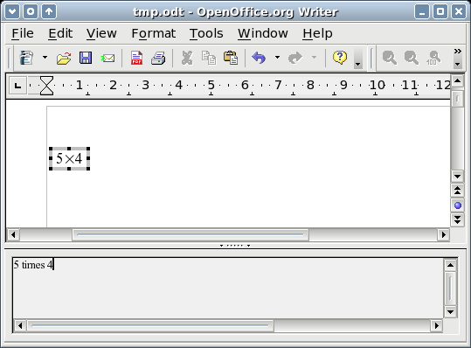

|  |  |
| --- | --- |
| Tip | To keep the equation from updating automatically, select View > AutoUpdate display.  To update a formula manually, press F9 or select View > Update. |

* + 1. Right-click menu

Another way to access mathematical symbols is to right-click on the equation editor. This produces a menu as shown in .

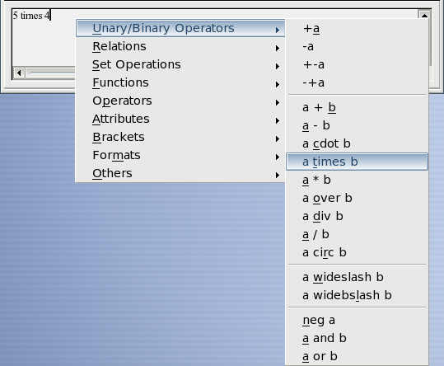

|  |  |
| --- | --- |
| Note | The entries in this menu correspond exactly to those in the Selection window. |

* + 1. Markup

You can type the markup directly in the equation editor. For example, you can type “5 times 4” to obtain $$5×4$$. If you know the markup, this can be the fastest way to enter a formula.

|  |  |
| --- | --- |
| Tip | As a mnemonic, the formula markup resembles the way the formula reads in English. |

Below is a short list of common equations and their corresponding markup.

|  |  |  |  |
| --- | --- | --- | --- |
| Display | Command | Display | Command |
| $$a=b$$ | a = b | $$\sqrt{a}$$ | sqrt {a} |
| $$a^{2}$$ | a^2 | $$a_{n}$$ | a_n |
| $$∫fxdx$$ | int f(x) dx | $$∑a_{n}$$ | sum a_n |
| $$a≤b$$ | a <= b | $$∞$$ | infinity |
| $$a×b$$ | a times b | $$x⋅y$$ | x cdot y |

* + 1. Greek characters

Greek characters ($$α,β,γ,θ$$, etc) are common in mathematical formulas. These characters are not available in the selection box or the right-click menu. Fortunately, the markup for Greek characters is simple: Type a % sign followed the name of the character, in English.

* To type a lowercase character, write the name of the character in lowercase.
* To type an uppercase character, write the name of the character in uppercase.

See the table below for some examples:

|  |  |
| --- | --- |
| Lowercase | Uppercase |
| %alpha $$→α$$ | %ALPHA $$→A$$ |
| %beta $$→β$$ | %BETA $$→B$$ |
| %gamma $$→γ$$ | %GAMMA $$→Γ$$ |
| %psi $$→ψ$$ | %PSI $$→Ψ$$ |
| %phi $$→φ$$ | %PHI $$→Φ$$ |
| %theta $$→θ$$ | %THETA |

|  |  |
| --- | --- |
| Note | A complete table of Greek characters is included in page . |

Another way to enter Greek characters is by using the catalog window. Go to Tools > Catalog. The catalog window is shown in . Under “Symbol Set” select “Greek” and double-click on a Greek letter from the list.

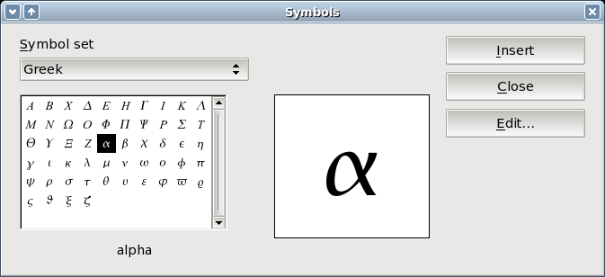

* + 1. Example 2: $$≃3.14159$$

For this example we will suppose that:

* We want to enter the above formula (the value of pi rounded to 5 decimal places).
* We know the name of the Greek character (“pi”).
* But we do not know the markup associated with the $$≃$$ symbol.

Step 1: Type “%” followed by the text “pi”. This displays the Greek character $$$$.

Step 2: Open the Selection window (View > Selection).

**Step 3**: The $$≃$$ symbol is a relation, so we click on the relations button 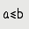. If you hover the mouse over this button you see the tooltip “Relations” ().

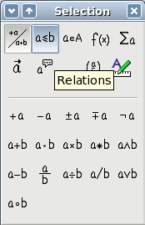

Step 4: Delete the <?> text and add “3.14159” at the end of the equation. Hence we end up with the markup “ %pi simeq 3.14159 ”. The result is shown in .

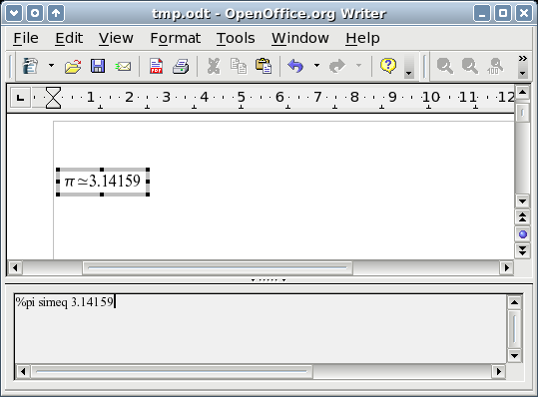

* 1. Customizations
     1. Formula editor as a floating window

As seen in , the formula editor can cover a large part of the Writer window. To turn the formula editor into a floating window, do this:

1. Hover the mouse over the editor frame, as shown in .
2. Hold down the Control key and double-click.

shows the result. You can make the floating window back into an embedded frame, using the same steps. Hold down the Control key and double-click the window frame.

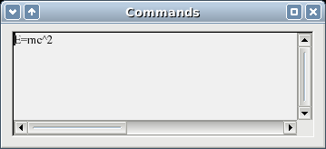

* + 1. How can I make a formula bigger?

This is one of the most common questions people ask about OOoMath. The answer is simple, but not intuitive:

1. Start the formula editor and go to Format > Font size.

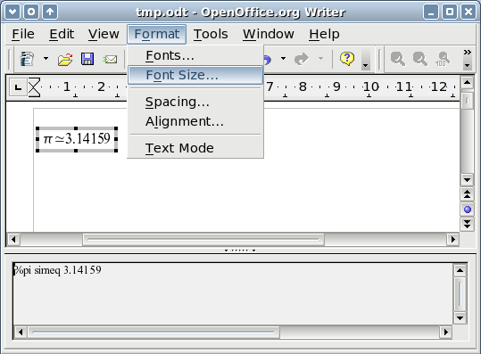

1. Select a larger font size under “Base Size” (top-most entry), as shown in .

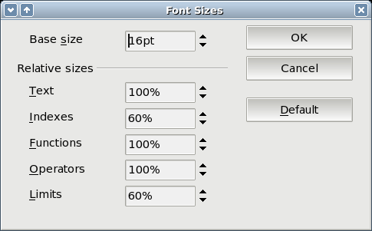

The result of this change is illustrated in .

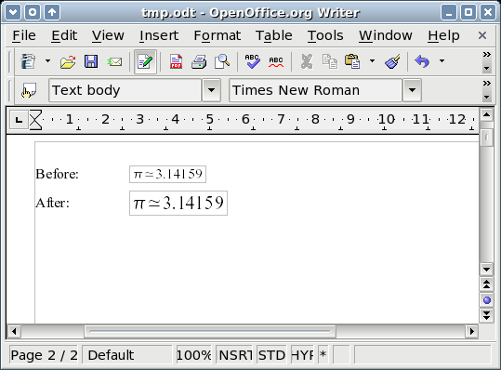

* 1. Formula layout

The most difficult part of using OOoMath comes when writing complicated equations. This section provides some advice about writing complex formulas.

* + 1. Brackets are your friends

OOoMath knows nothing about order of operation. You must use brackets to state order of operations explicitly. Consider the following example:

|  |  |
| --- | --- |
| Markup | Result |
| 2 over x + 1 | $$\frac{2}{x}1$$ |
| 2 over {x + 1} |  |

* + 1. Equations over more than one line

Suppose you want to type an equation covering more than one line. For example: $$\begin{matrix}x=3 \\ y=1\end{matrix}$$

Your first reaction would be to simply press the Enter key. However, if you press the Enter key, though the markup goes to a new line, the resulting equation does not. You must type the newline command explicitly. This is illustrated in the table below.

|  |  |
| --- | --- |
| Markup | Result |
| x = 3  y = 1 | $$x=3y=1$$ |
| x = 3 newline  y = 1 |  |

* 1. Common problem areas
     1. How do I add limits to my sum/integral?

The “sum” and “int” commands can (optionally) take in the parameters “from” and “to”. These are used for lower and upper limits respectively. These parameters can be used singly or together. Limits for integrals are usually treated as subscripts and superscripts.

|  |  |
| --- | --- |
| Markup | Result |
| sum from k = 1 to n a_k | $$\sum_{n}^{k=1}{a_{k}}$$ |
| int from 0 to x f(t) dt  or  int_0^x f(t) dt | $$\int_{x}^{0}{f}(t)dt$$ or $$∫_{0}^{x}f(t)dt$$ |
| int from Re f | $$\underset{ℜ}{∫}f$$ |
| sum to infinity 2^{-n} |  |

|  |  |
| --- | --- |
| Note | For more details on integrals and sums, see the table on page . |

* + 1. Brackets with matrices look ugly!

For background, we start with an overview of the matrix command:

|  |  |
| --- | --- |
| Markup | Result |
| matrix { a # b ## c # d } |  |

|  |  |
| --- | --- |
| Note | Rows are separated by two #’s and entries within each row are separated by one #. |

The first problem people have with matrices is that brackets do not “scale” with the matrix:

|  |  |
| --- | --- |
| Markup | Result |
| ( matrix { a # b ## c # d } ) | $$\begin{matrix}a & b \\ c & d\end{matrix}$$ |

OOoMath provides “scalable” brackets. That is, the brackets grow in size to match the size of their contents. Use the commands left( and right) to make scalable brackets.

|  |  |
| --- | --- |
| Markup | Result |
| left( matrix { a # b ## c # d } right) |  |

|  |  |
| --- | --- |
| Tip | Use left[ and right] to obtain square brackets. |

* + 1. How do I make a derivative?

Making derivatives essentially comes down to one trick: Tell OOo it’s a fraction.

In other words, you have to use the “over” command. Combine this with either the letter “d” (for a total derivative) or the “partial” command (for a partial derivative) to achieve the effect of a derivative.

|  |  |
| --- | --- |
| Markup | Result |
| {df} over {dx} | $$\frac{df}{dx}$$ |
| {partial f} over {partial y} | $$\frac{∂f}{∂y}$$ |
| {partial^2 f} over {partial t^2} |  |

|  |  |
| --- | --- |
| Note | Notice that we had to use squiggly brackets to make the derivative. |

* + 1. Numbering equations

Equation numbering is one of OOoMath’s best hidden features. The steps are simple, but obscure:

1. Start a new line.
2. Type “fn” and then press F3.

The “fn” is replaced by a numbered formula:

|  |  |
| --- | --- |
| $$E={mc}^{2}$$ | (2) |

Now you can double-click on the formula to edit it. For example, here is the Riemann Zeta function:

|  |  |
| --- | --- |
| $$z=\sum_{∞}^{n=1}{\frac{1}{n^{z}}}$$ | (3) |

You can reference an equation (“as shown in Equation ”) with these steps:

1. Insert > Cross-reference.
2. Click on the References tab ().
3. Under Type, select Text.
4. Under Selection, pick the equation number.
5. Under Format, choose Reference.
6. Click Insert.

Done! If you later add more equations to the paper before the referenced equation, all the equations will automatically renumber and the cross-references will update.

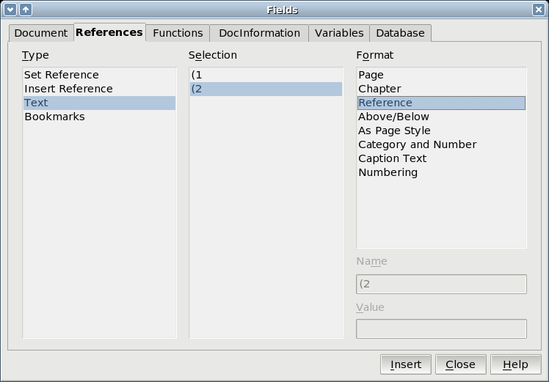

|  |  |
| --- | --- |
| Tip | To insert the equation number without parenthesis around it, choose Numbering under Format instead of Reference. |

* 1. Math commands - Reference
     1. Unary / binary operators

|  |  |  |
| --- | --- | --- |
| Operation | Command | Display |
| +sign | +1 | $$1$$ |
| –sign | –1 | $$−1$$ |
| +/– sign | +–1 | $$±1$$ |
| –/+ sign | –+1 | $$∓1$$ |
| Boolean not | neg a | $$¬a$$ |
| Addition + | a + b | $$ab$$ |
| Multiplication dot | a cdot b | $$a⋅b$$ |
| Multiplication (X) | a times b | $$a×b$$ |
| Multiplication (*) | a * b | $$a∗b$$ |
| Boolean and | a and b | $$a∧b$$ |
| Subtraction (–) | a – b | $$a−b$$ |
| Division (fraction) | a over b | $$\frac{a}{b}$$ |
| Division (operand) | a div b | $$a÷b$$ |
| Division (slash) | a / b | $$a/b$$ |
| Boolean or | a or b | $$a∨b$$ |
| Concatenate | a circ b |  |

* + 1. Relational operators

|  |  |  |
| --- | --- | --- |
| Operation | Command | Display |
| Is equal | a = b | $$a=b$$ |
| Is not equal | a <> b | $$a≠2$$ |
| Approximately | a approx 2 | $$a≈2$$ |
| Divides | a divides b | $$a∣b$$ |
| Does not divide | a ndivides b | $$a∤b$$ |
| Less than | a < 2 | $$a2$$ |
| Greater than | a > 2 | $$a2$$ |
| Similar to or equal | a simeq b | $$a≃b$$ |
| Parallel | a parallel b | $$a∥b$$ |
| Orthogonal to | a ortho b | $$a⊥b$$ |
| Less than or equal to | a leslant b | $$ab$$ |
| Greater than or equal to | a geslant b | $$ab$$ |
| Similar to | a sim b | $$a\sim b$$ |
| Congruent | a equiv b | $$a≡b$$ |
| Less than or equal to | a <= b | $$a≤b$$ |
| Greater than or equal to | a >= b | $$a≥b$$ |
| Proportional | a prop b | $$a∝b$$ |
| Toward | a toward b | $$ab$$ |
| Arrow left | a dlarrow b | $$a⇐b$$ |
| Double arrow left and right | a dlrarrow b | $$a⇔b$$ |
| Arrow right | a drarrow b |  |

* + 1. Set operations

|  |  |  |
| --- | --- | --- |
| Operation | Command | Display |
| Is in | a in B | $$a∈B$$ |
| Is not in | a notin B | $$a∉B$$ |
| Owns | A owns b | $$A∋b$$ |
| Empty set | emptyset | $$∅$$ |
| Intersection | A intersection B | $$A∩B$$ |
| Union | A union B | $$A∪B$$ |
| Difference | A setminus B | $$A∖B$$ |
| Quotient | A slash B | $$A/B$$ |
| Aleph | aleph | $$ℵ$$ |
| Subset | A subset B | $$A⊂B$$ |
| Subset or equal to | A subseteq B | $$A⊆B$$ |
| Superset | A supset B | $$A⊃B$$ |
| Superset or equal to | A supseteq B | $$A⊇B$$ |
| Not subset | A nsubset B | $$A⊄B$$ |
| Not subset or equal | A nsubseteq B | $$A⊈B$$ |
| Not superset | A nsupset B | $$A⊅B$$ |
| Not superset or equal | A nsupseteq B | $$A⊉B$$ |
| Set of natural numbers | setN | $$ℕ$$ |
| Set of integers | setZ | $$ℤ$$ |
| Set of rational numbers | setQ | $$ℚ$$ |
| Set of real numbers | setR | $$ℝ$$ |
| Set of complex numbers | setC |  |

* + 1. Functions

|  |  |  |
| --- | --- | --- |
| Operation | Command | Display |
| Exponential | func e^{a} | $$e^{a}$$ |
| Natural logarithm | ln(a) | $$lna$$ |
| Exponential function | exp(a) | $$expa$$ |
| Logarithm | log(a) | $$loga$$ |
| Power | a^{b} | $$a^{b}$$ |
| Sine | sin(a) | $$sina$$ |
| Cosine | cos(a) | $$cosa$$ |
| Tangent | tan(a) | $$tana$$ |
| Cotangent | cot(a) | $$cota$$ |
| Square root | sqrt{a} | $$\sqrt{a}$$ |
| Arcsine | arcsin(a) | $$arcsina$$ |
| Arc cosine | arccos(a) | $$arccosa$$ |
| Arctangent | arctan(a) | $$arctana$$ |
| Arc cotangent | arccot(a) | $$arccota$$ |
| nth root | nroot{a}{b} | $$\sqrt[a]{b}$$ |
| Hyperbolic sine | sinh(a) | $$sinha$$ |
| Hyperbolic cosine | cosh(a) | $$cosha$$ |
| Hyperbolic tangent | tanh(a) | $$tanha$$ |
| Hyperbolic cotangent | coth(a) | $$cotha$$ |
| Absolute value | abs{a} |  |
| Arc hyperbolic sine | arsinh(a) | $$arsinha$$ |
| Arc hyperbolic cosine | arccosh(a) | $$arcosha$$ |
| Arc hyperbolic tangent | arctanh(a) | $$artanha$$ |
| Arc hyperbolic cotangent | arccoth(a) | $$arcotha$$ |
| Factorial | fact{a} |  |

* + 1. Operators

All operators can be used with the limit functions (“from” and “to”).

|  |  |  |
| --- | --- | --- |
| Operation | Command | Display |
| Limit | lim{a} | $$lima$$ |
| Sum | sum{a} | $$∑a$$ |
| Product | prod{a} | $$∏a$$ |
| Coproduct | coprod{a} | $$∐a$$ |
| Upper and lower bounds shown with integral | int from {r_0} to {r_t} a | $$\int_{r_{t}}^{r_{0}}{a}$$ |
| Integral | int{a} | $$∫a$$ |
| Double integral | iint{a} | $$∬a$$ |
| Triple integral | iiint{a} | $$∭a$$ |
| Lower bound shown with summation symbol | sum from{3}b | $$\underset{3}{∑}b$$ |
| Contour integral | lint a | $$∮a$$ |
| Double curved integral | llint a | $$∯a$$ |
| Triple curved integral | lllint a | $$∰a$$ |
| Upper bound shown with product symbol | prod to{3} r |  |

* + 1. Attributes

|  |  |  |
| --- | --- | --- |
| Operation | Command | Display |
| Acute accent | acute a | $$\overset{}{a}$$ |
| Grave accent | grave a | $$\overset{}{a}$$ |
| Reverse circumflex | check a | $$\overset{}{a}$$ |
| Breve | breve a | $$\overset{}{a}$$ |
| Circle | circle a | $$\overset{˚}{a}$$ |
| Vector arrow | vec a | $$\overset{}{a}$$ |
| Tilde | tilde a | $$\overset{}{a}$$ |
| Circumflex | hat a | $$\overset{}{a}$$ |
| Line above | bar a | $$\overset{}{a}$$ |
| Dot | dot a | $$\overset{˙}{a}$$ |
| Wide vector arrow | widevec abc | $$\overset{}{abc}$$ |
| Wide tilde | widetilde abc | $$\overset{}{abc}$$ |
| Wide circumflex | widehat abc | $$\overset{}{abc}$$ |
| Double dot | ddot a | $$\overset{¨}{a}$$ |
| Line over | overline abc | $$\overset{¯}{abc}$$ |
| Line under | underline abc | $$\underset{̲}{abc}$$ |
| Line through | overstrike abc | $$acb$$ |
| Triple dot | dddot a | $$\overset{}{a}$$ |
| Transparent (useful to get a placeholder of a given size) | phantom a |  |
| Bold font | bold a | $$a$$ |
| Italic font[3]3 | ital “a” | $$\text{a}$$ |
| Resize font | size 16 qv | $$qv$$ |
| Following item in sans serif font[4]4 | font sans qv | $$qv$$ |
| Following item in serif font | font serif qv | $$qv$$ |
| Following item in fixed font | font fixed qv | $$qv$$ |
| Make color of following text cyan[5]5 | color cyan qv | $$qv$$ |
| Make color of following text yellow | color yellow qv | $$qv$$ |
| Make color of following text white | color white qv | $$qv$$ |
| Make color of following text green | color green qv | $$qv$$ |
| Make color of following text blue | color blue qv | $$qv$$ |
| Make color of following text red | color red qv | $$qv$$ |
| Make color green returns to default color black | color green X qv | $$Xqv$$ |
| Brace items to change color of more than one item | color green {X qv} |  |

* + 1. Miscellaneous

|  |  |  |
| --- | --- | --- |
| Operation | Command | Display |
| Infinity | infinity | $$∞$$ |
| Partial | partial | $$∂$$ |
| Nabla | nabla | $$∇$$ |
| There exists | exists | $$∃$$ |
| For all | forall | $$∀$$ |
| H bar | hbar | $$ℏ$$ |
| Lambda bar | lambdabar | $$ƛ$$ |
| Real part | re | $$ℜ$$ |
| Imaginary part | im | $$ℑ$$ |
| Weierstrass p | wp | $$℘$$ |
| Left arrow | leftarrow | $$$$ |
| Right arrow | rightarrow | $$$$ |
| Up arrow | uparrow | $$$$ |
| Down arrow | downarrow | $$$$ |
| Dots at bottom | dotslow | $$$$ |
| Dots at middle | dotsaxis | $$⋯$$ |
| Dots vertical | dotsvert | $$⋮$$ |
| Dots diagonal upward | dotsup | $$⋰$$ |
| Dots diagonal downward | dotsdown |  |

* + 1. Brackets

|  |  |  |
| --- | --- | --- |
| Operation | Command | Display |
| Round Brackets | (a) | $$a$$ |
| Square Brackets | [b] | $$[b]$$ |
| Double Square Brackets | ldbracket c rdbracket | $$〚c〛$$ |
| Single line | lline a rline | $$∣a∣$$ |
| Double line | ldline a rdline | $$∥a∥$$ |
| Braces | lbrace w rbrace | $$\{w\}$$ |
| Angle Brackets | langle d rangle | $$〈d〉$$ |
| Operator Brackets | langle a mline b rangle | $$〈a∣b〉$$ |
| Group brackets (used for program control) | {a} | $$a$$ |
| Scalable round brackets (add the word “left before a left bracket and “right” before a right bracket) | left ( stack{a # b # z} right ) |  |
| Square brackets scalable  (as above) | left [ stack{ x # y} right ] |  |
| Double square brackets scalable | left ldbracket c right rdbracket |  |
| Line scalable | left lline a right rline |  |
| Double line scalable | left ldline d right rdline |  |
| Brace scalable | left lbrace e right rbrace |  |
| Angle bracket scalable | left langle f right rangle |  |
| Operator brackets scalable | left langle g mline h right rangle |  |
| Over bracescalable | {The brace is above} overbrace a | $$\overset{a}{\overset{}{Thebraceisabove}}$$ |
| Under bracescalable | {the brace is below}underbrace {f} |  |

* + 1. Formats

|  |  |  |
| --- | --- | --- |
| Operation | Command | Display |
| Left superscript | a lsup{b} |  |
| Center superscript | a csup{b} | $$\overset{b}{a}$$ |
| Right superscript | a^{b} | $$a^{b}$$ |
| Left subscript | a lsub{b} |  |
| Center subscript | a csub{b} | $$\underset{b}{a}$$ |
| Right subscript | a_{b} | $$a_{b}$$ |
| Align character to left (text is aligned center by default) | stack { Hello world # alignl (a) } | $$\begin{matrix}Helloworld \\ a\end{matrix}$$ |
| Align character to center | stack{Hello world # alignc(a)} | $$\begin{matrix}Helloworld \\ a\end{matrix}$$ |
| Align character to right | stack { Hello world # alignr(a)} | $$\begin{matrix}Helloworld \\ a\end{matrix}$$ |
| Vertical stack of 2 | binom{a}{b} | |
| Vertical stack, more than 2 | stack{a # b # z} | |
| Matrix stack | matrix{a # b ## c # d} | $$\begin{matrix}a & b \\ c & d\end{matrix}$$ |
| Common mathematical arrangement | matrix{a # "="b ## {} # "="c} | $$\begin{matrix}a & \text{=}b \\ & \text{=}c\end{matrix}$$ |
| New line | asldkfjo newline sadkfj | |
| Small gap (grave) | stuff `stuff | $$stuffstuff$$ |
| Large gap (tilde) | stuff~stuff |  |

* + 1. Characters – Greek

|  |  |  |  |  |  |  |  |  |  |
| --- | --- | --- | --- | --- | --- | --- | --- | --- | --- |
| %ALPHA | $$A$$ | %BETA | $$B$$ | %CHI | $$X$$ | %DELTA | $$$$ | %EPSILON | $$E$$ |
| %ETA | $$H$$ | %GAMMA | $$$$ | %IOTA | $$I$$ | %KAPPA | $$K$$ | %LAMBDA | $$$$ |
| %MU | $$M$$ | %NU | $$N$$ | %OMEGA | $$$$ | %OMICRON | $$O$$ | %PHI | $$$$ |
| %PI | $$$$ | %PSI | $$$$ | %RHO | $$P$$ | %SIGMA | $$$$ | %THETA | $$$$ |
| %UPSILON | $$$$ | %XI | $$$$ | %ZETA | $$Z$$ |  |  |  |  |
| %alpha | $$$$ | %beta | $$$$ | %chi | $$$$ | %delta | $$$$ | %epsilon | $$$$ |
| %eta | $$$$ | %gamma | $$$$ | %iota | $$$$ | %kappa | $$$$ | %lambda | $$$$ |
| %mu | $$$$ | %nu | $$$$ | %omega | $$$$ | %omicron | $$$$ | %phi | $$$$ |
| %pi | $$$$ | %rho | $$$$ | %sigma | $$$$ | %tau | $$$$ | %theta | $$$$ |
| %upsilon | $$$$ | %varepsilon | $$$$ | %varphi | $$$$ | %varpi | $$$$ | %varrho | $$ϱ$$ |
| %varsigma | $$$$ | %vartheta | $$$$ | %xi |  | %zeta |  |  |  |

* + 1. Characters – Special

|  |  |  |  |
| --- | --- | --- | --- |
| %and $$∧$$ | %angle $$∢$$ | %element $$∈$$ | %identical $$≡$$ |
| %infinite $$∞$$ | %noelement $$∉$$ | %notequal $$≠$$ | %or $$∨$$ |
| %perthousand $$$$ | %strictlygreaterthan $$≫$$ | %strictlylessthan $$≪$$ | %tendto $$$$ |



Writer Guide

1. Appendix A  
   Keyboard Shortcuts
   1. Shortcut keys – Introduction

You can use OpenOffice.org (OOo) without requiring a pointing device, such as a mouse or trackball, by using its built-in keyboard shortcuts. Tasks as varied and complex as docking and un-docking toolbars and windows, or changing the size or position of objects can all be accomplished with only a keyboard. Although OOo has its own extensive set of keyboard shortcuts, each component provides others which are specific to its work.

For help with OOo’s keyboard shortcuts, or using OOo with a keyboard only, search the OOo On-line Help using the “shortcut” or “accessibility” keywords.

* 1. Assigning shortcut keys

To adapt shortcut keys to your needs, use the Customize dialog box. You can assign shortcuts to standard Writer functions and/or macros and save them for use with Writer only, or with the entire OpenOffice.org suite.

|  |  |
| --- | --- |
| Caution | Be careful when reassigning your operating system, or OOo’s predefined shortcut keys. Many key assignments are universally understood shortcuts, such as F1 for Help, and are always expected to provide certain results. Although you can easily reset the shortcut key assignments to the OOo defaults, changing some common shortcut keys can cause confusion, frustration and possible data loss or corruption, especially if other users share your computer. |

As an example, suppose you wish to apply a particular character style during document creation or editing, for example to add emphasis to a word, or words, and would like to do this via a shortcut key combination, rather than using the rather more long-winded menu access. You could assign *Shift-F4*as a shortcut for this purpose, as described below:

1. Select Tools > Customize > Keyboard. The Customize dialog box () opens.
2. To have the shortcut key assignment available only with Writer, select the **Writer** button ( located at the upper right corner of the Keyboard tab), otherwise select the **OpenOffice.org** button which will make it available to every component.
3. Next select Styles > CharacterStyles in the Category list and Strong Emphasis in the Function list.
4. Now select the shortcut keys *Shift+F4* in the Shortcut keys list and click the Modify button at the upper right.
5. Click **OK** to accept the change. Now the *Shift+F4* shortcut will apply the Strong Emphasis style to any selection.

|  |  |
| --- | --- |
| Notes | 1. All existing shortcut keys for the currently selected Function are listed in theKeys box. Since there is no currently assigned shortcut for the Styles > CharacterStyles function the Keys list is empty. If it were not, and you wished to reassign a shortcut key combination that is already in use, you must first Delete the existing *Key*. 2. Shortcut keys that are greyed-out in the listing on the Customize dialog box, such as F1 and F10, are not available for reassignment. 3. Remember, since the **Writer** button was selected at the start of this procedure, the newly assigned shortcut key will only work within the Writer component. To set this shortcut for use by all of the components within the suite, repeat this procedure after first selecting the **OpenOffice.org** button. |

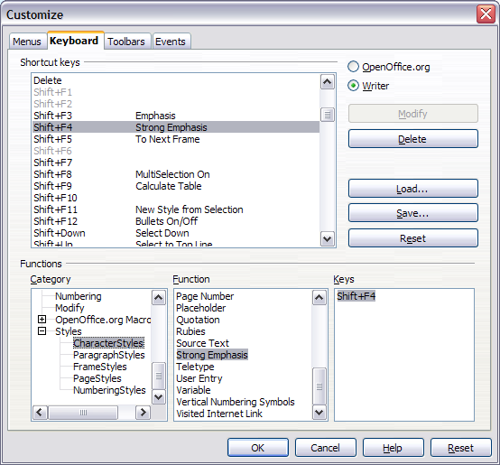

* + 1. Saving changes to a file

Changes to the shortcut key assignments (and other configurations) can be saved in a keyboard configuration file for use at a later time, thus permitting you to create and apply different configurations as the need arises. To save keyboard shortcuts to a file:

1. After making your keyboard shortcut assignments, click the **Save** button at the bottom right of the Customize dialog box ().
2. In the Save Keyboard Configuration dialog box, select *All files* from the **Save as Type** combo box.
3. Next enter a name for the keyboard configuration file in the **File name** text box, or select an existing file from the listbox. If you need to, browse to find a file from another location.
4. Click **Save**. A confirmation message will appear if you are about to overwrite an existing file, otherwise there will be no feedback and the file will be saved.
   * 1. Loading a saved keyboard configuration

To load a saved keyboard configuration file and replace your existing configuration, click the **Load** button at the bottom right of the Customize dialog box (). Then select the configuration file from the Load Keyboard Configuration dialog box.

* + 1. Resetting the shortcut keys

To reset all of the keyboard shortcuts to their default values, click the **Reset** button at the bottom right of the Customize dialog box (). Use this feature with care as no confirmation message will be displayed; the defaults will be set without any further notice or user input.

* + 1. Running macros

You can also define shortcut key combinations that will run macros. These shortcut keys are strictly user-defined; none are built in.To terminate a macro that is currently running, press Shift+Control+Q.

1. Shortcut keys for OpenOffice.org Writer

Table 6: Writer shortcut keys

|  |  |
| --- | --- |
| Shortcut Keys | Effect |
| Ctrl+A | Select All |
| Ctrl+J | Justify. |
| Ctrl+D | Double Underline. |
| Ctrl+E | Centred. |
| Ctrl+F | Find and Replace. |
| Ctrl+Shift+P | Superscript. |
| Ctrl+L | Align Left. |
| Ctrl+R | Align Right. |
| Ctrl+Shift+B | Subscript. |
| Ctrl+Y | Redo last action. |
| Ctrl+0 (zero) | Apply Default paragraph style. |
| Ctrl+1 | Apply Heading 1 paragraph style. |
| Ctrl+2 | Apply Heading 2 paragraph style. |
| Ctrl+3 | Apply Heading 3 paragraph style. |
| Ctrl+5 | 1.5 Line Spacing. |
| Ctrl+ Plus Key(+) | Calculates the selected text and copies the result to the clipboard. |
| Ctrl+Hyphen(-) | Custom hyphens; hyphenation set by you. |
| Ctrl+Shift+minus sign (-) | Non-breaking dash (is not used for hyphenation). |
| Ctrl+multiplication sign * (only on number pad) | Run macro field. |
| Ctrl+Space | Non-breaking spaces. Non-breaking spaces are not used for hyphenation and are not expanded if the text is justified. |
| Shift+Enter | Line break without paragraph change. |
| Ctrl+Enter | Manual page break. |
| Ctrl+Shift+Enter | Column break in multi-columnar texts. |
| Alt+Enter | Inserting a new paragraph without numbering. |
| Alt+Enter | Inserting a new paragraph directly before or after a section or a table. |
| Arrow Left | Move cursor to left. |
| Shift+Arrow Left | Move cursor with selection to the left. |
| Ctrl+Arrow Left | Go to beginning of word. |
| Ctrl+Shift+Arrow Left | Selecting to the left word by word. |
| Arrow Right | Move cursor to right. |
| Shift+Arrow Right | Move cursor with selection to the right. |
| Ctrl+Arrow Right | Go to end of word. |
| Ctrl+Shift+Arrow Right | Selecting to the right word by word. |
| Arrow Up | Move up one line. |
| Shift+Arrow Up | Selecting lines in an upwards direction. |
| Arrow Down | Move cursor down one line. |
| Shift+Arrow Down | Selecting lines in a downward direction. |
| Home | Go to beginning of line. |
| Shift+Home | Go and select to the beginning of a line. |
| End | Go to end of line. |
| Shift+End | Go and select to end of line. |
| Ctrl+Home | Go to start of document. |
| Ctrl+Shift+Home | Go and select text to start of document. |
| Ctrl+End | Go to end of document. |
| Ctrl+Shift+End | Go and select text to end of document. |
| Ctrl+PageUp | Switch cursor between text and header. |
| Ctrl+PageDown | Switch cursor between text and footer. |
| Insert | Insert mode on/off. |
| PageUp | Screen page up. |
| Shift+PageUp | Move up screen page with selection. |
| PageDown | Move down screen page. |
| Shift+PageDown | Move down screen page with selection. |
| Ctrl+Del | Delete text to end of word. |
| Ctrl+Backspace | Delete text to beginning of word. |
| Ctrl+Shift+Del | Delete text to end of sentence. |
| Ctrl+Shift+Backspace | Delete text to beginning of sentence. |
| Ctrl+Tab | Next suggestion with Automatic Word Completion. |
| Ctrl+Shift+Tab | Use previous suggestion with Automatic Word Completion. |
| Alt+W | Spell checker dialog box: Call back the original unknown word into the text box. |
| Ctrl+ double-click or Ctrl+Shift+F10 | Use this combination to quickly dock or un-dock the Navigator, Styles and Formatting window, or other windows. |

* 1. Shortcut keys for tables

Table 7: Shortcut keys for tables in OpenOffice.org Writer

|  |  |
| --- | --- |
| Shortcut Keys | Effect |
| Ctrl+A | If the active cell is empty Ctrl+A selects the whole table; otherwise it selects the contents of the active cell. Depressing Ctrl+A a second time selects the entire table. |
| Ctrl+Home | If the active cell is empty Ctrl+Home moves the cursor to the beginning of the table. Depressing Ctrl+Home again moves the cursor to the beginning of document.  If the active cell is not empty Ctrl+Home moves the cursor to the beginning of the active cell. A second depression of Ctrl+Home moves the cursor to the beginning of the current table. A third depression moves the cursor to the beginning of the document. |
| Ctrl+End | If the active cell is empty Ctrl+End moves the cursor to the end of the table. Depressing Ctrl+End again moves the cursor to the end of document.  If the active cell is not empty Ctrl+End moves the cursor to the end of the active cell. A second depression of Ctrl+End moves the cursor to the end of the current table. A third depression moves the cursor to the end of the document. |
| Ctrl+Tab | Inserts a tab stop (only in tables). Depending on the Window Manager in use, Alt+Tab may be used instead. |
| Ctrl+Shift+Arrow Up | Jump to start of table |
| Ctrl+Shift+Arrow Down | Jump to end of table |
| Alt+Arrow Keys | Increases or decreases the size of the column or row on the right or bottom cell edge |
| Alt+Shift+Arrow Keys | Increase or decrease the size of the column or row on the left or top cell edge |
| Ctrl+Alt+Shift+Arrow Keys | Like Alt, but only the active cell is modified |
| Alt+Insert | Provides 3 seconds in Insert mode, during which time an Arrow Key will insert a row or column, or Ctrl+Arrow Key will insert a cell. |
| Alt+Del | Provides 3 seconds in Delete mode, during which time an Arrow key will delete a row or column, Ctrl+Arrow Key will merge the active cell with the neighbouring cell. |
| Ctrl+Shift+T | Removes cell protection from all selected tables. If no table is selected, then cell protection is removed from all of the tables in the document. |
| Ctrl+Shift+Del | If nothing is selected, the contents of the next cell will be deleted. If cells are selected, the whole row(s) of the selection will be deleted. If all rows are selected completely or partially, the entire table will be deleted. |

1. Shortcut keys for paragraphs and heading levels

Table 8: Shortcut keys for paragraph and heading levels

|  |  |
| --- | --- |
| Shortcut Keys | Effect |
| Ctrl+Alt+Up Arrow or  Ctrl+Up Arrow | Move the active paragraph or selected paragraphs up one paragraph. |
| Ctrl+Alt+Down Arrow or Ctrl+Down Arrow | Move the active paragraph or selected paragraphs down one paragraph. |
| Tab | The heading in format Heading X (X = 1–9) is moved down one level in the outline. |
| Shift+Tab | The heading in format Heading X (X = 2–10) is moved up one level in the outline. |
| Ctrl+Tab | At the start of a heading: Inserts a tab stop. Depending on the Window Manager in use, Alt+Tab may be used instead.  To change the heading level with the keyboard, first position the cursor in front of the heading. |

Index

A

accepting or rejecting changes 81

address book 286

address data source 285

align cells in table 249

aligning graphics 236

alphabetic index

adding index entries 335

creating 335

anchoring frames 105

anchoring graphics 239

antialiasing screen font 29

appearance options 36

Apply Style list 190

arranging graphics 236

Asian languages 51

Assign action dialog (form) 418

attribute commands (Math) 439

AutoCaption 49, 240

AutoCorrect 44, 54, 66, 75

Autofit 257

AutoFormat 54

AutoFormat dialog box 264

autoformat table 249

autoformatting 66

automatic caption 49, 262

automatic page or column breaks 200

AutoText 76

AutoText dialog box 382

AutoText for entering fields 381

autoupdate styles 194

B

Base main window 412

bibliographic database

adding entries 347

columns 345

creating 344

fields 345

filter 345

bibliography

creating 343

creating database 344

editing 354

formating 349

master document 368

paragraph style 351

references 348

book preview 21, 137

booklet printing 138

bookmarks 84, 384, 385

brackets (Math) 430

brackets commands (Math) 442

brochure printing 138

bulleted list 66, 68

Bullets and Numbering toolbar 68, 216

C

Caption dialog box 241

captions 240

captions, manual 242

cells in table, formatting 252

change tracking options 47

chapter numbers 389

character formatting 66

character styles

applying 179

undoing 179

using 178

characters – special (Math) 444

characters – Greek (Math) 444

citations 348

clipboard 31

closing a document 22

closing Writer 23

color options 33

column width in table 257

column, inserting in table 249

columns

changing the number 101

defining 98

distributing text evenly 99

formatting 100

newspaper-style 99

separator lines 100

command line, starting Writer 8

comments 80

comparing documents 79, 83

compatibility options 48

complex text layout languages 51

conditional content 390, 392

conditional text 391, 394

convert colors to grayscale 45

converting between table and text 265

counting words 87

create document from template 272

creating a document 16

cross-reference 129

cross-references

between documents 369

in headers or footers 388

inserting references 386

overview 84, 384

preparing headings as targets 385

setting references 385

cutting and copying text 57

D

dashes 64

data entry in tables 265

data source

accessing existing 414

accessing using a form 411

definition 284

registering 285

database

access permissions 419

creating 411

Table Design window 413

Database Wizard 412, 414

default file format 38

default template 278

derivative markup (Math) 432

dictionaries 51

dictionary 71

different first page 93

digital rights management (DRM) 149

digital signature 153

direct cursor 44

distribute columns or rows in table 249

dithering 30

DocInformation field 392

dockable/floating windows 13

document

closing 22

create from template 272

creating 16

opening 17

printing 19

saving 18

saving as a Microsoft Word 18

document status 28

document views 12

double-sided printing 45

Drawing Object Properties toolbar 244

drawing objects

anchoring 239

grouping 245

properties 244

Drawing toolbar 244

drawing tools 243

duplex printer 45

E

e-mail options 50

e-mailing

Mail Merge Wizard 151

several recipients 150

Writer document as attachment 150

edit document properties before saving 38

Edit Fields dialog box 397

en and em dashes 64

endnotes 69, 117

envelope

formatting address blocks 139

Mail Merge dialog 303

mail merge from database 139

printing 138

envelope printing 138

EPS images in PDF 146

equation

inserting 422

layout 429

numbering 432

equation editor 422

brackets 430

derivative markup 432

equations over more than one line 430

floating window 428

font size 429

formula layout 429

limits to sum/integral 431

markup 425

matrix markup 431

right-click menu 425

Selection window 423

export directly as PDF 21, 145

exporting to PDF 21, 145

extended tips 22, 27

Extension Manager 277

F

facing pages 169

fax icon, adding to toolbar 143

fax sending 143

Fax Wizard 274

FDF 147

features 2

field names, show/hide 390

field shadings on/off 390

fields

automatic updating 397

AutoText entry 384

AutoText for entering 381

bookmark 84, 385

bookmarks 384

converting into text 390

cross-reference 84, 384

DocInformation 392

document properties 380

document title 388

entering 378

fixed content 381, 390

gray background on screen 378

hidden text 395

in headers and footers 388

keyboard shortcuts 390

number range variable 382

page count 389

page number 378, 388

placeholder 398

updating 390

user-defined variable 384, 392

Fields dialog box

DocInformation tab 380

Document tab 381, 388

Functions tab: conditional text 394

Functions tab: hidden text 395

Functions tab: placeholder field 398

open using keyboard 390

References tab 384, 386, 387

file locations 32

file sharing options 35

Fill Format mode 190

finding and replacing text 59

floating toolbars 10, 11

floating/dockable windows 13

font family 44

font history 30

font options 34

font preview 30

font replacements 34

font size, relative 202

fonts, default 44

footnote (or endnote) marker 70

footnote formatting 70

footnotes 69, 115

form

accessing data sources 411

adding form controls 408

configuring controls 402

configuring form controls 409

control formatting options 419

creating 401

customization, advanced 417

data entry form creation 415

database access permissions 419

Design Mode 402

entering data 417

example of creating a form 408

form controls reference 404

form properties 416

Form Properties dialog 416

inserting form controls 402

linking macro to a control 417

read-only 419

toolbars 401

using the form 403

when to use 400

XForms 420

Form Control dialog 403

Form Controls toolbar 401

Form Design toolbar 401, 406

form letter

creating with wizard 305

Form Properties dialog 416

formats commands (Math) 443

Formatting Aids options 43

formatting, finding and replacing 61

formula

inserting 422

layout 429

numbering 432

formula editor

brackets 430

derivative markup 432

equations over more than one line 430

floating window 428

font size 429

limits to sum/integral 431

markup 425

matrix markup 431

right-click menu 425

Selection window 423

frame

anchoring 105

border 104

creating 102

linking 106

moving, resizing, and changing attributes 103

Frame dialog box 104, 107

frame styles

applying 221

formatting 220

overview 219

Frame toolbar 236

function commands (Math) 437

G

Gallery

adding an image 233

opening 232

general options 27

general options for Writer 41

GNOME 3, 4

graphics

adding 233

adding captions 240

adding from file 228

alignment 236

anchoring 239

arrangement 236

file types supported 246

GIMP 234

linking 229

modifying 234

positioning 236

resizing 229

wrapping text around 237

Greek characters 426

grid intervals 44

H

header

different on right and left pages 177

headers 173

headers and footers 121, 388

Help 22, 27

Help Agent 22, 28

hidden paragraphs 391

hidden section 114

hidden sections 391

hidden text 391, 395

high contrast 28

horizontal lines 66

HTML compatibility 40

HTML documents 44

hyperlinks

editing 86

inserting 84

hyphenation 73

I

icon size and style 29

icons in menus 29

images

adding from file 228

anchoring 239

linking 229

resizing 229

scanned 232

wrapping text around 237

indent distance 42

indents 65

index

capitalizing entries 339

creating 335

customizing 337

figures, tables, and other 342

key 337, 339

sorting entries 339

index entries 335

customizing 336, 339

editing 342

Index Link character style 328

Insert Bookmark dialog box 385

Insert Index Entry dialog 336

Insert Index/Table dialog 322

insert mode 87

Insert Section dialog box 111, 396

interface, Writer 9

Internet Link character style 328

K

KDE 3, 5, 8

KDocker 8

kerning text 205

keyboard shortcuts

customizing 191

select nonconsecutive items 57

keyboard shortcuts for fields 390

L

label printing 141

labels

printing 141

landscape page in portrait document 96

landscape pages 95, 130

language selection for paragraph styles 203

language settings 51

limits to sum/integral 431

line numbering 77

lines 66

linking frames 106

Linux 3, 4, 5, 8

list (numbering) styles

Bullets and Numbering toolbar 216

overview 213

load/save options 37

loading styles 198

locale settings 51

logical expressions 391

long-click buttons 10

M

Mac OS X 3, 6

Macintosh 56

macro

linking to a form control 417

mail merge

Adjust Layout dialog 312

Create Salutation dialog 311

edit saved file 298

envelopes 303

Mail Merge dialog 291, 303

Match Fields dialog 310

New Address Block dialog 309

overview 284

personalize documents 315

save, print or send 316

Select Address Block dialog 308

Select Address List dialog 307

Mail Merge dialog 291, 303

mail merge e-mail options 50

Mail Merge Wizard

e-mailing Writer document 151

mailing labels 293

manual formatting, removing 66

manual page breaks 171

marginal notes 108

margins, changing 97

master document

anchoring pictures to page 376

bibliography 368

breaking links 372

changing styles 368

chapter reference in header 373

combining several documents 358

creating 358

creating one file 372

cross-referencing between subdocuments 369

editing 368

editing subdocuments 368

exporting to .odt file 372

index 368

landscape pages in portrait document 375

Navigator 356

no existing documents 359

planning 360

splitting one document 358

styles 356, 361

subdocument creation 362

subdocument inclusion 365

table of contents 368

template 362

title page 363

Match Fields dialog 310

Math commands reference 434

mathematical equations 422

mathematical markup 425

mathematical symbols 423

matrix markup (Math) 431

measurement unit 65

menus 9

merge cells in table 249

merging and splitting cells in table 253

merging and splitting tables 254

merging documents 83

Microsoft Office file conversion 39

Microsoft Word 7, 48

middle mouse button function 31

mirrored margins 169

miscellaneous commands (Math) 441

More (Form) Controls toolbar 401, 405

mouse positioning 31

N

name and initials of user 26

Navigator

in master document 356

in normal document 14

nested tables 251

New Address Block dialog 309

newsletter layout 91

Next Style 94

no wrap 237

non-breaking hyphen 64

non-breaking spaces 63

non-consecutive items, selecting 56

notes 80

Number Format dialog box 110

number formats in tables 261

number range variable 382

number recognition 47, 110, 261, 265

numbered lists 66, 68

numbering equations 432

numbering pages 125

numbering pages by chapter 131

numbering sequence, defining 382

O

Office Assistant 28

Open/Save dialog boxes 28

OpenGL 30

operator commands (Math) 438

optimal page wrap 237

organizing templates 279

orientation of page 95

orphan control 200

OutlineCrossRef3 macro 369

overwrite mode 87

P

page break, manual 92

page breaks 171, 199

page count in header or footer 389

page count, problem 127

page headers 212

page layout

choosing best method 90

different first page 93

headers and footers 121

landscape page 95

landscape page in portrait document 96

margins, changing 97

newsletter 91

orientation 95

portrait headers on landscape pages 122

snaking columns 91

using columns 98

using frames 102

using sections 111

using styles 92

using tables 108

page number

automatic 125

format, changing 127

numbering by chapter 131

odd and even 177

restarting 126, 175

restarting, problems 127

starting with page number greater than 1 130

page numbers 173, 378

Page Preview 20, 137

page style

book sequence 172

current 168

facing pages 169

inserting a page with special formatting 172

mirrored margins 169

modifying 169

Next Style property 170

page styles 92

overview 222

page wrap 237

pages, total number of 125

paragraph

formatting 64

moving 58

spacing at tops of pages 49

paragraph ends 43

paragraph markers 101

paragraph styles

conditional 216

custom 163

features 199

finding and replacing 62

kerning text 205

language selection 203

linked 162

next style 164

orphan and widow control 200

outline levels 206

page headers 212

rotating text 204

password 79

password-protect PDF 149

pasting text 57

path options 32

PDF

blank page export 147

digital rights management (DRM) 149

encrypt 149

EPS images 146

export documents to 21, 145

form 147

image compression and resolution 146

initial view selection 147

pages to export 145

password-protect 149

security settings 149

tagged 146

user interface settings 147

PDF Options dialog 145

Picture dialog box 236

pictures

adding 233

adding from file 228

anchoring 239

linking 229

resizing 229

wrapping text around 237

placeholder field 398

preview of fonts 30

previewing pages 20

Print dialog 19

Print dialog box 134

print file directly 134

print options 31, 45

printer metrics 48

Printer Options dialog 135

printer settings 38

printer warnings 31

printer, specifying 20

printing

black and white on color printer 136

book preview 137

booklet 138

brochure 138

choosing what to print 134

default settings 136

envelopes 138

grayscale on color printer 136

labels 141

overview 19

previewing 137

print options 20, 135

printer selection 134

Properties dialog box 379

protecting a document 79

Q

Quickstarter

Linux 8

Windows 7

R

read-only forms 419

recording changes 79, 80

redlines 79

redo 79

regular expressions 60

rejecting changes 81

relational operator commands (Math) 435

relative font size 202

replacement table (font) 34

reverse order printing 45

revision marks 79

rotating text 204

rotating text in a table cell 264

row height in table 257

row, inserting in table 249

rulers 12, 65

rulers, changing margins 98

S

Save 18

scaled resizing of graphics 231

scaling factor 29

scanner 232

screen font antialiasing 29

searching in Japanese 51

section

boundaries 36

conditional 396

creating 111

deleting 118

editing the format 119

hidden 396

hiding 114

linking 112

links, updating 120

naming 112

password-protecting 113

saving 117

selecting 117

uses of 111

write-protecting 113

security options 35

Select Address Block dialog 308

Select Address List dialog 307, 308

selecting text 56

selection clipboard 31

send document as e-mail 150

set operations commands (Math) 436

set reference 128

shortcut keys, assigning styles 191

sideheads 108

size optimization 38

snaking columns 91

snap to grid 44

Solaris 58

sorting data in a table 249, 266

spacing at tops of pages 49

spacing between paragraphs and tables 48

special characters 63

spelling 71

spelling options 53

split cells in table 249

spreadsheet functions in table 268

starting Writer

from an existing document 7

from the command line 8

from the system menu 3

preloading OOo under Linux/KDE 8

Quickstarter 8

Style dialog box 192

styles

applying 159, 188

AutoUpdate 194

book chapter sequence of pages 222

changing formatting 166

character 178

copying 196

creating by drag and drop 196

creating from selection 195

custom 163

definition 156

deleting 198

example of use 156

linked 162

linking 195

list (numbering) styles 213

loading from template or document 198

modifying 159, 192

moving 196

next style 164

overview 188

page styles 168, 222

paragraph styles 158

relative font size 202

Style dialog box 194

tab stops 201

types 157, 188

updating from document or template 194

updating from selection 193

Styles and Formatting window 157, 189

subdocuments 358, 362

sum cells in table 249

superordinate object settings 256

system font for user interface 29

system menu, starting from 3

T

tab stops 42, 65, 201

table

alignment on page 254

allow to break across pages 256

AutoCorrect to create 251

autoformat 249

automatic caption 262

background colors and graphics 259

borders 258

boundaries 36, 264

caption 261

column width 257

columns and rows 249

converting between table and text 265

copying 267

creating 250

creating using AutoCorrect 251

cross-reference to caption 263

data entry 265

deleting 266

do not split 251

formatting 252

formatting cells 252

heading 250

heading, creating in existing table 264

inserting 250

line arrangement (borders) 258

linking graphic file 260

merging and splitting 253

moving 267

moving between cells 265

nested table 251

number formats 261

number recognition 261, 265

page layout using 108

page or column break 256

properties 250

repeat heading 251

resizing rows and columns 257

rotating text 264

row height 257

rows 253

sort cells 249

sorting data 266

spacing at tops of pages 49

spacing on page 254

spacing to contents 258

spreadsheet functions 268

sum cells 249

text flow 256

vertical alignment of cells 261

vertical alignment of text in cells 257

when to use 248

Table Design window 413

Table Format dialog box 110

Background tab 260

Borders tab 259

Columns tab 258

Table tab 255

Text Flow tab 96, 256

Table menu and toolbar 248

table of contents

accessing from the Navigator 334

adding or changing elements 327

background 331

changing number of levels included 324

character styles 328

columns 330

creating 320

creating from additional styles 324

creating from an outline 324

creating from index marks 324

customizing 322

deleting 334

editing 333

formating entries 326

graphic in background 332

hyperlinking entries 327

including chapter numbers 327

Index Link character style 328

Internet Link character style 328

paragraph styles 329

protecting against manual changes 324

scope 323

Tab position relative to Paragraph Style indent 329

updating 333

table options 46

tabs vs tables 248

tear-off toolbars 10

template

create document from 16, 272

creating from document 273

creating using wizard 274

deleting 280

description 272

editing 275

exporting 281

Extension Manager 277

folders 279

importing 280

moving 280

organizing 279

setting a default 278

update document styles from 276

Template Management dialog box 196

text boundaries 36

text flow in tables 256

text size in user interface 29

text wrapping 237

theme, Gallery 233

thesaurus 72

three-D view 30

toolbars 10

tooltips 22, 27

total number of pages 125

tracking changes 79, 80

transparency 238

two-digit years 28

U

unary / binary operator commands (Math) 434

undo 78

update fields and charts automatically 42

update links when loading 42

updating fields 390

URL Recognition 84

User Data options 26

user-defined variable field 384

user-specific settings 37

V

variables 392

VBA 38

view options 29

View options for Writer 43

W

What’s This? help 22

widow control 200

wildcards 60

Windows 3, 7

wizard

Address Data Source 285

Mail Merge 305

word completion 75

word count 87

workspace 9

wrap off 237

wrap through 238

wrapping text around graphics 237

writing aids 53

X

XForms 420

XML 38

Y

year (two digits) 28

Z

zoom 12

1. However, the method does not work in some situations. See “” on page for details.
2. See “” on page for one example.
3. Unquoted text that is not a command is considered to be a variable. Variables are, by default, italicized.
4. There are three custom fonts: sans serif (without kicks), serifs (with kicks), and fixed (non-proportional). To change the actual fonts used for custom fonts and the fonts used for variables (unquoted text), numbers and functions, use Format > Fonts.
5. For all coloring, the color will apply only to the text immediately following the command until the next space is encountered. In order to have the color apply to more characters, place the text you want in color in curly brackets.